I have Achive mentioned requiremets.

What I have Done:-

I have created Web API for search address.

I am consumnig this API for search filter as per given input by user

Supposed I have search keyword street so it is returning 4 result as per match case in orderby distance

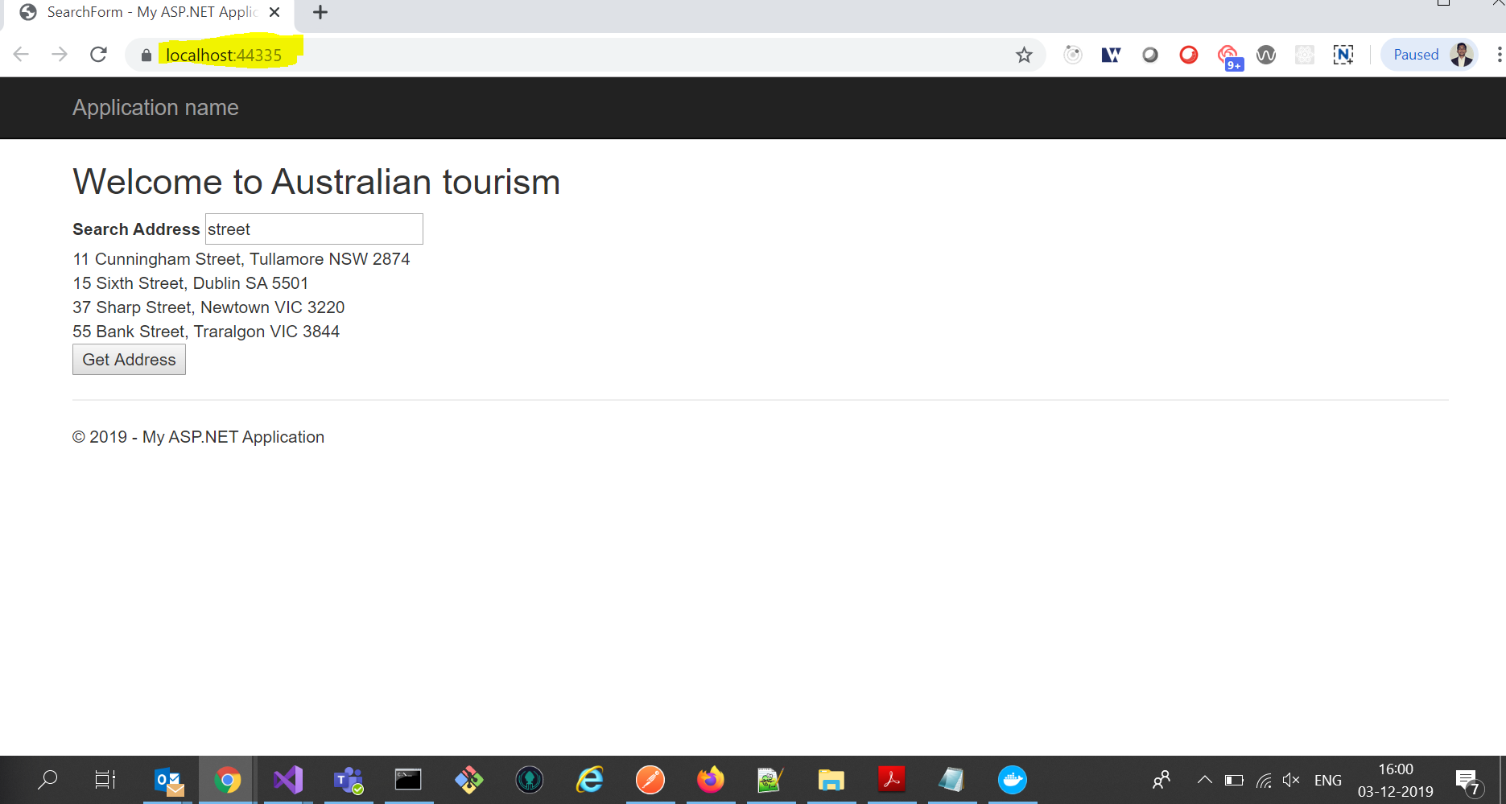

Technology:-

Visual Studio -2019

Web API

Ajax

JQuery

Unit Testing

For Run Project Just Press- F5 and enter keyword related to address it should be return response as per current request and nearest distance. See in above Image.