

### Practice Test - 04 26/08/2022

**JEE Advance Paper – 2**

**Chemistry**

**SECTION - A**

**4.** For a reaction 2A + B  C with the rate law

#### More Than one Correct (1–6)

1. In which of the following reaction(s) the product

d[C]  k[A][B]1

dt

and started with A and B in

is/are correctly matched? (1)

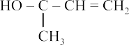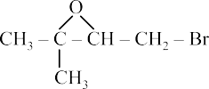

(2)



(3)



stoichiometric proportion. Which is/are true?

(1) [C] = 2kt

* 1. [C] = kt
  2. Unit of k is mol/L–1 s–1
  3. Concentration of A, B and C will vary linearly with time

1. Copper is purified by electrorefining of blister copper. The correct statement(s) about tis process is(are)
   1. Impure Cu strip is used as cathode
   2. Acidified aq. CuSO4 is used as electrolyte
   3. Pure Cu is deposited at cathode
   4. Impurities like Au, Ag settle down as anode- mude
2. 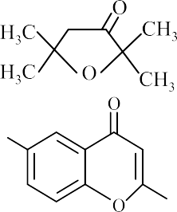Identify the correct statement(s).



1. (1) After hydrolysis sucrose will give -D-glucose and -D-fructose only
   1. After hydrolysis sucrose will give -D-glucose,
2. Colemanite Na2CO3 [x] HCl

Ca2B6O11

[y]

Monobasic lewis acid

-D-glucose, -D-fructose and -D-fructose

* 1. Sucrose has C1—C2 glycosidic linkage
  2. Sucrose has C1—C4 glycosidic linkage

[z] Mg [w]

an element

Identify incorrect statement(s)

* + 1. Oxidation number of boron in colemanite is +3
    2. z when heated with Co gives blue colour in oxidising flame and red.
    3. Almost all compounds of w are ionic
    4. Decahydrated form of X has 4 O—H bonds

### SECTION - B

#### Non Negative Integer Type (7–13)

**7.** Total number of compounds among the following which give iodoform test is

1. 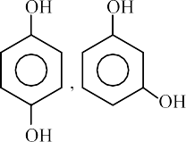C3H7Cl Na  A  B  C



Dry ether (Major)

1. A and C give negative test with cold alkaline KMnO4 but ‘B’ decolourises pink colour of cold alkaline KMnO4



(ii) A Cr2O3D BE (i)O2,  F

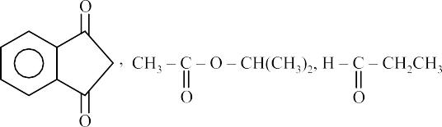Al2O3, 

H (ii) H3O

carbolic acid

The correct statement about the above reactions.

* 1. F reacts with FeCl3 to give violet colour
  2. F reacts with Br2 + H2O to give white ppt
  3. E on oxidation with KMnO4/H+ gives benzoic acid



* 1. D on ozonolysis gives glyoxal

1. 3.4 g impure sample of AgNO3 is dissolved in water to prepare a 50 mL solution. The prepared solution is treated with 50 mL of 0.3 M KI solution. The AgI precipitated is filtered off. Excess of KI in the filtrate is titrated with 0.1 M KIO3 solution in presence of HCl and to reach equivalence point 50 mL of KIO3 is consumed. If the percentage of AgNO3 in the sample is X, then

### SECTION - C

***Comprehension Type (14-19)***

# Direction: (Qs. 14 and 15)

A dilute solution contains ‘x’ moles of solute A in 1 kg of solvent with molal elevation constant Kb. The solute dimerises in the solution according to the following equation. The degree of association is ():

the value of X

5

is [Atomic mass of Ag = 108 u]

2A

**14.** The van’t Hoff factor will be:

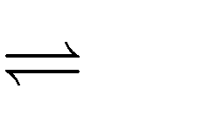

A2

[Reaction: KIO3 + KI + HCl  ICl + KCl + H2O]

1. 100 ml of strong monobasic acid (HX) of 0.3 M is mixed with 100 ml of 0.4 M NH3. pH of resulting solution is . [Given pKa of NH + = 9.48,

4

(1) i = 1 – 2 (2) i  1 

2

(3) i  1  (4) i = 1 + 

2

log 3 = 0.48]

**15.** The degree of association is equal to:

1. Out of the given aq. Ions, find the number of ions which produce ppt with dil. HCl + H2S.

Pb+2, Ba+2, Ca+2, Fe+3, Bi+3, Hg+2, Zn+2, Cu+2, Cd+2, Al+3, NH +, Sn+2

(1)

 (Kbx  Tb )

Tb.2

2Tb

(2)

 2(Kbx  Tb )

Kbx

Tb

4

1. The number of stereoisomers of [Pt(bn)2]2+ and

(3)

  2  (4)

Kbx



2Kbx

[Co(en)Cl2BrI]– are x and y respectively. What is the value of (x + y)?

* *

(Where bn CH3 – CH(NH2 )  CH(NH2 )  CH3 )

1. One mole ideal monoatomic gas is heated according to path AB and AC. If temperature of

# Direction: (Qs. 16 and 17)

The aliphatic aldehyde P and Q react in the presence of aq. K2CO3 to give a compound R. R upon treatment with KCN forms compound S. On acidification and heating ‘S’ gives the product shown below



state B and C are equal. Calculate



1. 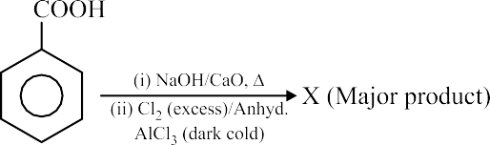Consider the following reactions:

I.



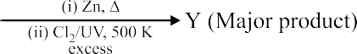II.

qAC 10 qAB

1. Identify the statement(s) which is/are correct.
   1. Nucleophilic substitution reaction takes place between P and Q to form R
   2. The molar formula of P and Q is same
   3. Nucleophilic addition reaction takes place to form S and R
   4. Compound R has two chiral centres
2. The correct structural formula of compound S is



(1) (2)



The summation of degree of unsaturation of products X and Y is

(3) (4)

# Direction: (Qs. 18 and 19)

A unielectronic ion M+q has electron in a state X1 that has two radial nodes and zero angular node. Energy of state X1 is equal to ground state energy of hydrogen atom. Electron de-excites from X1 to state X2 and velocity of electron X2 is 3.3 × 106 ms–1. State X2 has one angular node and zero radial node.

1. Atomic number of element M is (1) 2 (2) 3

(3) 4 (4) 5

1. The incorrect statement(s) is/are
   1. Velocity of electron of M+q in state X1 is equal to half of velocity of electron M+q in state X2
   2. Velocity of electron of M+q in state X1 is equal to velocity of electron in ground state of hydrogen atom
   3. Time period of revolution of electron in state X1 of M+q is equal to time period of revolution of electron ground state of H-atom
   4. State X2 of M+q has same energy of ground state of He+



### ANSWERS

|  |  |
| --- | --- |
| **1. (1, 2, 3, 4)** | **11. (13)** |
| **2. (2, 3, 4)** | **12. (8)** |
| **3. (1, 2, 3, 4)** | **13. (5)** |
| **4. (1, 3, 4)** | **14. (2)** |
| **5. (2, 3, 4)** | **15. (2)** |
| **6. (1, 2, 3)** | **16. (3)** |
| **7. (8)** | **17. (1)** |
| **8. (5)** | **18. (2)** |
| **9. (9)** | **19. (1, 3, 4)** |
| **10. (6)** |  |

**1. (1, 2, 3, 4)**



HO

### Hints and Solution

O

n-Hexane (A) Cr2O3

Al2O3, 



D CH3

(a)

(b)

Me2C CH CH2 (CH3)2 C CH CH2 Br

OTs

Br

S



S

OTs

S

CH3–CH=CH2

H+



CH CH3 (E)

cumene

O2,H2O/

## OH



CH3

CH3

Hg2+ /H O+

OH

## (F) (carbolic acid)

HO C C C C

2

H2SO4

CH3

## CH3 O

CH3

## CH3 O



1. Phenol gives violet colour with FeCl3
2. Phenol gives white ppt with Br2 + H2O

(c)

## HO C C CH3

CH2

C CH3

OH H+

## O

CH3

CH CH3



1. Isopropyl benzene (E)

KMnO /H+ COOH



4

(d)



O

OH

O

O

O

O

### 2. (2, 3, 4)

Colemanite is Ca2B6O11 (B is in +3 oxidation state)

1. (D)

### 4. (1, 3, 4)

(O)

1. O3
2. H2O/Zn

## CHO 3

CHO

Benzoic acid

## Glyoxal

Ca2B6O11  Na2CO3  Na2B4O7

x

Rate  dC  kAB–1

dt

HCl H3BO3  B2O3 Mg B

y z w

Decahydrated borax is Na2[B4O5–(OH)4] 8H2O.

⇒ Reaction is of zero order.

Reaction is zero order so rate of formation of product or rate of decomposition of reactant is constant so concentration will be linear function of time.

### 3. (1, 2, 3, 4)

Alkyl halides show Wurtz reaction with sodium in dry ether. Alkanes having at least six C-atoms in

For zero order reaction, k 

So unit of k is mol L–1 S–1

a 2.t1/2

the parent chain show aromatisation reaction.

dx 

   –1

CH – CH – CH – Cl Na 

3 2 2

Dryether

CH3 – CH2 – CH2 – CH2 – CH2 – CH3  CH3 – CH  CH2 

n  Hexane (B)

k 2a – 2x

dt

* a – x

 2k

* 1. CH3 – CH2 – CH3 (Major) (C)

A and C saturated hydrocarbons, so do not decolourise the pink colour of KMnO4. ‘B. unsaturated hydrocarbon. It decolourises pink colour of KMnO4

### 5. (2, 3, 4)

During purification of copper by electrolytic refining of blister copper,

(A) Impure Cu strip (blister copper) is used as anode whereas pure Cu strip is used as cathode. Hence, the option (A) is incorrect.

(B) The electrolyte used is acidified aqueous copper sulphate solution. Hence, the option

(B) is correct.

(C) Pure Cu transfers from anode to cathode and deposits at cathode. Hence, the option (C) is correct.

(D) Impurities like Fe, Zn, Ni, Co etc. dissolve in the solution as sulphates and others like Au and Ag settle as anode-mud. Hence, the option (D) is correct.

### 8. (5)

Balanced reaction:

KIO3 + 2KI + 6HCI  3ICI + 3KCI + 3H2O

M(eq) of KI = meq of KIO3

nKI × 2 = 50 × 0.1 × 4 = 20 meq

⇒ nKI = 10 m moles

m moles of KI consumed in precipitation

= 50 × 0.3 – 10 = 5 m moles

### 6. (1, 2, 3)

Sucrose is

CH2OH OH

 % of AgNO3 in sample = 5170

1000  3.4

= 25%

100

H O H

H

CH2 O H

### 9. (9)

HO OH H

H O

OH

H HO

OH H

CH2 OH

pOH of a bsic buffer is given by

pOH = pK + log Salt

In aqueous medium glucose and fructose have tendency for mutarotation. Hence finally -D-

4

b Base

HA 

NH3

→ NGA–

glucose and -D-glucose will be in equilibrium and also -D-fructose and -D-fructose will be in equilibrium.

### 7. (8)

O

||

Millimoles(t  0) 100  0.3 100  0.4 0

Reacted 30 40

Millimolesafter 0 10 30

reaction

So, [WB] = 10, salt = 30

pKaNH  9.26, so its pKb = 10 – 9.48 = 4.52

4

CH3 – C– O – CHCH3 2

on hydrolysis gives

pOH of basic buffer = pKb

Salt

+ log WB

CH COO– and CH3 – CH– CH3 (basic medium)

3 |

OH

## OH



H – C– CH2I,

,

||

= 4.52 + log 30

10

### 10. (6)

= 5; pH = 9

O

## OH O



O O

OH, , ,

Group II cations (Hg2+, Pb2+, Bi3+, Cu2+, Cd2+, As3+, Sb3+ and Sn2+) give ppt of their sulphides with dil. HCl + H2S (g).

II-group Pb+2, Bi+3, Hg+2, Cu+2, Cd+2, Sn+2

## O O



OH,

## O

and

total = 6

Ba+2, Ca+2  V group Fe+3, AI+3  III group

Zn+2  IV group

4

CH3 – C– OCH – CH3 2 given iodoform test.

||

O

NH  zerogroup

### 11. (13)

 2R TC – TA  2.5R TB – TA 

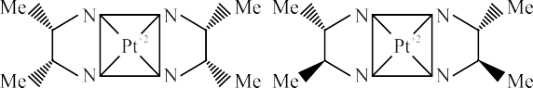= 0.8 (As TC = TB, then TC – TA = TC – TB)

qAC 10  8 qAB

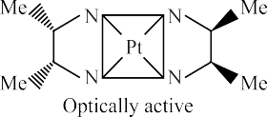

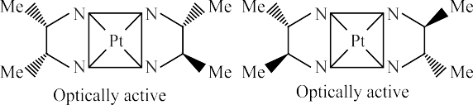x = 7

[Co(en)Cl2Br]– y = 06

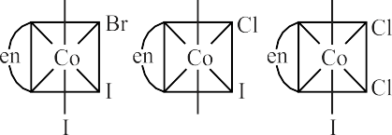



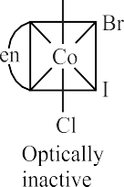

y = 06

x + y = 13

### 13. (5)

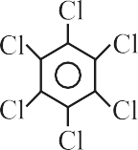X = 4 and Y = 1

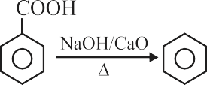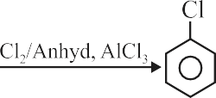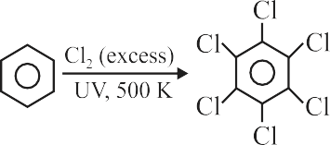

### 14. (2)

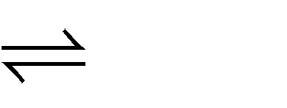

2A A2 ;n  2

i  1   1 – 1  1 – 



 n  2

 

### 15. (2)

**12. (8)**

T     1 – 1 K x

b 1  2   b

P = KV (K is proportionality constant) PV–1 = K ….(1)

This equation satisfies the equation of polytropic process, i.e.,

PVn = Constant …(2)

From the equation (1) and (2) we get n = –1

   

  2Kbx – Tb 

Kbx

### 16. (3)

**17. (1)**

## O

So the process AC is a polytropic process.

For the polytropic process molar heat capacity is

## CH H H O +

(P)

C K2CO3 H

## O OH

C

Cm  Cv,m

* R 1 – n

(Q)

## OH

(R)

H O–

C

3

HCN

## OH

⇒ Cm  Cv

* R  2R 2

(n = –1)

 CN

## O OH

O

Process AB is isobaric C

m  Cp

 5R

2

(S)

## OH

TC

⇩ nCmdT

TC

⇩ 2R dT

CN

Compound S is OH

C

qAC  TA  TA

qAB TB TB 5R

⇩ nCp,mdT

TA

⇩ 2 dT

TA

**18. (2)** If energy of X1 = ground state energy of H-atom, it

**Hint:** M is Li.

means

Z  1 .

n1

### 19. (1, 3, 4)

Hint: Z

n

 1 so velocity of H-atom in ground state

From the velocity of e– in X2,

3.3106  2.2 106  Z 

 2 

 

Z = 3

and X1 state of M+q is same. X2  𝑙 = 1 and n2 – 𝑙 – 1 = 0.

So, n2 = 2

It means M+q = Li2+



**For more questions, kindly visit the library section: Link for app:** <https://links.physicswallah.live/vyJw>

**For more questions, kindly visit the library section: Link for web:** <https://physicswallah.live/tabs/tabs/library-tab>

**PW Mobile APP:** <https://physicswala.page.link/?type=contact-us&data=open>

**For PW Website:** <https://www.physicswallah.live/contact-us>