**ANUJ VISHWAKARMA_JH**

CDAC MUMBAI

**Concepts of Operating System Assignment 2**

**Part A**

**What will the following commands do?**

* echo "Hello, World!"

**Ans: Prints the text "Hello, World!"**

* name="Productive"

**Ans: Assigns the string "Productive" to the variable name**

* touch file.txt

**Ans : touch is use to create a file.**

* ls -a

**Ans: Lists all files and directories in the current directory, including hidden files (those starting with a dot .).**

* rm file.txt

**Ans: Deletes the file named file.txt**

* cp file1.txt file2.txt

**ans: command used to** **Copy file1.txt to file2.txt. If file2.txt exists, it will be overwritten the existing file.**

* mv file.txt /path/to/directory/

**Ans: Moves file.txt to the specified directory**

* chmod 755 script.sh

**Ans:** **The given command Changes the permissions of file45.txt to 755, giving the owner full read, write, and execute permissions, and giving others read and execute permissions.**

* grep "pattern" file.txt

**Ans:** **Searches for the string "pattern" in file.txt and displays all matching lines.**

* kill PID

**Ans :** **Terminates the process with the specified Process ID (PID)**

* mkdir mydir && cd mydir && touch file.txt && echo "Hello, World!" > file.txt && cat file.txt

**Ans:** **The command mkdir mydir && cd mydir && touch file.txt && echo "Hello, World!" > file.txt && cat file.txt is a sequence of commands combined using &&, which ensures that each command is executed only if the previous one is exicuted.**

* ls -l | grep ".txt"

**Ans:** **Lists files in the current directory in long format (-l) and filters the output to show only those with .txt in their names.**

* cat file1.txt file2.txt | sort | uniq

**Ans: Concatenates file1.txt and file2.txt, sorts the combined output, and removes duplicate lines**

* ls -l | grep "^d"

**Ans: Lists files in the current directory in long format and filters the output to show only directories (which are identified by starting with "d" in the permissions field).**

* grep -r "pattern" /path/to/directory/

**Ans:** **The command grep -r "pattern" /path/to/directory/ is used to search for a specific text pattern within all files in a directory and its subdirectories.**

**Command: grep -r "pattern" /home/cdac/LinuxAssignment/**

* cat file1.txt file2.txt | sort | uniq –d

**Ans: Concatenates file1.txt and file2.txt, sorts the combined output, and displays only duplicate lines**

* chmod 644 file.txt

**Ans: the Chmod 644 Changes the permissions of file.txt to 644, giving the owner read and write permissions, and giving others read-only permissions**

* cp -r source_directory destination_directory

**Ans: cp -r source_directory destination_directory makes a complete copy of source_directory and everything inside it, putting the copy in destination_directory**

**Command: cp -r mydir LinuxAssignment**

* find /path/to/search -name "*.txt"

**Ans: Searches for all files with a .txt extension within the specified directory and its subdirectories.**

* chmod u+x file.txt

**Ans:** **Adds execute permission for the owner (user) of file.txt**

* echo $PATH

**Ans: echo $PATH shows the list of folders ( or path) where your computer looks for programs to run when we used this command.**

# **Part B**

## Identify True or False:

1. **ls** is used to list files and directories in a directory. **True**
2. **mv** is used to move files and directories. **True**
3. **cd** is used to copy files and directories. **False**
4. **pwd** stands for "print working directory" and displays the current directory. **True**
5. **grep** is used to search for patterns in files. **True**
6. **chmod 755 file.txt** gives read, write, and execute permissions to the owner, and read and execute permissions to group and others.  **True**
7. **mkdir -p directory1/directory2** creates nested directories, creating directory2 inside directory1 if directory1 does not exist. **True**
8. **rm -rf file.txt** deletes a file forcefully without confirmation. **True**

## Identify the Incorrect Commands:

1. **chmodx** is used to change file permissions. **Ans: incorrect, Correct is chmod.**
2. **cpy** is used to copy files and directories. **Ans: incorrect, Correct is cp.**
3. **mkfile** is used to create a new file. **Ans: incorrect, Correct is mkdir.**
4. **catx** is used to concatenate files. **Ans: incorrect, Correct is cat.**
5. **rn** is used to rename files. **Ans: incorrect, Correct is mv.**

# **Part C**

**Question 1:** Write a shell script that prints "Hello, World!" to the terminal.

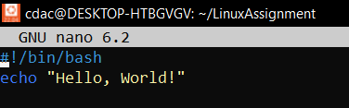

**Output:**

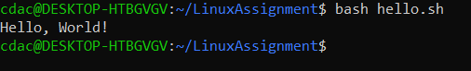

**Question 2:** Declare a variable named "name" and assign the value "CDAC Mumbai" to it. Print the value of the variable.

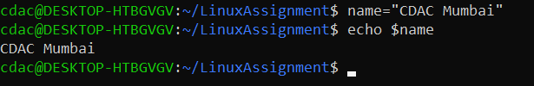

**Question 3:** Write a shell script that takes a number as input from the user and prints it.

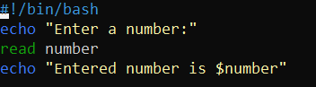

**Output:**

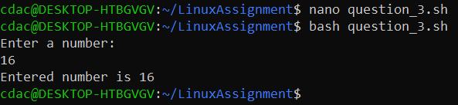

**Question 4:** Write a shell script that performs addition of two numbers (e.g., 5 and 3) and prints the result.

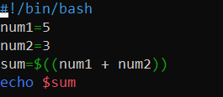

**Output:**

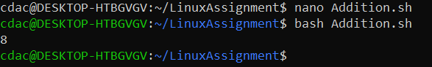

**Question 5:** Write a shell script that takes a number as input and prints "Even" if it is even, otherwise prints "Odd".