**Lab report of**

**Web Technologies I**

**Submitted to:**

Name: Binayak Maharjan

**Submitted by:**

Name: Anurani Karki

Class: 5th Semester

**Citizen College**

**Kumaripati,Lalitpur**

**Table of Contents**

|  |  |  |  |  |
| --- | --- | --- | --- | --- |
| **S.N** | **Date** | **Lab Title** | **Signature** | **Remarks** |
| **1.** | **2024/12/26** | Design a webpage by using basic HTML tag |  |  |
|  |  |  |  |  |
|  |  |  |  |  |
|  |  |  |  |  |
|  |  |  |  |  |
|  |  |  |  |  |

**Objectives**

1. To tell web browser how to structure it to display.
2. To ensure proper formatting of text and images for your internet browser.

**Introduction**

HTML stands for **Hypertext Markup Language**, and it is the most widely used language to write Web Pages. It was first developed by Tim Berners-Lee in 1990. HTML code ensures the proper formatting of text and images for your Internet browser. It also provides a basic structure of the page, upon which Cascading Style Sheets are overlaid to change its appearance. It is not case sensitive.

**Structure of HTML**

<html>

<head>

Head section

<title>…</title>

</head>

<body>

……

Body section

……

</body>

</html>

**Tags used in HTML**

* <!DOCTYPE>: It declares the document type.
* <html>: The root element of an HTML document.
* <head>: It contains metadata, scripts, and links to stylesheets.
* <body> : It contains the visible content of the web page.
* <title>: It is used for providing title for document.
* <header>: It gives header of web page.
* <h1> to <h6> : It is used for heading.
* <p> : It is used for paragraph.
* <ol> and <ul>: OL tag is used for listing ordered list and UL for unordered list.
* <a>: It is used for links.
* <b>: It is used for making text bold.
* <br>: It is used for breaking line,
* <i>:It is used for italic text.
* <em>: It emphasizes text.
* <ins>: It defines text that has been inserted to the document.
* <del>: It defines text that has been deleted to the document.
* <mark>: It highlights the text.
* <sup>: It defines superscripted text.
* <sub>: It defines subscripted text.
* <strong>: This tag also bold the sentence.
* <nav>: It defines navigation links.
* <dl>: It is used of discriptive lists.
* <small>: It is used to make sentences small.
* <footer>: It defined secton footer.
* <fieldset>: It is used to group related elements in a form.
* <div>: It defines division in HTML document.
* <section>: It defines section in a document.
* <span>:It is used to mark up a part of a text, or a part of a document.

**Code Implementation**

<!DOCTYPE html>

<html lang="en">

<head>

<meta charset="UTF-8" />

<meta name=”viewport”

content="width=device-width, initial-scale=1.0" />

<title>Document</title>

</head>

<body>

<nav>

<a href="#1">Home</a>

<a href="#2">About Us</a>

<a href="#3">Contact</a>

</nav>

<h1>This is the first web pages.</h1>

<header>This is the header of the web page.</header>

<p>This tag is use to write paragraph.</p>

<b>This tag bold the sentence.</b>

\ <br />

<strong>This tag also bold the sentence.</strong> <br />

<small>This tag make the sentence small.</small> <br />

<i>It will italic the sentnce</i> <br />

<em>Same as the italic font.</em> <br />

<mark>Use to highlight.</mark> <br />

<del>It is used to cut the sentence.</del> <br />

<ins>Underline </ins> <br />

2<sup>2</sup> = 4 <br />

<br />

H <sub>2</sub>O

<h2>Orderlist</h2>

<ol>

<li>Water</li>

<li>Coffee</li>

<li>Orange juice</li>

<li>Black tea</li>

<li>Milk tea</li>

</ol>

<h3>Unorder list</h3>

<ul>

<li>Apple juice</li>

<li>Banana juice</li>

<li>Orange juice</li>

<li>Coffees</li>

<li>Tea</li>

</ul>

<h4>Description list</h4>

<dl>

Introduction

<li>Hello guys welcome to my vlog</li>

</dl>

<hr />

<div

<p>Hello Guys welcome to my vlog..</p>

</div>

<section>

<p>There is no video is uploded till now. please guys wait for video.</p>

</section>

<hr />

<span>This is the span tag</span>

<fieldset>

<legend>Details</legend>

<label for="fname">First Name</label>

<input type="text" name="fname" id="fname" />

<footer>

<h5>Some Signs</h5>

9&pound; &gt; 3&pound; <br />

6 &lt; 9 <br />

&copy; <br />

&REG;

</footer>

</fieldset>

</body>

</html>

**Output**

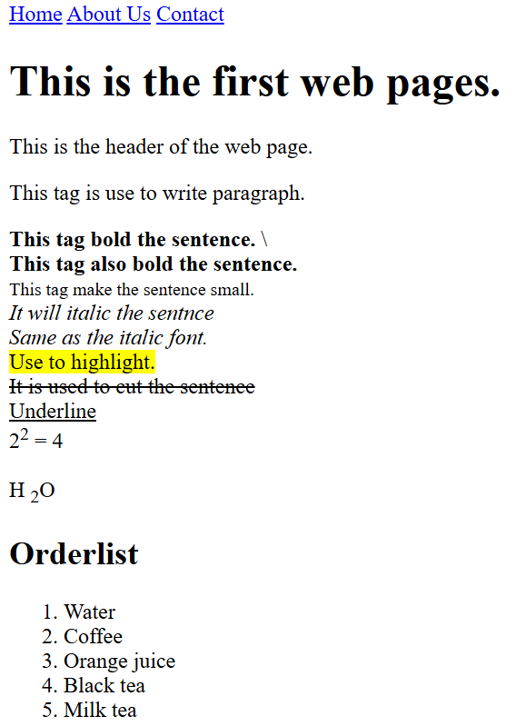

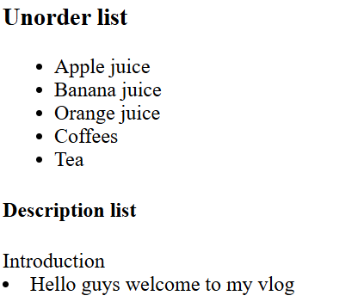

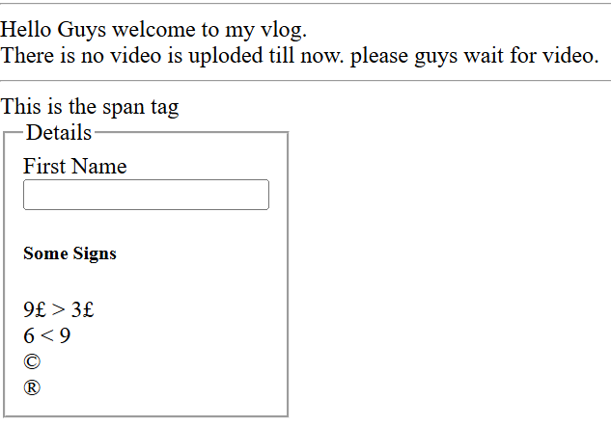

**Conclusion**

In this lab, we explore fundamental HTML tags and their functionality. By implementing various tags such as <h1>, <p>, <ol>, <ul>, and <form>, the importance of HTML in structuring and presenting content on the web was reinforced.