**Admin Panel Features**

Multilingual Chatbot Project

**1/11/2024**

**Anuki Tsimintia**

# Introduction

The Admin Panel serves as the central hub for managing the functionalities of the Multilingual Chatbot Project. Designed with user-friendliness and efficiency in mind, the admin panel allows authorized personnel to perform essential tasks such as authenticating users, uploading and managing documents, and integrating external web content to enhance the chatbot's knowledge base. By providing a streamlined interface, the admin panel ensures that the chatbot remains up-to-date, accurate, and capable of delivering meaningful interactions across multiple languages.

**\*\*Key Functionalities Include:\*\***

- **Admin Authentication:** Secure login system to ensure that only authorized users can access and modify the chatbot's backend.

- **File Uploads:** Ability to upload DOCX and PDF documents, which are then processed and integrated into the chatbot's knowledge base.

- **URL Inputs:** Functionality to add content from external web URLs, expanding the chatbot's informational resources.

# Admin Authentication

## Description:

Admin Authentication is a critical security feature that ensures only authorized users can access and manage the admin panel. Implemented using Flask-Login, this feature verifies user credentials against stored hashed passwords to maintain secure access. The authentication process includes login and logout functionalities, session management, and protection against unauthorized access.

## Testing:

I accessed : <http://127.0.0.1:5000/login>, login page  
with the correct admin username and password, I logged in and was redirected to <http://127.0.0.1:5000/admin>

Then I tested again with an incorrect password- I got an invalid credentials message.

Same for an incorrect username.

## Screenshots:

**Screenshot 1:** Login Page before submission

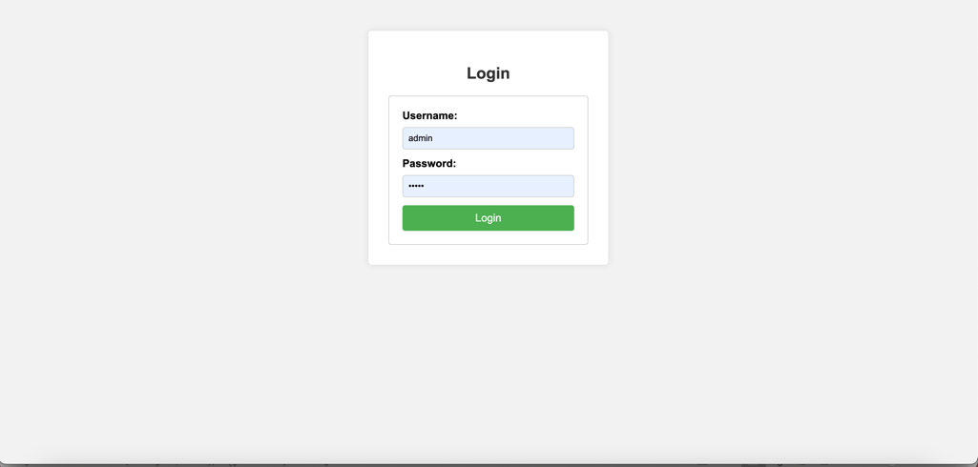

**Screenshot 2:** Admin Panel after successful login

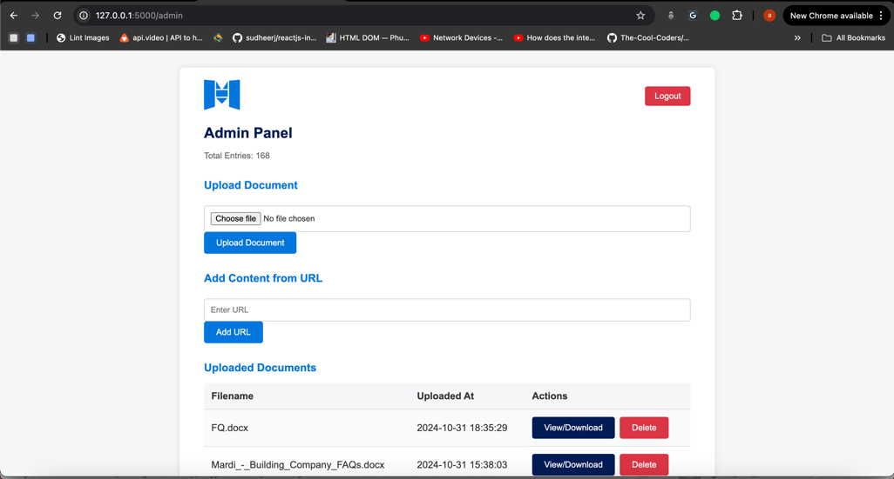

**Screenshot 3:** Error message after failed login attempt.

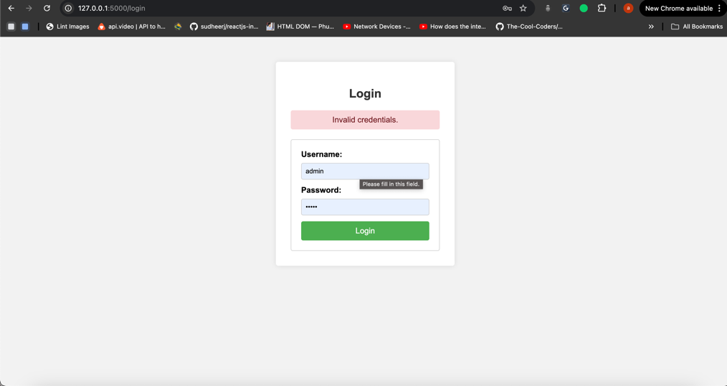

## Verification:

- Successfully logging in with the correct credentials redirects the user to the admin panel.

- Attempting to log in with incorrect credentials displays an appropriate error message.

-The session remains active until the user logs out using the logout button.

- Logging out successfully ends the session and redirects the user to the login page.

# File Uploads (DOCX, PDF)

## Description:

The File Uploads feature enables administrators to add documents in DOCX and PDF formats to the chatbot's knowledge base. Upon uploading, these documents are processed to extract textual content, which is then indexed using FAISS for efficient retrieval during user interactions. This functionality allows the chatbot to provide accurate and contextually relevant responses based on the uploaded documents.

## Test and screenshots:

* I uploaded the dox file successfully – and got the success message
* I uploaded a PDF file successfully – and got the success message
* I deleted the file – and got a confirmation message
* I was not able to upload the unsupported format - .txt, from upload it was disabled
* I clicked edit/download – File was downloaded in my system

### File Upload Form

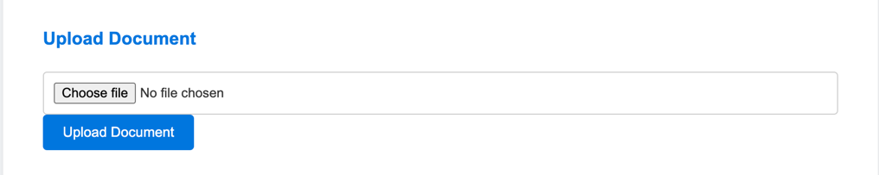

### Successful DOCX File Upload

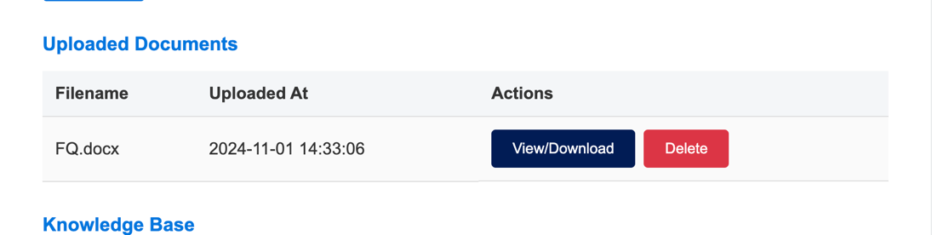



### Successful PDF File Upload

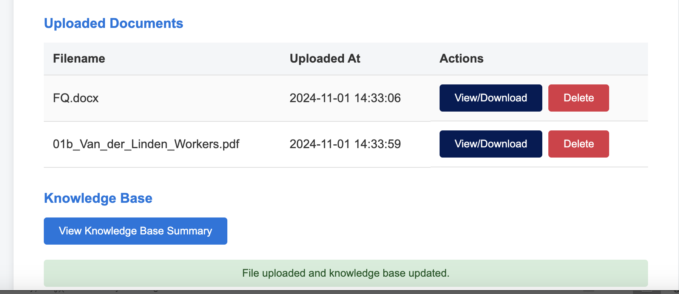

### Deleting files

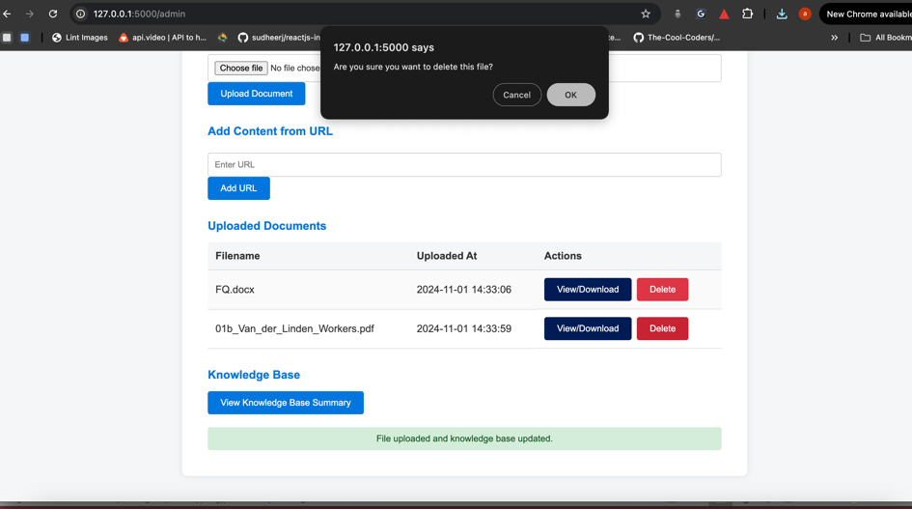

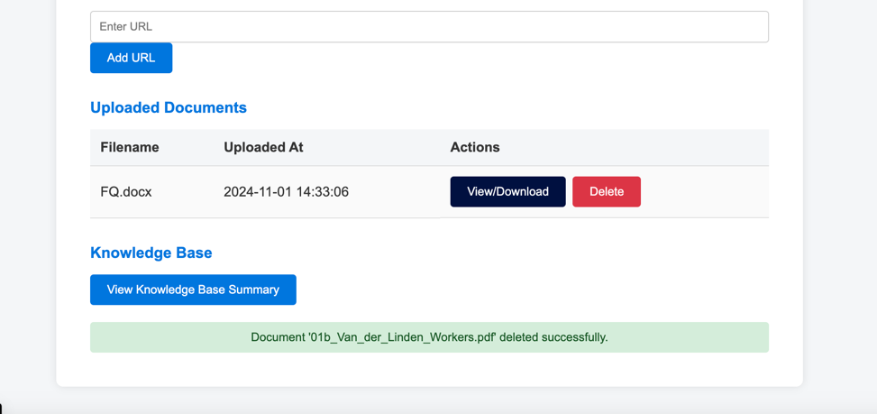

# URL Inputs

## Description:

The URL management feature allows administrators to expand the chatbot's knowledge base by adding URLs. This functionality fetches text content from the specified URL and indexes it in the knowledge base. Additionally, administrators can now view added URLs, ensuring they have visibility over the external resources integrated into the chatbot’s knowledge base. If necessary, admins can delete any URL, and its associated content will be removed from the knowledge base to maintain relevancy and accuracy.

## Test and Screenshots:

* "Add Content from URL" section, enter a URL, and click "Add URL".

A success message appears and the URL is listed under "Added URLs."

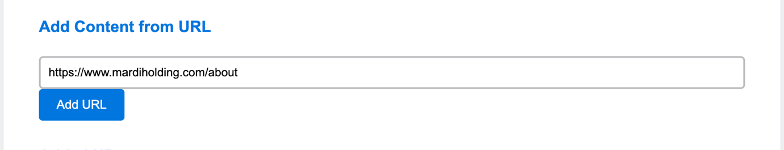

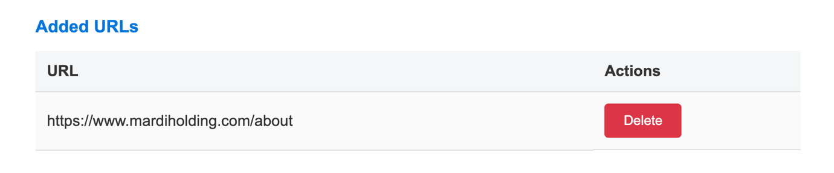

* Clicking delete deletes URL, and knowladge base is updated accordingly

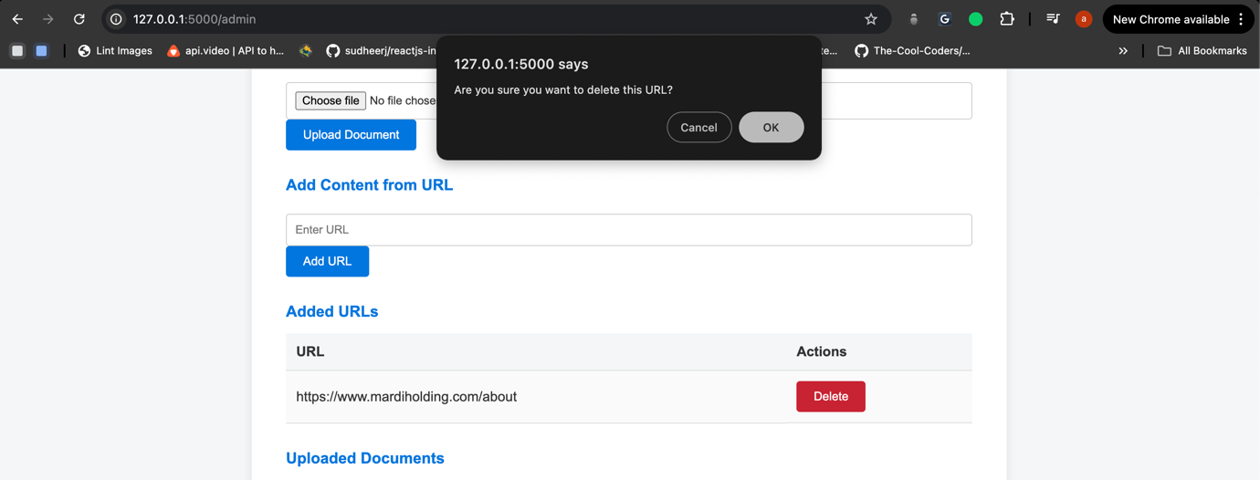

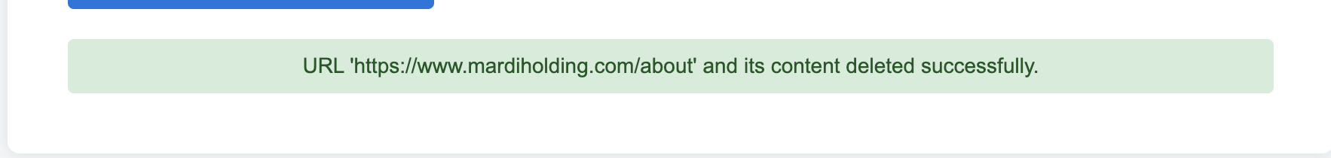

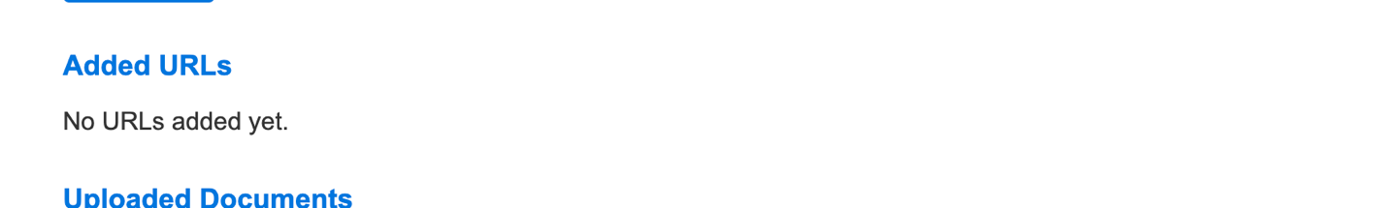

* When entering invalid URL we get user friendly error message

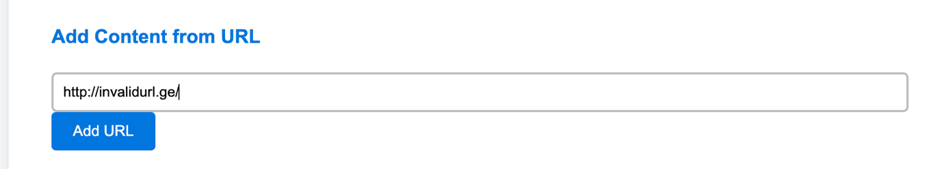



## Verification

* Successfully adding a URL updates the knowledge base with new content.
* Deleting a URL removes associated entries from the knowledge base and updates the summary.

# Knowledge Base Summary with Pagination

## Description:

The Knowledge Base Summary gives administrators a detailed view of all indexed content within the chatbot’s knowledge base. With the latest update, pagination has been added to improve navigation, allowing admins to browse through extensive knowledge base entries more efficiently. Each page displays a sample of indexed content along with its source (e.g., document or URL), making it easy to identify and manage content sources.

## Testing and Screenshots:

* Access the Knowledge Base Summary from the admin panel.
* Click through multiple pages using the pagination controls.



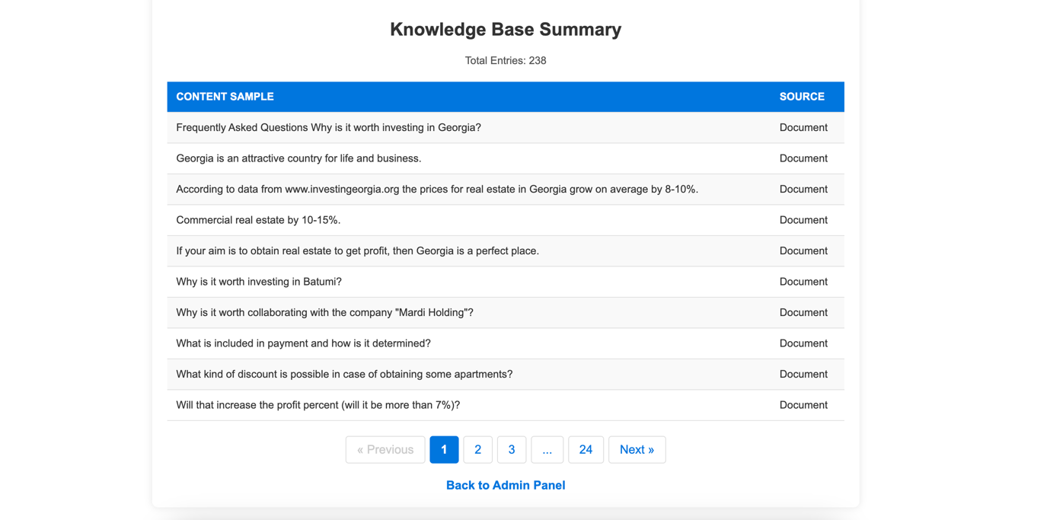

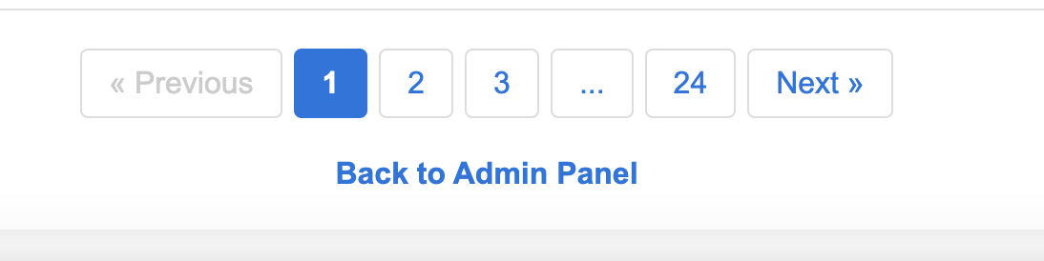

# Summary Table

|  |  |
| --- | --- |
| Feature | Description |
| Admin Authentication | Secure login and session management. |
| File Uploads (DOCX, PDF) | Upload and manage DOCX and PDF files in the knowledge base. |
| URL Management | Add, view, and delete URLs in the knowledge base. |
| Knowledge Base Summary | View knowledge base entries with pagination and source indicators. |