**Assignment:**

**Develop a django project for ERP project. Create 5 apps product, purchase, sales, stock & warehouse. Create urls for each app.**

**Example: When we keep 127.0.0.1:8000/products in url, it shows table. Show create link on top of the products table. Follow same thing for each app.**

**Steps to do ERP Project**

1. Created project named as ERP

Use command: django-admin startproject ERP

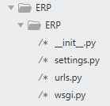



2. Create app named as product under ERP project

Use command: python manage.py startapp product

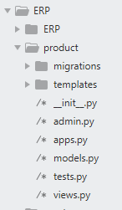

3. In product app, created a function named as fun_product()

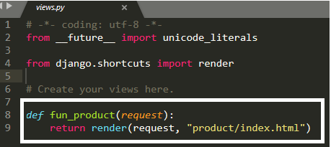

4. In ERP project, in urls.py import fun_product and keep it in url

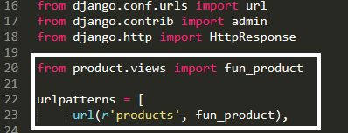

5. Create templates folder under product app. Create product sub-folder under templates and keep index.html file in product sub-folder as shown below.

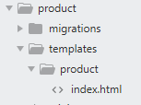

6. Written html code in index.html.

index.html is kept in github(ERP project-> product app->templates->product->index.html

7. Go to settings.py in ERP project, in INSTALLED_APPS keep product as shown below

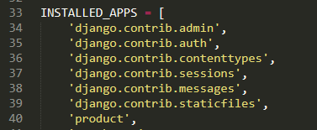

8. Go to command prompt, type command as below

python manage.py runserver

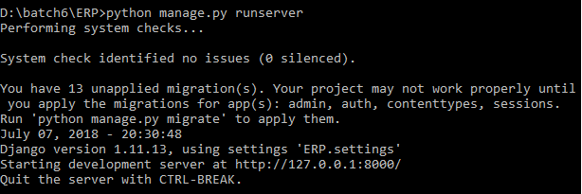

9. Go to internet explorer or Mozilla Firefox and type address 127.0.0.1:8000/ in url

We will get page as below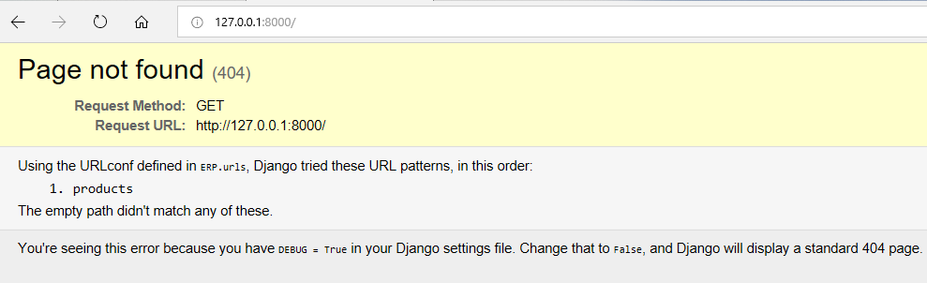

10. Again type 127.0.0.1:8000/products in url.

Below is the output

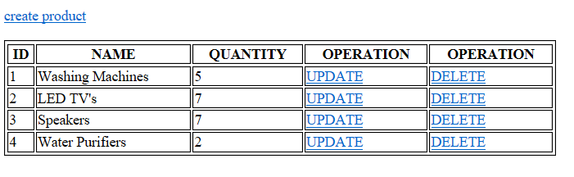

11. Create another apps(purchase, sales, stock & warehouse) by following steps(1 to 10)