**Introduction to Enterprise Analytics**

**Module 2 Project: Benefit-Cost Analysis**

**ALY 6050**

**Anukriti Baijal**

**Baijal.a@northeastern.edu**

**Introduction:**

For this assignment, we are given information regarding two dam project constructions that the JET Corporation is considering. The information has both benefits and costs details. There are 6 benefits and 2 areas of cost. Also, there are three different estimates included for each type of benefit and cost. The following is the information available:

**DAM 1:**

After calculations of estimates (in millions of dollars), using Triangular Distribution:

**DAM 2:**

After calculations of estimates (in millions of dollars), using Triangular Distribution:

Now we divide the analysis into 3 parts:

* **PART 1:**

1. We perform a simulation for benefit-cost ratios for Dam 1 and Dam 2 using the following random number generator formula:

We generate 10,000 random numbers for each type of benefit and cost and then calculate the Total Benefits and Total Costs. Afterward, we calculate Benefit-Cost Ratio for the 10,000 simulated values. This is repeated for both Dams 1 and 2.

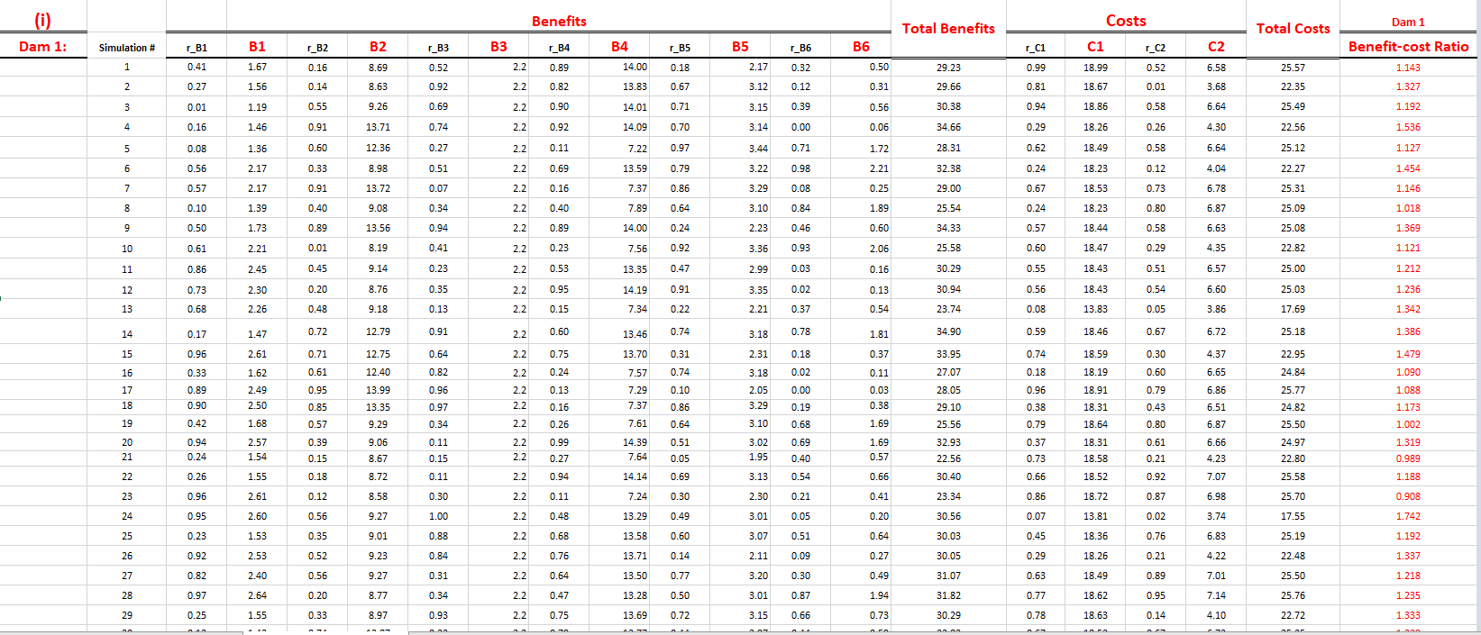

1. Next, we construct Frequency Distributions for both Dams 1 and 2:

Looking at the above graph, for Dam 1, we see that the shape of the graph is like an unsymmetrical triangle. It is positively skewed with its tail extending towards the right.

Observing the frequency distribution for Dam 2, we see it slightly more symmetrical triangle as compared to the frequency distribution of Dam 1.

1. Next, we tabulate the observed and the theoretical values for both Dam 1 and 2:

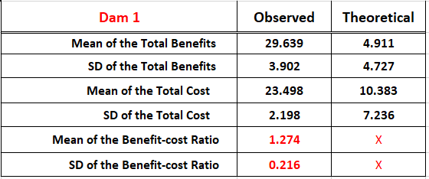

* **PART 2:**

Now, we conduct a Chi-Square Goodness to Fit test. The following hypotheses are considered:

H0: The observed values and theoretical values do not have statistically significant difference between them.

H1: The observed values and theoretical values have statistically significant difference between them.

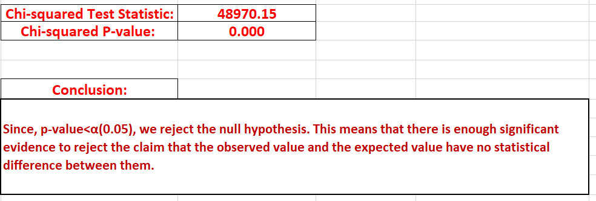

* **PART 3:**

From the above observations, **Dam 2** is the recommended project for the JET Corporation. It is because of the following reasons:

* The mean of Benefit-Cost ratio of Dam 2 is greater than that of Dam 1.
* The median value of Benefit-Cost ratio of Dam 2 is greater than that of Dam 1.
* The probability that the Benefit-Cost Ratio will be greater than 2 is greater for Dam 2 as compared to Dam 1.
* The probability that the Benefit-Cost Ratio will be greater than 1.8 is greater for Dam 2 as compared to Dam 1.
* The probability that the Benefit-Cost Ratio will be greater than 1.5 is greater for Dam 2 as compared to Dam 1.
* The probability that the Benefit-Cost Ratio will be greater than 1.2 is greater for Dam 2 as compared to Dam 1.
* The probability that the Benefit-Cost Ratio will be greater than 1 is greater for Dam 2 as compared to Dam 1.
* The probability that the Benefit-Cost Ratio will be greater for Dam 1 as compared to Dam 2 is less than 50% at 45.3%.

Therefore, the corporation should proceed with project related to Dam 2.

**References:**

[1] R. Behboudi (2023). *Triangular Probability Distribution-Lab*. Retrieved on March 3, 2023, from Northeastern Canvas.

[2] Zach (March 28, 2021). *How to Use the Triangular Distribution in Excel (With Examples).* Retrieved on March 3, 2023, from <https://www.statology.org/triangular-distribution-excel/>

[3] Zach (January 28, 2021). *An Introduction to the Triangular Distribution*. Retrieved on March 3, 2023, from <https://www.statology.org/triangular-distribution/>

[4] Monte Carlo Excel Addin. *Triangular Distribution*. Retrieved on March 4, 2023, from <https://www.montecarloexceladdin.com/triangular-distribution>

[5] Zach (April 24, 2020). *Chi-Square Goodness of Fit Test: Definition, Formula, and Example*. Retrieved on March 5, 2023, from <https://www.statology.org/chi-square-goodness-of-fit-test/>

[6] Turney, S. (November 10, 2022). *Chi-Square Goodness of Fit Test | Formula, Guide & Examples.* Retrieved on March 5, 2023, from <https://www.scribbr.com/statistics/chi-square-goodness-of-fit/>