**Team Name:** 3musketeers

**Student Names:**

* Anu Sebastian – 012496276
* Ravali Nagabandi – 011530454
* Saloni Sharad Bhalerao - 012466623

**Decision tree Classifier:**

The root node, with the most information gain, tells us that the biggest factor in determining fire is month.

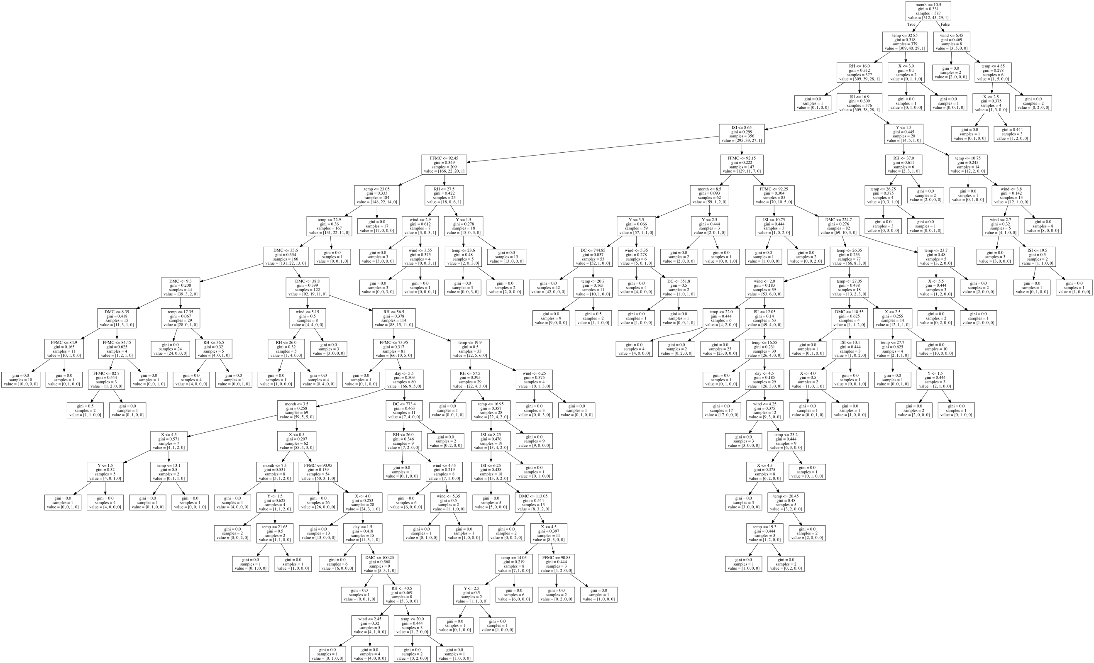

**Decision tree Regressor:**

In a regression tree the idea is this: since the target variable does not have classes, we fit a regression model to the target variable using each of the independent variables. Then for each independent variable, the data is split at several split points.

