Note: The expectation is to run the command as suggested. I know that you will probably don't understand the commands, but this is just to start being familiarized with common commands and the file structure.

* Login as root
* How many files are on /bin directory? (**#ls /bin | wc -l**)
* What is the purpose of wc -l command? (you can do **#man wc** to check wc command manual)
* Check date command file type (**#file /usr/bin/date**)
* Check date command permissions (**#ls -l /usr/bin/date**)
* Check /var /etc directories disk usage (**#du -sh /var /etc**)
* How many executables files are on /usr/bin directory? (**#cd /usr/bin; file * | grep executable | wc -l**)
* What’s the meaning of grep command on question 7)?

1. Login as root 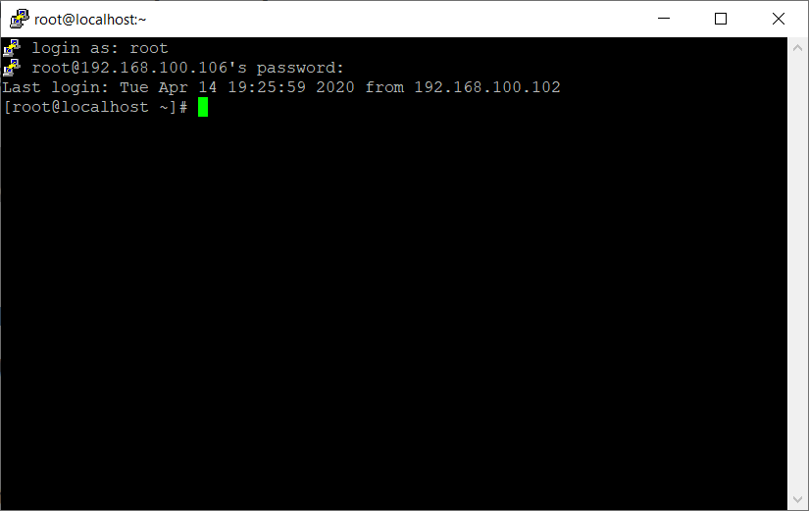
2. How many files are on /bin directory? (**#ls /bin | wc -l**) – **664 files**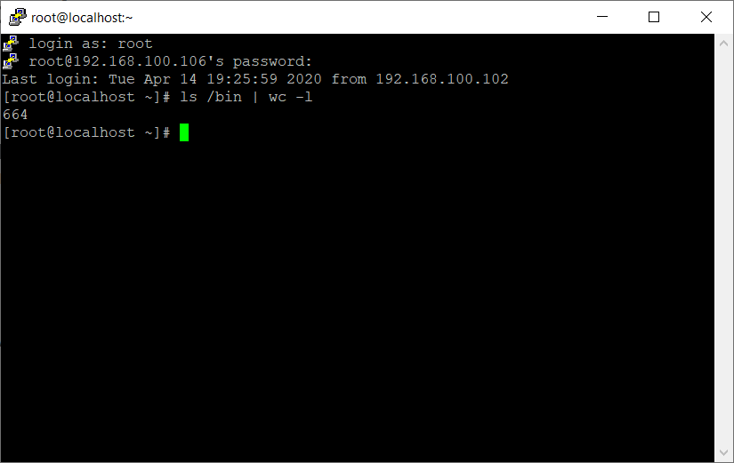
3. What is the purpose of wc -l command? (you can do **#man wc** to check wc command manual)

Answer: The purpose of the wc -l command is to print the newline counts of the output lines that we get through the command we put for the command-line. 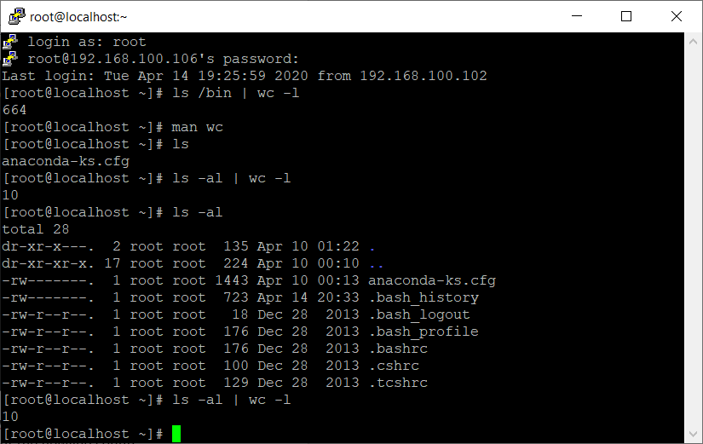

1. Check date command file type (**#file /usr/bin/date**) 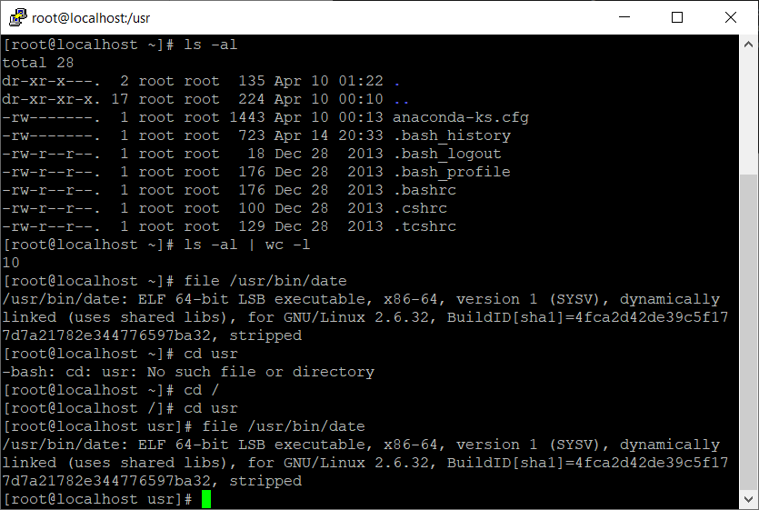
2. Check date command permissions (**#ls -l /usr/bin/date**) 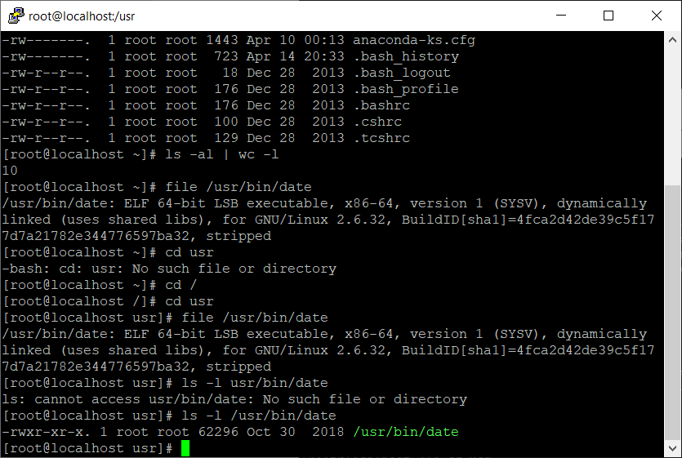
3. Check /var /etc directories disk usage (**#du -sh /var /etc**) 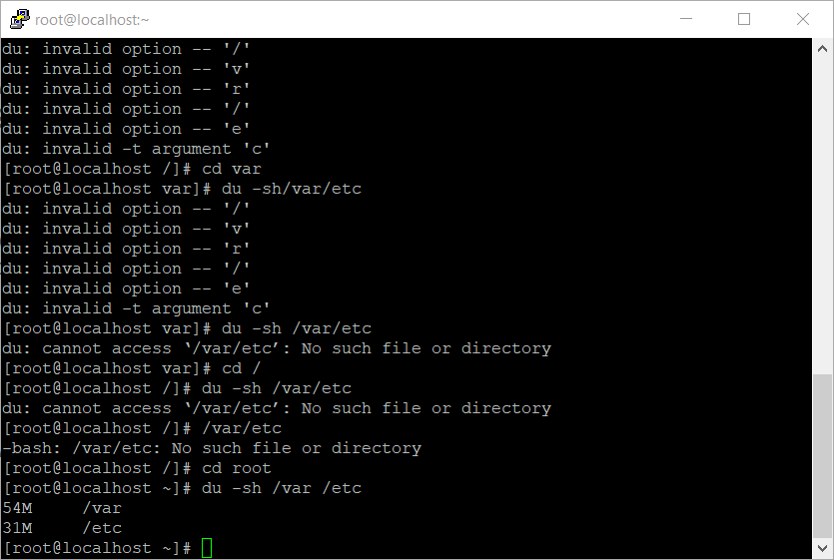
4. How many executables files are on /usr/bin directory? (**#cd /usr/bin; file * | grep executable | wc -l**) **517 files** 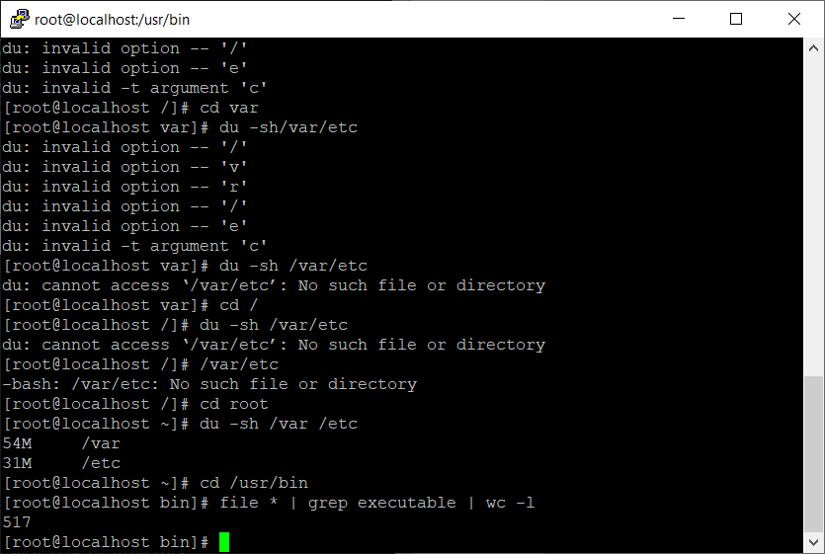
5. What’s the meaning of grep command on question 7)?

The **grep command** which stands for “global regular expression print,” processes text line by line and prints any lines which match a specified pattern. The **grep command** is used to search text or searches the given file for lines containing a match to the given strings or words