Note: Replace PS with your own initials.

1. Shutdown your Linux VM
2. Create the following drives:  
   PS1 5Gb  
   PS2 10GB  
   PS3 12GB
3. Power on your Linux VM and login as superuser
4. Run lsblk to find the new 3 drives. The size should be the ones you assigned to each drive. Take note of the device names. (/dev/sdb, /dev/sdc, etc)
5. Run pvcreate on all 3 drives to initialize the PVs.
6. Run pvdisplay to see the info of each device. Take note about the following entries:  
   PV Name  
   PV Size  
   PE Size  
   PV UUID
7. Create vgSP1 including PS1 and PS2 drives
8. Create vgSP2 including PS3 drives
9. Run vgdisplay vgSP1. Check:  
   Act PV  
   VG Size  
   PE Size  
   Total PE  
   Alloc PE  
   Free PE
10. Run lvcreate -L 3G -n lv_SP1 vgSP1
11. Run lvcreate -L 4G -n lv_SP2 vgSP1
12. Run lvcreate -L 5G -n lv_SP3 vgSP2
13. Run vgdisplay -v vgSP1. Check:  
    Alloc PE  
    Free PE  
    LV Path  
    LV Size  
    Current LE  
    Physical Volumes: Names and Total PE/Free PE
14. Run mkfs -t xfs  /dev/vgSP1/lv_SP1
15. Run mkfs -t xfs  /dev/vgSP1/lv_SP2
16. Run mkfs -t xfs  /dev/vgSP2/lv_SP3
17. Run mkdir /SP1 /SP2 /SP3
18. Run mount /dev/vgSP1/lv_SP1 /SP1
19. Run mount /dev/vgSP1/lv_SP2 /SP2
20. Run mount /dev/vgSP2/lv_SP3 /SP3
21. Run df to see a list of mounted file systems
22. Reboot server
23. Run df again. Are they mounted?  
      
    Optional
24. Add 3 file systems on /etc/fstab and reboot again.
25. Are the fs mounted now?

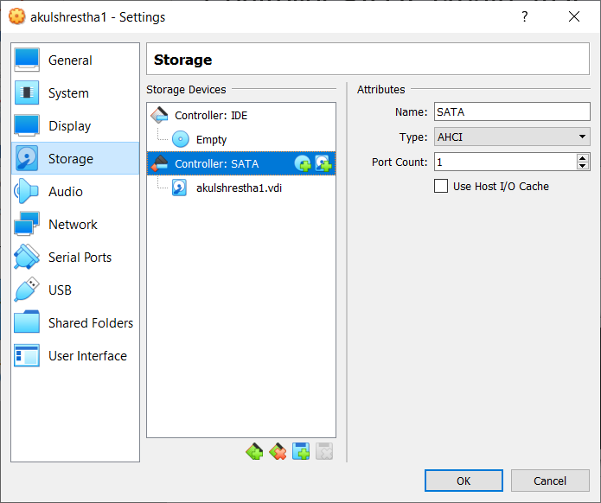

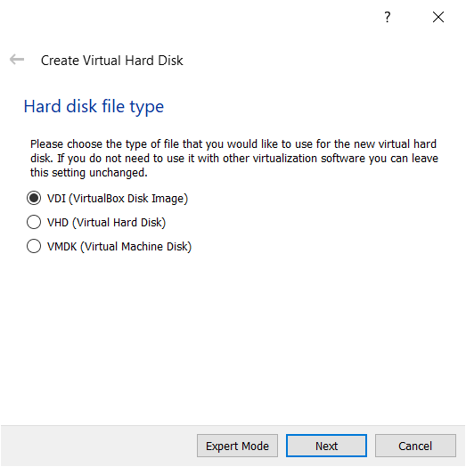

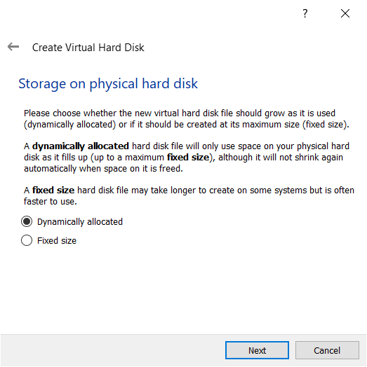

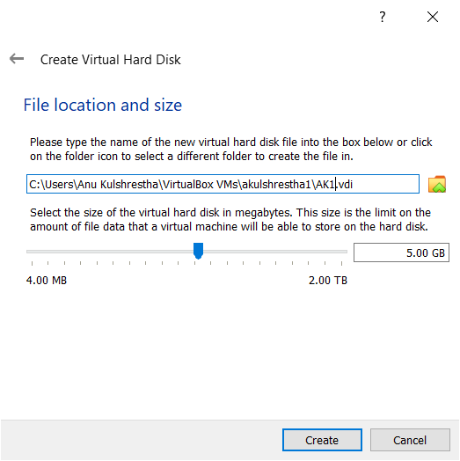

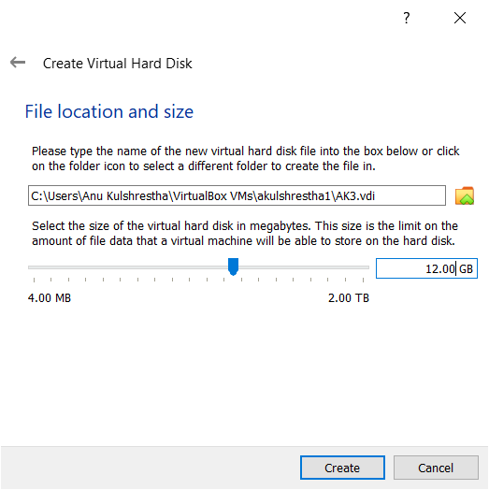

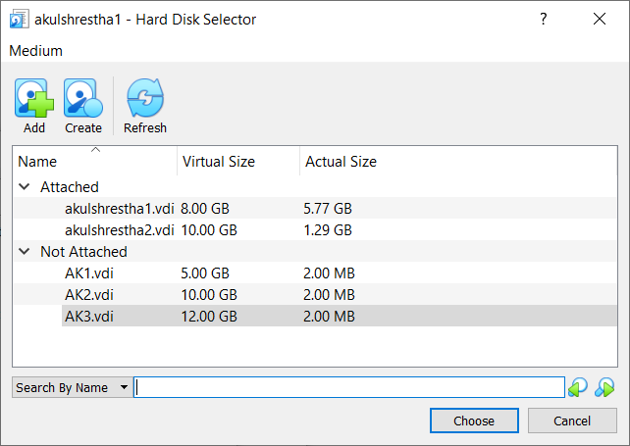

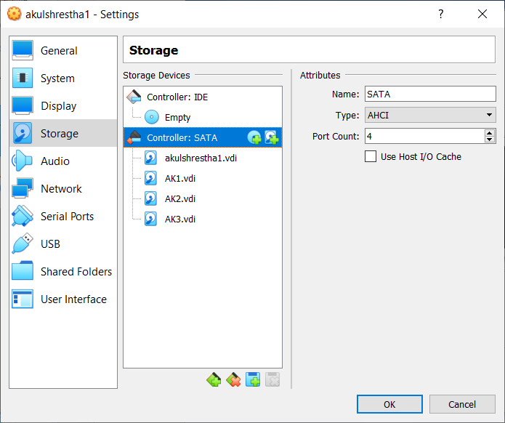

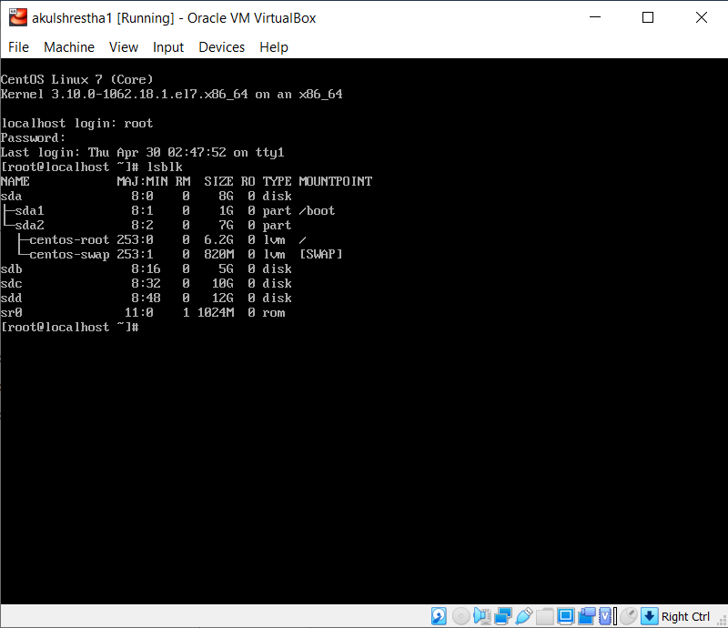

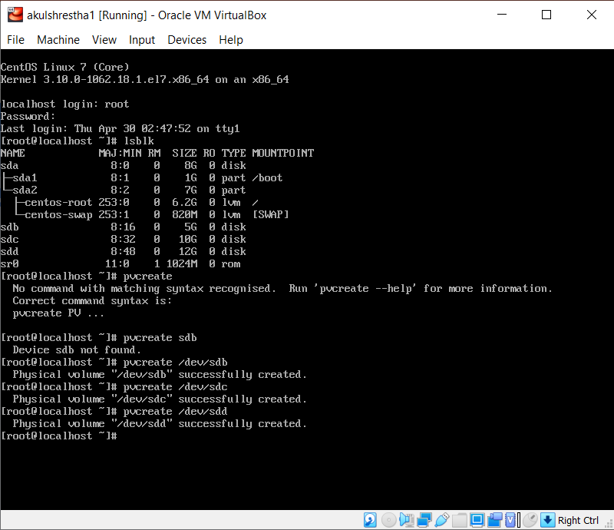

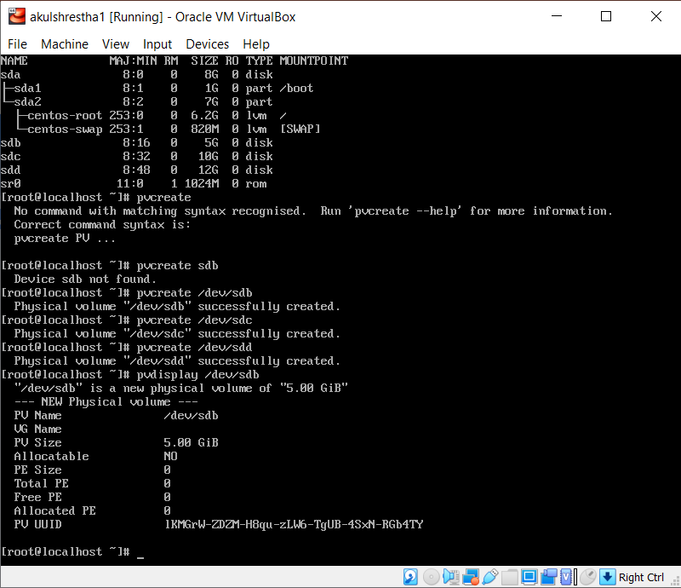

PV Name /dev/sdb  
PV Size 5.00 GiB  
PE Size 0  
PV UUID

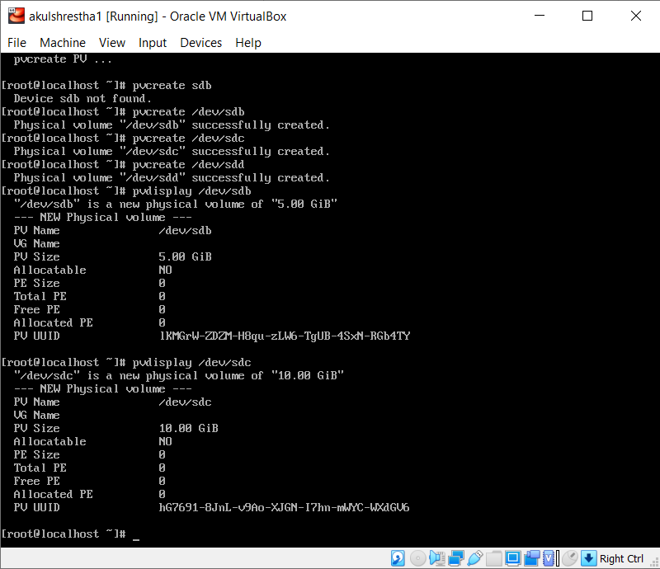

PV Name /dev/sdc  
PV Size 10.00 GiB  
PE Size 0  
PV UUID

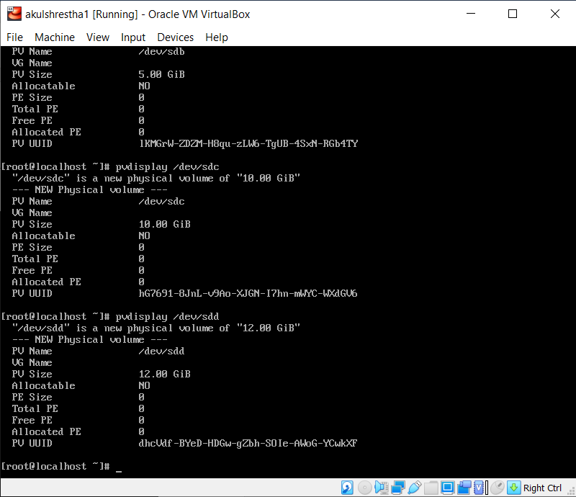

PV Name /dev/sdd  
PV Size 12.00 GiB  
PE Size 0  
PV UUID

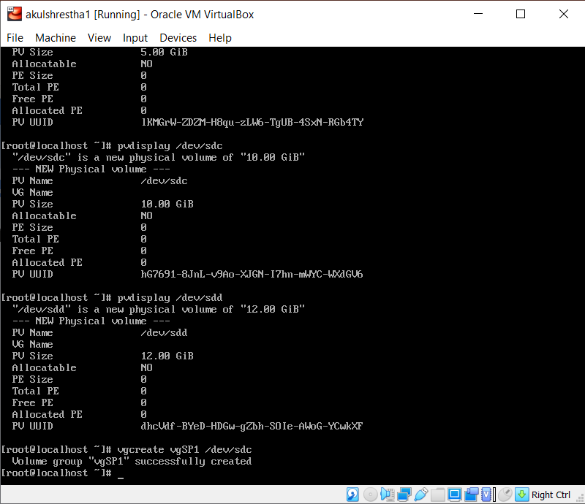

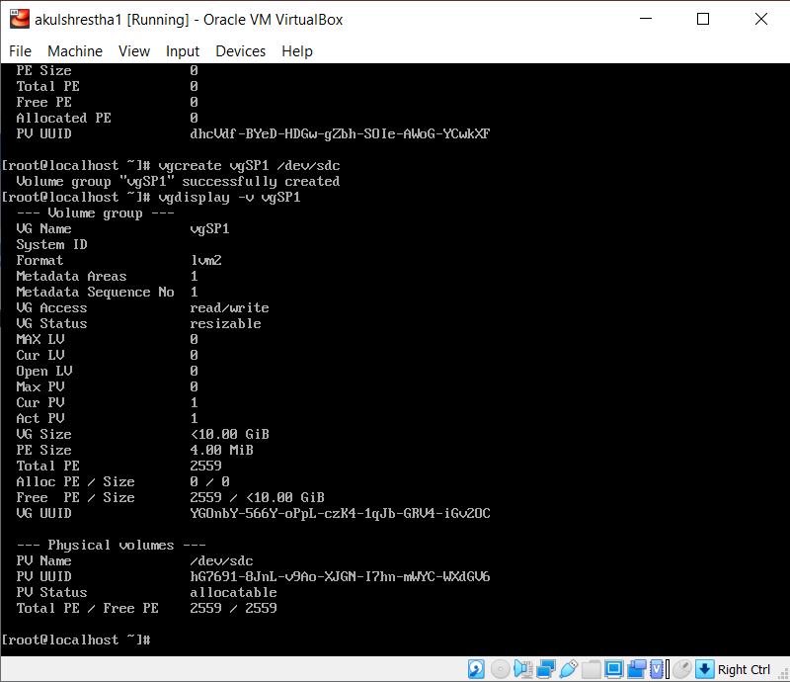

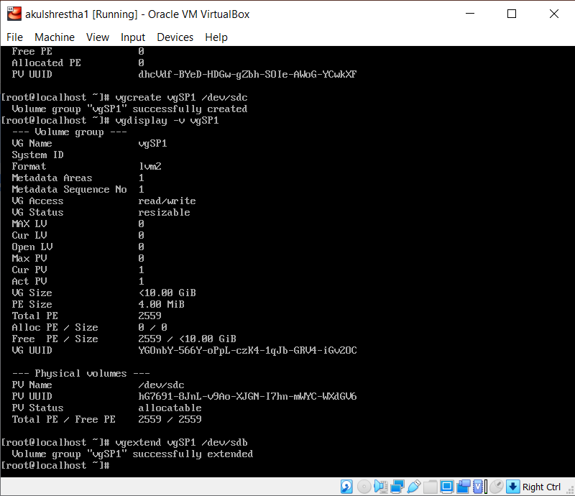

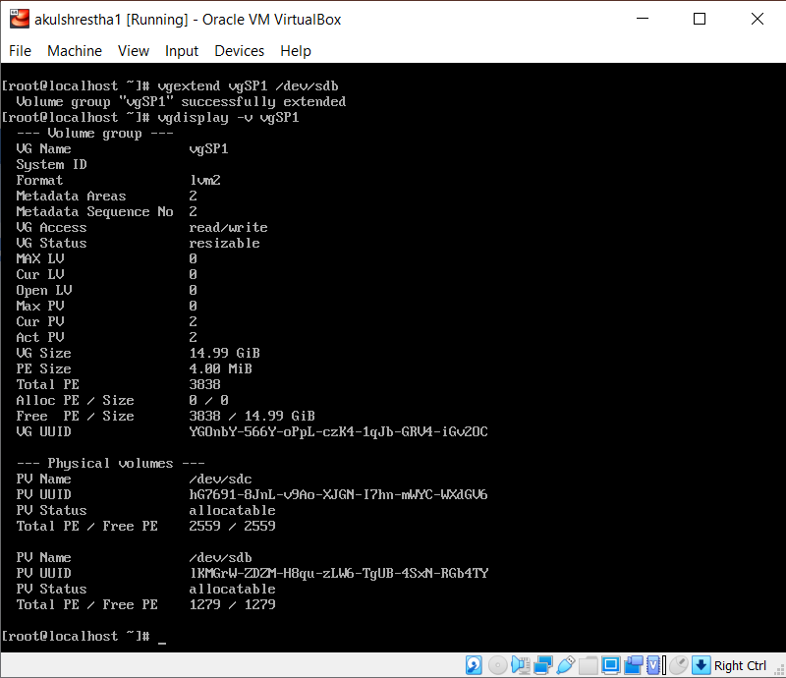

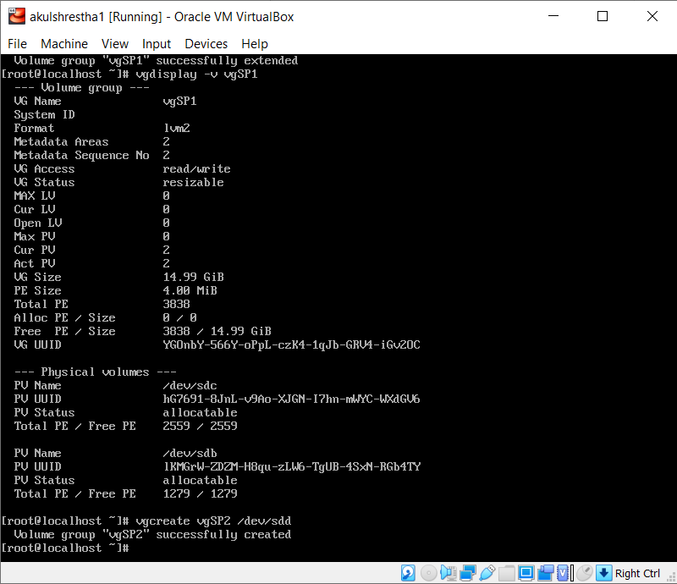

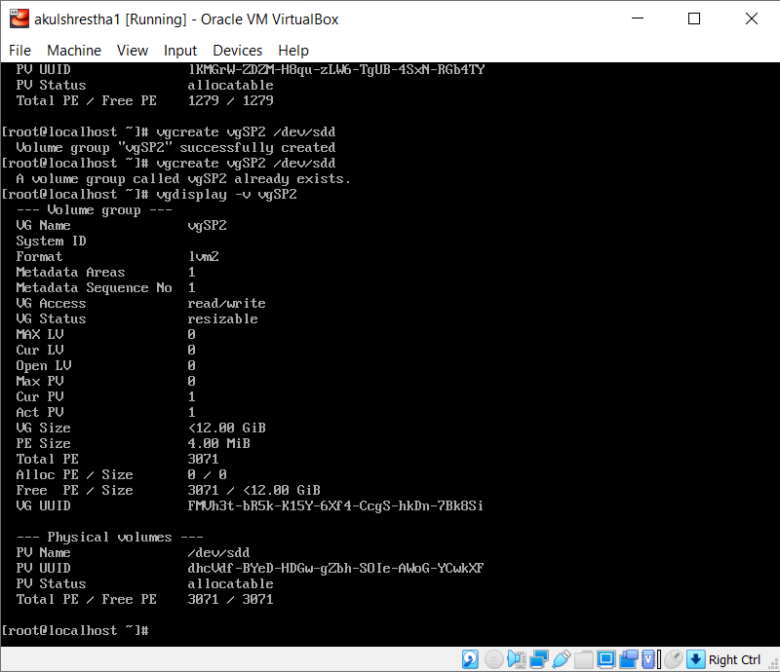

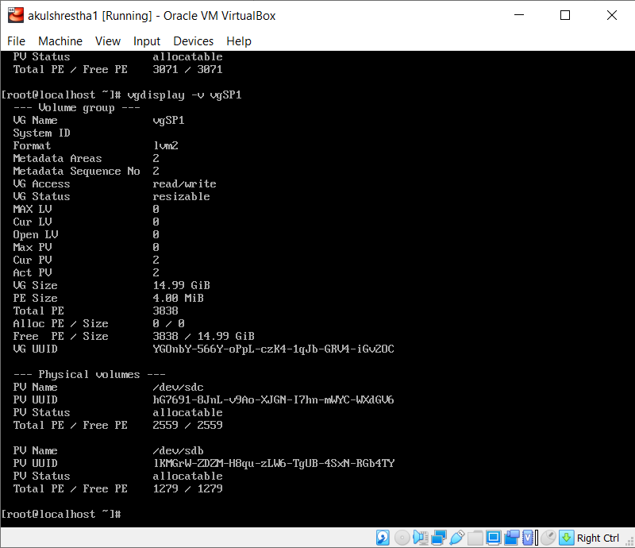

Act PV 2  
VG Size 14.99 GiB   
PE Size 4.00 MiB  
Total PE 3838  
Alloc PE 0/0  
Free PE 3838/ 14.99 GiB

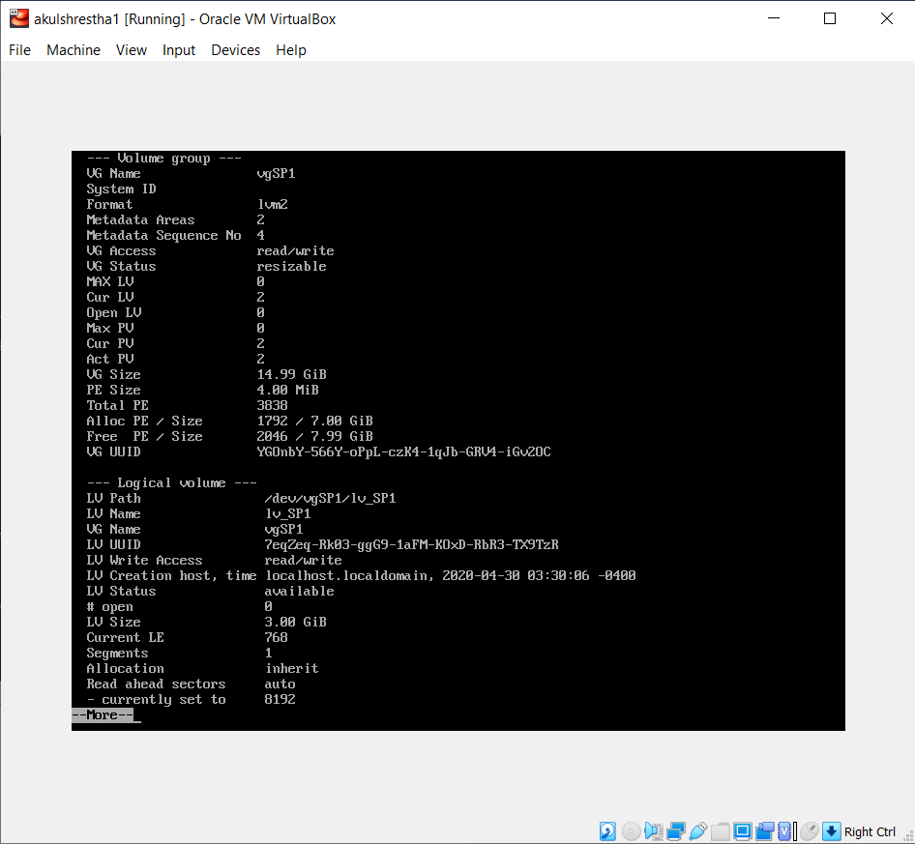

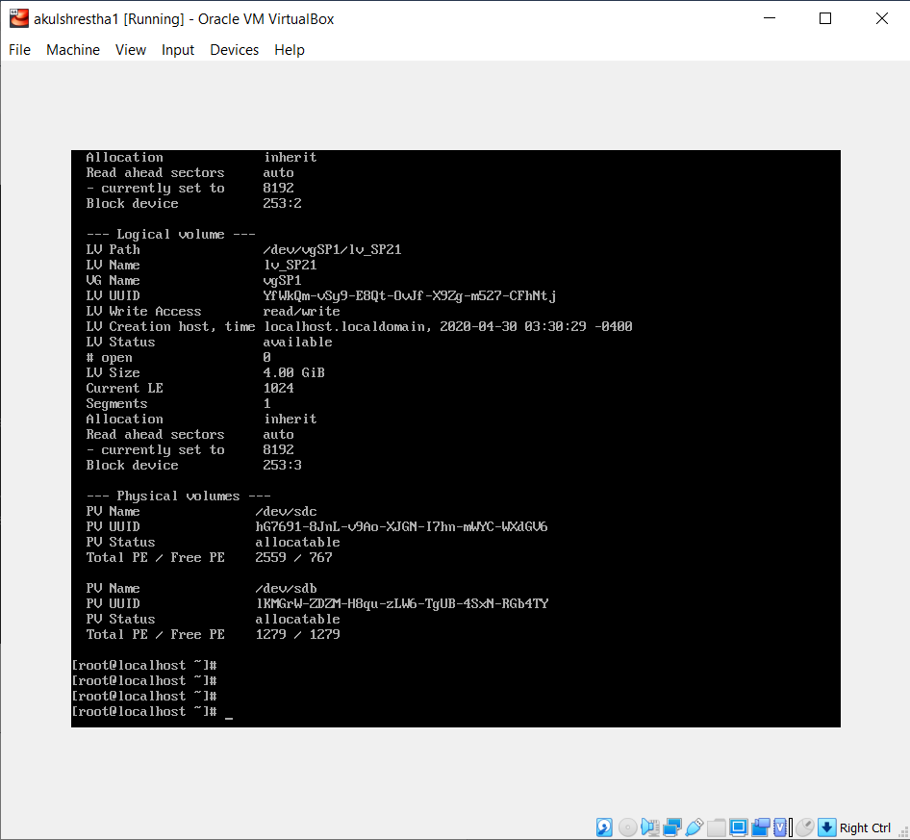

Alloc PE 1792/7 GiB  
Free PE 2046/7.99 GiB  
LV Path /dev/vgSP1/lv_SP1, /dev/vgSP1/lv_SP21  
LV Size 3.00 GiB, 4.00 GiB  
Current LE 768, 1024  
Physical Volumes: Names and Total PE/Free PE

PV Name /dev/sdc

Total PE/Free PE 2559 / 767

PV Name /dev/sdb

Total PE/Free PE 1279/1279

