1. Optional. Watch [RHEL 7 and basic systemd commands video](https://www.youtube.com/watch?v=BS8cdl7dOUI) (18 mins) (you can start on min 3' 44'')
2. Login to your Linux vm as a regular user
3. List active services. Type **systemctl list-units --type service**
4. How many services are loaded on your system?
5. List all services. Type **systemctl list-units --type service --all**
6. Why the difference with the previous command?
7. Check the status of **httpd** daemon. If it's not installed, install it. (**#yum install httpd**)
8. If it's not enabled, **enable** it.
9. Then **start** the service.
10. Check the **status** again.
11. **Stop** the service
12. Check the **status** again.

List active services. Type **systemctl list-units --type service**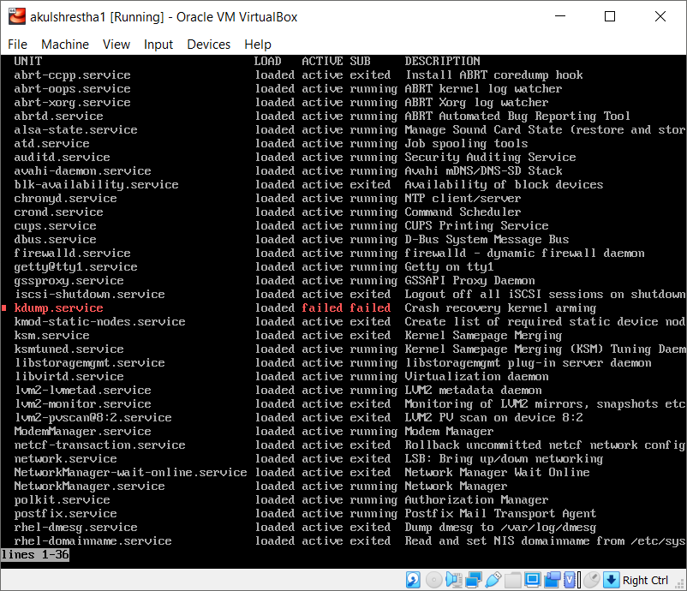

How many services are loaded on your system? 59

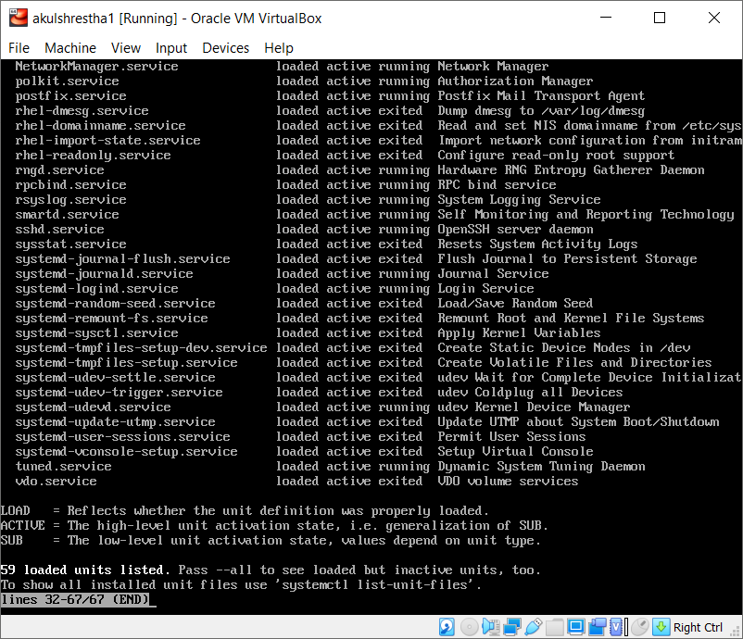

List all services. Type **systemctl list-units --type service --all**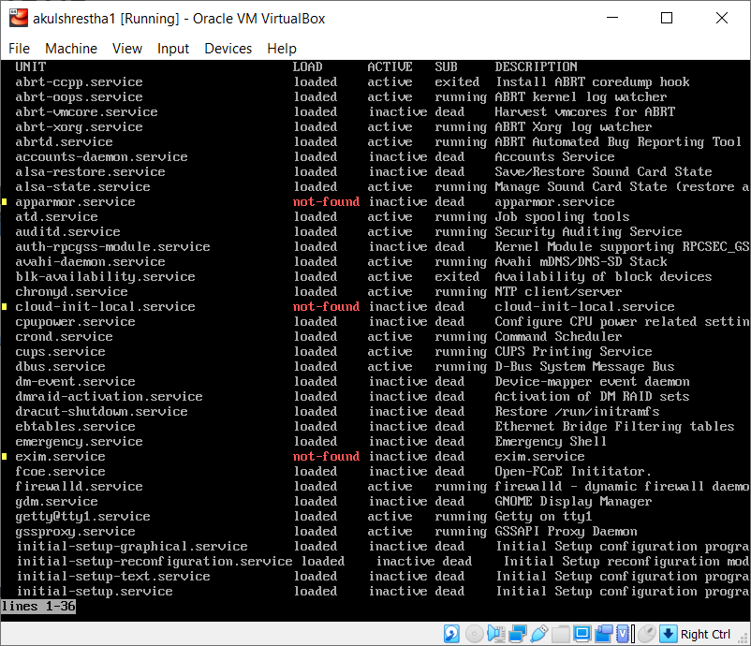

Why the difference with the previous command? Adding -- all shows the inactive processes as well. Hence, we can see the difference in number of units loaded in the list.

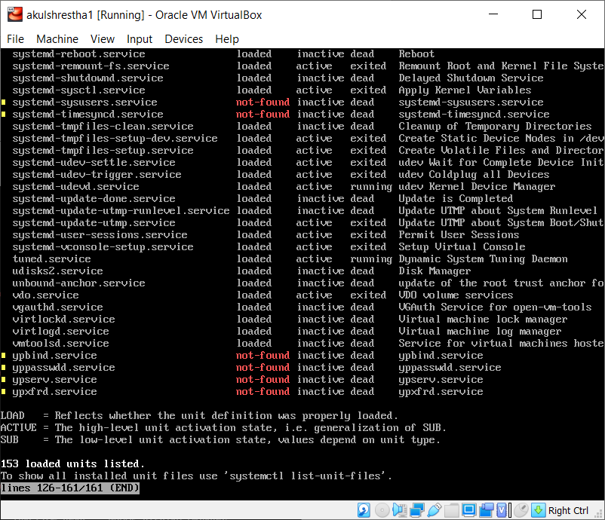

Check the status of **httpd** daemon. If it's not installed, install it. (**#yum install httpd**)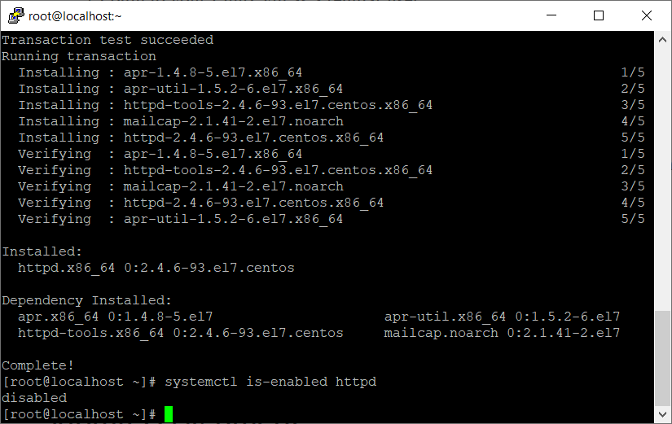

If it's not enabled, **enable** it.

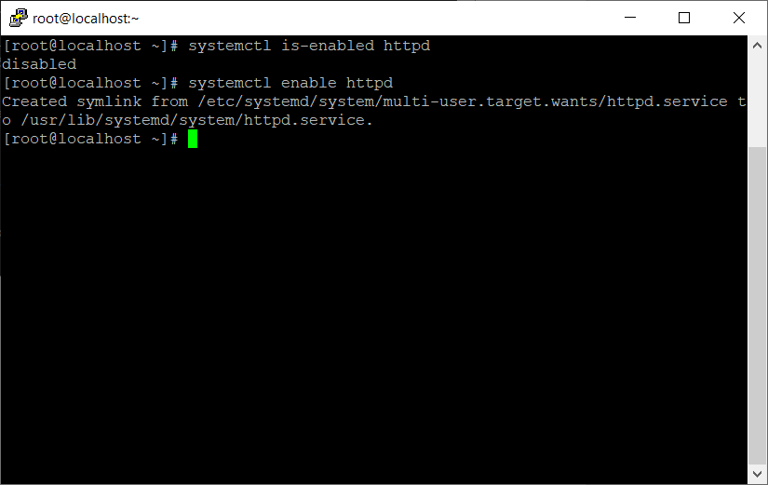

Then **start** the service.

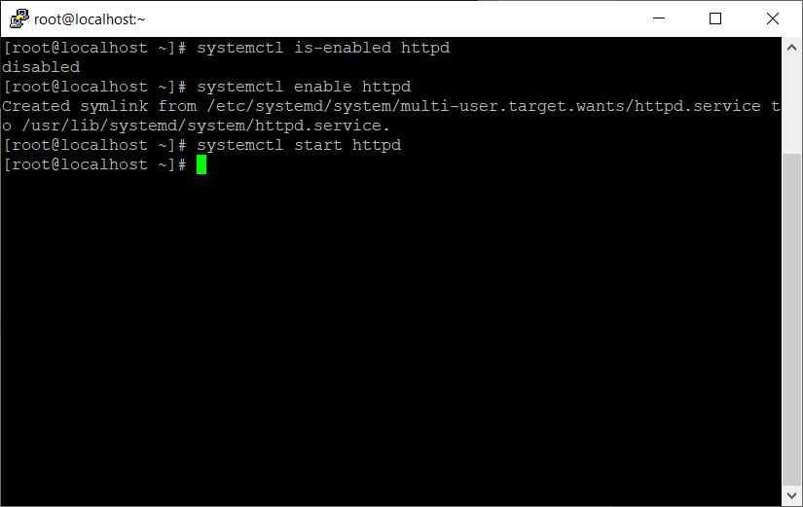

Check the **status** again.

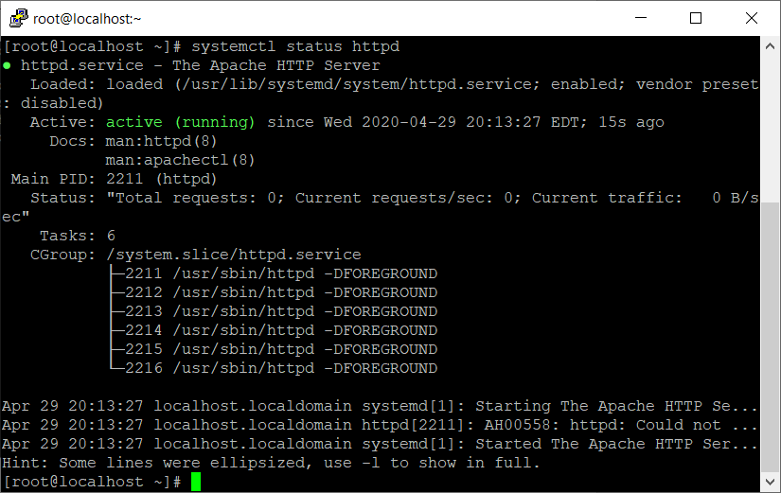

• **Stop** the service

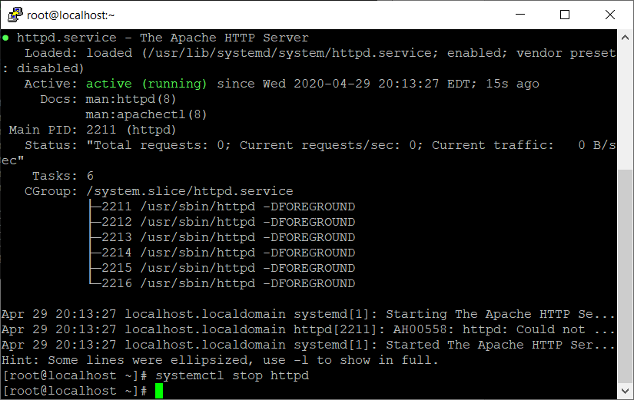

Check the **status** again.

