DocuMind AI

Reference diagram A — Logical architecture (ASCII)

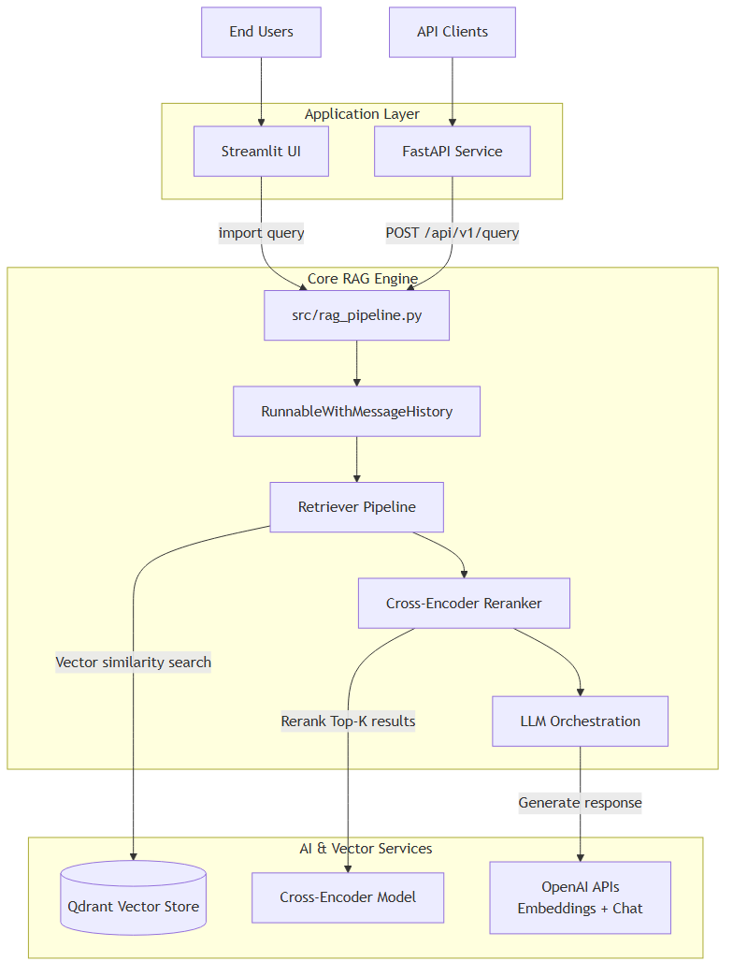

Reference diagram B — Query sequence (ASCII)

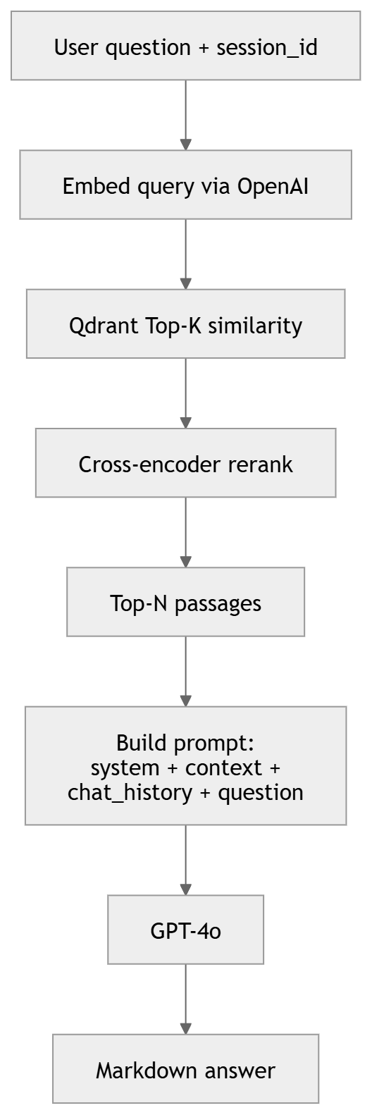

Section 1 — Product & problem framing
Q: What is DocuMind AI, in one sentence?
A: It is a retrieval-augmented documentation assistant: it searches your indexed technical docs in Qdrant, reranks the best passages, then asks GPT-4o to answer strictly using that context, with optional per-session chat memory.
Q: What business problem does it solve?
A: Developers and support teams waste time hunting through long documentation. DocuMind reduces time-to-answer and improves accuracy by grounding responses in the actual corpus instead of relying on the model’s parametric memory.
Q: Who are the users and how do they access the system?
A: End users interact through Streamlit for demos or through the FastAPI REST API for integration. Operators run indexing scripts (or future batch jobs) to load markdown/text into Qdrant. In production you would add authentication.

Section 2 — RAG fundamentals
Q: Explain RAG in simple terms.
A: Retrieval-Augmented Generation first retrieves relevant text chunks from a knowledge base, then passes them to a language model as context. The model generates an answer conditioned on that context, which reduces fabricated details compared to ‘the model alone’ when facts must match your documents.
Q: Why not just use ChatGPT on the whole document set?
A: Context windows and cost: you cannot fit all docs in one prompt. Even if you could, models attend poorly to huge contexts. Retrieval narrows down to dozens of passages. It also lets you cite sources and refresh knowledge by re-indexing without retraining.
Q: What embedding model does DocuMind use and why?
A: Settings default to OpenAI text-embedding-3-small. It is a good balance of quality, latency, and cost for semantic search; vectors are consumed by Qdrant with cosine distance. You could swap dimensions/model in src/config.py.
Q: Dense retrieval vs keyword (BM25) search — compare them.
A: Dense retrieval matches meaning (synonyms, paraphrases). BM25 matches exact or lexical overlap. Dense can miss precise identifiers; BM25 can miss conceptual questions. Many production systems use hybrid retrieval (ensemble) for both.
Q: Does this codebase implement hybrid BM25 + dense search?
A: Not yet. The retriever is Qdrant similarity (dense) only, followed by cross-encoder reranking. A natural extension is LangChain’s EnsembleRetriever with BM25Retriever from the same chunk set and tuned weights (e.g. 0.4 BM25, 0.6 dense).
Q: Why do you have a reranker after vector search?
A: Vector search optimizes approximate similarity at scale; ordering is imperfect. A cross-encoder scores each (query, passage) pair jointly, which is slower but more accurate for the top results. You retrieve K=8 then rerank to top_n=5 before building the LLM prompt, improving grounding and reducing noise.
Q: What reranker is used and could you use Cohere instead?
A: The code uses HuggingFaceCrossEncoder with a configurable model (default cross-encoder/ms-marco-MiniLM-L-6-v2) via CrossEncoderReranker in langchain_classic. You could swap to Cohere Rerank v3 using LangChain’s Cohere integrations and treat it as a managed API trade-off (latency/cost vs ops).

Reference diagram — Mermaid: system context (paste into mermaid.live)

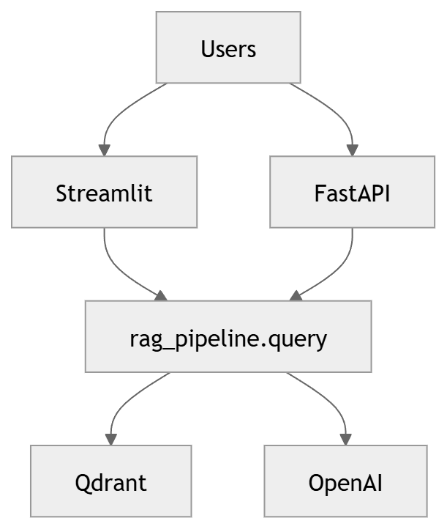

Section 3 — Architecture & components
Q: Describe the runtime architecture at container level.
A: The Dockerfile runs Uvicorn on api.main:app (port 8000). It bundles src/, api/, pipelines/, scripts/. Qdrant is not inside that image—it is external (Docker Compose locally, Qdrant Cloud or another service in GCP). Streamlit runs as a separate process for demos.
Q: What is in src/config.py?
A: A Pydantic BaseSettings class with typed fields: OPENAI_API_KEY, QDRANT_URL, COLLECTION_NAME, embedding and LLM model names, chunk_size/overlap, top_k, rerank_top_n, CROSS_ENCODER_MODEL, optional GCP vars. get_settings() is lru_cached for efficiency.
Q: What does src/retriever.py encapsulate?
A: Qdrant client construction, QdrantVectorStore with cosine distance, shared OpenAIEmbeddings, and a similarity retriever with search_kwargs.k = top_k. This is stage-one recall.
Q: What does src/reranker.py do?
A: It wraps the base retriever in ContextualCompressionRetriever with CrossEncoderReranker, returning fewer, better-ordered documents before the prompt is built.
Q: How is the LangChain chain structured in rag_pipeline.py?
A: build_rag_chain uses RunnableParallel: one branch pipes question -> retriever -> format_docs into context string; parallel branches carry question and chat_history. That dict feeds a ChatPromptTemplate (system with {context}, MessagesPlaceholder for history, human question), then ChatOpenAI, then StrOutputParser.
Q: How does conversational memory work?
A: RunnableWithMessageHistory wraps the chain. get_session_history maps session_id to InMemoryChatMessageHistory. Input key is question; history key is chat_history. For production you would persist history in Redis/Firestore and bound length.
Q: Why cache _rag_with_history_default?
A: Lazy singleton avoids reloading the cross-encoder Hugging Face model on every request, reducing cold latency after the first invocation in a warm instance.
Q: How does indexing work end-to-end in code?
A: index_documents loads paths via pipelines/components/loader.py (recursive .md/.txt), splits with RecursiveCharacterTextSplitter from chunker.py, then vector_store.add_documents in Qdrant (embeddings via LangChain/OpenAI integration). Scripts/index_docs.py is the CLI wrapper.

Reference diagram — Mermaid: indexing flow

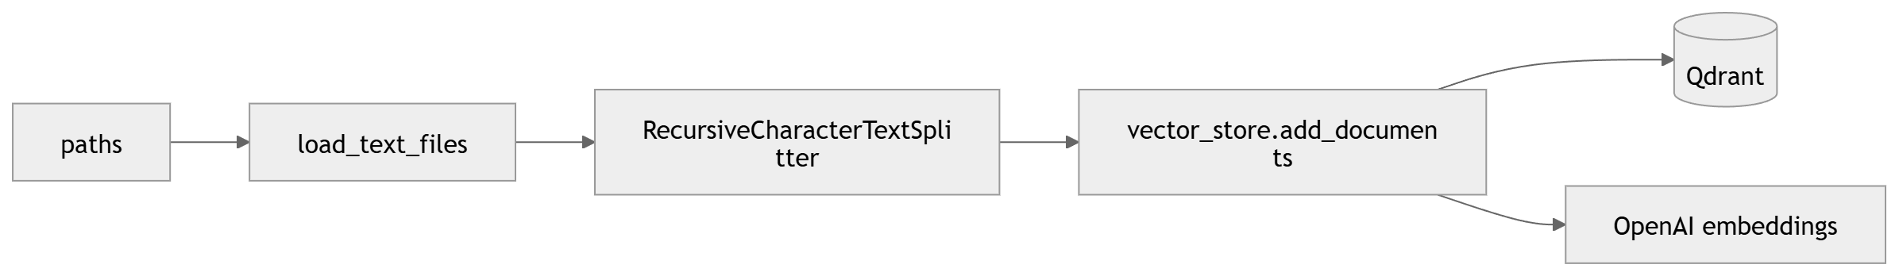
Q: What are the FastAPI endpoints?
A: GET /health for liveness-style checks; POST /api/v1/query with JSON { question, session_id } returning { answer, session_id }. Root GET returns pointers to docs.
Q: Why import query inside the route handler?
A: It defers importing the heavy LangChain/OpenAI/Qdrant stack until the endpoint is exercised, slightly improving startup of the API container in environments where imports matter. Alternative: lifespan hooks or eager init for predictable cold start.

Section 4 — Prompt & safety
Q: How do you instruct the model to stay grounded?
A: The system prompt says to answer based on provided context, cite source sections, include code examples when relevant, and explicitly state when information is not in the context. That pattern reduces confident hallucinations on missing facts.
Q: What temperature do you use and why?
A: Settings use temperature 0.1 — low randomness for factual, documentation-style answers where consistency beats creativity.

Section 5 — Evaluation & quality
Q: How would you measure retrieval quality?
A: Offline: labeled question–chunk relevance sets; metrics like Precision@k, Recall@k, nDCG, MRR on your corpus or a sampled benchmark. Compare dense-only vs dense+rerank vs future hybrid.
Q: How would you measure end-to-end answer quality?
A: Frameworks such as RAGAS (faithfulness, answer relevance, context precision/recall), human eval rubrics, A/B testing in production with user feedback thumbs, or LLM-as-judge with safeguards.
Q: What would you log in production?
A: Request id, latency per stage (retrieval, rerank, LLM), token counts, model versions, retrieval scores, chunk ids, errors, and user/session keys (hashed) for GDPR-aware analytics.

Section 6 — GCP, security, ops (Datatonic angle)
Q: How would you deploy this on Google Cloud?
A: Build the Dockerfile to Artifact Registry. Run Cloud Run for the FastAPI service with min/max instances tuned for demos. Store raw docs in GCS (versioned buckets). Secrets (OpenAI, QDRANT_URL) in Secret Manager, injected as env vars. Use Terraform for repeatable IAM + resources; see GCP_deployment_guide.docx in the repo root.
Q: Where does Qdrant run in GCP?
A: Not in this image. Options: Qdrant Cloud, a second Cloud Run service with persistence trade-offs, GKE StatefulSet, or managed vector offerings as they fit latency and SLA needs.
Q: Failure modes and mitigations?
A: OpenAI rate limits or outages: exponential backoff, circuit breakers, cached answers for FAQs, degraded mode messaging. Qdrant unavailable: health checks, retries, failover read replica pattern. Empty index: surface clear 'not indexed yet' messaging.
Q: Cost levers?
A: Reduce LLM tokens by tightening top_n and shortening chunks; smaller LLM for simple queries routing; caching embeddings for static chunks; hybrid search to shrink bad retrievals; min instances=0 on Cloud Run for dev.
Q: Data privacy considerations?
A: User questions may contain sensitive strings—avoid logging raw PII, redact secrets, define retention for chat history if persisted, encrypt GCS buckets, restrict invoker IAM on Cloud Run instead of public allUsers where possible.

Reference diagram — Mermaid: target GCP deployment
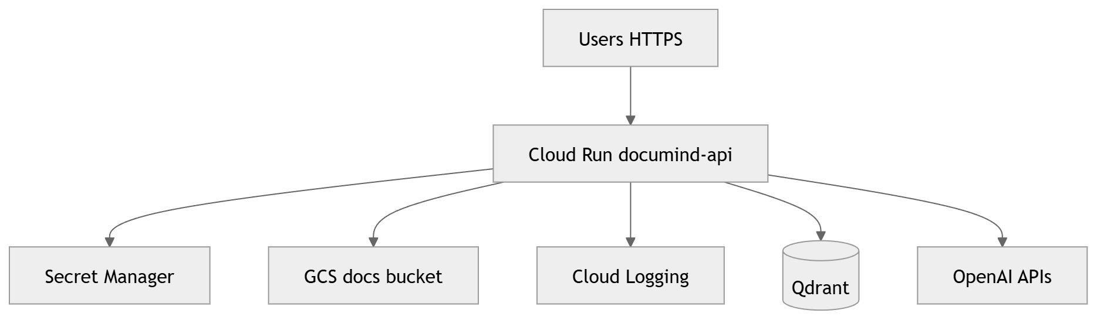

Section 7 — Scaling & roadmap
Q: How does this scale to millions of chunks?
A: Sharding collections, multi-replica Qdrant, quantization and ANN tuning, batch indexing via Vertex pipelines, asynchronous ingestion, CDN for assets, caching hot queries.
Q: What improvements would you add next?
A: Hybrid BM25+dense retrieval; managed Cohere rerank optional path; citations with chunk IDs and URIs stored in payload; Cloud Run Jobs for scheduled reindex from GCS; Prometheus metrics; authenticated API Gateway; multilingual embeddings.
Q: Limitations of InMemoryChatMessageHistory?
A: It is process-local and lost on restart; not suited for horizontally scaled replicas without sticky sessions unless replaced by external conversation store.

Section 8 — Code hygiene & testing
Q: What tests exist?
A: Tests cover chunk splitter behavior on long documents, file loader parsing, FastAPI health route; full RAG integration test is marked skipped until env + Qdrant + indexed data are available.
Q: Why LangChain instead of raw SDK calls?
A: Composable runnables (LCEL), retriever abstractions, and integration with multiple vector stores and models speed iteration. Trade-off: framework overhead and version churn—mitigate by keeping core logic small in rag_pipeline.py.
Q: Why does reranker code import from langchain_classic?
A: In LangChain v1 layouts, contextual compression retrievers and cross-encoder compressors live under the langchain-classic compatibility package; this project pins that stack so imports stay stable alongside langchain-community cross-encoder adapters.
Q: What does operator.itemgetter do in the parallel chain?
A: It pulls keys (question, chat_history) from the dict that RunnableWithMessageHistory passes into the inner chain, while the context branch computes document text from question | retriever | format_docs.
Q: Do returned answers include explicit source filenames today?
A: The prompt asks for citations, but loader metadata (e.g. source path) is only as rich as LangChain attaches to Document metadata. A strong next step is to persist file path and heading in chunk metadata and surface it in format_docs or the prompt.
Q: Is re-running indexing idempotent?
A: add_documents appends vectors; duplicates can appear if you ingest the same path twice without delete/upsert policy. Production pipelines usually use deterministic ids, versioning, or wipe collection before full reindex.
Q: How do you choose chunk_size and overlap?
A: They trade context vs noise: larger chunks carry more surrounding text but dilute retrieval; overlap preserves sentences split across boundaries. Tune with offline eval (hit rate / user satisfaction) starting from 512 tokens and ~50 overlap as in Settings.
Q: Could you run the cross-encoder on GPU?
A: Yes for self-hosted inference; sentence-transformers/torch will use CUDA if installed and configured. Cloud Run CPUs are typical for MS-MARCO Mini models; GPU would move to GKE or specialized serving if latency dominates.
Q: How does docker-compose.yml fit local dev?
A: It runs only the Qdrant container on ports 6333/6334 with a named volume—lightweight substitute for managed vector DB during development.
Q: What would you say about fine-tuning vs RAG for this use case?
A: RAG updates facts by editing documents and re-indexing—fast for evolving docs. Fine-tuning improves style or domain phrasing but stale knowledge remains a risk unless paired with continual training. Hybrid: RAG for facts, light fine-tune for tone if needed.
Q: How would you integrate GCS ingestion with existing code?
A: Download objects to tmp or stream to memory in a new loader component, reuse chunker/embed pipeline, optionally trigger from Cloud Storage notifications via Cloud Functions/Run Jobs. Keep secrets and service accounts scoped to objectViewer on the docs bucket.

Section 9 — Quick flashcard answers
Q: top_k vs rerank_top_n?
A: top_k is how many candidates Qdrant returns; rerank_top_n is how many survive cross-encoder scoring for the prompt.
Q: Distance metric?
A: Cosine similarity on embeddings in QdrantVectorStore configuration.
Q: Collection name?
A: Configurable via COLLECTION_NAME env defaulting to docs-index.
Q: Languages supported?
A: Only as far as embeddings/LLM support; no explicit language routing in code yet.
Q: PDF support?
A: Not in loader.py today—would add parsers or unstructured pipeline.

Appendix — Full Mermaid: query sequence

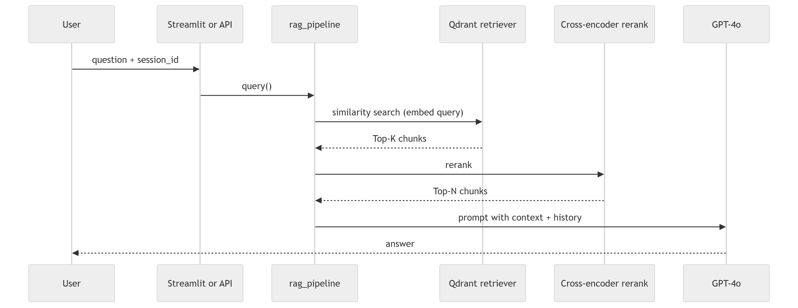

Section 10 — Terraform layout & workflow
Q: Why is Terraform split into apis.tf, iam.tf, secrets.tf, gcs.tf, artifact_registry.tf, cloud_run_api.tf, cloud_run_webui.tf, and outputs.tf?
A: Separating resources by concern keeps plans readable and changes safer: API enablement, identity, secrets, storage, artifacts, and each Cloud Run service can evolve independently. It mirrors how infra reviews isolate IAM, secrets, and compute.
Q: What Terraform and provider versions does this repo expect?
A: Terraform >= 1.5.0 and the hashicorp/google provider ~> 5.0 are declared in versions.tf. Keeping Terraform current matters for google_cloud_run_v2_* resources and predictable plan output.
Q: How is remote state recommended, and why?
A: versions.tf documents an optional gcs backend bucket (e.g. gs://PROJECT_ID-tf-state with prefix documind-ai/state). Remote state avoids local-only state loss, enables shared applies in CI/CD, and can use locking when configured. Create the bucket once, uncomment the backend block, then terraform init -migrate-state.
Q: What prerequisite steps does main.tf comment call out before terraform init?
A: Application Default Credentials via gcloud auth application-default login, gcloud config set project, and optionally creating a GCS bucket dedicated to Terraform state (separate from the docs content bucket provisioned inside this module).
Section 11 — GCP APIs enabled by Terraform
Q: Which APIs does terraform/apis.tf enable, and why each?
A: Cloud Run (run.googleapis.com), Cloud Storage (storage.googleapis.com), Secret Manager (secretmanager.googleapis.com), Artifact Registry (artifactregistry.googleapis.com), Cloud Build for optional CI/CD (cloudbuild.googleapis.com), IAM (iam.googleapis.com), Resource Manager for IAM metadata (cloudresourcemanager.googleapis.com), Logging (logging.googleapis.com), and Monitoring (monitoring.googleapis.com). Together they cover deploy, secrets, images, buckets, IAM bindings, and baseline observability.
Q: Why set disable_on_destroy = false on google_project_service?
A: Automatically disabling project APIs on terraform destroy can break unrelated workloads in the same project. Leaving APIs enabled after destroy is usually safer for shared dev or demo projects.
Section 12 — Artifact Registry & image variables
Q: What Artifact Registry setup does Terraform create?
A: A regional DOCKER repository named documind in Artifact Registry with standard labels (app=documind-ai, environment, managed_by=terraform). The output artifact_registry_repo gives the docker push prefix REGION-docker.pkg.dev/PROJECT_ID/documind.
Q: Why are api_image and webui_image required variables while both may point at the same image?
A: Terraform needs concrete image URIs before Cloud Run revisions can be created. The Web UI reuses the API image but overrides the container command to run Streamlit. One build artifact avoids dependency drift between API and UI layers.
Section 13 — Cloud Run (API service)
Q: Describe the documind-api Cloud Run v2 service Terraform provisions.
A: Service name documind-api in var.region on google_service_account.documind_api, scaling between api_min_instances and api_max_instances (defaults 0–10). Container uses 2 vCPU / 4Gi memory, exposes port 8000, sets env for ENVIRONMENT, GCP_PROJECT_ID, GCS_BUCKET_DOCS, COLLECTION_NAME, LOG_LEVEL, and injects OPENAI_API_KEY, QDRANT_URL, QDRANT_API_KEY from Secret Manager (version latest). Startup and liveness HTTP probes hit /health.
Q: What are cpu_idle and startup_cpu_boost on the API container?
A: cpu_idle throttles CPU outside request handling to reduce cost; startup_cpu_boost grants extra CPU during cold starts to shorten boot when min instances is zero. Together they tune demo spend versus latency.
Q: How are secrets wired without putting them in terraform.tfvars?
A: google_secret_manager_secret creates Secret Manager containers; sensitive payloads are added post-apply via gcloud secrets versions add or the Console. Cloud Run reads them through secret_key_ref. IAM grants the runtime service account roles/secretmanager.secretAccessor only on the secrets it needs.
Section 14 — Cloud Run (Streamlit WebUI)
Q: How does Terraform run Streamlit versus the default process in the Docker image?
A: The web UI Cloud Run service overrides command to streamlit run ui/streamlit_app.py with --server.address=0.0.0.0 and --server.headless=true on port 8080. The startup probe uses Streamlit’s /_stcore/health endpoint instead of FastAPI /health.
Q: How does the browser UI discover the deployed API URL?
A: Environment variable DOCUMIND_API_URL is set to google_cloud_run_v2_service.api.uri so the UI calls the freshly deployed backend without baking hostnames into the image.
Q: Why does webui_max_instances default to 3 while the API allows 10?
A: The UI tier is typically lighter per session; capping replicas controls cost and fan-out while the API tier can scale further for concurrent RAG traffic. Both are environment-tunable.
Section 15 — GCS bucket & lifecycle
Q: What does the Terraform-managed docs GCS bucket provide operationally?
A: A regional bucket named var.gcs_bucket_docs with versioning enabled for recoverability, force_destroy false to avoid accidental wholesale deletion through Terraform alone, and a lifecycle rule deleting non-current objects in ARCHIVED state after 30 days to control versioning storage cost.
Q: What IAM does the runtime service account have on this bucket?
A: roles/storage.objectAdmin on the docs bucket so the app (or ingestion jobs using the same identity) can read and write objects without project-wide blanket storage permissions.
Section 16 — IAM, logging, public access choices
Q: Which IAM bindings does Terraform apply to google_service_account.documind_api?
A: storage.objectAdmin on the docs bucket, secretAccessor on each DocuMind secret, plus project-level roles/logging.logWriter and roles/monitoring.metricWriter so Cloud Run can emit structured logs and custom metrics without extra manual binding steps.
Q: Why grant roles/run.invoker to allUsers on both Cloud Run services?
A: It enables public HTTPS URLs for quick demos without signed identity tokens. For production you typically remove allUsers and restrict invokers, or front services with IAP or an API gateway. Pair with abuse controls because unauthenticated surfaces are discoverable.
Section 17 — Apply/destroy order of operations
Q: After terraform apply, which outputs should you capture?
A: api_url, webui_url, gcs_bucket_docs, artifact_registry_repo, service_account_email, and secret_names (map of Secret Manager IDs that still need secret versions unless already populated).
Q: If Secret Manager secrets have no versions yet, will Cloud Run roll out healthy revisions?
A: Revisions that reference missing or invalid secret versions usually fail deployment or crash-loop on startup probes. Populate secret versions after creating containers, then redeploy or roll forward. Practical order: push image to Artifact Registry, apply with real image URIs, add secret payloads, verify /health.
Q: How does COLLECTION_NAME from Terraform relate to Qdrant?
A: It is passed into the API container so the application queries the intended Qdrant collection. Terraform does not create that collection; indexing must use the same name against the external Qdrant deployment.
Q: Does Terraform in this repo provision Qdrant or OpenAI?
A: Neither. It configures Cloud Run env and Secret Manager for OpenAI/Qdrant credentials and endpoints. OpenAI stays a SaaS API; Qdrant remains an external datastore you operate or subscribe to separately.
Section 18 — Hardening & operations follow-ups
Q: How would you move from allUsers invoker to authenticated access?
A: Remove the google_cloud_run_v2_service_iam_member bindings that add allUsers and grant roles/run.invoker selectively to users, groups, or service accounts, or terminate TLS at IAP / API Gateway. Clients then send OIDC bearer or identity tokens from gcloud/workload identity.
Q: How would you wire CI/CD to this stack beyond enabling the Cloud Build API?
A: Typical pattern: Cloud Build (or GitHub Actions) builds and pushes semver-tagged images to Artifact Registry, then runs terraform apply with remote GCS backend, OIDC federation to GCP, and protected variables for tfvars values; optionally trigger rollout only after staging health checks.
Q: How do you safely rotate OpenAI or Qdrant credentials?
A: Add a new Secret Manager secret version holding the rotated value—Cloud Run uses version latest—then redeploy or let the next revision pick it up. Validate error budgets, revoke outdated provider keys after cutover, and audit Secret Manager IAM accessors.
Q: What is a sensible tfvars strategy across environments?
A: Keep a committed terraform.tfvars.example; store real bucket names and image URIs per env in CI secrets or Terraform Cloud variables. Separate workspaces or state prefixes for staging vs prod with differing min/max instances and invoker policies.
Q: Would you import existing manually created Cloud Run services into Terraform?
A: When legacy resources already exist in the project you can terraform import them into google_cloud_run_v2_service addresses, reconcile drift carefully (especially probes, SA, secrets), then manage exclusively via Terraform afterward to prevent split-brain ops.
(End of appended Terraform & GCP deployment Q&A — May 2026.)

