GaariDoc
AI Car Diagnosis Assistant for Pakistan
Software Requirements, Feature Plan, Data & AI Plan, Database Schema and Class Diagrams
Stack: Django REST Framework + React (PWA) + PostgreSQL
Version 1.0 | Working name; final name to be decided

Table of Contents
1. Introduction
2. Functional Requirements
3. Non-Functional Requirements
4. Feature Plan
5. System Architecture
6. Diagnosis Engine Design
7. Mechanic Panel and Content Workflow
8. Data and AI Plan
9. Database Schema
10. Class Diagrams
11. Risks and Mitigations
12. Success Metrics
13. Promotion Strategy

1. Introduction

1.1 Purpose
This document defines the requirements, feature plan, data strategy, database design and class design for GaariDoc, a web application that helps car owners in Pakistan work out why their car is misbehaving, what a fair repair costs, and whether a mechanic's diagnosis is believable.

1.2 Problem
Many car owners cannot judge a mechanic's diagnosis or quote. They are often told several different problems for the same symptom and cannot tell which is real. This leads to unnecessary repairs and overpayment.

1.3 Product vision
A mechanic in your pocket. The user describes a problem in text, Roman Urdu or voice. The app asks adaptive follow-up questions and returns ranked likely causes, a free check the owner can do first, a fair repair cost range, and what to ask the mechanic. A Mechanic Scam Shield compares a mechanic's claim and quote against the symptoms.
Important: the app narrows down likely causes and helps users ask better questions. It does not replace a physical inspection and never claims certainty.

1.4 Target users
User | Description
Car owner | Ages 18 to 40, driving Alto, Cultus, Mehran, Corolla, Civic, City, Vitz or Yaris; first-time owners; people who feel overcharged.
Mechanic / expert | Auto-electricians and mechanics who contribute and validate diagnostic knowledge and gain visibility and referrals.
Reviewer / admin | Product owner who approves content, manages data and monitors quality.

1.5 Scope
In scope: diagnosis flows, scam shield, warning-light decoder, OBD2 code lookup, garage and service log, mechanic content panel, admin panel, analytics.
Out of scope (initially): car marketplace, live mechanic booking and payments, insurance, and fully automated diagnosis without human-approved rules.

1.6 Definitions
Term | Meaning
Symptom | An observable problem (for example, slow cranking, white smoke).
Cause | A possible underlying fault (for example, weak battery).
Strength | How strongly a symptom points to a cause: Always, Often, Sometimes, Rarely.
Flow | The set of symptoms, questions, causes, checks and costs for one problem category.
OBD2 | On-board diagnostics standard whose fault codes (for example, P0301) can be read with a cheap Bluetooth scanner.
Scam Shield | Feature that checks a mechanic's claimed diagnosis and quote against the user's symptoms and market ranges.

2. Functional Requirements
Priority: Must = needed for launch, Should = important, Could = later.

2.1 Accounts and Garage
ID | Requirement | Priority
FR-1 | Users can sign up and log in with phone number (OTP) or Google. | Must
FR-2 | Users can create and edit a profile (name, city, preferred language). | Must
FR-3 | Users can add one or more cars to My Garage (make, model, year, mileage, fuel, transmission). | Must
FR-4 | Users can view the history of past diagnoses per car. | Should

2.2 Diagnosis
ID | Requirement | Priority
FR-5 | User selects a car and a problem category (won't start, overheating, noise, AC, vibration, smoke, brakes, warning light). | Must
FR-6 | User can describe the problem in free text or Roman Urdu/Urdu; the system maps it to structured symptoms. | Should
FR-7 | The system asks adaptive questions; each answer updates cause scores and the next question is chosen to best separate remaining causes. | Must
FR-8 | Every question offers a "not sure" option. | Must
FR-9 | Questions can include images or audio samples to help users answer. | Should
FR-10 | The system returns a ranked list of likely causes with confidence levels and a short explanation of why. | Must
FR-11 | Safety interrupt: for brake failure, overheating, fuel smell or smoke, the system immediately shows a stop-driving warning. | Must
FR-12 | The system shows self-checks the owner can perform (with tools needed and difficulty). | Must
FR-13 | The system shows fair repair cost ranges (parts and labour) by city, with a last-verified date. | Must
FR-14 | The system generates an "ask your mechanic" script in Roman Urdu or English. | Should
FR-15 | User can save, share and export a diagnosis result as a card or PDF. | Must

2.3 Scam Shield
ID | Requirement | Priority
FR-16 | User enters the mechanic's claimed diagnosis and quoted price. | Must
FR-17 | The system gives a plausibility score and verdict (plausible, doubtful, suspicious) against the user's symptoms and cost ranges. | Must
FR-18 | The system suggests what proof or tests to request from the mechanic. | Should
FR-19 | A shareable Scam Shield result card is generated. | Must

2.4 Tools and Extras
ID | Requirement | Priority
FR-20 | Dashboard warning-light decoder with severity (stop now, repair soon, safe), first by icon selection and later by photo. | Should
FR-21 | OBD2 fault-code lookup by manual entry; later via Bluetooth scanner. | Should
FR-22 | Service log with maintenance reminders (oil, filters, tyres, battery). | Should
FR-23 | Voice input in Urdu, Punjabi and English. | Could
FR-24 | Engine or brake sound recording and analysis (experimental). | Could
FR-25 | Verified mechanic directory with ratings, reviews and an honesty score. | Could

2.5 Feedback and Learning
ID | Requirement | Priority
FR-26 | After a diagnosis, the system asks for the actual fix and actual cost (outcome feedback). | Must
FR-27 | User can rate whether the result was helpful. | Must
FR-28 | All sessions, answers, results and outcomes are logged for evaluation and recalibration. | Must

2.6 Mechanic Panel
ID | Requirement | Priority
FR-29 | Mechanics can register, create a profile and apply for verification. | Must
FR-30 | A guided form lets mechanics add symptoms, causes, symptom-cause links (Always/Often/Sometimes/Rarely), questions, self-checks, red flags and costs. | Must
FR-31 | Mechanics can submit drafts but cannot publish; content moves through draft, submitted, under review, approved, published. | Must
FR-32 | A test simulator lets mechanics run a fake customer session and see the app's result before submitting. | Must
FR-33 | Mechanic input supports Roman Urdu text and voice notes and is mobile-friendly. | Should
FR-34 | Version history is kept; edits to approved content do not go live until re-approved. | Must

2.7 Admin Panel
ID | Requirement | Priority
FR-35 | Admin can manage cars, symptoms, causes, questions, rules, costs and warning lights without code changes. | Must
FR-36 | Admin can approve, reject or return content with comments, and resolve conflicting mechanic opinions. | Must
FR-37 | Seed or AI-drafted content is flagged is_dummy / ai_draft, shown with a SAMPLE DATA banner, and blocked from release until replaced by approved content. | Must
FR-38 | Analytics dashboard: popular problems, drop-off points, feedback accuracy, top-3 hit rate. | Should
FR-39 | Moderation of reviews and flagged results. | Should

3. Non-Functional Requirements
Category | Requirement
NFR-1 Performance | Each diagnosis step responds in under 1.5 seconds (rules engine); page load under 3 seconds on 4G.
NFR-2 Availability | 99% uptime target; if the LLM API is unavailable the rules-only mode keeps working.
NFR-3 Scalability | Stateless API, Redis cache and Celery workers; support 1,000 concurrent users on a modest VPS, with a path to scale horizontally.
NFR-4 Low bandwidth | PWA with cached symptom flows, compressed images and a lightweight bundle; usable on weak mobile data.
NFR-5 Usability | Mobile-first; English, Roman Urdu and Urdu (RTL); at most 3 taps per question; non-technical wording.
NFR-6 Accuracy and safety | Never claim certainty; show "likely causes"; safety interrupts override every flow; visible disclaimer; all live content expert-approved.
NFR-7 Explainability | Each ranked cause shows which answers supported it.
NFR-8 Security | HTTPS, JWT authentication, role-based access, rate limiting, input validation, OWASP Top 10 protections, secrets kept out of code.
NFR-9 Privacy | Collect minimal personal data; explicit consent for photos, audio and location; deletion on request.
NFR-10 Maintainability | Knowledge (rules, costs) stored as data, not code; unit tests for the scoring engine; CI/CD pipeline; API documentation (OpenAPI).
NFR-11 Localization | Prices in PKR; city-level cost variance; date and number formats suitable for Pakistan.
NFR-12 Compatibility | Chrome and Safari on Android and iOS; works on low-end Android devices.
NFR-13 Auditability | Every content change records author, reviewer, timestamps and version.
NFR-14 Backup and recovery | Daily database backups, tested restores, recovery time under 4 hours.

4. Feature Plan
Phase | Timing | Deliverables
0 Knowledge groundwork | Weeks 1-2 | Collect real customer phrases from mechanics; AI drafts the first flows; set up the review process.
1 MVP | Weeks 3-6 | Auth, My Garage, 5 symptom categories (won't start, overheating, noise, AC, vibration), adaptive questions, ranked causes, self-checks, cost ranges, safety interrupts, shareable card, admin panel with dummy data.
2 Mechanic panel | Weeks 7-9 | Guided content forms, test simulator, approval workflow, versioning; onboard 2-3 mechanics to replace dummy data.
3 Scam Shield and language | Weeks 10-12 | Mechanic quote checker, Roman Urdu free text via LLM, warning-light decoder, OBD2 code lookup, outcome feedback loop.
4 Beta launch | Week 13 | Closed beta with honest beta labelling; collect feedback; fix top issues.
5 Retention | Months 4-5 | Service log and reminders, case history, push notifications, more cars and symptoms, city price benchmarks.
6 Intelligence | Months 5-7 | Recalibrate probabilities from outcomes, OBD2 Bluetooth, voice input, sound-analysis experiment.
7 Business | Month 7+ | Verified mechanic directory with referral fees, premium reports (Rs. 299-999), workshop dashboards, parts-brand partnerships.

4.1 Launch gate
Public launch is blocked until: (a) every live flow is approved by a qualified mechanic or auto-electrician, (b) all safety rules are expert-checked, (c) no content is flagged is_dummy, and (d) cost ranges have a verified date.

5. System Architecture
Layer | Technology and role
Frontend | React PWA with Tailwind CSS, i18n (English, Roman Urdu, Urdu RTL), chat-style step-by-step interface, result and share cards.
Backend API | Django + Django REST Framework; JWT auth; role-based permissions (user, mechanic, reviewer, admin).
Database | PostgreSQL for all relational data; Redis for caching and session state.
Background jobs | Celery workers for notifications, report generation, analytics aggregation and LLM calls.
Diagnosis engine | Python service inside Django: scoring service plus question selector (Section 6).
LLM layer | External LLM API used only for language understanding (free text to symptoms) and plain-language explanations; the rules engine stays the source of truth.
Storage | S3-compatible or Cloudinary storage for images, audio and generated cards.
Deployment | Docker containers, Nginx, CI/CD pipeline, managed backups, monitoring and error tracking.

6. Diagnosis Engine Design

6.1 Scoring
The engine keeps a score for every candidate cause for the selected car and problem category. It starts from the cause's prior probability and updates it each time the user answers a question.
Strength mapping: Always = 0.9, Often = 0.7, Sometimes = 0.4, Rarely = 0.1. Mechanics choose the label; the system stores the number.
Update rule (Naive Bayes style): for each cause, score = prior x product of the likelihoods of the observed answers; present symptoms use the link weight, absent symptoms use (1 - weight); "not sure" answers are skipped. Scores are then normalised so they sum to 100%.

6.2 Next-best question
Among unanswered questions, choose the one with the highest expected information gain, meaning the question whose answer is expected to separate the top causes the most. Stop when the top cause exceeds a confidence threshold (for example 70%), the gap to the second cause is large enough, or a maximum number of questions is reached.

6.3 Safety rules
Safety-critical symptoms are checked before and after every answer. If any is present (for example brake pedal goes to the floor, fuel smell, steam with temperature gauge in red), the engine stops the flow and returns a stop-driving message with towing advice.

6.4 Scam Shield logic
Given the user's answers and the mechanic's claimed cause: (1) look up the claimed cause's probability among the ranked causes; (2) compare the quoted price with the stored cost range for that cause and city; (3) combine into a plausibility score; (4) output a verdict and the proof or tests to request. The result is always worded as guidance, for example "unlikely based on your symptoms".

7. Mechanic Panel and Content Workflow
The platform is built first with clearly marked dummy data. Mechanics then fill it with real knowledge through their panel, similar to a seller dashboard in an e-commerce app. Unlike products, diagnostic entries depend on each other, so the panel is a guided flow.

7.1 Roles
Role | Permissions
Mechanic / Expert | Create and edit drafts, run the test simulator, submit for review; cannot publish.
Reviewer / Admin | Approve, reject or return content with comments; resolve conflicts; manage verification.
User | Sees only approved content.

7.2 Guided content flow
- Pick the car model(s) and the problem category.
- List the symptoms customers describe, in their own words.
- Add the possible causes.
- Link each symptom to causes using Always / Often / Sometimes / Rarely.
- Add the self-check the owner can do at home.
- Add repair cost ranges per city, with parts and labour separate.
- Add red-flag warnings (for example, stop driving if...).
- Run the test simulator, then submit for review.

7.3 Status workflow
ai_draft or draft → submitted → under_review → approved → published. Editing approved content creates a new version; the live version stays unchanged until the new version is approved.

7.4 Dummy-data safety
- Seed data carries is_dummy = true and the app shows a SAMPLE DATA banner.
- AI-generated drafts are imported with status ai_draft so mechanics edit rather than start from scratch.
- A launch check blocks release until the minimum set of approved, non-dummy flows exists.

7.5 Keeping mechanics engaged
- Mobile-friendly forms, Roman Urdu and voice-note input, tasks under 5 minutes.
- Benefits: verified badge, public profile in the app, customer referrals.
- Conflicting opinions are stored side by side and resolved by the admin, with who approved what recorded.

8. Data and AI Plan

8.1 Is AI needed?
Not for version 1. Start with an expert-validated rules and probability engine. It is explainable, safer and does not need a large dataset, which does not exist for Pakistani cars. Machine learning is added gradually as real user data accumulates.

8.2 Where AI fits
Component | Approach | Training data needed?
Diagnosis scoring | Weighted rules / Naive Bayes; Bayesian network later | No at first; outcomes later
Next-best question | Information-gain selection | No
Roman Urdu understanding | Pretrained LLM with structured output mapped to the symptom list | No (evaluation set only)
Explanations | LLM over the curated knowledge base | No
Warning-light decoder | Icon picker first; image classifier later (transfer learning) | Yes, labelled images
OBD2 interpretation | Lookup table plus rules | No (public code lists)
Sound diagnosis | Audio classification on spectrograms (experimental) | Yes, labelled recordings
Cost estimation | Statistical ranges (median, percentiles) | Yes, collected prices

8.3 Data sources

Public and open sources (verify licences before use)
- OBD-II trouble code lists: standardised generic codes are widely documented; build the lookup table from them.
- NHTSA complaints, recalls and service bulletins: free public data useful for common failure patterns on globally sold models; US conditions differ from Pakistan's.
- Kaggle: search for vehicle maintenance, predictive maintenance, OBD-II fault, engine sound and dashboard warning-light datasets. Quality and licences vary; use for prototyping, not as ground truth for Pakistani cars.
- Roboflow Universe: community-labelled dashboard and car-part image datasets for the vision feature.
- Research sound datasets (for example MIMII, industrial machine sound): usable to prototype audio models only.
- Owner's manuals: warning-light meanings and service schedules for the knowledge base (cite, do not copy).

Pakistan-specific data you must create
- Mechanic and auto-electrician interviews to validate flows, priors, tests and cost ranges.
- Parts and labour price survey for the top 50 repair jobs in Lahore, Karachi and Islamabad, refreshed quarterly.
- Forum and community research (PakWheels forums, Facebook car groups, YouTube channels) to discover common problems and Roman Urdu wording; respect each site's terms before any scraping.
- Users' outcome feedback: the proprietary labelled dataset that grows with use.
- A synthetic Roman Urdu test set of 300 to 500 realistic symptom descriptions to evaluate language mapping.

8.4 Learning path
- Cold start: AI-drafted flows, expert-validated priors and weights.
- Log every session, answer, result and outcome.
- After roughly 500 to 1,000 sessions with outcomes: compare predicted and actual causes and recalibrate weights.
- After roughly 5,000 sessions: trial supervised models (gradient boosting or a learned Bayesian network) against the rules baseline; ship only if offline tests show an improvement.
- Vision and audio models only after enough labelled local data is collected.

8.5 Evaluation metrics
- Top-3 accuracy: the true cause appears in the top 3 results.
- Question efficiency: average questions to a confident result.
- Cost-range hit rate: the actual price falls within the shown range.
- Trust signals: helpful votes, repeat use, shares.
- Safety audit: 100% of dangerous symptoms trigger the stop-driving alert.

9. Database Schema
Relational schema for PostgreSQL, implemented as Django models. All tables also carry created_at and updated_at timestamps. PK = primary key, FK = foreign key.

9.1 Users and Garage

users
Application users of every role.
Field | Type | Notes
id | BIGINT PK | Auto-increment
phone | VARCHAR(20) | Unique, used for OTP login
email | VARCHAR(254) | Optional, unique
name | VARCHAR(120)
role | ENUM | user, mechanic, reviewer, admin
city | VARCHAR(60)
language | ENUM | en, roman_ur, ur
is_active | BOOLEAN | Default true

mechanic_profiles
Extra data for users with the mechanic role (one-to-one with users).
Field | Type | Notes
user_id | BIGINT PK/FK | References users.id
workshop_name | VARCHAR(150)
city | VARCHAR(60)
experience_years | SMALLINT
specialization | VARCHAR(100) | For example auto-electrical, engine, AC
is_verified | BOOLEAN | Set by admin
honesty_score | DECIMAL(3,2) | Derived from reviews and outcomes

car_makes
Manufacturers.
Field | Type | Notes
id | BIGINT PK
name | VARCHAR(60) | Unique (Toyota, Honda, Suzuki)

car_models
Models and generations.
Field | Type | Notes
id | BIGINT PK
make_id | BIGINT FK | References car_makes.id
name | VARCHAR(80) | For example Corolla
generation | VARCHAR(40) | For example XI (2014-2023)
year_from | SMALLINT
year_to | SMALLINT | Null if current
engine_cc | SMALLINT
fuel_type | ENUM | petrol, diesel, hybrid, cng

cars
A user's car in My Garage.
Field | Type | Notes
id | BIGINT PK
user_id | BIGINT FK | References users.id
car_model_id | BIGINT FK | References car_models.id
year | SMALLINT
mileage_km | INTEGER
transmission | ENUM | manual, automatic
fuel_type | ENUM
nickname | VARCHAR(60) | Optional

service_logs
Maintenance history and reminders.
Field | Type | Notes
id | BIGINT PK
car_id | BIGINT FK | References cars.id
service_type | VARCHAR(80) | Oil change, tyres, battery
service_date | DATE
mileage_km | INTEGER
cost | INTEGER | PKR
next_due_date | DATE | Drives reminders
notes | TEXT

9.2 Knowledge Base

symptom_categories
Problem categories shown at the start.
Field | Type | Notes
id | BIGINT PK
name_en | VARCHAR(80)
name_roman | VARCHAR(80)
name_ur | VARCHAR(80)

symptoms
Observable problems, in three languages.
Field | Type | Notes
id | BIGINT PK
category_id | BIGINT FK | References symptom_categories.id
text_en | VARCHAR(200)
text_roman | VARCHAR(200) | Real customer wording
text_ur | VARCHAR(200)
is_safety_critical | BOOLEAN | Triggers stop-driving alert
status | ENUM | ai_draft, draft, submitted, under_review, approved, published
is_dummy | BOOLEAN | Seed data flag

causes
Possible underlying faults.
Field | Type | Notes
id | BIGINT PK
name | VARCHAR(150)
system | VARCHAR(60) | Electrical, cooling, fuel, brakes, AC...
description | TEXT
prior | DECIMAL(4,3) | Base likelihood
severity | ENUM | low, medium, high, critical
safe_to_drive | BOOLEAN
status | ENUM | Workflow status
version | INTEGER | Increments on approved edits
is_dummy | BOOLEAN
created_by | BIGINT FK | users.id
approved_by | BIGINT FK | users.id, nullable

cause_car_models
Which causes apply to which car models (many-to-many).
Field | Type | Notes
cause_id | BIGINT FK | causes.id
car_model_id | BIGINT FK | car_models.id
(PK) | composite | (cause_id, car_model_id)

cause_symptom_links
How strongly a symptom points to a cause.
Field | Type | Notes
id | BIGINT PK
cause_id | BIGINT FK | causes.id
symptom_id | BIGINT FK | symptoms.id
strength | ENUM | always, often, sometimes, rarely
weight | DECIMAL(3,2) | Derived from strength
car_model_id | BIGINT FK | Optional model-specific override

questions
Questions the engine can ask.
Field | Type | Notes
id | BIGINT PK
symptom_id | BIGINT FK | Symptom this question helps confirm
text_en | VARCHAR(250)
text_roman | VARCHAR(250)
text_ur | VARCHAR(250)
type | ENUM | single_choice, yes_no, media_choice
media_url | VARCHAR(300) | Image or audio sample
status | ENUM | Workflow status

answer_options
Choices for a question.
Field | Type | Notes
id | BIGINT PK
question_id | BIGINT FK | questions.id
label | VARCHAR(150)
is_unsure | BOOLEAN | Marks the not-sure option
implies_symptom_id | BIGINT FK | Symptom confirmed when chosen, nullable

self_checks
Checks owners can do themselves.
Field | Type | Notes
id | BIGINT PK
cause_id | BIGINT FK | causes.id
steps | TEXT | Step-by-step instructions
tools_needed | VARCHAR(150) | Multimeter, jump leads...
difficulty | ENUM | easy, medium, hard

repair_costs
Cost ranges per cause and city.
Field | Type | Notes
id | BIGINT PK
cause_id | BIGINT FK | causes.id
city | VARCHAR(60)
parts_min | INTEGER | PKR
parts_max | INTEGER | PKR
labour_min | INTEGER | PKR
labour_max | INTEGER | PKR
last_verified | DATE | Shown to users
source | VARCHAR(100) | Mechanic, shop survey, user reports

warning_lights
Dashboard indicator reference.
Field | Type | Notes
id | BIGINT PK
name | VARCHAR(100)
icon_url | VARCHAR(300)
severity | ENUM | stop_now, repair_soon, info
meaning | TEXT
recommended_action | TEXT

obd_codes
Standard fault codes.
Field | Type | Notes
code | VARCHAR(10) PK | For example P0301
description | VARCHAR(250)
system | VARCHAR(60)

obd_code_causes
Links codes to likely causes (many-to-many).
Field | Type | Notes
obd_code | VARCHAR(10) FK | obd_codes.code
cause_id | BIGINT FK | causes.id

9.3 Diagnosis and Feedback

diagnosis_sessions
One run of the diagnosis flow.
Field | Type | Notes
id | BIGINT PK
user_id | BIGINT FK | users.id
car_id | BIGINT FK | cars.id
category_id | BIGINT FK | symptom_categories.id
status | ENUM | in_progress, completed, abandoned
safety_alert | BOOLEAN | Stop-driving alert shown
free_text | TEXT | Original user description
started_at | TIMESTAMP
completed_at | TIMESTAMP

session_answers
Answers given during a session.
Field | Type | Notes
id | BIGINT PK
session_id | BIGINT FK | diagnosis_sessions.id
question_id | BIGINT FK | questions.id
option_id | BIGINT FK | answer_options.id
free_text | VARCHAR(300) | Optional
answered_at | TIMESTAMP

session_results
Ranked causes returned for a session.
Field | Type | Notes
id | BIGINT PK
session_id | BIGINT FK | diagnosis_sessions.id
cause_id | BIGINT FK | causes.id
rank | SMALLINT | 1 = most likely
confidence | DECIMAL(4,3) | 0 to 1
explanation | TEXT | Why this cause ranked here

outcomes
What actually happened (the learning data).
Field | Type | Notes
id | BIGINT PK
session_id | BIGINT FK | Unique, diagnosis_sessions.id
actual_cause_id | BIGINT FK | causes.id, nullable
actual_cause_text | VARCHAR(200) | If not in the list
actual_cost | INTEGER | PKR
mechanic_id | BIGINT FK | users.id, nullable
was_helpful | BOOLEAN
notes | TEXT

scam_checks
Scam Shield checks.
Field | Type | Notes
id | BIGINT PK
session_id | BIGINT FK | diagnosis_sessions.id, nullable
user_id | BIGINT FK | users.id
claimed_cause_id | BIGINT FK | causes.id, nullable
claim_text | VARCHAR(300)
quoted_price | INTEGER | PKR
plausibility | DECIMAL(3,2) | 0 to 1
verdict | ENUM | plausible, doubtful, suspicious

reviews
User reviews of mechanics.
Field | Type | Notes
id | BIGINT PK
user_id | BIGINT FK | Reviewer
mechanic_id | BIGINT FK | mechanic_profiles.user_id
rating | SMALLINT | 1 to 5
comment | TEXT
status | ENUM | pending, approved, rejected

9.4 Content Governance

content_reviews
Generic approval and version history for any knowledge item.
Field | Type | Notes
id | BIGINT PK
content_type | VARCHAR(40) | symptom, cause, question, repair_cost...
object_id | BIGINT | Id in that table
version | INTEGER
status | ENUM | submitted, under_review, approved, rejected, returned
submitted_by | BIGINT FK | users.id
reviewed_by | BIGINT FK | users.id, nullable
comment | TEXT | Reviewer feedback
snapshot | JSONB | Content at that version
reviewed_at | TIMESTAMP

9.5 Relationship Summary
Relationship | Type | Notes
users - mechanic_profiles | 1 : 0..1 | Only for the mechanic role
users - cars | 1 : many | My Garage
car_makes - car_models | 1 : many
car_models - cars | 1 : many
cars - service_logs | 1 : many
cars - diagnosis_sessions | 1 : many
diagnosis_sessions - session_answers | 1 : many
diagnosis_sessions - session_results | 1 : many | Ranked causes
diagnosis_sessions - outcomes | 1 : 0..1
symptom_categories - symptoms | 1 : many
causes - symptoms | many : many | Through cause_symptom_links with strength
causes - car_models | many : many | Through cause_car_models
questions - answer_options | 1 : many | At least two options
causes - self_checks / repair_costs | 1 : many
obd_codes - causes | many : many | Through obd_code_causes
any content - content_reviews | 1 : many | Versioned through content_type and object_id

9.6 Indexing and Integrity Notes
- Index foreign keys, session_results(session_id, rank) and cause_symptom_links(cause_id, symptom_id).
- Unique constraint on (cause_id, symptom_id, car_model_id) in cause_symptom_links.
- Unique constraint on repair_costs(cause_id, city).
- Only rows with status = published and is_dummy = false are served to end users in production.

10. Class Diagrams
The diagrams show the main domain classes with attributes, key operations and multiplicities. Figure 1 covers users, garage and diagnosis sessions. Figure 2 covers the knowledge base, content approval and the diagnosis engine services.

10.1 Figure 1: Users, Garage and Sessions
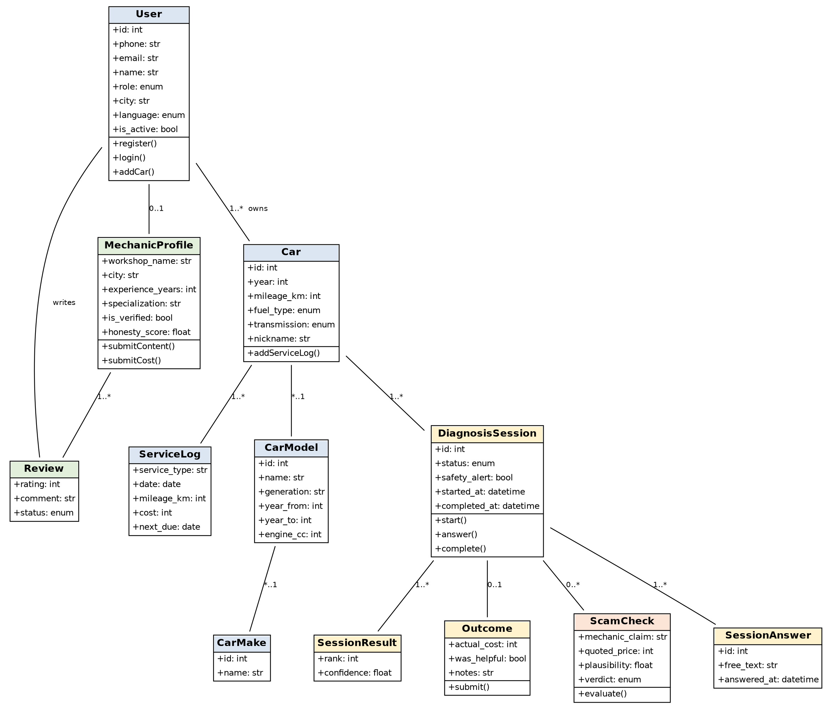

10.2 Figure 2: Knowledge Base and Diagnosis Engine
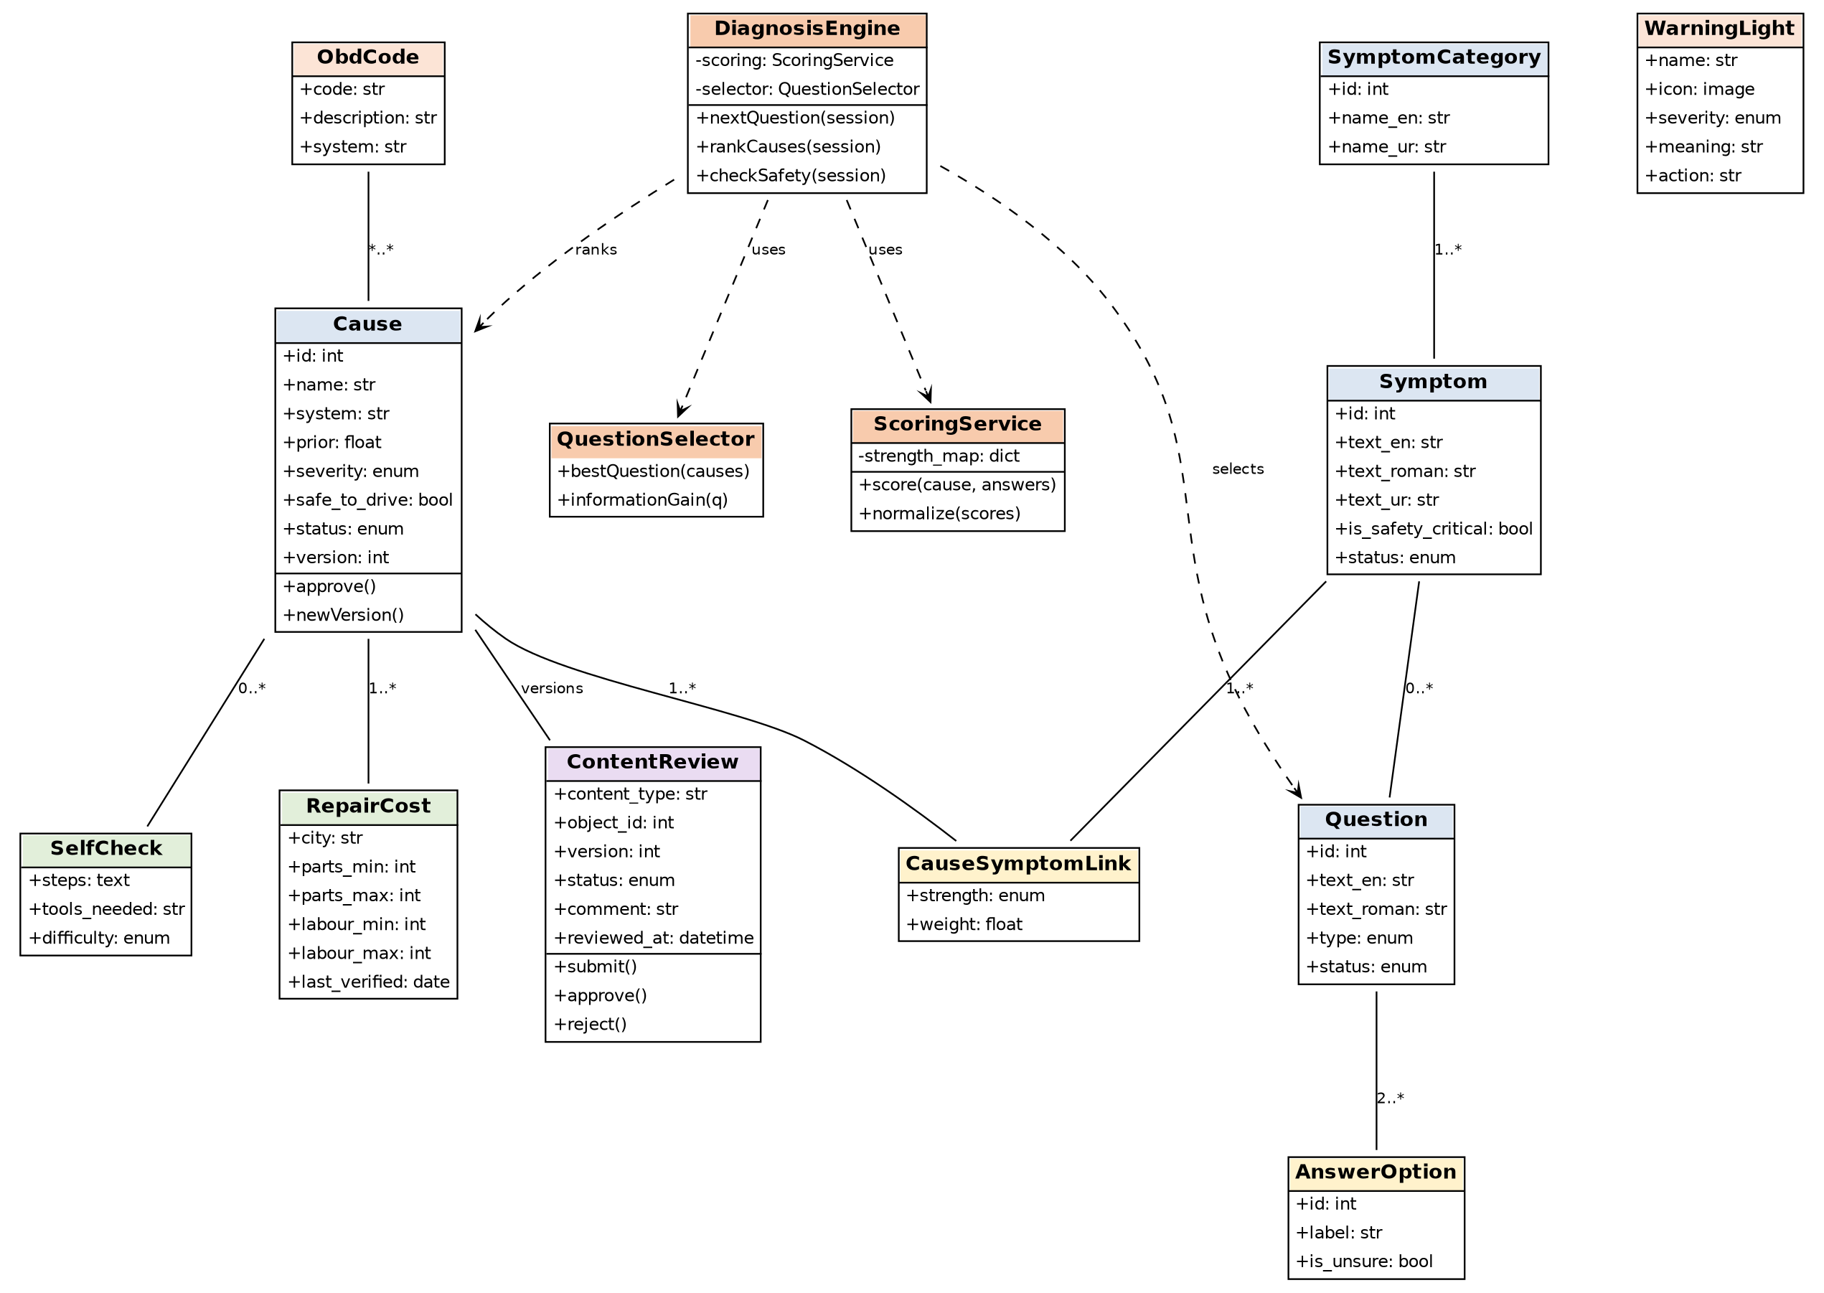

10.3 Class Responsibilities
Class | Responsibility
User / MechanicProfile | Identity, role and mechanic verification data.
Car / CarModel / CarMake | The user's vehicles and the catalogue of models.
DiagnosisSession | Holds the state of one diagnosis: answers, results, safety alert, status.
Outcome | Captures what really happened; the main source of learning data.
ScamCheck | Evaluates a mechanic's claim and quote against symptoms and cost ranges.
Symptom / Question / AnswerOption | The vocabulary and questions that gather evidence.
Cause / CauseSymptomLink | Candidate faults and the weighted links between symptoms and causes.
SelfCheck / RepairCost | Practical guidance and fair price ranges for each cause.
ContentReview | Approval workflow and version snapshots for all knowledge content.
DiagnosisEngine | Coordinates scoring, question selection and safety checks for a session.
ScoringService | Computes and normalises cause scores from answers.
QuestionSelector | Chooses the next question with the highest expected information gain.

11. Risks and Mitigations
Risk | Mitigation
Wrong diagnosis harms users or trust | "Likely causes" wording, safety interrupts, disclaimers, expert review of every rule before launch.
LLM hallucination | LLM only parses language and explains; diagnosis comes from approved rules.
Not enough Pakistani data | Start narrow (5 cars, 10 problems) and build the outcome-feedback loop from day one.
Stale prices | Quarterly refresh, ranges not single figures, last-verified dates, user-reported prices.
Mechanics disengage or oppose the app | Position as an informed-customer tool; offer verified badge, profile and referrals; keep forms short.
Legal and terms-of-service issues with scraping | Prefer manual and licensed data; check terms before any automated collection.
Founder lacks car expertise | AI drafts, mechanics validate through the panel, and the launch gate blocks unreviewed content.

12. Success Metrics (First 3 Months After Beta)
- 1,000 completed diagnoses.
- 30% of users leave outcome feedback.
- 10% of results shared on social media.
- Top-3 cause accuracy of 70% or higher on feedback-confirmed cases.
- At least 3 verified mechanics actively contributing.

13. Promotion Strategy
- Short videos: "Mechanic quoted Rs. 60,000, the app found a Rs. 800 fix."
- Partnerships with Pakistani car YouTubers and TikTokers.
- Shareable Scam Shield and result cards with the app watermark.
- Presence in Facebook car groups and university engineering communities.

