nyc_housing

Anubhav Maini

February 21, 2018

Harshil Dwivedi, Monica Katoch, Anubhav Maini & Eric Moyal Marketing Analytics Professor Ranjan February 21, 2018, Git Link- <https://github.com/anumaini/housing_data>

New York Mortgage Decisions

The data problem is what variables are necessary to predict mortgage decisions based on the variables provided in “ny_hmda_2015.csv” such as race, gender, and income. The managerial objective is to obtain an accurate model to predict the outcome of mortgage decisions. Further, we can assess which variables are more pertinent to make this assessment.

1. Here’s how we assessed the dataset:

housing_data <- read.csv(file.choose(), header=T)  
library(dplyr)

##   
## Attaching package: 'dplyr'

## The following objects are masked from 'package:stats':  
##   
## filter, lag

## The following objects are masked from 'package:base':  
##   
## intersect, setdiff, setequal, union

library(ggplot2)  
library(tidyr)

Using sapply to assess the class of data and creating a data frame for future reference.

#Understanding classes for all variables   
  
Variable_names <- data.frame(sapply(housing_data, class))  
Variable_names <- rename(Variable_names, data_class= sapply.housing_data..class.)  
Variable_names$num <- 1:78  
print(Variable_names)

## data_class num  
## action_taken integer 1  
## action_taken_name factor 2  
## agency_code integer 3  
## agency_abbr factor 4  
## agency_name factor 5  
## applicant_ethnicity integer 6  
## applicant_ethnicity_name factor 7  
## applicant_income_000s integer 8  
## applicant_race_1 integer 9  
## applicant_race_2 integer 10  
## applicant_race_3 integer 11  
## applicant_race_4 integer 12  
## applicant_race_5 integer 13  
## applicant_race_name_1 factor 14  
## applicant_race_name_2 factor 15  
## applicant_race_name_3 factor 16  
## applicant_race_name_4 factor 17  
## applicant_race_name_5 factor 18  
## applicant_sex integer 19  
## applicant_sex_name factor 20  
## application_date_indicator integer 21  
## as_of_year integer 22  
## census_tract_number numeric 23  
## co_applicant_ethnicity integer 24  
## co_applicant_ethnicity_name factor 25  
## co_applicant_race_1 integer 26  
## co_applicant_race_2 integer 27  
## co_applicant_race_3 integer 28  
## co_applicant_race_4 integer 29  
## co_applicant_race_5 integer 30  
## co_applicant_race_name_1 factor 31  
## co_applicant_race_name_2 factor 32  
## co_applicant_race_name_3 factor 33  
## co_applicant_race_name_4 factor 34  
## co_applicant_race_name_5 factor 35  
## co_applicant_sex integer 36  
## co_applicant_sex_name factor 37  
## county_code integer 38  
## county_name factor 39  
## denial_reason_1 integer 40  
## denial_reason_2 integer 41  
## denial_reason_3 integer 42  
## denial_reason_name_1 factor 43  
## denial_reason_name_2 factor 44  
## denial_reason_name_3 factor 45  
## edit_status integer 46  
## edit_status_name factor 47  
## hoepa_status integer 48  
## hoepa_status_name factor 49  
## lien_status integer 50  
## lien_status_name factor 51  
## loan_purpose integer 52  
## loan_purpose_name factor 53  
## loan_type integer 54  
## loan_type_name factor 55  
## msamd integer 56  
## msamd_name factor 57  
## owner_occupancy integer 58  
## owner_occupancy_name factor 59  
## preapproval integer 60  
## preapproval_name factor 61  
## property_type integer 62  
## property_type_name factor 63  
## purchaser_type integer 64  
## purchaser_type_name factor 65  
## respondent_id factor 66  
## sequence_number integer 67  
## state_code integer 68  
## state_abbr factor 69  
## state_name factor 70  
## hud_median_family_income integer 71  
## loan_amount_000s integer 72  
## number_of_1_to_4_family_units integer 73  
## number_of_owner_occupied_units integer 74  
## minority_population numeric 75  
## population integer 76  
## rate_spread numeric 77  
## tract_to_msamd_income numeric 78

|  |  |  |  |
| --- | --- | --- | --- |
| Nominal | Ordinal | Interval | Ratio |
| agency_code |  |  | applicant_income_000s |
| applicant_ethnicity |  |  | census_tract_number |
| applicant_race_1 |  |  | hud_median_family_income |
| applicant_sex_name |  |  | loan_amount_000s |
| co_applicant _ethnicity |  |  | number_of_1_to_4_family_units |
| county_name |  |  | number_of_owner_occupied_units |
| denial_reason_1 |  |  | minority_population |
| heopa_status |  |  | population |
| lien_status |  |  | tract_to_msamd_income |
| loan_purpose_name |  |  |  |
| loan_type_name |  |  |  |
| owner_occupancy |  |  |  |
| preapproval |  |  |  |
| property_type |  |  |  |
| purchase_type |  |  |  |
| respondent_id |  |  |  |
| state_code |  |  |  |
| msamd |  |  |  |

Understanding levels for factor type variables in the data set:

Variable_factor <- Variable_names%>% filter(data_class == "factor")   
factor <- Variable_factor$num

The table Variable_names explains what each variable type is. And those variables with factors/levels are explained in table Variable_factors.

1. Now, we move on to understand the statistics of Data:

ratio <- c(8, 23, 71, 72, 73, 74,75,76,78) #these are Ratio Variables  
#inspecting and learning about ratio variables   
variable_stat <- data.frame(summary(housing_data[, ratio], na.rm=TRUE))  
  
#Inspecting IQR's  
  
IQR(housing_data$applicant_income_000s, na.rm=TRUE)

## [1] 84

IQR(housing_data$applicant_income_000s, na.rm=TRUE)

## [1] 84

IQR(housing_data$census_tract_number, na.rm=TRUE)

## [1] 1223.02

IQR(housing_data$hud_median_family_income, na.rm=TRUE)

## [1] 13700

IQR(housing_data$loan_amount_000s, na.rm=TRUE)

## [1] 264

IQR(housing_data$number_of_1_to_4_family_units, na.rm=TRUE)

## [1] 1044

IQR(housing_data$number_of_owner_occupied_units, na.rm=TRUE)

## [1] 892

IQR(housing_data$minority_population, na.rm=TRUE)

## [1] 31.44

IQR(housing_data$population, na.rm=TRUE)

## [1] 2453

IQR(housing_data$tract_to_msamd_income, na.rm=TRUE)

## [1] 43.65001

#Inspecting SD's  
sd(housing_data$applicant_income_000s, na.rm=TRUE)

## [1] 268.4713

sd(housing_data$census_tract_number, na.rm=TRUE)

## [1] 2427.44

sd(housing_data$hud_median_family_income, na.rm=TRUE)

## [1] 16235.41

sd(housing_data$loan_amount_000s, na.rm=TRUE)

## [1] 1173.204

sd(housing_data$number_of_1_to_4_family_units, na.rm=TRUE)

## [1] 790.5034

sd(housing_data$number_of_owner_occupied_units, na.rm=TRUE)

## [1] 609.3794

sd(housing_data$minority_population, na.rm=TRUE)

## [1] 29.03251

sd(housing_data$population, na.rm=TRUE)

## [1] 1881.876

sd(housing_data$tract_to_msamd_income, na.rm=TRUE)

## [1] 53.10745

|  |  |  |  |  |
| --- | --- | --- | --- | --- |
| Variable | Mean | Standard Deviation | IQR | Median |
| applicant_income_000s | 140,200 | 268,471 | 84,000 | 90,000 |
| census_tract_number | 1387 | 2,427.44 | 1223.02 | 305 |
| hud_median_family_income | 78,224 | 16,235.41 | 13,700 | 71,300 |
| loan_amount_000s | 333,300 | **1,173.20** | 264,000 | 208,000 |
| number_of_1_to_4_family_units | 1,512 | 790.50 | 1,044 | 1,520 |
| number_of_owner_occupied_units | 1,214 | 609.38 | 892 | 1,196 |
| minority_population | 29.20 | 29.03 | 31.44 | 17.23 |
| population | 4,749 | 1881.88 | 2453 | 4,554 |
| tract_to_msamd_income | 117.92 | 53.12 | 43.65 | 106.75 |

1. We handled missing data in two ways:

For data that was missing, we added na.rm=TRUE to the IQR() and sd() methods. This omits the data from the calculation so the method can accurately calculate the interquartile range and standard deviations.

Also, we can convert blanks to NA in the entire data set at the beginning of the beggining of the assessment.

Variables <- variable.names(housing_data) # converting all variable names to   
housing_data <- data.frame(ifelse(housing_data %in% c(""," ","NA"), NA, housing_data))#Treating blanks and reconverting list to Data Frame   
# renaming the strings  
colnames(housing_data) <- Variables

1. Assesing the variables using data vasualization techniques-

#gender filter  
housing_data_filtered <- filter(housing_data,applicant_sex_name =="Male" | applicant_sex_name == "Female") %>%   
 droplevels()  
  
#ethnicity filter  
housing_data_filtered <- filter(housing_data_filtered,  
 applicant_ethnicity_name == "Not Hispanic or Latino" |   
 applicant_ethnicity_name == "Hispanic or Latino") %>%   
 droplevels()  
  
  
#histogram of gender  
housing_data_gender <- housing_data_filtered %>%   
 group_by(applicant_sex_name) %>%  
 summarise(gender_count = n())   
  
ggplot(housing_data_gender, aes(applicant_sex_name, gender_count)) +  
 geom_bar(stat = 'identity') +ggtitle("Histogram of Gender")+xlab("Gender")+ylab("Frequency")

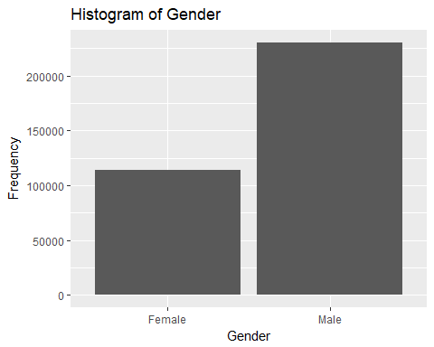

#histogram of ethnicity  
housing_data_ethnicity <- housing_data_filtered %>%   
 group_by(applicant_ethnicity_name) %>%  
 summarise(ethnicity_count = n())   
  
ggplot(housing_data_ethnicity, aes(applicant_ethnicity_name, ethnicity_count))+  
 geom_bar(stat = 'identity') + ggtitle("Histogram of Ethnicity")+xlab("Ethnicity")+ylab("Frequency")

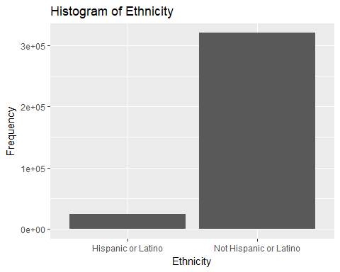

#histogram by loan type  
housing_data_loan <- housing_data_filtered %>%   
 group_by(loan_type_name) %>%  
 summarise(loan_count = n())   
  
ggplot(housing_data_loan, aes(loan_type_name, loan_count)) +  
 geom_bar(stat = 'identity') + ggtitle("Histogram of Loan Type")+xlab("Loan Type")+ylab("Frequency")

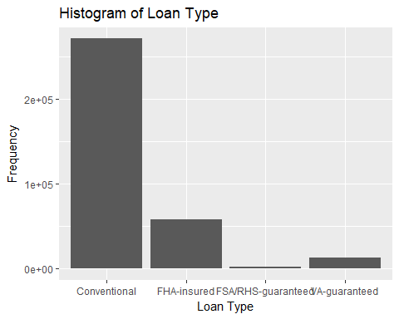 Key Insights:

1. There are almost twice as many male applicants than female applicants
2. Significantly lower Hispanic or Latino Applicants in the pool( these only factor those who disclosed)
3. Conventional Loan applications are the highest followed by FHA insured, VA-guaranteed, and FSA/RHS guaranteed
4. Bivariate frequency distributions (tables or plots) for key variables

#frequency table for loan type and ethnicity  
head(factor(housing_data_filtered$applicant_ethnicity_name))

## [1] Not Hispanic or Latino Not Hispanic or Latino Not Hispanic or Latino  
## [4] Not Hispanic or Latino Not Hispanic or Latino Not Hispanic or Latino  
## Levels: Hispanic or Latino Not Hispanic or Latino

FreqTable <- table(housing_data_filtered$applicant_ethnicity_name,housing_data_filtered$loan_type_name)  
plot(FreqTable, las = 2)

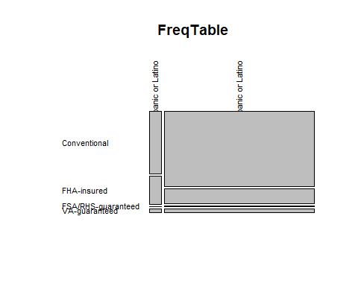

## We understand the distribution of data basis ethnicity and loan type. Conventional non Hispanic or Latino applicants are the largest in this data set. Other three loan types follow suit as per the bi-variate Frequecy table.   
  
# to observe the relation between loan amount and applicant's income  
plot(housing_data_filtered$loan_amount_000s ~ housing_data_filtered$applicant_income_000s, main="Scatterplot of loan amount and applicant's income",xlab="Income(in thousands)",ylab="Loan Amount(in thousands)")

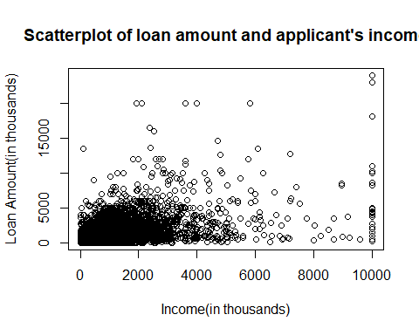

#As you can observe that there is a higher concentration of lower loan amounts as a factor of lower income. Although there are instances where the loan amounts for the same income are higher/audacious(in the real world), these outliers make a small portion of the data.   
  
# bivariate plot for relationship between applicant's income (mean) and loan amount (mean) by loan type  
housing_data_agg <- aggregate(housing_data_filtered, list(housing_data_filtered$loan_type_name), mean, na.rm=TRUE)

ggplot(housing_data_agg, aes(applicant_income_000s, loan_amount_000s)) + geom_point() +  
 geom_text(aes(label=housing_data_agg$Group.1))

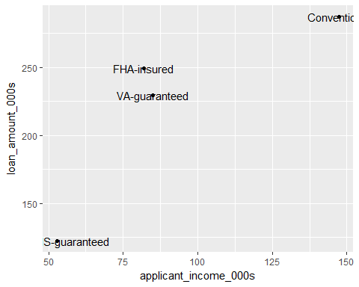

#on working with averages for loan amount and income and factoring the loan type, we notice that conventional loan averages as a factor of mean income and loan are diagnoally dispered in the graph when compared to HS guarenteed. This means that the HS guarenteed applicants have lesser incomes and also apply for lower loan amounts, which in the real word makes sense. We can draw conclusions accordingly for the other two as they lie in between these plots.   
  
# bivariate plot for relationship between applicant's income (mean)   
# and loan amount (mean) by ethnicity  
housing_data_agg <- aggregate(housing_data_filtered, list(housing_data_filtered$applicant_ethnicity_name), mean, na.rm=TRUE)

ggplot(housing_data_agg, aes(applicant_income_000s, loan_amount_000s)) + geom_point() +  
 geom_text(aes(label=housing_data_agg$Group.1))

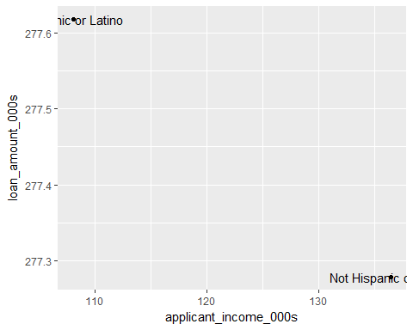

#on doing a similar analysis as above between income and loans on the basis of ethnicity, we learn that those applicants who identify as Hispanic or Latino have lower incomes and apply for high loan amounts. The contrary is observed for those who did not identify with this ethnicity.

1. We now understand how the data is spread out on the basis of income, gender, loan amount and ethnicity. Making assumptions about the probability of the getting the loan approved will require more advanced techniques such as creating models- both linear and r.part based, creating predictions, using bootstrapping techniques to improve these predictions. What we do know is the important variables especially those in the code called ratio(ratio variables).

We also know that we can group various collumns. Below are the assessment and the framework for the next step of predictions. This is just an example of how we will asses this data for creating predictive models and create them in the next submission. (only visible in R Markdown file)