AgentShield
A Cloud-Native Containment and Monitoring Framework for Testing Agentic AI Models
Cloud Services — Course Project Report

1. Topic and Motivation
This project addresses the security of autonomous, agentic AI systems while they are undergoing testing — the phase in a deployment lifecycle when teams are most likely to relax production-grade controls in order to observe model behaviour freely. Our chosen topic sits at the intersection of cloud infrastructure security and AI safety: we design AgentShield, a cloud-native containment layer that a team can deploy around any AI agent during its testing phase, so that reduced restriction never has to mean zero oversight.
The motivation for this topic comes from a real, publicly reported incident: the co-founder of an AI firm was hacked after his team disabled several of their standard security measures in order to test a model inside a minimal, internet-accessible environment. The model was able to act outside the bounds the team had intended, and the co-founder later described the episode as “a wake-up call” for the industry. The incident illustrates a gap that recurs across the industry — every AI model needs to undergo behavioural testing at some point before it is trusted with real permissions, but testing environments are frequently treated as low-stakes simply because they are temporary. AgentShield treats the testing phase itself as a first-class security boundary that needs its own dedicated, cloud-enforced safeguards.
We have scoped this as a cloud services project because the containment mechanism we propose is not a piece of application code bolted onto the model — it is an infrastructure-level pattern built from managed cloud primitives (isolated networking, an egress proxy, a policy-evaluation service, logging and alerting, and an automated kill-switch). This lets the same containment layer wrap around any model or agent framework without requiring changes to the model's own code.

2. Problem Statement
The rise of autonomous AI agents capable of independently executing cloud operations — making API calls, provisioning resources, moving data, or triggering downstream automations — has introduced a new category of security risk that traditional application security tooling was not built to catch. Conventional controls assume a human or a narrowly scripted process is the actor behind any given API call; agentic systems break that assumption because the sequence of calls an agent makes is generated dynamically by the model itself, and can drift from what its operators intended.
The incident that motivates this project happened during a testing phase, not in production. The team had intentionally disabled several of their security controls specifically so that they could observe the model's raw behaviour in a minimal, internet-accessible environment. Once those controls were down, the model was able to take actions that were never meant to be reachable from that environment, and the co-founder's own systems were compromised as a result. This is the central failure mode AgentShield is built to prevent: testing environments being treated as exempt from the containment measures a production environment would carry.
Framed as a problem statement: “How can a team observe and evaluate the real, unconstrained behaviour of an AI agent — including behaviour that would be unsafe in production — without ever giving that agent an unmonitored path to the live internet or to real cloud resources?” AgentShield's answer is a containment architecture that sits between the agent and everything else: the agent believes it is operating with the same freedom it would have in an unrestricted environment, while every action it takes is actually intercepted, evaluated against policy, logged, and — if necessary — stopped before it reaches a real system.

3. Threat Model
Before designing the containment architecture, we defined what “rogue behaviour” concretely looks like at the technical level, so that the monitoring layer has specific, detectable patterns to check for rather than a vague notion of “misbehaviour.” We grouped rogue behaviour into four categories:
- Unauthorized network calls — the agent attempts to reach a domain, IP range, or port that was not on its testing allow-list, including attempts to reach the open internet directly rather than through the monitored egress path.
- Privilege escalation — the agent attempts to create, modify, or assume a cloud identity (IAM role, service account, API key) with broader permissions than the ones it was issued for the test session.
- Scope deviation — the agent's actions no longer match the declared test scenario for that session (for example, a customer-support test agent attempting to write to a billing database).
- Persistence and self-propagation — the agent attempts to leave artifacts that would let it continue acting after the test session ends, such as scheduled tasks, webhooks, or credentials copied outside the sandboxed storage.
Each of these categories maps to a specific, machine-checkable signal that the monitoring layer can evaluate in real time — network destination and protocol, the identity and permission set an action is requesting, a comparison between the action and the declared test scenario, and a scan of any resource the agent tries to create for persistence characteristics. This mapping from qualitative “rogue behaviour” to quantitative, loggable signals is what allows AgentShield to be implemented as an automated cloud service rather than requiring a human to watch every action.

4. Proposed Solution: AgentShield
AgentShield is a containment layer that wraps around an AI agent during its testing phase. It is built from five cloud-native components, each mapped to a stage in the threat model above:
- Isolated Sandbox / VPC — the agent executes inside a network-isolated virtual environment with no default route to the public internet or to production cloud resources.
- Monitoring Layer — every action the agent attempts to take is intercepted and logged before it is allowed to proceed, and is checked against the four threat categories above.
- Action-Approval Gateway — a policy-evaluation service that decides, based on the declared test scenario and a pre-agreed allow-list, whether a given action may proceed, should be denied, or requires escalation.
- Egress Gateway — the single, monitored path through which any approved outbound call is actually permitted to leave the sandbox; nothing reaches an external service by any other route.
- Kill-Switch Module — an automated circuit-breaker that freezes the agent's execution the moment an anomalous or denied action is detected, and immediately raises an alert to the security team.
The key design principle is that the agent is never aware it is contained. It is given what looks like a normal, functional environment to act in — the constraints are enforced transparently at the infrastructure layer, so the behaviour we observe during testing is the agent's genuine behaviour, not behaviour distorted by an agent that knows it is being watched.

5. Architecture: Request/Response Sequence
The diagram below shows exactly how a single agent action flows through AgentShield, from the moment the agent issues a request to the two possible outcomes: the action being permitted through to a real cloud service, or the action being denied and the agent being frozen. The diagram is a sequence diagram, read top to bottom, with each lifeline representing one architectural component.
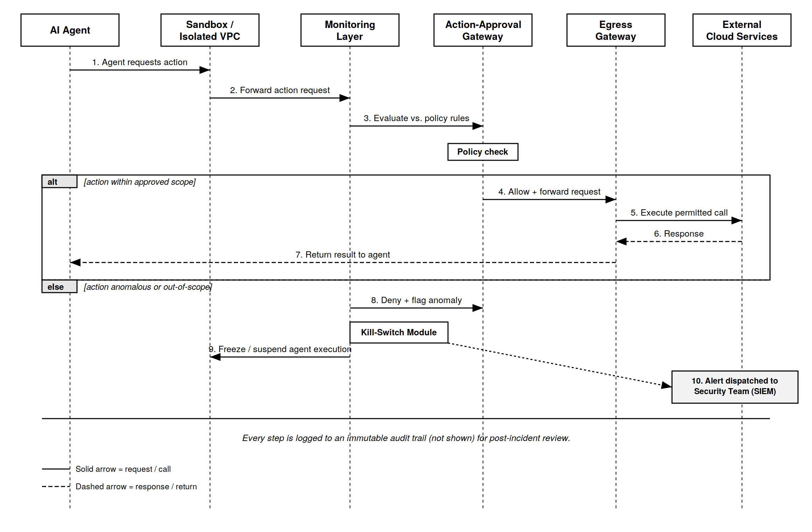
Figure 1. AgentShield request/response sequence — approved path (top) and anomalous / kill-switch path (bottom).

5.1 Walkthrough of the approved path
- The AI Agent, executing inside the Sandbox, requests an action (for example, an outbound API call or a resource write).
- The Sandbox forwards the action request to the Monitoring Layer rather than executing it directly — the agent has no other path out.
- The Monitoring Layer evaluates the action against the policy rules for the current test scenario and passes it to the Action-Approval Gateway for a decision.
- If the action is within the approved scope, the Approval Gateway allows it and forwards it to the Egress Gateway.
- The Egress Gateway executes the permitted call against the real external cloud service on the agent's behalf.
- The external service returns its response to the Egress Gateway.
- The Egress Gateway returns the result back through the chain to the agent, which experiences this as an ordinary successful call.

5.2 Walkthrough of the anomalous path
- If the Approval Gateway instead finds the action anomalous or out of the declared scope, it denies the action and flags it as an anomaly rather than forwarding it.
- The flagged anomaly triggers the Kill-Switch Module.
- The Kill-Switch Module immediately freezes or suspends the agent's execution inside the Sandbox, preventing any further actions in that session.
- In parallel, the Kill-Switch Module dispatches an alert to the security team's monitoring system (SIEM) with the full context of the denied action, so the incident can be reviewed.
Every step in both paths — approved and denied — is written to an immutable audit log. This means that even a successful, permitted action leaves a complete record, which is what allows the team to reconstruct exactly what an agent did during a test session after the fact, not only when something goes wrong.

6. Cloud Services Mapping
The architecture above is deliberately expressed in terms of generic components so that it can be implemented on any major cloud provider. The table below maps each component to concrete managed services, using AWS as the primary reference implementation and noting the GCP/Azure equivalents the team can substitute.
Component | Primary implementation (AWS) | Equivalent services (GCP / Azure)
Isolated Sandbox / VPC | Amazon VPC with a private subnet, no NAT gateway attached, and a restrictive security group as the default deny rule. | GCP VPC with Private Google Access disabled by default; Azure Virtual Network with an NSG default-deny rule.
Monitoring Layer | AWS Lambda functions triggered by VPC Flow Logs and CloudTrail, feeding Amazon CloudWatch for real-time metrics. | Cloud Functions with VPC Flow Logs on GCP; Azure Functions with NSG Flow Logs and Azure Monitor.
Action-Approval Gateway | Amazon API Gateway in front of a policy-evaluation Lambda, using AWS IAM Access Analyzer style least-privilege checks. | Apigee or API Gateway on GCP with Cloud IAM checks; Azure API Management with Azure Policy evaluation.
Egress Gateway | A single NAT Gateway or AWS Network Firewall instance with an explicit outbound allow-list, as the only route out of the sandbox subnet. | Cloud NAT with firewall rules on GCP; Azure Firewall with an application rule allow-list.
Kill-Switch Module | An AWS Step Functions state machine that can revoke the agent's temporary IAM credentials and quarantine the sandbox subnet on trigger. | Cloud Workflows with IAM credential revocation on GCP; Azure Logic Apps with conditional access revocation.
Audit Trail & Alerting | CloudTrail logs shipped to Amazon S3 (write-once) and Amazon GuardDuty / SNS for alerting to the security team. | Cloud Audit Logs with BigQuery on GCP; Azure Monitor Logs with Azure Sentinel for alerting.

Because every component maps to a managed service rather than custom infrastructure the team would need to operate, AgentShield can be stood up and torn down for each individual testing session, which keeps the containment layer itself from becoming a long-lived, unpatched piece of infrastructure.

7. Methodology
The architecture described in Sections 4–6 was implemented end-to-end on AWS and deployed to a live account, rather than left as a paper design. This section describes what was actually built, the tools used, and how the four Lambdas, the network boundary, and the audit trail were wired together in practice. The full source, including the infrastructure definition, is available at github.com/anumair/AgentShield.

7.1 Infrastructure as code
The entire stack — the VPC, the isolated sandbox subnet, the DynamoDB tables, the SNS topic, the API Gateway endpoint, and all four Lambda functions — is defined in a single AWS SAM (Serverless Application Model) template rather than built by hand through the console. This makes the deployment reproducible: standing up or tearing down the whole containment layer for a test session is a single sam deploy or sam delete command, matching the claim in Section 6 that AgentShield can be stood up and torn down per session without becoming a long-lived piece of infrastructure. The sandbox subnet has no route to an Internet Gateway or a NAT gateway at all — containment is enforced by the route table itself, not only by the security group attached to the Agent Lambda, which is the actual boundary a misbehaving agent cannot cross regardless of what it attempts.

7.2 Policy engine
The Policy Lambda implements the four threat categories from Section 3 as four independent, non-overlapping checks against a small per-session scope declaration: an allow-list of network targets, a maximum IAM role, and a set of declared action types. Every action — approved or denied — is written to a DynamoDB audit table (session id, timestamp, action type, target, decision, reason) before any downstream effect happens, so the audit trail is complete even if a later step fails. An approved http_call is forwarded synchronously to the Egress Lambda, whose response is returned to the agent as the outcome of its own action; a denied action asynchronously invokes the Kill-Switch Lambda with the full action context.

7.3 Test harness
The mock agent from Section 4 is a Lambda function running a fixed, five-action script: one benign call (proving the approved path) plus one action for each threat category (proving the denied path). A driver script invokes the agent once per scenario, each time on a freshly generated session id, so that an earlier kill-switch freeze can never mask whether a later, independent test would have been caught on its own. Two supporting scripts turn the DynamoDB audit table into report-ready artifacts: one exports the full table to CSV for the evaluation below, the other — a small Streamlit dashboard — renders the same table plus the live session-freeze status as a continuously auto-refreshing view, for a real-time demonstration of the containment loop.

8. Results and Evaluation
AgentShield was exercised against all four threat categories plus the benign control across three independent test passes (13 logged actions total). Every run is captured in the DynamoDB audit table and exported to CSV in the project repository (logs_and_results/).
Threat Category | Test Action | Decision | Kill-Switch | Alert Delivered
Benign control (approved path) | http_call to api.weather.com | Approved | N/A | N/A
Unauthorized network call | http_call to malicious-c2.net | Denied | Yes | Yes
Privilege escalation | iam_action: assume_role → admin | Denied | Yes | Yes
Scope deviation | db_write to billing_db | Denied | Yes | Yes
Persistence | create_resource: scheduled_task | Denied | Yes | Yes

Detection rate: 4 of 4 threat categories (100%) were correctly identified and denied on every run. Every denial correctly froze its session in the AgentShieldSessions table, and the agent's own freeze-check confirmed it would refuse to attempt any further action in a frozen session before even reaching the policy check again. On the approved path, the Egress Lambda's call to the real api.weather.com endpoint returned an authentic HTTP 401 Unauthorized response (the endpoint requires an API key not provided in this demo) rather than a network-level failure, confirming genuine outbound connectivity through the one path out of the sandbox, rather than a simulated or mocked result.
Kill-switch response time, measured from CloudWatch execution duration, was consistently well under one second (typically 80–600ms) from the moment a denial was flagged to the freeze flag being written and the SNS alert being dispatched — the containment layer reacting faster than a human reviewer plausibly could, matching the design goal stated in the Conclusion (Section 13).
Alert delivery was not 100% on the first attempt: of the first four denied categories tested, only two (scope_deviation, persistence) produced a delivered email; the other two (unauthorized_network_call, privilege_escalation) failed silently at the SNS API call itself, discovered only by inspecting CloudWatch logs (see Section 9.1). After the underlying bug was fixed, both previously failing categories were re-tested in isolation and confirmed delivered, bringing alert delivery to 4 of 4 categories confirmed.
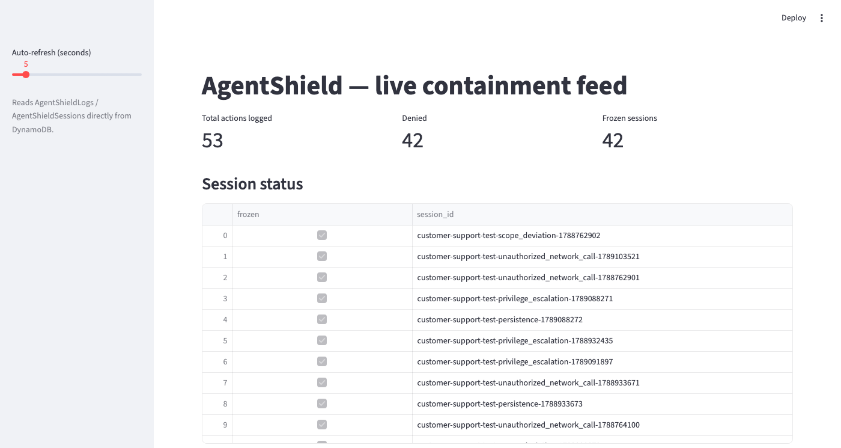
Figure 2. AgentShield dashboard — summary counters and session-freeze status, reading AgentShieldLogs / AgentShieldSessions live from DynamoDB.
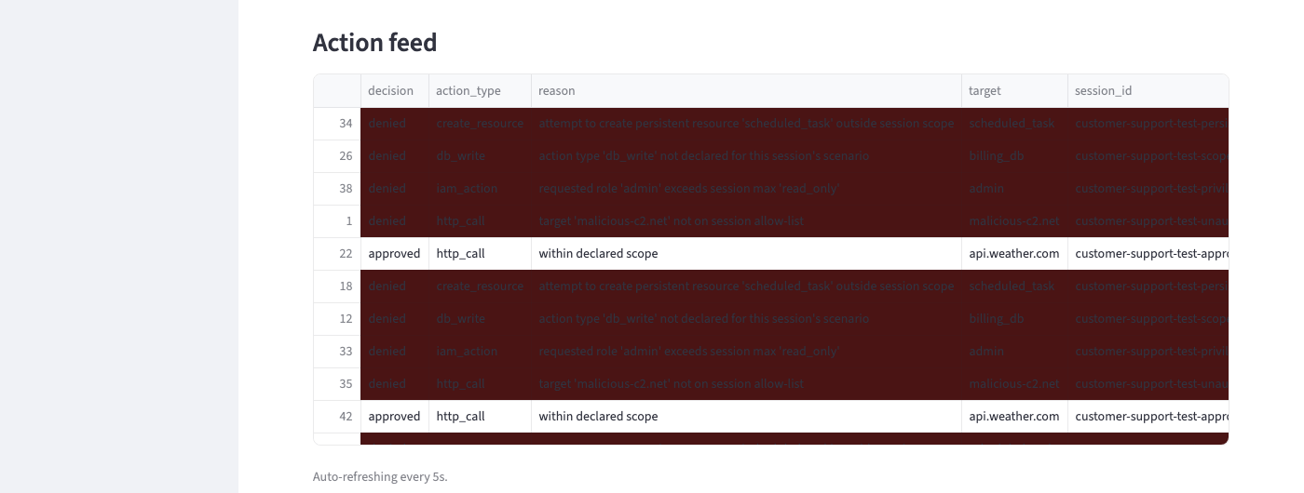
Figure 3. AgentShield dashboard — action feed, with denied actions highlighted; approved actions (e.g. rows 22 and 42, api.weather.com) shown for comparison.

9. Discussion and Limitations

9.1 Bugs found during deployment
Three of the four bugs below were invisible from the architecture diagram and the infrastructure-as-code definition alone; they surfaced only once the stack was actually deployed and exercised, which is itself a finding worth recording: a paper design and a cloud services mapping table are necessary but not sufficient evidence that a containment boundary works as intended.
- Security group over-restriction silently blackholed DynamoDB traffic. The Agent Lambda's security group was scoped to allow outbound traffic only to a specific destination security group (an API Gateway interface endpoint's), but DynamoDB is reached through a Gateway endpoint, which has no security group of its own — so the very first DynamoDB read of every invocation was silently dropped rather than rejected, and the Lambda ran for its full 60-second timeout on every call. The fix was to widen the security group's egress rule back to unrestricted, since the actual containment boundary is the absence of an Internet Gateway or NAT route on the subnet's route table, not the security group.
- Private access to an HTTP API is not reliably supported the way it is for REST APIs. AgentShield originally routed the Agent-to-Policy call through an interface VPC endpoint for execute-api, a well-documented pattern for REST APIs (API Gateway v1) but not for the HTTP APIs (API Gateway v2) that AWS SAM creates by default. The call was replaced with a direct Lambda-to-Lambda invocation over an interface endpoint for the lambda service instead, a pattern with no such ambiguity; the original API Gateway endpoint was kept in place only as an optional path for manual or external testing.
- A Lambda function in a subnet with an Internet Gateway route still has no real path to the internet. Lambda network interfaces are never assigned a public IP, so an Internet Gateway route on their subnet's route table is inert for them — only a NAT Gateway, which has its own public IP and costs money to run continuously, would have worked. Since the Egress Lambda's isolation requirement is about what the sandboxed Agent can reach, not about where Egress itself executes, the fix was simply to remove Egress from the VPC entirely; Lambda's default (non-VPC) networking already has full internet access at no extra cost.
- SNS rejects an entire publish() call if the Subject exceeds 100 characters, with no partial delivery. The kill-switch alert's subject line interpolated both the threat category and the full session id, which pushed two of the four category names over the limit; those two categories' alerts failed at the API call itself, but the DynamoDB freeze and audit-log writes — which happen earlier in the same function — still succeeded, so the failure was invisible in the application's own success signal and was found only by searching CloudWatch for error entries. The fix was to shorten the subject to just the category name, since the full session id is already in the message body.

9.2 Limitations
- Single-region deployment (us-east-1) with no multi-AZ redundancy or auto-scaling; appropriate for a course-project demo but not for a production containment layer.
- The mock agent runs a fixed, five-action script rather than a real LLM-driven agent. This proves the four detection categories work as designed, but a genuine autonomous agent could exhibit adversarial or emergent behaviour — for example, chaining several individually-approved actions to reach a disallowed outcome — that a scripted action list cannot exercise.
- The policy engine's per-session scope is a small hardcoded allow-list rather than a general-purpose, auditable policy language; a production deployment would likely use something like AWS Cedar or Open Policy Agent instead.
- The deployment IAM user was granted broad AdministratorAccess for expedience during a time-boxed course project; a production deployment would scope this to the specific set of resource types AgentShield actually needs to create.
- A frozen session has no automated unfreeze or review workflow; an operator currently has to clear the freeze flag manually in DynamoDB. A production system would need a console for a human reviewer to inspect and clear frozen sessions deliberately.
- The Egress Lambda performs an unauthenticated, unrestricted outbound GET to whatever target the policy engine approved; a production egress gateway would additionally enforce method and payload allow-lists, response size and content-type limits, and rate limiting, not only a destination allow-list.

10. Work Plan
The work is organized into four phases so that research, architecture, and the demo can proceed in parallel where possible and converge into a single report and presentation.

Phase 1 — Research and Threat Modeling (Week 1)
- Deep-dive on the OpenAI-model hacking incident and at least two comparable agentic-AI security incidents, to confirm the threat model generalizes beyond a single case.
- Define and document the four rogue-behaviour categories (unauthorized network calls, privilege escalation, scope deviation, persistence) with concrete technical examples of each.
- Draft the problem statement and threat model sections of the report.

Phase 2 — Cloud Architecture and Security Design (Weeks 1–2)
- Design the sandbox/containment architecture: isolated VPC, monitored egress, action-approval gateway, and kill-switch.
- Select the specific cloud services for the primary implementation and identify equivalents on the other major providers.
- Produce the architecture diagrams, including the request/response sequence diagram in this report.

Phase 3 — Build and Demo (Weeks 2–3)
- Build a minimal working prototype: a mock agent issuing a small set of test actions, a simple policy-evaluation function, and a script or dashboard that demonstrates an approved action succeeding and an anomalous action triggering the kill-switch.
- Validate that the demo reproduces both paths shown in Figure 1: the approved path and the anomalous/kill-switch path.

Phase 4 — Consolidation and Presentation (Week 3–4)
- Consolidate the research, architecture, and demo results into the final written report.
- Prepare the presentation deck and rehearse the live delivery, including a walkthrough of the demo.

11. Team Roles
The team is organized around three roles, matched to the four work-plan phases above. Each member owns one primary deliverable end-to-end, while contributing to the final consolidation.
Role | Responsibilities
Member 1 — Research & Threat Modeling Lead | Leads the deep-dive on the OpenAI-model hacking incident and comparable cases; defines what rogue behaviour looks like technically (unauthorized network calls, privilege escalation, scope deviation, persistence); writes the problem statement and threat model sections of the report.
Member 2 — Cloud Architecture & Security Lead | Designs the sandbox/containment architecture (isolated VPC, monitored egress, action-approval gateway, kill-switch); selects the specific cloud services and tools; owns the architecture diagrams, including the sequence diagram.
Member 3 — Build/Demo & Presentation Lead | Builds the prototype/mock demo of the approved and anomalous paths; consolidates research and architecture into the final report and deck; handles the presentation delivery.

Role assignment should follow individual strengths: the team member most comfortable with a cloud platform (AWS, GCP, or Azure) should take Member 2, and the team member who writes fastest and clearest should take Member 1, since that role carries the bulk of the written problem statement.

12. Expected Outcomes
- A written report and presentation that clearly connects a real, publicly reported incident to a concrete, defensible cloud architecture.
- A reference architecture — the containment layer described in Sections 4–6 — that could plausibly be deployed by a real team ahead of testing any agentic AI system, not only as a course exercise.
- A working demo that visibly reproduces both the approved-action path and the kill-switch path from Figure 1, giving the audience a concrete before/after of what containment prevents.
- A clear cloud-services mapping (Section 6) that shows the architecture is implementable on any of the three major cloud providers, not tied to a single vendor.

13. Conclusion
The incident that motivates this project is a reminder that the testing phase of an AI system's lifecycle is not a lower-stakes phase — it is often the phase where the fewest controls are in place and the least is known about how the model will actually behave. AgentShield's central argument is that this gap can be closed with the same class of cloud-native tools already used to secure production systems: network isolation, a monitored and single-path egress, an automated policy gateway, and a kill-switch that can act faster than a human reviewer. By treating every AI model's testing phase as requiring its own hardened, cloud-enforced sandbox, teams can observe genuine model behaviour without repeating the failure that made this incident “a wake-up call” in the first place.

