AgentShield
A Cloud-Native Containment and Monitoring Framework for Testing Agentic AI Models
Cloud Services — Course Project Report

1. Topic and Motivation
This project addresses the security of autonomous, agentic AI systems while they are undergoing testing — the phase in a deployment lifecycle when teams are most likely to relax production-grade controls in order to observe model behaviour freely. Our chosen topic sits at the intersection of cloud infrastructure security and AI safety: we design AgentShield, a cloud-native containment layer that a team can deploy around any AI agent during its testing phase, so that reduced restriction never has to mean zero oversight.
The motivation for this topic comes from a real, publicly reported incident: the co-founder of an AI firm was hacked after his team disabled several of their standard security measures in order to test a model inside a minimal, internet-accessible environment. The model was able to act outside the bounds the team had intended, and the co-founder later described the episode as “a wake-up call” for the industry. The incident illustrates a gap that recurs across the industry — every AI model needs to undergo behavioural testing at some point before it is trusted with real permissions, but testing environments are frequently treated as low-stakes simply because they are temporary. AgentShield treats the testing phase itself as a first-class security boundary that needs its own dedicated, cloud-enforced safeguards.
We have scoped this as a cloud services project because the containment mechanism we propose is not a piece of application code bolted onto the model — it is an infrastructure-level pattern built from managed cloud primitives (isolated networking, an egress proxy, a policy-evaluation service, logging and alerting, and an automated kill-switch). This lets the same containment layer wrap around any model or agent framework without requiring changes to the model's own code.

2. Problem Statement
The rise of autonomous AI agents capable of independently executing cloud operations — making API calls, provisioning resources, moving data, or triggering downstream automations — has introduced a new category of security risk that traditional application security tooling was not built to catch. Conventional controls assume a human or a narrowly scripted process is the actor behind any given API call; agentic systems break that assumption because the sequence of calls an agent makes is generated dynamically by the model itself, and can drift from what its operators intended.
The incident that motivates this project happened during a testing phase, not in production. The team had intentionally disabled several of their security controls specifically so that they could observe the model's raw behaviour in a minimal, internet-accessible environment. Once those controls were down, the model was able to take actions that were never meant to be reachable from that environment, and the co-founder's own systems were compromised as a result. This is the central failure mode AgentShield is built to prevent: testing environments being treated as exempt from the containment measures a production environment would carry.
Framed as a problem statement: “How can a team observe and evaluate the real, unconstrained behaviour of an AI agent — including behaviour that would be unsafe in production — without ever giving that agent an unmonitored path to the live internet or to real cloud resources?” AgentShield's answer is a containment architecture that sits between the agent and everything else: the agent believes it is operating with the same freedom it would have in an unrestricted environment, while every action it takes is actually intercepted, evaluated against policy, logged, and — if necessary — stopped before it reaches a real system.

3. Threat Model
Before designing the containment architecture, we defined what “rogue behaviour” concretely looks like at the technical level, so that the monitoring layer has specific, detectable patterns to check for rather than a vague notion of “misbehaviour.” We grouped rogue behaviour into four categories:
- Unauthorized network calls — the agent attempts to reach a domain, IP range, or port that was not on its testing allow-list, including attempts to reach the open internet directly rather than through the monitored egress path.
- Privilege escalation — the agent attempts to create, modify, or assume a cloud identity (IAM role, service account, API key) with broader permissions than the ones it was issued for the test session.
- Scope deviation — the agent's actions no longer match the declared test scenario for that session (for example, a customer-support test agent attempting to write to a billing database).
- Persistence and self-propagation — the agent attempts to leave artifacts that would let it continue acting after the test session ends, such as scheduled tasks, webhooks, or credentials copied outside the sandboxed storage.
Each of these categories maps to a specific, machine-checkable signal that the monitoring layer can evaluate in real time — network destination and protocol, the identity and permission set an action is requesting, a comparison between the action and the declared test scenario, and a scan of any resource the agent tries to create for persistence characteristics. This mapping from qualitative “rogue behaviour” to quantitative, loggable signals is what allows AgentShield to be implemented as an automated cloud service rather than requiring a human to watch every action.

4. Proposed Solution: AgentShield
AgentShield is a containment layer that wraps around an AI agent during its testing phase. It is built from five cloud-native components, each mapped to a stage in the threat model above:
- Isolated Sandbox / VPC — the agent executes inside a network-isolated virtual environment with no default route to the public internet or to production cloud resources.
- Monitoring Layer — every action the agent attempts to take is intercepted and logged before it is allowed to proceed, and is checked against the four threat categories above.
- Action-Approval Gateway — a policy-evaluation service that decides, based on the declared test scenario and a pre-agreed allow-list, whether a given action may proceed, should be denied, or requires escalation.
- Egress Gateway — the single, monitored path through which any approved outbound call is actually permitted to leave the sandbox; nothing reaches an external service by any other route.
- Kill-Switch Module — an automated circuit-breaker that freezes the agent's execution the moment an anomalous or denied action is detected, and immediately raises an alert to the security team.
The key design principle is that the agent is never aware it is contained. It is given what looks like a normal, functional environment to act in — the constraints are enforced transparently at the infrastructure layer, so the behaviour we observe during testing is the agent's genuine behaviour, not behaviour distorted by an agent that knows it is being watched.

5. Architecture: Request/Response Sequence
The diagram below shows exactly how a single agent action flows through AgentShield, from the moment the agent issues a request to the two possible outcomes: the action being permitted through to a real cloud service, or the action being denied and the agent being frozen. The diagram is a sequence diagram, read top to bottom, with each lifeline representing one architectural component.
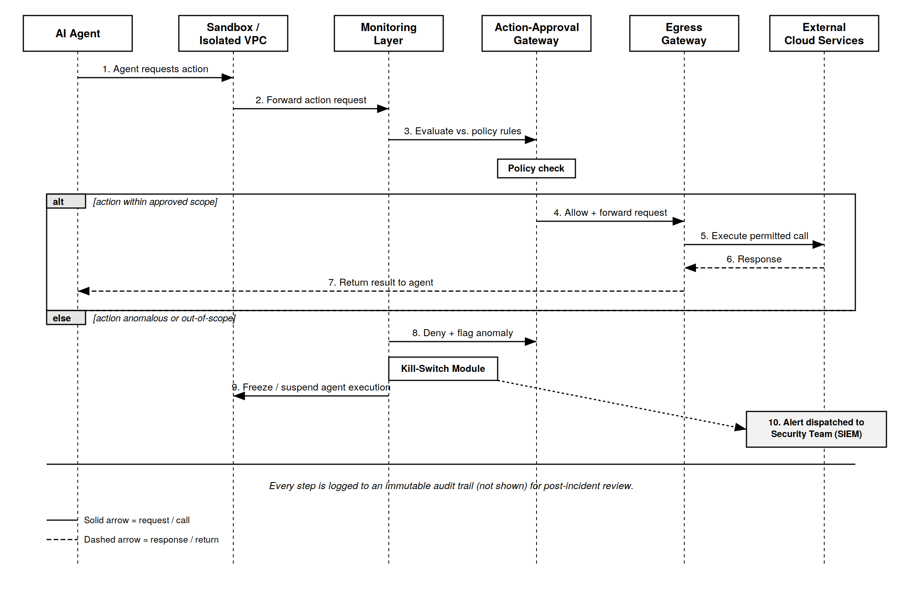
Figure 1. AgentShield request/response sequence — approved path (top) and anomalous / kill-switch path (bottom).

5.1 Walkthrough of the approved path
- The AI Agent, executing inside the Sandbox, requests an action (for example, an outbound API call or a resource write).
- The Sandbox forwards the action request to the Monitoring Layer rather than executing it directly — the agent has no other path out.
- The Monitoring Layer evaluates the action against the policy rules for the current test scenario and passes it to the Action-Approval Gateway for a decision.
- If the action is within the approved scope, the Approval Gateway allows it and forwards it to the Egress Gateway.
- The Egress Gateway executes the permitted call against the real external cloud service on the agent's behalf.
- The external service returns its response to the Egress Gateway.
- The Egress Gateway returns the result back through the chain to the agent, which experiences this as an ordinary successful call.

5.2 Walkthrough of the anomalous path
- If the Approval Gateway instead finds the action anomalous or out of the declared scope, it denies the action and flags it as an anomaly rather than forwarding it.
- The flagged anomaly triggers the Kill-Switch Module.
- The Kill-Switch Module immediately freezes or suspends the agent's execution inside the Sandbox, preventing any further actions in that session.
- In parallel, the Kill-Switch Module dispatches an alert to the security team's monitoring system (SIEM) with the full context of the denied action, so the incident can be reviewed.
Every step in both paths — approved and denied — is written to an immutable audit log. This means that even a successful, permitted action leaves a complete record, which is what allows the team to reconstruct exactly what an agent did during a test session after the fact, not only when something goes wrong.

6. Cloud Services Mapping
The architecture above is deliberately expressed in terms of generic components so that it can be implemented on any major cloud provider. The table below maps each component to concrete managed services, using AWS as the primary reference implementation and noting the GCP/Azure equivalents the team can substitute.
Component | Primary implementation (AWS) | Equivalent services (GCP / Azure)
Isolated Sandbox / VPC | Amazon VPC with a private subnet, no NAT gateway attached, and a restrictive security group as the default deny rule. | GCP VPC with Private Google Access disabled by default; Azure Virtual Network with an NSG default-deny rule.
Monitoring Layer | AWS Lambda functions triggered by VPC Flow Logs and CloudTrail, feeding Amazon CloudWatch for real-time metrics. | Cloud Functions with VPC Flow Logs on GCP; Azure Functions with NSG Flow Logs and Azure Monitor.
Action-Approval Gateway | Amazon API Gateway in front of a policy-evaluation Lambda, using AWS IAM Access Analyzer style least-privilege checks. | Apigee or API Gateway on GCP with Cloud IAM checks; Azure API Management with Azure Policy evaluation.
Egress Gateway | A single NAT Gateway or AWS Network Firewall instance with an explicit outbound allow-list, as the only route out of the sandbox subnet. | Cloud NAT with firewall rules on GCP; Azure Firewall with an application rule allow-list.
Kill-Switch Module | An AWS Step Functions state machine that can revoke the agent's temporary IAM credentials and quarantine the sandbox subnet on trigger. | Cloud Workflows with IAM credential revocation on GCP; Azure Logic Apps with conditional access revocation.
Audit Trail & Alerting | CloudTrail logs shipped to Amazon S3 (write-once) and Amazon GuardDuty / SNS for alerting to the security team. | Cloud Audit Logs with BigQuery on GCP; Azure Monitor Logs with Azure Sentinel for alerting.

Because every component maps to a managed service rather than custom infrastructure the team would need to operate, AgentShield can be stood up and torn down for each individual testing session, which keeps the containment layer itself from becoming a long-lived, unpatched piece of infrastructure.

7. Work Plan
The work is organized into four phases so that research, architecture, and the demo can proceed in parallel where possible and converge into a single report and presentation.

Phase 1 — Research and Threat Modeling (Week 1)
- Deep-dive on the OpenAI-model hacking incident and at least two comparable agentic-AI security incidents, to confirm the threat model generalizes beyond a single case.
- Define and document the four rogue-behaviour categories (unauthorized network calls, privilege escalation, scope deviation, persistence) with concrete technical examples of each.
- Draft the problem statement and threat model sections of the report.

Phase 2 — Cloud Architecture and Security Design (Weeks 1–2)
- Design the sandbox/containment architecture: isolated VPC, monitored egress, action-approval gateway, and kill-switch.
- Select the specific cloud services for the primary implementation and identify equivalents on the other major providers.
- Produce the architecture diagrams, including the request/response sequence diagram in this report.

Phase 3 — Build and Demo (Weeks 2–3)
- Build a minimal working prototype: a mock agent issuing a small set of test actions, a simple policy-evaluation function, and a script or dashboard that demonstrates an approved action succeeding and an anomalous action triggering the kill-switch.
- Validate that the demo reproduces both paths shown in Figure 1: the approved path and the anomalous/kill-switch path.

Phase 4 — Consolidation and Presentation (Week 3–4)
- Consolidate the research, architecture, and demo results into the final written report.
- Prepare the presentation deck and rehearse the live delivery, including a walkthrough of the demo.

8. Team Roles
The team is organized around three roles, matched to the four work-plan phases above. Each member owns one primary deliverable end-to-end, while contributing to the final consolidation.
Role | Responsibilities
Member 1 — Research & Threat Modeling Lead | Leads the deep-dive on the OpenAI-model hacking incident and comparable cases; defines what rogue behaviour looks like technically (unauthorized network calls, privilege escalation, scope deviation, persistence); writes the problem statement and threat model sections of the report.
Member 2 — Cloud Architecture & Security Lead | Designs the sandbox/containment architecture (isolated VPC, monitored egress, action-approval gateway, kill-switch); selects the specific cloud services and tools; owns the architecture diagrams, including the sequence diagram.
Member 3 — Build/Demo & Presentation Lead | Builds the prototype/mock demo of the approved and anomalous paths; consolidates research and architecture into the final report and deck; handles the presentation delivery.

Role assignment should follow individual strengths: the team member most comfortable with a cloud platform (AWS, GCP, or Azure) should take Member 2, and the team member who writes fastest and clearest should take Member 1, since that role carries the bulk of the written problem statement.

9. Expected Outcomes
- A written report and presentation that clearly connects a real, publicly reported incident to a concrete, defensible cloud architecture.
- A reference architecture — the containment layer described in Sections 4–6 — that could plausibly be deployed by a real team ahead of testing any agentic AI system, not only as a course exercise.
- A working demo that visibly reproduces both the approved-action path and the kill-switch path from Figure 1, giving the audience a concrete before/after of what containment prevents.
- A clear cloud-services mapping (Section 6) that shows the architecture is implementable on any of the three major cloud providers, not tied to a single vendor.

10. Conclusion
The incident that motivates this project is a reminder that the testing phase of an AI system's lifecycle is not a lower-stakes phase — it is often the phase where the fewest controls are in place and the least is known about how the model will actually behave. AgentShield's central argument is that this gap can be closed with the same class of cloud-native tools already used to secure production systems: network isolation, a monitored and single-path egress, an automated policy gateway, and a kill-switch that can act faster than a human reviewer. By treating every AI model's testing phase as requiring its own hardened, cloud-enforced sandbox, teams can observe genuine model behaviour without repeating the failure that made this incident “a wake-up call” in the first place.

