QKSM: Architecture and Novelty
Quantum Kernel Methods for Survival Analysis · Oct 13, 2026 · @umair

Architecture
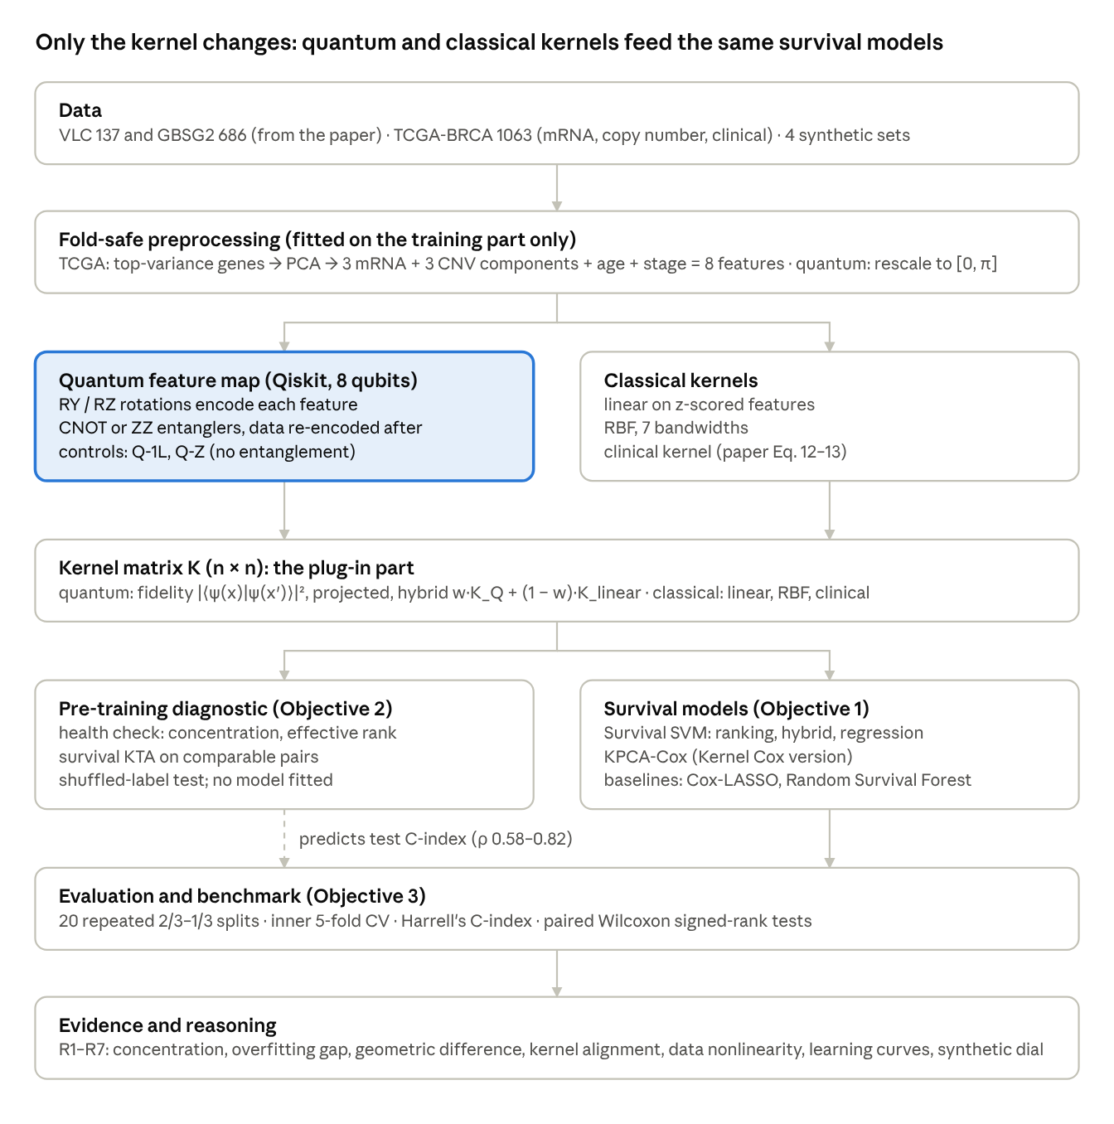
QKSM architecture · data to reasoning, 9 stages
The only new component is the quantum feature map: its kernel matrix substitutes the classical kernel in the same survival models, splits and metric, and KTA scores that kernel before any model is fitted.

Stages of the pipeline
- Data: VLC (137 patients) and GBSG2 (686) from Van Belle et al. (2011); TCGA-BRCA multi-omics (1063 patients, 148 deaths; mRNA, copy number, clinical); 4 synthetic datasets with a known risk shape.
- Fold-safe preprocessing: all transformations are estimated on the training portion of each split. TCGA genes are reduced to 3 mRNA + 3 CNV principal components + age + stage = 8 features. For quantum kernels, the features are rescaled to angles in [0, π].
- Quantum feature map: each patient is represented as an 8-qubit state by RY/RZ rotations and CNOT or ZZ entanglers. The gates cannot cancel because the data is re-encoded after each entangling layer. The statevectors are simulated exactly with Qiskit.
- Kernel matrix: the fidelity kernel |⟨ψ(x)|ψ(x′)⟩|² (or the projected kernel) is computed alongside the classical linear, RBF and clinical kernels.
- Pre-training diagnostic: a kernel health check and the survival KTA, scored only on comparable pairs and tested against shuffled labels. No model is fitted.
- Survival models: Survival SVM in ranking, hybrid and regression forms, and KPCA-Cox, all with the kernel as a plug-in. Baselines: Cox-LASSO and Random Survival Forest.
- Evaluation: 20 repeated 2/3–1/3 splits, inner 5-fold CV on C-index, Harrell's C-index on the test part, paired Wilcoxon tests.
- Evidence and reasoning: measurements R1–R7 (concentration, overfitting gap, geometric difference, kernel alignment, data nonlinearity, learning curves, synthetic dial) explain why each kernel won or lost.

Novelty
Our first contribution is, to the best of our knowledge, the first framework to integrate quantum kernels into established kernel survival models. In medicine, quantum machine learning has been almost exclusively binary classification (Maheshwari et al. 2022). The two survival-related quantum studies use variational circuits, either for propensity scores (Novák et al. 2025) or as a residual booster on Cox-LASSO (Colak et al. 2026). Our Quantum Kernel Survival Model keeps the Survival SVM of Van Belle et al. (2011) in its ranking, hybrid and regression forms, with a Kernel Cox variant, and swaps only the kernel for a quantum fidelity kernel. The comparison with classical kernels is fair because the model, splits, tuning budget and metric are the same. Each circuit has an unentangled control and ablation (Q-1L, Q-Z) to isolate the effect of entanglement, and a unit test shows that trailing entangling gates cancel and cannot fake a quantum kernel.
The second contribution is a pre-training diagnostic validated against observed test outcomes. It extends the KTA-Survival approach of Colak et al. (2026): the target kernel is based on the comparable-pairs rule of the C-index, it is evaluated on true fidelity kernels rather than an RBF on measured outputs, and it is validated against shuffled labels and event-only patients. Across 44–51 kernel configurations it predicts the test C-index before any model is trained (Spearman ρ = 0.82 VLC, 0.73 GBSG2, 0.58 TCGA-BRCA), and we report where it fails as a tuner. The third contribution is the explained negative result. Classical kernels win on VLC, GBSG2 and TCGA-BRCA, and seven measurements explain why: the clinical data has little nonlinear signal, the best quantum kernels are 99–100% aligned with RBF, larger angles concentrate the kernel and overfit, and entanglement never improves the C-index. The only win is on periodic synthetic data, and there the kernel is unentangled and therefore classical. This shows when a quantum kernel could help, not only whether it did here.

