**QA & INSPECTION CIRCLE, BANGALORE**

**ACCEPTANCE TEST SCHEDULE**

**4G Phase IX.2 – eNode-B:** **[SITEID]**

Document No

No of Pages 26

Issue No.

Issued By:

Approved By:

Date of Issue:

**Amendment No (If Any)**

Date of Issue:

**Restricted use by BSNL Employees only**

**“FIX IT RIGHT AT THE FIRST INSTANCE”**

**ACCEPATNCE TEST SCHEDULE FOR eNode-B**

1. Details of eNode-B: Cross check with planning document from Local Craft Terminal

/EMS/DTT kit/Engg. Handset/Physical verification.

Type of site: (BSNL/NBSNL/IP): ------BSNL----------

|  |  |  |  |  |
| --- | --- | --- | --- | --- |
| Lat/Long | [LATID]  [LONGID] | Equipment type: (Macro/Micro/Pico) | Macro | Config: (TDD/FDD)  FDD |
| Project name | [PROJECTID] | Site name | [SITENAMEID] | Site ID: [SITEID] |
| BA | [BA] | SDCA / OA | [BA] | Cell Ids: [ECGI]0  [ECGI]1  [ECGI]2 |
| Circle name | RAJASTHAN | Vendor name | TCS | MIMO Config: 2T2R |
| On Air Date | [ONAIRID] | A/T Date | 21-APR-2025 |  |
| Site type :(ID/OD) | OD | Site Category: (RTT/RTP/GBT) | GBT | Transmission type: (MW/Fiber/VSAT)  OFC |
| Antenna type /Port (Single Band / Dual Band) (4 / 6 / 8 / 10 Port) | HUBER+SUHNER  Dual Band /10 Port | CPRI length | [CPRIID]M |  |
| eNode –B: CAT (A/B/C/D/E/ any other) | CAT-B | Bandwidth (5MHz/ 10MHz /20MHz etc.) | L700-[BW]MHz |  |
| Sector (Antenna details for the Installed 4G site) | Mechanical Tilt in degree | E-Tilt | Height | Azimuth |
| Sec 1 | [MTILTID] | [ETILTID] | [HIGHID] | [ORTID1] |
| Sec 2 | [MTILTID] | [ETILTID] | [HIGHID] | [ORTID2] |
| Sec 3 | [MTILTID] | [ETILTID] | [HIGHID] | [ORTID3] |

|  |  |  |  |  |  |
| --- | --- | --- | --- | --- | --- |
| Site ID(IP)  [IPID] | Site Name:  [SITENAMEID] |  | MME: [MMEID] |  | SGW:  [SGWID] |
| SACFA ID (New site) | [APPLICATIONID] | |  | | |  |
| Equipment  configuration | No. of racks (ODC): Mention (Indoor/Outdoor) and Rack/ODC: Outdoor (1)  No. of sectors: 3  No. of carrier/ sector: 1  No. of Antenna per sector: 1  MME Location: Chandigarh  SGW C Location : Chandigarh  SGW U Location : JAIPUR | | | | |
| Sector No. | Cell ID/PCI | eARFCN | | TAC | |
| [SITEID]0 | [ECGI]0/ [PCIID1] | [DLID] | | [TACNO] | |
| [SITEID]1 | [ECGI]1/[PCIID2] | [DLID] | | [TACNO] | |
| [SITEID]2 | [ECGI]2/[PCIID3] | [DLID] | | [TACNO] | |

NOT Related to TCS

1. Infrastructure provided by: BSNL VENDOR Capacity/Rating (Please tick appropriate box)

|  |  |
| --- | --- |
| i. | Power plant |
| ii. | Battery |
| iii. | Engine Alternator |
| iv. | Air-conditioning |
| v. | Fire detection system. |
| vi. | Tower |
| vii. | Earthing |
| viii | Media |
| ix | Shelter (for Indoor eNode-B) |
| x | Microwave |
| xi | Outdoor UPS with Li-ion battery backup of 2Hr/4Hr |

|  |  |
| --- | --- |
| Yes |  |
| Yes |  |
| YES |  |
| NA |  |
| Yes |  |
| GBT |  |
| Yes |  |
| **OFC** |  |
| OD |  |
| NA |  |
| NA |  |

|  |
| --- |
|  |
|  |
|  |
|  |
|  |
|  |
|  |
|  |
|  |
|  |
|  |

|  |  |
| --- | --- |
| 350A |  |
| 800AH |  |
| 15KWH |  |
|  |  |
|  |  |
|  |  |
| 0.45 |  |
| **OFC** |  |
| OD |  |
| NA |  |
| NA |  |

Test results as per QA & Inspection Circle latest test schedule (In case infra provided by vender).

For BSNL deliverables, BSNL has to submit a sufficiency certificate for existing infra and in case of new infra, it has to be tested as per approved test schedule.

**PART – A: INFRASTRUCTURE TEST**

|  |  |  |  |
| --- | --- | --- | --- |
| **S.No** | **TEST DESCRIPTION** | **REFERENCE**  **/ PROCEDURE** | **REMARK** |
| 1 | Check of documentation. | Hard/Soft copy as per PO. | Available with CMP CO  ATTACHED |
| 2 | Check QA certificate. | QA certificate to be submitted. BBU, RRH and ODC serial no. as per release report. | Available with CMP CO  ATTACHED |
| 3 | Location, Alignment & Rigidity (LAR). | As per approved plan. | Ok |
| 4 | Check for protection from lightning /accidental high voltage/ induced high power for power plant and outdoor eNode-B. | Lightning protector earth continuity should be checked. | Ok |
| 5 | Check the electrical tilt of the antenna. | Yes/No (Put value from NMS). | YES (2/2/2) |
| 6 | Check for site Earthing and connectivity with BBU and RRH etc. | Use Megger for measuring the earth’s resistance value. The value of earth to be measured and the same shall be indicated irrespective of whether the earth was provided by the supplier or not. Earth resistance value should be  .5 Ohm. | The earth resistance threshold value upto   1 Ohm may be accepted, as per letter no. BSNLCO-NGSM  /16(14) /5/2023-NWP-  GSM-II-Part (2) dated 06/10/2023.  0.45 |

**PART-B: SYSTEM TEST**

* 1. **System Related Test: (As per planning document)**

|  |  |  |  |
| --- | --- | --- | --- |
| **S.No** | **TEST DESCRIPTION** | **REFERENCE**  **/ PROCEDURE** | **REMARK** |
| 1.1 | Hardware conformity check. | Verify the HW details as deployed on the site. As per vetted BoM. | AS PER BOM  (ATTACHED) |
| 1.2 | eNode-B software version. | SW version to be filled from EMS and should be as per document approved by the planning wing. | I24 |
| 1.3 | Check EMS integration. | OK/NOK | Ok |
| 1.4 | Check integration with SON. | OK/NOK | Ok |
| 1.5 | Transport - related information. Connection type, quantity and its capacity: |  |  |
| a . Microwave | Provide the MW Make and Model details. | NA |
| b. Integrated Transport Module   1. Port type-1G/10G/E1 2. No. of Ports-1G/10G/E1 | 1G | OK |
| 1.6 | MME and SGW IP address. | MME-[MMEID] | SGW- [SGWID] |
| 1.7 | eNode-B details (TX). | Electrical / Optical | Optical |
| 1.7.1 | IP details (Table to be plugged in w.r.t. IP,VLAN including GW). | CEF- [CEFID]  RACB5- [RACB5ID]  S1CB5- [S1CB5ID]  S1UB5- [S1UB5ID] |  |

* 1. **eNode-B status check from Access Point:**

A/T procedure:

* + 1. Check the visual alarm (LED) indication on all cards. All LEDs should show a healthy condition.
    2. Connect a Laptop with Control Card through RJ45/Console port. (CEF will be accessible through RJ 45 and RAC through Console Port (Diag cable).
    3. Login through eNode-B Maintenance Tool (Like LMT)/CLI.
    4. Check the working status of all cards by LMT/CLI. All cards should be healthy.

|  |  |  |
| --- | --- | --- |
| **Expected Results:** | Status | OK |

* 1. **Installation, cabling and marking:** All cabling should be done by straight wire without having any joint in between. Marking should be at both ends to identify the cable as per documentation and correlate both ends.

|  |  |  |
| --- | --- | --- |
| CHECK | STATUS (OK/NOK) | REMARK |
| Check the installation and cabling, crimping of cable and iron work of the eNode-B. | OK |  |
| Check of proper laying of CPRI & its termination / RF connectors & sealing of CPRI cable. | OK |  |
| Labelling of CPRI. | OK |  |
| CPRI Details. | Make: Rosenberger | Size:[CPRIID]m*3 |
| Data Rate/CPRI. | 10.1736Gbps. |  |

* 1. **Power Measurement:**

|  |  |  |
| --- | --- | --- |
| CHECK | STATUS (OK/NOK) | REMARK |
| Polarity and labelling of power cables. | OK | GOOD |
| Measure the voltage at battery point. | OK | 52 V |
| Measure input voltage to ODC. | OK | 51.6 V |
| Calculate voltage drop (Between Battery terminal & eNode-B). | OK | 0.4 V |

1. **Functional & Service Related Test:**
   1. eNode-B restart test.

Test procedure (Hardware reset and Power reset):

1. Check for eNode-B recovery after switching off the power supply to eNode-B.
2. Check for eNode-B recovery after hardware reset.

The eNode-B should come up and the status of the site should be same as what was before the reset.

|  |  |  |
| --- | --- | --- |
| **Expected Results:** | **Status** | **OK/NOK** |
| **I** | 5 to 15 Min | OK |
| **Ii** | 5 to 15 Min | OK |

Check for the related alarm on OMC-R /LMT Log-in.

* 1. Check for Wideband-AMR (HD-voice) enabled. Yes / No-NO
  2. Check of Clock synchronization ( as per planning document) : OK / NOK-OK
     1. Synchronization type : PTP

1. **Outdoor eNode-B:** Fan Cooling Unit operational status. (OK / NOK)-OK
2. **System alarm test:** Generation of alarms for power failure/ media failure/ fan failure alarm by manually switching off or unplugging module.: Manually switching
3. **Transmit Power Outputs:** Configured power to be checked through EMS.

**Integrated module (for RRH type):** Check TX power of eNode-B using LMT.

|  |  |  |  |
| --- | --- | --- | --- |
| **Sector –1**  TX-46 | **Sector –2**  TX-46 |  | **Sector –3**  TX-46 |

1. **VSWR Measurements:**

Check feeder grounding is done properly, if applicable. Status (OK/Not -OK)

* 1. Measure the VSWR values of each sector (<=1.3). Measurement can be done through LMT/EMS/NMS/CLI.

|  |  |  |  |
| --- | --- | --- | --- |
| **Antennas & Cables** | **VSWR** | **Antennas & Cables** | **VSWR** |
| Sector 1 Main | 1.22 1.22 | Sector 1 Div | 1.22 1.22 |
| Sector 2 Main | 1.22 1.22 | Sector 2 Div | 1.22 1.22 |
| Sector 3 Main | 1.22 1.22 | Sector 3 Div | 1.22 1.22 |

1. **4G services to be tested in all sectors.**
2. VoLTE/ CSFB/ SRVCC/eSRVCC /Fast return to LTE– O/G and I/C call.
3. ViLTE.
4. DATA, Video and Audio Streaming/Web Browsing.
5. SMS, USSD.
6. Emergency call (112).
7. LBS services. NA
8. Cell Broadcast on handset. NA
9. Check NB-IoT / M2M service. NA

|  |  |
| --- | --- |
| **Sec 1** | **OK For I To V Point** |
| **Sec 2** | **OK For I To V Point** |
| **Sec 3** | **OK For I To V Point** |

1. **Calls for Handover (4G to 4G)**
   1. CALL 1 CELL A -----> CELLB------>CELL C >CELL A

Check that call should not be disconnected during sector handover. Status (OK/ NOK) :OK

* 1. Inter site handover (Handover between eNode-Bs installed at two different nearby sites), if applicable Status (OK/ NOK) :OK

1. **External alarm tests:**

Vendor is responsible in all types of sites (NBSNL, IP and BSNL) for extending external alarm termination from eNode-B to the nearest KRONE-box. For eNode-B A/T external alarm generation may be verified from the KRONE box.:OK

In the case of sites where infra items are supplied by the vendor, the vendor should extend external alarms from elements like PP/Bty etc all the way to eNode-B.

Alarm cables are punched firmly and correctly.Status(OK/NOK)- OK

List of External alarms to be extended–

|  |  |  |
| --- | --- | --- |
| 1. AC Main Fail | By Simulation: Y | Actual Y |
| 2. DG on Load | By Simulation: Y | Actual Y |
| 3. Diesel Low (below a threshold level) | By Simulation: Y | Actual Y |
| 4. High Temperature | By Simulation: Y | Actual Y |
| 5. ENode-B Battery Low (Voltage of the battery bank below a threshold level)  By Simulation: Y Actual Y | | |
| 6. Cabin Door Open | By Simulation: Y | Actual Y |
| 7. DG Battery Low (Voltage of the battery of the DG set below a threshold level  By Simulation: Y Actual Y | | |
| 8. Fire | By Simulation: Y | Actual Y |

**PART C: COVERAGE TEST**

The vendor shall carry out the simulation of coverage and generate prediction maps of the cities with the existing and identified sites to be specified by the purchaser. The supplier shall indicate additional locations, if any, required to meet the coverage requirements of the purchaser. The prediction map so generated and agreed upon shall form the basis for acceptance testing of the coverage.

**Prior requisite to start coverage test:**

* Basic calls / messages / data may be checked. Geographical clusters and size of cluster may be finalized by the Circle RF Planning teams in consultation with the vendor.
* Link budget should be submitted for all bands as mentioned in the PO & DTR.
* Coverage A/T should cover all sectors of the sites included in the cluster and plots may be prepared cluster wise. Event based KPIs may be performed as static tests for each of the sectors and cell wise statistics may also be submitted as part of the A/T reports along with cluster wise plots and KPI statistics.
* 80% [minimum] of technology-specified throughput shall be demonstrated in field drive tests as applicable.
* The coverage A/T reports submitted by the vendor should be evaluated & approved by the BA / Circle RF teams after ensuring that suitable measures to improve the QoS are incorporated, in case issues are identified during A/T.

1. **Drive Test Results: The following drive test results plots are prepared.**
   1. RSRP Plot
   2. RSRQ Plot
   3. SINR Plot
   4. DL Throughput plot

The plot indicates the coverage parameters marked by different colours for different levels

e.g. Excellent, Good, Poor etc.

|  |  |  |  |  |
| --- | --- | --- | --- | --- |
| Results | PASS | Remarks | Pass | Fail |

Passing criteria as per approved prediction plot by BSNL RF planning teams for RSRP, RSRQ, SINR, DL & UL Throughput. Colour legends (Green, Yellow, and Red etc) for different levels of respective coverage parameters to be decided by planning in consultation with the vendor.

1. **Physical site information**

Physical site data collected from field.

|  |  |  |  |  |  |  |  |  |  |  |  |
| --- | --- | --- | --- | --- | --- | --- | --- | --- | --- | --- | --- |
| Circle | SSA | City/Town | eNodeBName | SectorID | CellID | Site Name | Lat | Long | Orientation | M-Tilt | E-Tilt |
|
| RAJASTHAN | [BA] | [BA] | [SITEID] | 0 | [ECGI]0 | [SITENAMEID] | [LATID] | [LONGID] | [ORTID1] | [MTILTID] | [ETILTID] |
| RAJASTHAN | [BA] | [BA] | [SITEID] | 1 | [ECGI]1 | [SITENAMEID] | [LATID] | [LONGID] | [ORTID2] | [MTILTID] | [ETILTID] |
| RAJASTHAN | [BA] | [BA] | [SITEID] | 2 | [ECGI]2 | [SITENAMEID] | [LATID] | [LONGID] | [ORTID3] | [MTILTID] | [ETILTID] |

1. **Technical site information**

Technical site information should be verified from EMS.

|  |  |  |  |  |  |  |  |  |  |  |
| --- | --- | --- | --- | --- | --- | --- | --- | --- | --- | --- |
| eNodeB Name | eNodeB Cell name | eNodeB ID | eNodeB Cell ID | Sector ID | TAC | PCI | RSI | RS Power | EUARFCN UL(700) | EUARFCN DL(700) |
| [SITEID] | [SITEID]0 | [ECGI] | [ECGI]0 | 0 | [TACNO] | [PCIID1] | [RSIID1] | [RSPID] | [ULID] | [DLID] |
| [SITEID] | [SITEID]1 | [ECGI] | [ECGI]1 | 1 | [TACNO] | [PCIID2] | [RSIID2] | [RSPID] | [ULID] | [DLID] |
| [SITEID] | [SITEID]2 | [ECGI] | [ECGI]2 | 2 | [TACNO] | [PCIID3] | [RSIID3] | [RSPID] | [ULID] | [DLID] |

1. **Drive test procedure**

The Drive Test will be done with NEMO/TEMS/X-CAL with Calibrated Mobiles. The phones will be in the following modes

|  |  |  |  |  |
| --- | --- | --- | --- | --- |
| Device | Type of Call | Operator | Mode | Comment |
| MS1 | Volte Call Short | BSNL | LTE | NA |
| MS2 | Volte Call Long | BSNL | LTE | NA |
| MS3 | Data Download | BSNL | LTE | OK |

1. **Drive test plots (Example)**
2. **RSRP Plot**

The plot indicates the **Reference *Signal Received Power*** with the following legend.

* + Samples with RSRP level < – 120 dbm- ({RSRP_RANGE_1_COUNT}:- {RSRP_RANGE_1_PERCENT}%)
  + Samples with RSRP level between –120 dbm to – 110 dbm - ({RSRP_RANGE_2_COUNT}:- {RSRP_RANGE_2_PERCENT}%)
  + Samples with RSRP level between –110 dbm to – 105 dbm- ({RSRP_RANGE_3_COUNT}:- {RSRP_RANGE_3_PERCENT}%)
  + Samples with RSRP level between –105 dbm to – 95 dbm- ({RSRP_RANGE_4_COUNT}:- {RSRP_RANGE_4_PERCENT}%)
  + Samples with RSRP level between –95 dbm to – 90 dbm- ({RSRP_RANGE_5_COUNT}:- {RSRP_RANGE_5_PERCENT}%)
  + Samples with RSRP level above -90 dbm- ({RSRP_RANGE_6_COUNT}:- {RSRP_RANGE_6_PERCENT}%)

1. **RSRQ Plot**

The plot indicates the Reference Signal Received Power with the following legend.

* + Samples <-20 dB--({RSRQ_RANGE_1_COUNT} :- {RSRQ_RANGE_1_PERCENT}%)
  + Samples -20 dB to -15dB—({RSRQ_RANGE_2_COUNT} :- {RSRQ_RANGE_2_PERCENT}%)
  + Samples -15dB to -12dB--({RSRQ_RANGE_3_COUNT} :- {RSRQ_RANGE_3_PERCENT}%)
  + Samples Above-12dB--({RSRQ_RANGE_4_COUNT} :- {RSRQ_RANGE_4_PERCENT}%)

1. **SINR Plot**

The plot indicates the SINR. The values indicated with the following legends.

* + Samples with <-5 dB--({SINR_RANGE_1_COUNT} :- {SINR_RANGE_1_PERCENT}%)
  + Samples with -5 dB to 0 db--({SINR_RANGE_2_COUNT} :- {SINR_RANGE_2_PERCENT}%)
  + Samples with 0 dB to 5 dB--({SINR_RANGE_3_COUNT} :- {SINR_RANGE_3_PERCENT}%)
  + Samples with 5 dB to 12 dB--({SINR_RANGE_4_COUNT} :- {SINR_RANGE_4_PERCENT}%)
  + Samples with 12 dB to 15 dB—({SINR_RANGE_5_COUNT} :- {SINR_RANGE_5_PERCENT}%)
  + Samples Above15dB--({SINR_RANGE_6_COUNT} :- {SINR_RANGE_6_PERCENT}%)

1. **DL Throughput plot**

The plot indicates probable DL throughput in the network. The following legend has been

followed in the plots.

* + Samples below512Kbps-({DL_RANGE_1_COUNT} :- {DL_RANGE_1_PERCENT}%)
  + Samples 512 to 1024 Kbps-({DL_RANGE_2_COUNT} :- {DL_RANGE_2_PERCENT}%)
  + Samples 1024 to 2048 Kbps--({DL_RANGE_3_COUNT} :- {DL_RANGE_3_PERCENT}%)
  + Samples 2048 to 4096 Kbps--({DL_RANGE_4_COUNT} :- {DL_RANGE_4_PERCENT}%)
  + Samples greater than 4096 Kbps--({DL_RANGE_5_COUNT} :- {DL_RANGE_5_PERCENT}%)

1. **Events Based KPIs**

|  |  |  |  |  |
| --- | --- | --- | --- | --- |
|  | Sector 1 | Sector 2 | Sector 3 | Comments |
| MOC/MTC Voice LTE | NA | NA | NA |  |
| Call Setup Time – VoLTE | [CSTVV1] | [CSTVV2] | [CSTVV3] |  |
| CSFB to WCDMA/GSM Success | Pass | Pass | Pass |  |
| SMS MO Success | Pass | Pass | Pass |  |
| SMS MT Success | Pass | Pass | Pass |  |
| Attach Success | Pass | Pass | Pass |  |
|  | Sector 1 | Sector 2 | Sector 3 |  |
| Intra eNB Handover - Sector1 | - | Pass | Pass |  |
| Intra eNB Handover - Sector2 | Pass | - | Pass |  |
| Intra eNB Handover - Sector3 | Pass | Pass | - |  |
| Inter eNB Handover (Inter Freq) | - | - | - |  |
| Inter eNB Handover (Intra Freq) |  |  |  |  |
| Intra eNB Handover (Inter Freq) |  |  |  |  |
| Intra eNB Handover (Intra Freq) |  |  |  |  |
| SRVCC to 2G/3G Handover | NA | NA | NA | Wherever applicable |
| IRAT Handover for Data | Pass | Pass | Pass | Wherever applicable |

|  |  |  |  |  |
| --- | --- | --- | --- | --- |
| 2G to 4G Cell Reselection | PASS | PASS | PASS | Wherever applicable |
| 3G to 4G Cell Reselection | PASS | PASS | PASS | Wherever applicable |
| 4G to 3G Cell Reselection | PASS | PASS | PASS | Wherever applicable |
| 4G to 2G Cell Reselection | PASS | PASS | PASS | Wherever applicable |
| 4G to 4G Cell Reselection | PASS | PASS | PASS |  |
|  |  |  |  |  |
| FTP Download | PASS | PASS | PASS | Stationary Test |
| DL Average & Peak Throughput (Mbps) | [DLAT1] | [DLAT2] | [DLAT3] | Stationary Test |
| FTP Upload | PASS | PASS | PASS | Stationary Test |
| UL Average & Peak Throughput (Mbps) | [ULAT1] | [ULAT2] | [ULAT3] | Stationary Test |

**The report confirms that Successful bidder/Installer has passed these new site Acceptance Test criteria.**

**Authorized Signatory**

**Event based summary :**

|  |  |  |  |  |  |  |  |  |  |  |  |
| --- | --- | --- | --- | --- | --- | --- | --- | --- | --- | --- | --- |
| **Event** | **Threshold** | **Sector 1** | | | **Sector 2** | | | **Sector 3** | | |  |
| **Att** | **Suc** | **Succ Rate (%)** | **Att** | **Suc** | **Succ Rate (%)** | **Att** | **Suc** | **Succ Rate (%)** | Comments |
| MOC/MTC Voice LTE | >= 99% | NA | NA | NA | NA | NA | 100 | NA | NA | NA |  |
| RRC | >=98% | 10 | 10 | 100 | 10 | 10 | 100 | 10 | 10 | 100 |  |
| Call drop | < 2% | 0 | 0 | 0 | 0 | 0 | 0 | 0 | 0 | 0 |  |
| Call Setup Time – VoLTE | <8 Sec | [CSTI1] | | | [CSTI2] | | | [CSTI3] | | |  |
| CSFB to WCDMA/GSM Success | >= 99% | 5 | 5 | 100 | 5 | 5 | 100 | 5 | 5 | 100 |  |
| SMS MO/MT Success LTE |  | 5 | 5 | 100 | 5 | 5 | 100 | 5 | 5 | 100 |  |
| SMS MO/MT Success Volte |  | 5 | 5 | 100 | 5 | 5 | 100 | 5 | 5 | 100 |  |
| Attach Success |  | 10 | 10 | 100 | 10 | 10 | 100 | 10 | 10 | 100 |  |
| Intra eNB Handover - Sector1 | >95% | 5 | 5 | 100 | 5 | 5 | 100 | 5 | 5 | 100 |  |
| Intra eNB Handover - Sector2 | >95% | 5 | 5 | 100 | 5 | 5 | 100 | 5 | 5 | 100 |  |
| Intra eNB Handover - Sector3 | >95% | 5 | 5 | 100 | 5 | 5 | 100 | 5 | 5 | 100 |  |
| Inter eNB Handover (Intra Freq) | >95% | PASS | PASS | 100 | PASS | PASS | 100 | PASS | PASS | 100 | Wherever applicable |
| Inter eNB Handover (Inter Freq) | >95% | NA | NA | NA | NA | NA | NA | NA | NA | NA | Wherever applicable |
| Intra eNB Handover (Inter Freq) | >95% | PASS | PASS | 100 | PASS | PASS | 100 | PASS | PASS | 100 | Wherever applicable |
| Intra eNB Handover (Inter Freq) | >95% | PASS | PASS | 100 | PASS | PASS | 100 | PASS | PASS | 100 | Wherever applicable |
| SRVCC to 2G/3G Handover | >95% | NA | NA | NA | NA | NA | NA | NA | NA | NA | Wherever applicable (2G or 3g) |
| IRAT Handover for Data 2G/3G | >95% | PASS | PASS | 100 | PASS | PASS | 100 | PASS | PASS | 100 | Wherever applicable |
| 2G to 4G Cell Reselection |  | 5 | 5 | 100 | 5 | 5 | 100 | 5 | 5 | 100 | Wherever applicable |
| 3G to 4G Cell Reselection |  | 5 | 5 | 100 | 5 | 5 | 100 | 5 | 5 | 100 | Wherever applicable |
| 4G to 3G Cell Reselection |  | 5 | 5 | 100 | 5 | 5 | 100 | 5 | 5 | 100 | Wherever applicable |
| 4G to 2G Cell Reselection |  | 5 | 5 | 100 | 5 | 5 | 100 | 5 | 5 | 100 | Wherever applicable |
| 4G to 4G Cell Reselection |  | 5 | 5 | 100 | 5 | 5 | 100 | 5 | 5 | 100 | Wherever applicable |
|  |  |  |  |  |  |  |  |  |  |  |  |

Prediction Plot RSRP

**The plot indicates the reference signal power based on Atoll planning tool result.**

**GRID 200*200**

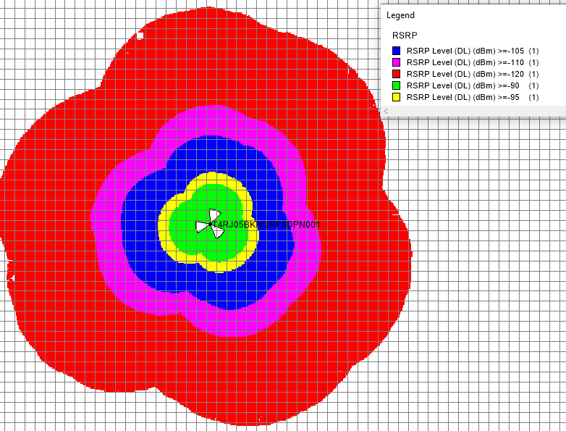

Prediction Plot RSRQ

**The plot indicates the reference signal Quality based on Atoll planning tool result.**

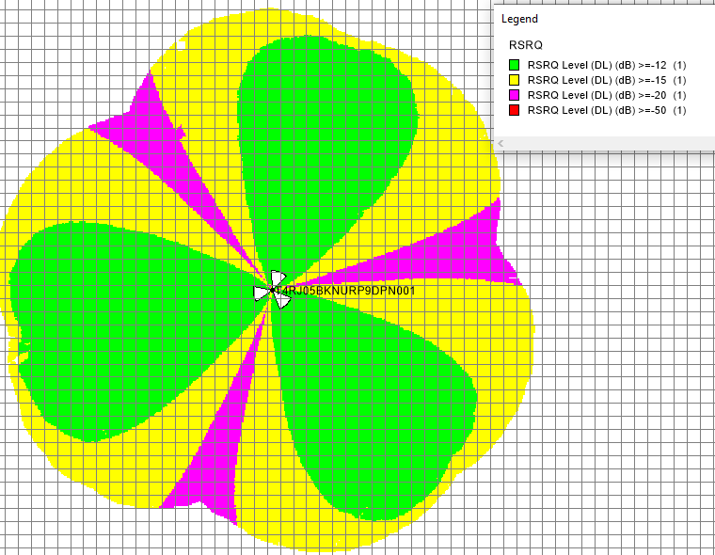

**GRID 200*200**

Prediction Plot-SINR

**The plot indicates the reference signal power based on Atoll planning tool result.**

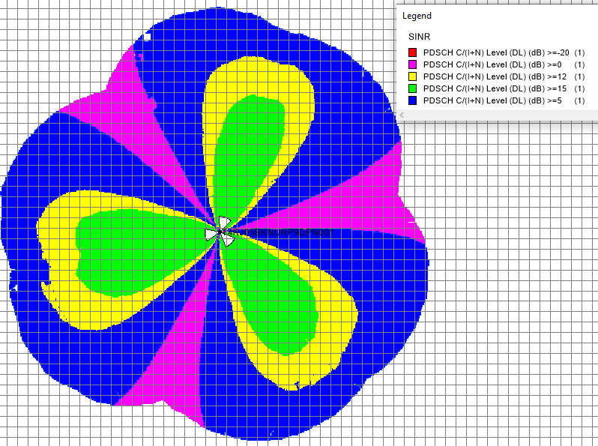

**GRID 200*200**

Prediction Plot Throughput

**The plot indicates the reference signal power based on Atoll planning tool result.**

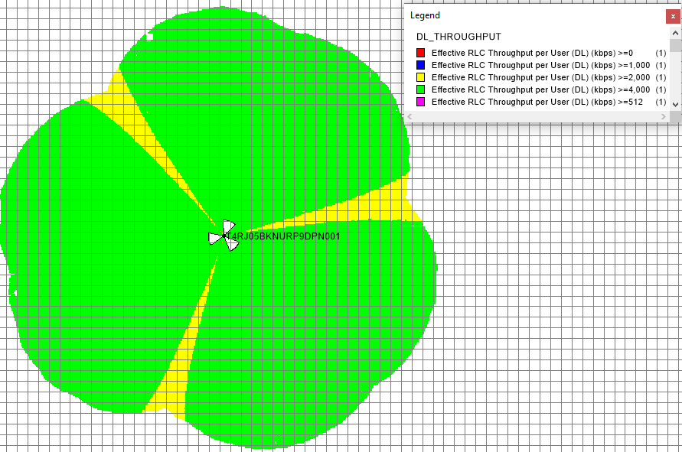

**GRID 200*200**

**A. Serving PCI Plot**

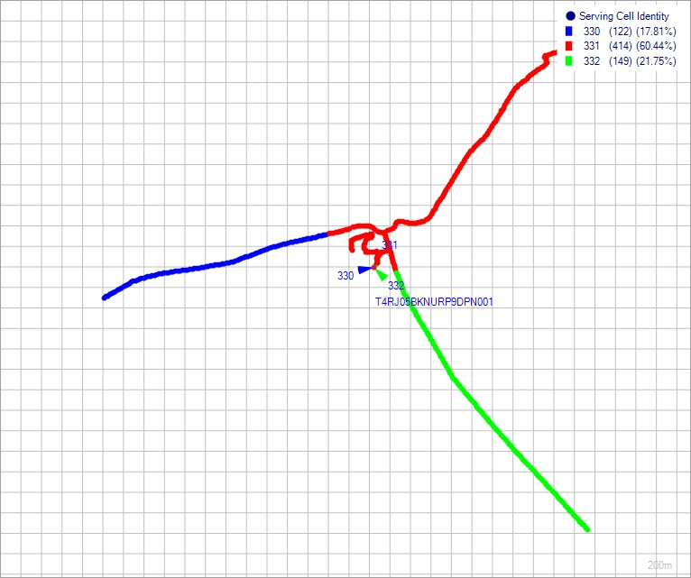

**GRID 200*200**

**B. Serving RSRP Plot**

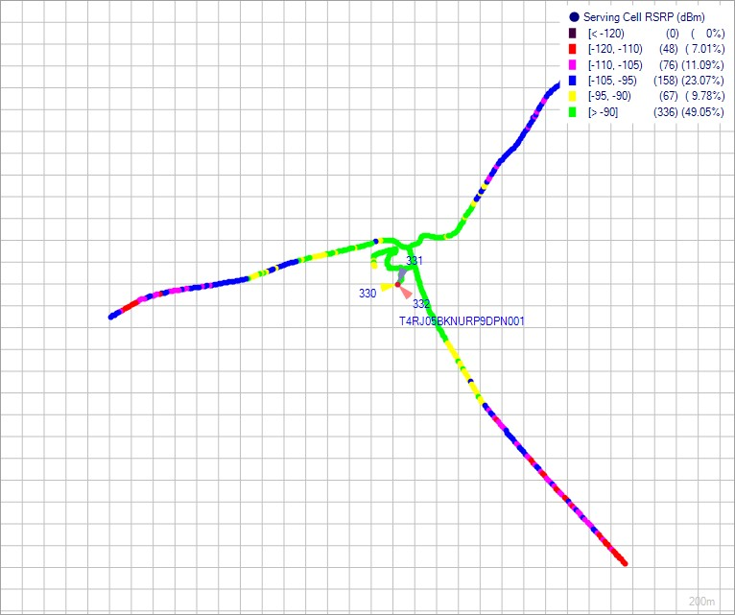

**GRID 200*200**

**C. Serving RSRQ Plot**

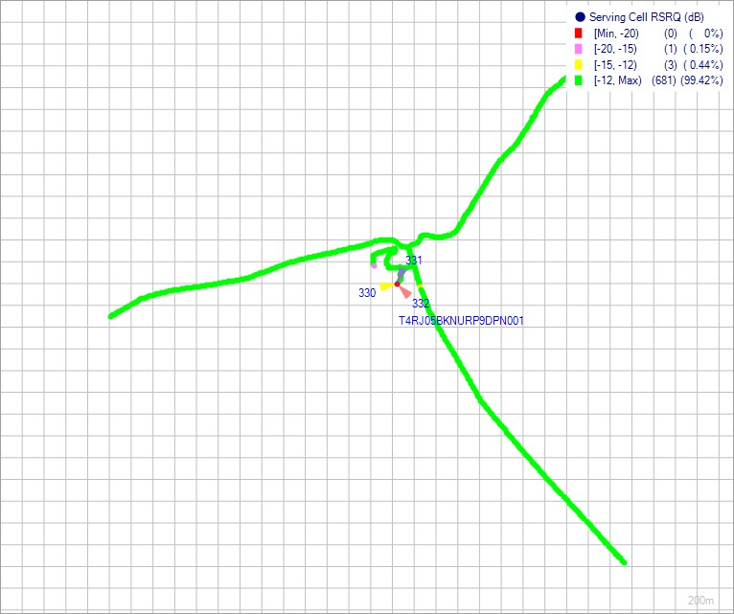

**GRID 200*200**

**D. Serving SINR Plot**

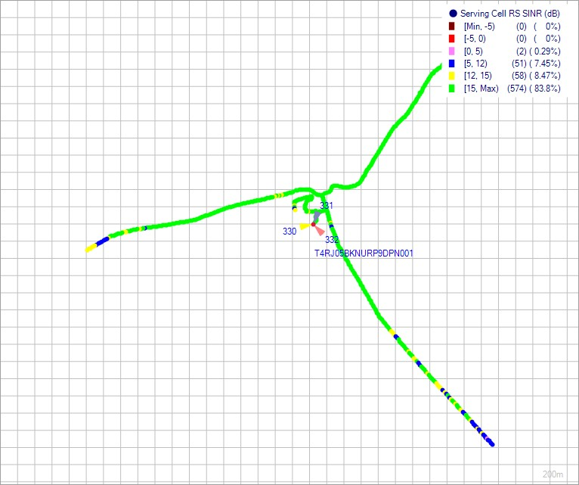

**GRID 200*200**

**E.DL Throughput Plot**

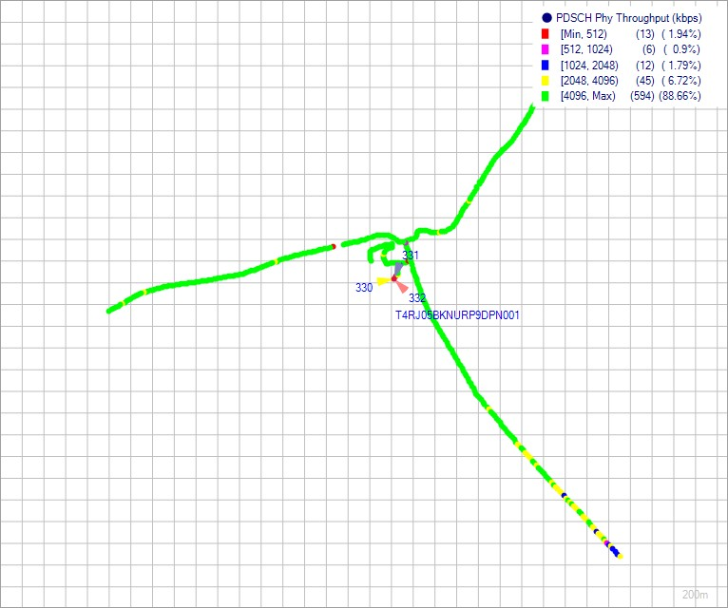

**GRID 200*200**

**F. TECHNOLOGY PLOT**

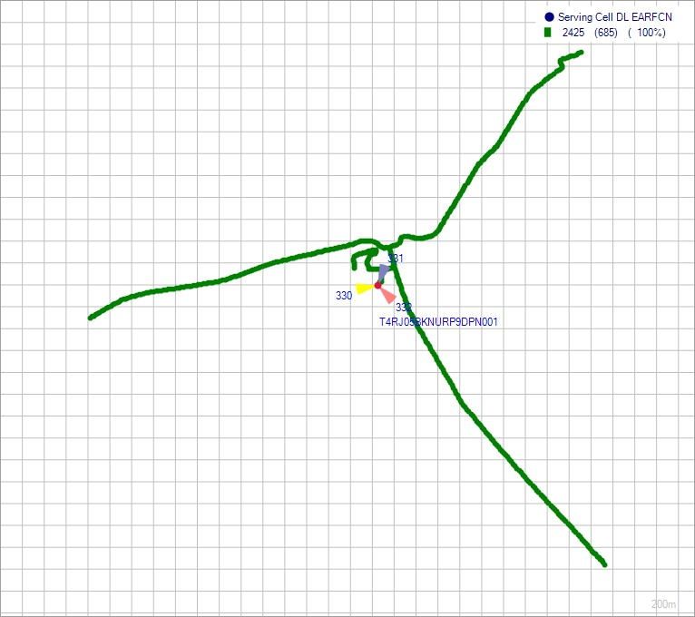

**GRID 200*200**

**G. Google Earth Plot**

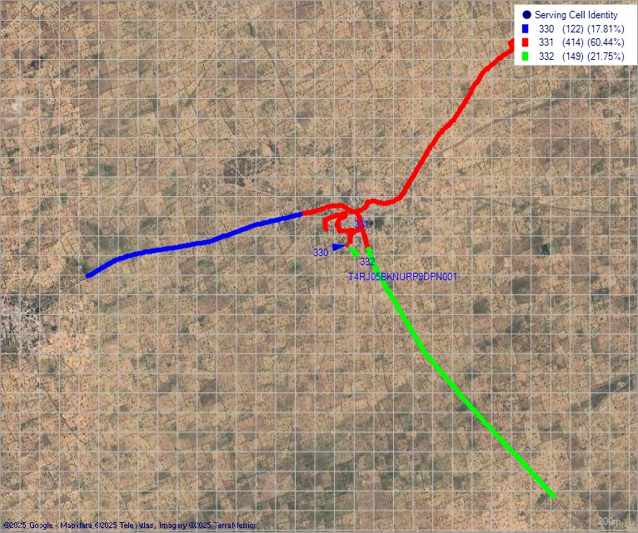

**GRID 200*200**

**The report confirms that Successful bidder/Installer has passed these new site Acceptance Test criteria.**

**Authorized Signatory**

**SITE LAYOUT Part-A Point no.3**