ARDUINO

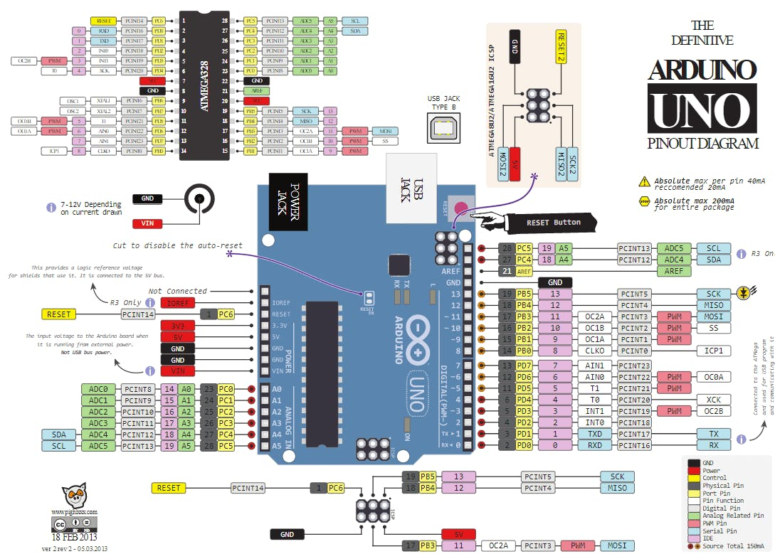

|  |  |
| --- | --- |
| 0 | 0 |
| IDREF | 0 |
| RESET | AREF |
| 3.3V | GND |
| 5V | 13 |
| GND | 12 |
| GND | 11 |
| VIN | 10 |
|  | 9 |
| A0 | 8 |
| A1 |  |
| A2 | 7 |
| A3 | 6 |
| A4 | 5 |
| A5 | 4 |
|  | 3 |
|  | 2 |
|  | 1 |
|  | 0 |