PICO

* Microcontrôleur RP2040 conçu par Raspberry Pi au Royaume-Uni
* Processeur ARM Cortex M0+ à double cœur, horloge flexible fonctionnant jusqu’à 133 MHz
* 264 Ko de SRAM et 2 Mo de mémoire Flash embarquée
* Le module peut se souder directement sur une carte
* Prise en charge de l’hôte et du périphérique USB 1.1 (OTG)
* Mise en veille à puissance réduite et modes « dormants »
* Programmation par glisser-déposer en utilisant le stockage de masse via USB
* 26 broches GPIO multifonctions
* 2 × SPI, 2 × I2C, 2 × UART, 3 × 12-bit ADC, 16 × canaux PWM contrôlables
* Horloge et minuterie précises intégrées
* Capteur de température
* Bibliothèques accélérées en virgule flottante intégrées
* 8 × machines d’état à entrées/sorties programmables (PIO) pour le support de périphériques personnalisés

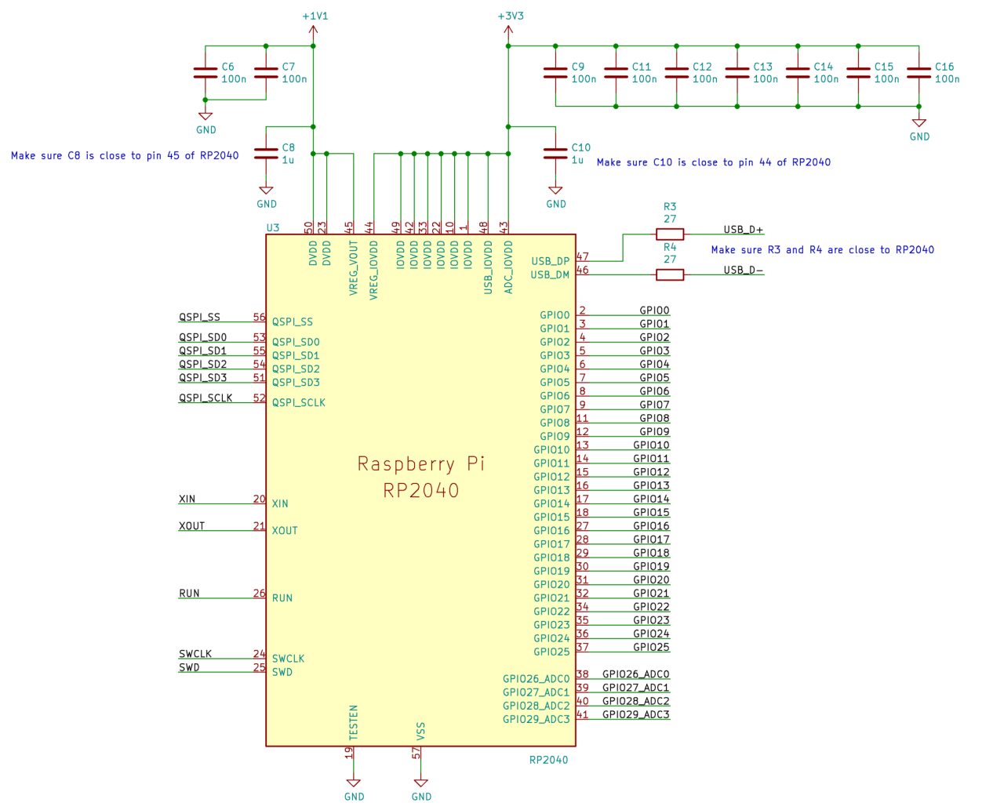

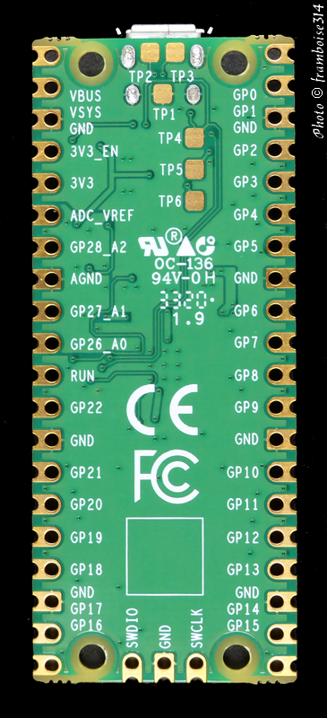

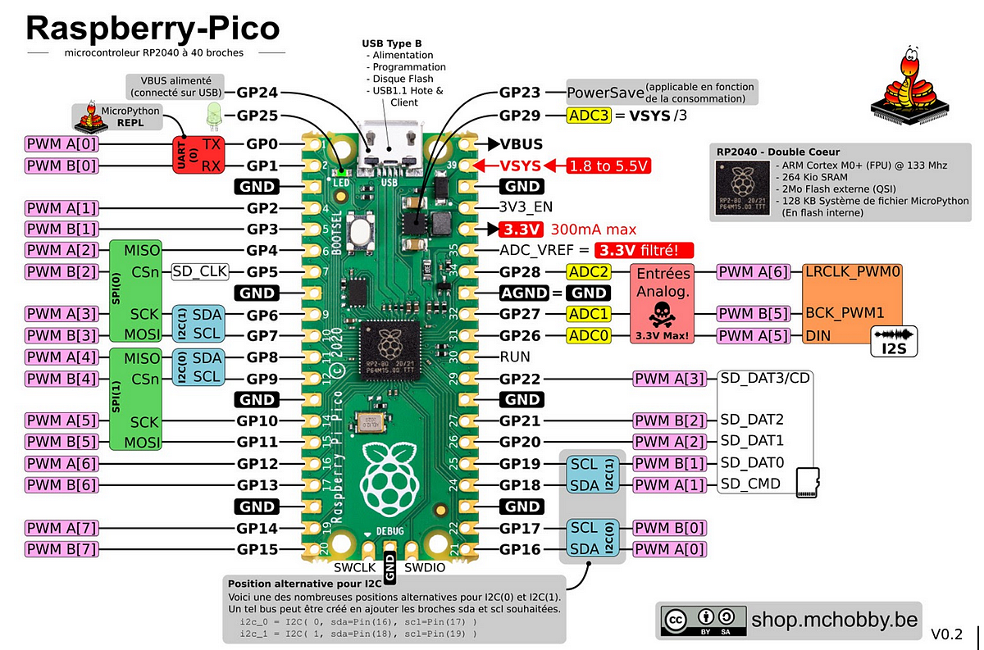

**General board control**[**¶**](https://docs.micropython.org/en/latest/rp2/quickref.html#general-board-control)

The MicroPython REPL is accessed via the USB serial port. Tab-completion is useful to find out what methods an object has. Paste mode (ctrl-E) is useful to paste a large slab of Python code into the REPL.

The [**machine**](https://docs.micropython.org/en/latest/library/machine.html#module-machine) module:

**import** **machine**

machine.freq() *# get the current frequency of the CPU*

machine.freq(240000000) *# set the CPU frequency to 240 MHz*

The [**rp2**](https://docs.micropython.org/en/latest/library/rp2.html#module-rp2) module:

**import** **rp2**

**Delay and timing**[**¶**](https://docs.micropython.org/en/latest/rp2/quickref.html#delay-and-timing)

Use the [**time**](https://docs.micropython.org/en/latest/library/time.html#module-time) module:

**import** **time**

time.sleep(1) *# sleep for 1 second*

time.sleep_ms(500) *# sleep for 500 milliseconds*

time.sleep_us(10) *# sleep for 10 microseconds*

start = time.ticks_ms() *# get millisecond counter*

delta = time.ticks_diff(time.ticks_ms(), start) *# compute time difference*

**Timers[¶](https://docs.micropython.org/en/latest/rp2/quickref.html" \l "timers" \o "Permalink to this headline)**

RP2040’s system timer peripheral provides a global microsecond timebase and generates interrupts for it. The software timer is available currently, and there are unlimited number of them (memory permitting). There is no need to specify the timer id (id=-1 is supported at the moment) as it will default to this.

Use the **[machine.Timer](https://docs.micropython.org/en/latest/library/machine.Timer.html" \l "machine.Timer" \o "machine.Timer)** class:

**from** **machine** **import** Timer

tim = Timer(period=5000, mode=Timer.ONE_SHOT, callback=**lambda** t:print(1))

tim.init(period=2000, mode=Timer.PERIODIC, callback=**lambda** t:print(2))

**Pins and GPIO**[**¶**](https://docs.micropython.org/en/latest/rp2/quickref.html#pins-and-gpio)

Use the [machine.Pin](https://docs.micropython.org/en/latest/library/machine.Pin.html" \l "machine-pin) class:

**from** **machine** **import** Pin

p0 = Pin(0, Pin.OUT) *# create output pin on GPIO0*

p0.on() *# set pin to "on" (high) level*

p0.off() *# set pin to "off" (low) level*

p0.value(1) *# set pin to on/high*

p2 = Pin(2, Pin.IN) *# create input pin on GPIO2*

print(p2.value()) *# get value, 0 or 1*

p4 = Pin(4, Pin.IN, Pin.PULL_UP) *# enable internal pull-up resistor*

p5 = Pin(5, Pin.OUT, value=1) *# set pin high on creation*

**Programmable IO (PIO)**[**¶**](https://docs.micropython.org/en/latest/rp2/quickref.html#programmable-io-pio)

PIO is useful to build low-level IO interfaces from scratch. See the [**rp2**](https://docs.micropython.org/en/latest/library/rp2.html#module-rp2) module for detailed explaination of the assembly instructions.

Example using PIO to blink an LED at 1Hz:

**from** **machine** **import** Pin

**import** **rp2**

**@rp2**.asm_pio(set_init=rp2.PIO.OUT_LOW)

**def** blink_1hz():

*# Cycles: 1 + 7 + 32 * (30 + 1) = 1000*

set(pins, 1)

set(x, 31) [6]

label("delay_high")

nop() [29]

jmp(x_dec, "delay_high")

*# Cycles: 1 + 7 + 32 * (30 + 1) = 1000*

set(pins, 0)

set(x, 31) [6]

label("delay_low")

nop() [29]

jmp(x_dec, "delay_low")

*# Create and start a StateMachine with blink_1hz, outputting on Pin(25)*

sm = rp2.StateMachine(0, blink_1hz, freq=2000, set_base=Pin(25))

sm.active(1)

**UART (serial bus)**[**¶**](https://docs.micropython.org/en/latest/rp2/quickref.html#uart-serial-bus)

There are two UARTs, UART0 and UART1. UART0 can be mapped to GPIO 0/1, 12/13 and 16/17, and UART1 to GPIO 4/5 and 8/9.

See [machine.UART](https://docs.micropython.org/en/latest/library/machine.UART.html" \l "machine-uart).

**from** **machine** **import** UART, Pin

uart1 = UART(1, baudrate=9600, tx=Pin(4), rx=Pin(5))

uart1.write('hello') *# write 5 bytes*

uart1.read(5) *# read up to 5 bytes*

**Note**

REPL over UART is disabled by default. You can see the [Getting started with MicroPython on the RP2xxx](https://docs.micropython.org/en/latest/rp2/tutorial/intro.html" \l "rp2-intro) for details on how to enable REPL over UART.

**PWM (pulse width modulation)**[**¶**](https://docs.micropython.org/en/latest/rp2/quickref.html#pwm-pulse-width-modulation)

There are 8 independent channels each of which have 2 outputs making it 16 PWM channels in total which can be clocked from 7Hz to 125Mhz.

Use the machine.PWM class:

**from** **machine** **import** Pin, PWM

pwm0 = PWM(Pin(0)) *# create PWM object from a pin*

pwm0.freq() *# get current frequency*

pwm0.freq(1000) *# set frequency*

pwm0.duty_u16() *# get current duty cycle, range 0-65535*

pwm0.duty_u16(200) *# set duty cycle, range 0-65535*

pwm0.deinit() *# turn off PWM on the pin*

**ADC (analog to digital conversion)**[**¶**](https://docs.micropython.org/en/latest/rp2/quickref.html#adc-analog-to-digital-conversion)

RP2040 has five ADC channels in total, four of which are 12-bit SAR based ADCs: GP26, GP27, GP28 and GP29. The input signal for ADC0, ADC1, ADC2 and ADC3 can be connected with GP26, GP27, GP28, GP29 respectively (On Pico board, GP29 is connected to VSYS). The standard ADC range is 0-3.3V. The fifth channel is connected to the in-built temperature sensor and can be used for measuring the temperature.

Use the [machine.ADC](https://docs.micropython.org/en/latest/library/machine.ADC.html" \l "machine-adc) class:

**from** **machine** **import** ADC, Pin

adc = ADC(Pin(26)) *# create ADC object on ADC pin*

adc.read_u16() *# read value, 0-65535 across voltage range 0.0v - 3.3v*

**Software SPI bus**[**¶**](https://docs.micropython.org/en/latest/rp2/quickref.html#software-spi-bus)

Software SPI (using bit-banging) works on all pins, and is accessed via the [machine.SoftSPI](https://docs.micropython.org/en/latest/library/machine.SPI.html" \l "machine-softspi) class:

**from** **machine** **import** Pin, SoftSPI

*# construct a SoftSPI bus on the given pins*

*# polarity is the idle state of SCK*

*# phase=0 means sample on the first edge of SCK, phase=1 means the second*

spi = SoftSPI(baudrate=100_000, polarity=1, phase=0, sck=Pin(0), mosi=Pin(2), miso=Pin(4))

spi.init(baudrate=200000) *# set the baudrate*

spi.read(10) *# read 10 bytes on MISO*

spi.read(10, 0xff) *# read 10 bytes while outputting 0xff on MOSI*

buf = bytearray(50) *# create a buffer*

spi.readinto(buf) *# read into the given buffer (reads 50 bytes in this case)*

spi.readinto(buf, 0xff) *# read into the given buffer and output 0xff on MOSI*

spi.write(b'12345') *# write 5 bytes on MOSI*

buf = bytearray(4) *# create a buffer*

spi.write_readinto(b'1234', buf) *# write to MOSI and read from MISO into the buffer*

spi.write_readinto(buf, buf) *# write buf to MOSI and read MISO back into buf*

**Warning**

Currently *all* of sck, mosi and miso *must* be specified when initialising Software SPI.

**Hardware SPI bus**[**¶**](https://docs.micropython.org/en/latest/rp2/quickref.html#hardware-spi-bus)

The RP2040 has 2 hardware SPI buses which is accessed via the [machine.SPI](https://docs.micropython.org/en/latest/library/machine.SPI.html" \l "machine-spi) class and has the same methods as software SPI above:

**from** **machine** **import** Pin, SPI

spi = SPI(1, 10_000_000) *# Default assignment: sck=Pin(10), mosi=Pin(11), miso=Pin(8)*

spi = SPI(1, 10_000_000, sck=Pin(14), mosi=Pin(15), miso=Pin(12))

spi = SPI(0, baudrate=80_000_000, polarity=0, phase=0, bits=8, sck=Pin(6), mosi=Pin(7), miso=Pin(4))

**Software I2C bus**[**¶**](https://docs.micropython.org/en/latest/rp2/quickref.html#software-i2c-bus)

Software I2C (using bit-banging) works on all output-capable pins, and is accessed via the [machine.SoftI2C](https://docs.micropython.org/en/latest/library/machine.I2C.html#machine-softi2c) class:

**from** **machine** **import** Pin, SoftI2C

i2c = SoftI2C(scl=Pin(5), sda=Pin(4), freq=100_000)

i2c.scan() *# scan for devices*

i2c.readfrom(0x3a, 4) *# read 4 bytes from device with address 0x3a*

i2c.writeto(0x3a, '12') *# write '12' to device with address 0x3a*

buf = bytearray(10) *# create a buffer with 10 bytes*

i2c.writeto(0x3a, buf) *# write the given buffer to the peripheral*

**Hardware I2C bus**[**¶**](https://docs.micropython.org/en/latest/rp2/quickref.html#hardware-i2c-bus)

The driver is accessed via the [machine.I2C](https://docs.micropython.org/en/latest/library/machine.I2C.html#machine-i2c) class and has the same methods as software I2C above:

**from** **machine** **import** Pin, I2C

i2c = I2C(0) *# default assignment: scl=Pin(9), sda=Pin(8)*

i2c = I2C(1, scl=Pin(3), sda=Pin(2), freq=400_000)

**I2S bus**[**¶**](https://docs.micropython.org/en/latest/rp2/quickref.html#i2s-bus)

See [machine.I2S](https://docs.micropython.org/en/latest/library/machine.I2S.html#machine-i2s).

**from** **machine** **import** I2S, Pin

i2s = I2S(0, sck=Pin(16), ws=Pin(17), sd=Pin(18), mode=I2S.TX, bits=16, format=I2S.STEREO, rate=44100, ibuf=40000) *# create I2S object*

i2s.write(buf) *# write buffer of audio samples to I2S device*

i2s = I2S(1, sck=Pin(0), ws=Pin(1), sd=Pin(2), mode=I2S.RX, bits=16, format=I2S.MONO, rate=22050, ibuf=40000) *# create I2S object*

i2s.readinto(buf) *# fill buffer with audio samples from I2S device*

The ws pin number must be one greater than the sck pin number.

The I2S class is currently available as a Technical Preview. During the preview period, feedback from users is encouraged. Based on this feedback, the I2S class API and implementation may be changed.

Two I2S buses are supported with id=0 and id=1.

**Real time clock (RTC)**[**¶**](https://docs.micropython.org/en/latest/rp2/quickref.html#real-time-clock-rtc)

See [machine.RTC](https://docs.micropython.org/en/latest/library/machine.RTC.html" \l "machine-rtc)

**from** **machine** **import** RTC

rtc = RTC()

rtc.datetime((2017, 8, 23, 2, 12, 48, 0, 0)) *# set a specific date and*

*# time, eg. 2017/8/23 1:12:48*

rtc.datetime() *# get date and time*

**WDT (Watchdog timer)**[**¶**](https://docs.micropython.org/en/latest/rp2/quickref.html#wdt-watchdog-timer)

The RP2040 has a watchdog which is a countdown timer that can restart parts of the chip if it reaches zero.

See [machine.WDT](https://docs.micropython.org/en/latest/library/machine.WDT.html#machine-wdt).

**from** **machine** **import** WDT

*# enable the WDT with a timeout of 5s (1s is the minimum)*

wdt = WDT(timeout=5000)

wdt.feed()

**OneWire driver**[**¶**](https://docs.micropython.org/en/latest/rp2/quickref.html#onewire-driver)

The OneWire driver is implemented in software and works on all pins:

**from** **machine** **import** Pin

**import** **onewire**

ow = onewire.OneWire(Pin(12)) *# create a OneWire bus on GPIO12*

ow.scan() *# return a list of devices on the bus*

ow.reset() *# reset the bus*

ow.readbyte() *# read a byte*

ow.writebyte(0x12) *# write a byte on the bus*

ow.write('123') *# write bytes on the bus*

ow.select_rom(b'12345678') *# select a specific device by its ROM code*

There is a specific driver for DS18S20 and DS18B20 devices:

**import** **time**, **ds18x20**

ds = ds18x20.DS18X20(ow)

roms = ds.scan()

ds.convert_temp()

time.sleep_ms(750)

**for** rom **in** roms:

print(ds.read_temp(rom))

Be sure to put a 4.7k pull-up resistor on the data line. Note that the convert_temp() method must be called each time you want to sample the temperature.

**NeoPixel and APA106 driver**[**¶**](https://docs.micropython.org/en/latest/rp2/quickref.html#neopixel-and-apa106-driver)

Use the neopixel and apa106 modules:

**from** **machine** **import** Pin

**from** **neopixel** **import** NeoPixel

pin = Pin(0, Pin.OUT) *# set GPIO0 to output to drive NeoPixels*

np = NeoPixel(pin, 8) *# create NeoPixel driver on GPIO0 for 8 pixels*

np[0] = (255, 255, 255) *# set the first pixel to white*

np.write() *# write data to all pixels*

r, g, b = np[0] *# get first pixel colour*

The APA106 driver extends NeoPixel, but internally uses a different colour order:

**from** **apa106** **import** APA106

ap = APA106(pin, 8)

r, g, b = ap[0]

APA102 (DotStar) uses a different driver as it has an additional clock pin.