**Technologies :** Spring Boot, JDBC PersistentFramework(Jpa), H2 ,Junit(added junits), Swagger, Logger

Rest API

<http://localhost:8080/today>

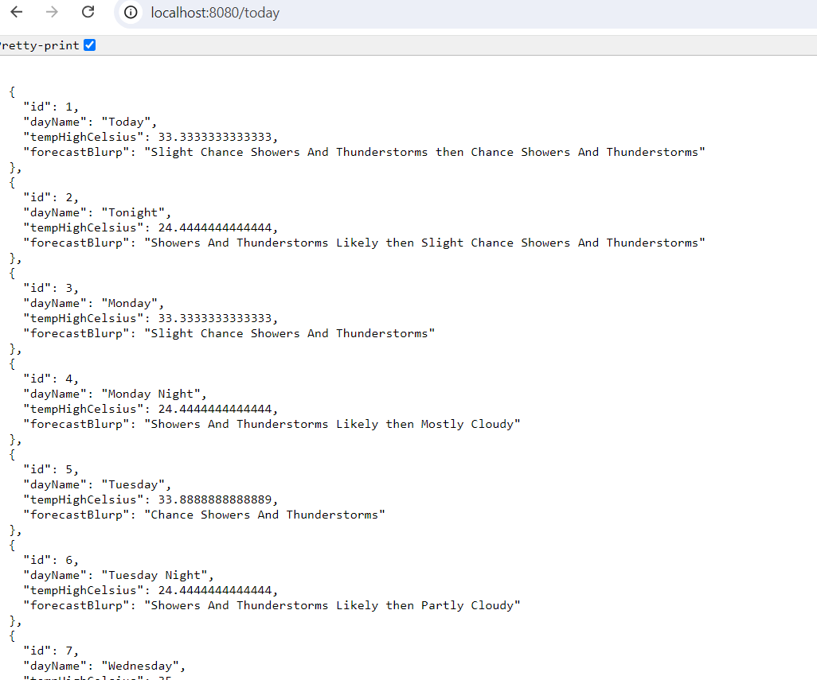

Swagger API

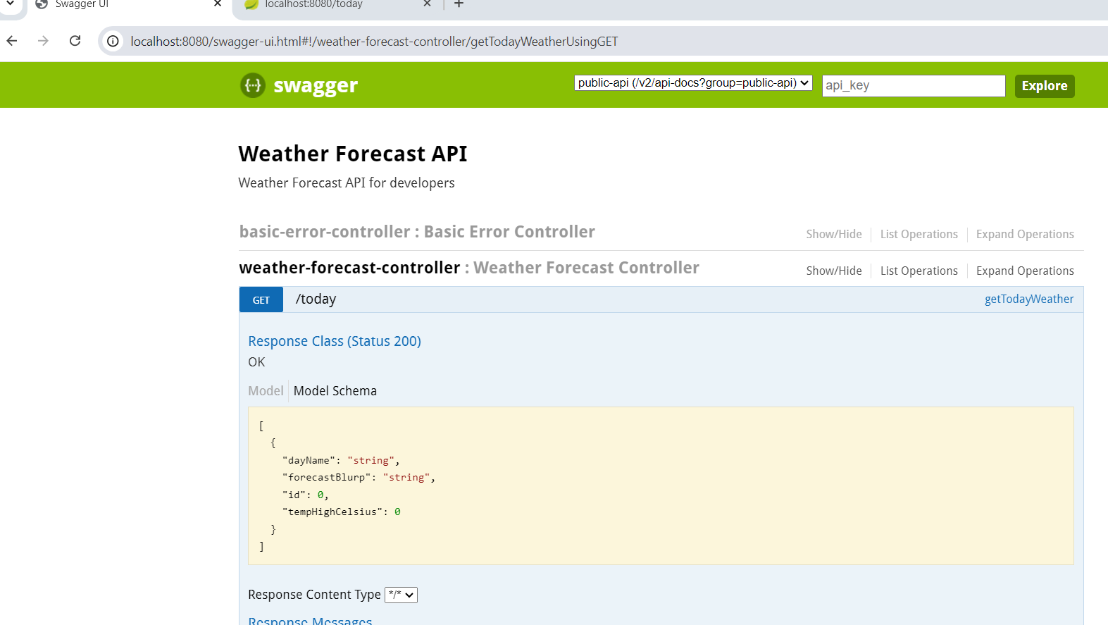

Junit

Run below test classes

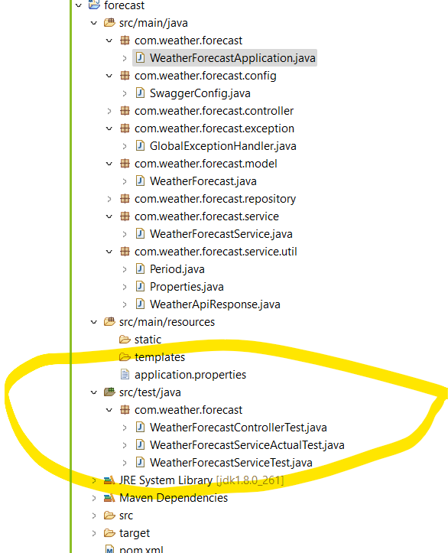

H2 and Loggers

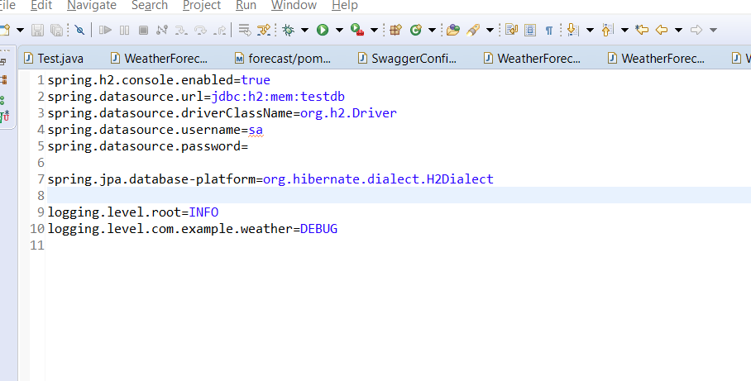

Exception Handling

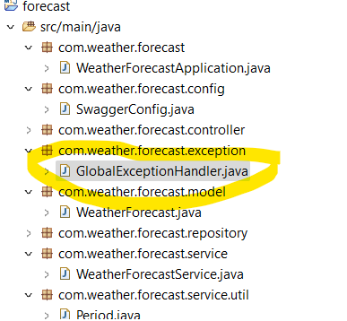

JDBC Persistence framework

