 

**Placement Empowerment Program**

***Cloud Computing and DevOps Centre***

Host a Static Website Locally: Set Up a Local Server Apache and Host a Simple HTML page with your name

Name: Subiksha R Department : AML



**Introduction:**

This task involves hosting a static website locally using Apache, a widely-used web server. You'll install Apache on your system, create a directory for your website, and place a simple HTML file (e.g., index.html) in that directory. Apache will then serve the file, allowing you to view your website in a local web browser. This setup is useful for web development, testing, and learning how websites are hosted before going live. It provides a simple, controlled environment for creating and debugging static websites.

**Objective:**

The goal is to:

1. Install and configure Apache on your local machine.
2. Create and place an index.html file in the appropriate directory.
3. Serve the static website locally, allowing you to test and view it in a web browser.
4. Understand how local web hosting works and prepare for hosting websites on live servers.

**Step-by-Step Procedure:**

**STEP 1: Install Apache Web Server**

1. Download **XAMPP** from https://www.apachefriends.org.

2. Install XAMPP and run Apache.

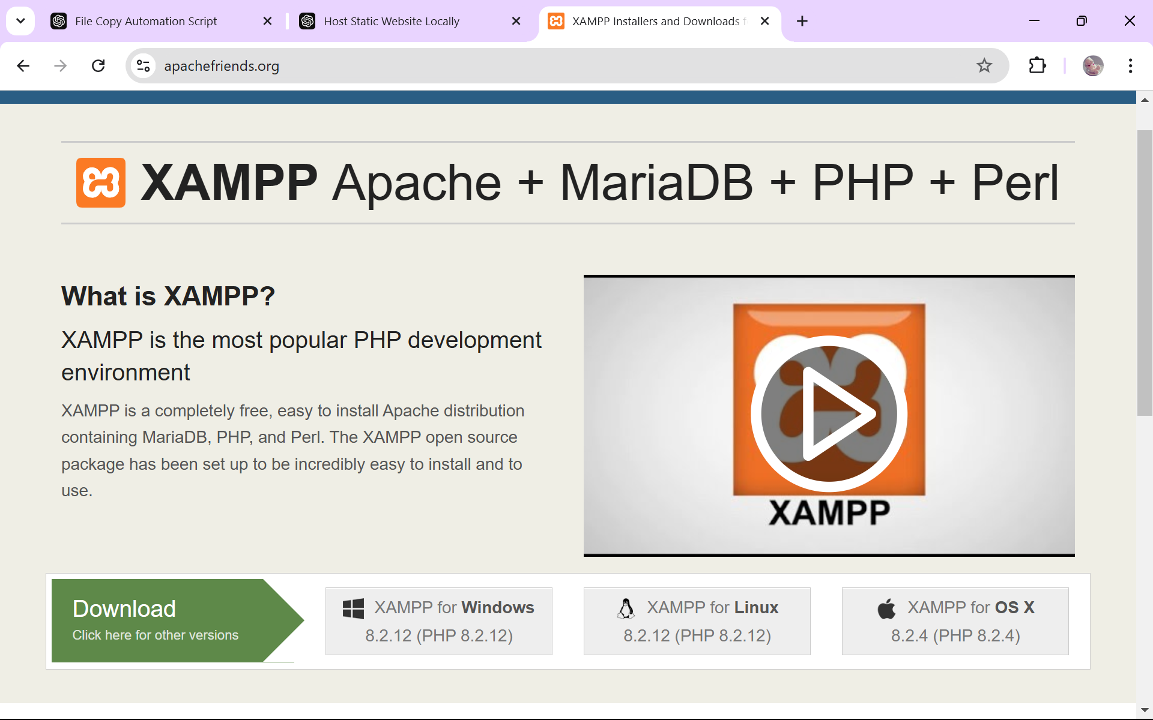

**STEP 2: Configure Apache**

3. Open the XAMPP Control Panel (search for it in the Start menu).

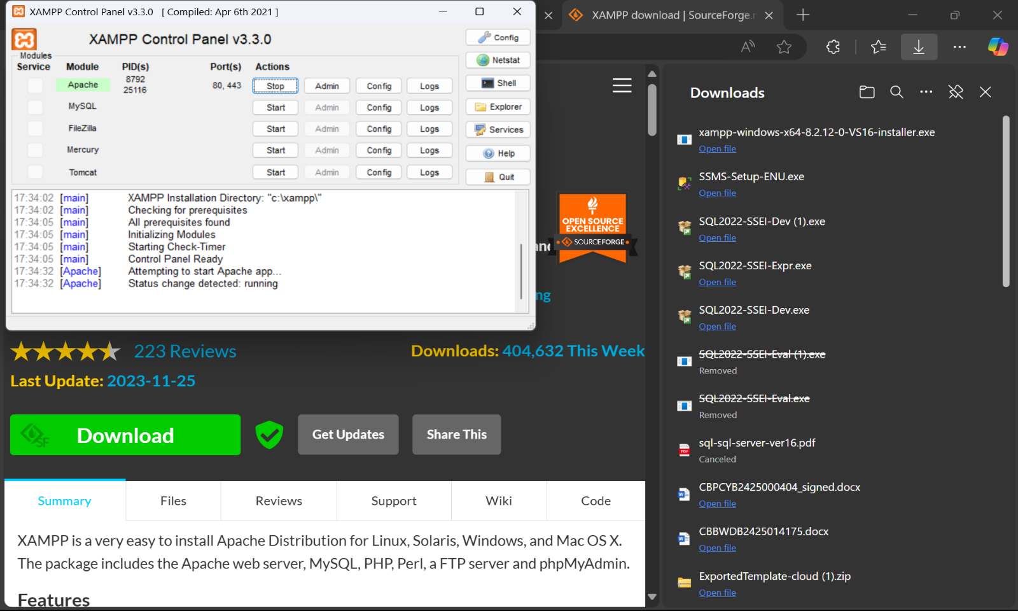4. Start the Apache service by clicking the "Start" button.

**STEP 3: Create a simple HTML file**

5. Open a text editor (e.g., Notepad or VS Code).

6. Add your HTML content

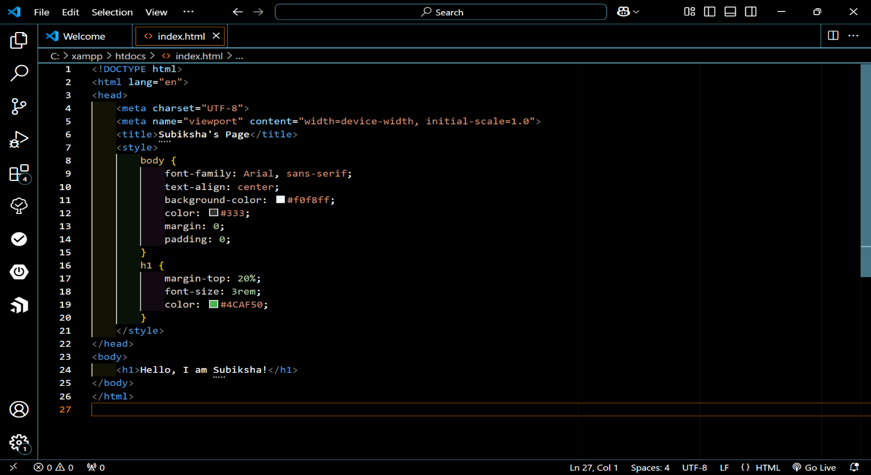

**STEP 4: Save the HTML file in the htdocs folder.**

7. The htdocs folder will be automatically created in our file manager when we install XAMPP.

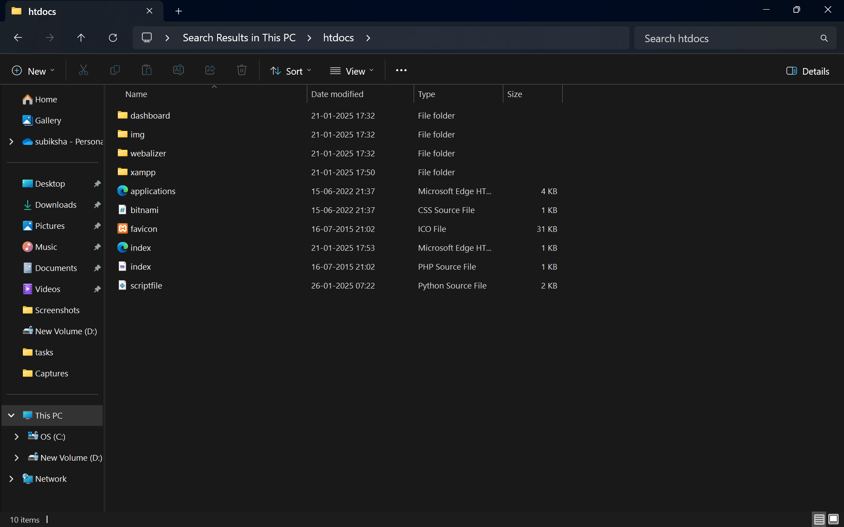

**STEP 5:**  **Access Your HTML Page**

1. Open your web browser.
2. Go to: http://localhost/index.html

10.Your HTML page should load, displaying the content you added.

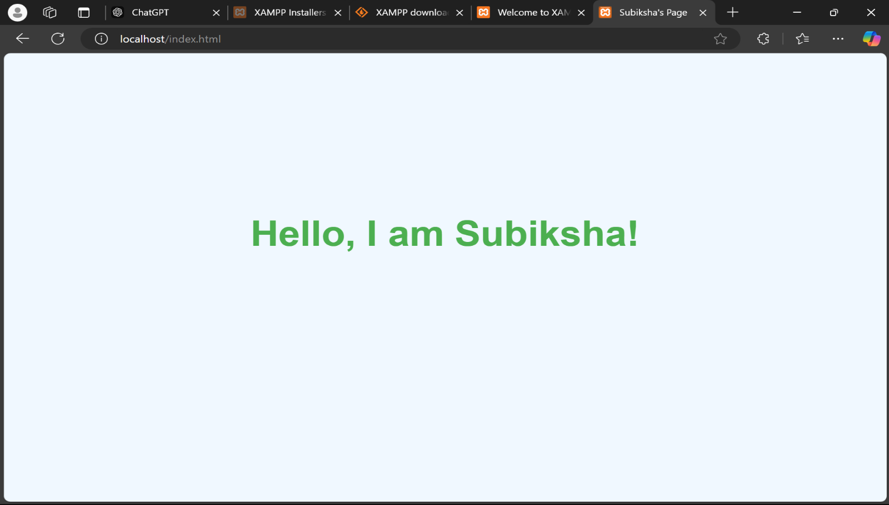

**Outcome:**

By completing this task, I learned:

1. Setting Up a Local Server: How to install and configure XAMPP to use Apache as your local web server.
2. Hosting Web Pages: How to save and host an HTML file in the htdocs folder and access it via http://localhost.
3. File Organization: Understanding the folder structure and organizing files for a web server.
4. Troubleshooting: Diagnosing and solving common issues like missing folders or server errors.
5. Foundations in Web Development: Basic knowledge of how local servers work, which is essential for future learning in web development.