Cloud-Based Secure Task Manager
AWS Cloud, DevOps and Cybersecurity Capstone Project

Project Summary
A secure Flask-based task management web application deployed on AWS EC2 using Docker and Nginx, with custom VPC networking, Linux server administration, role-based access control, security hardening, CI/CD validation, CloudWatch monitoring, logging, and S3 backup storage.

Field | Details
Student Name | Anumithra S Kumar
Project Type | Internship Capstone Project
Technology Focus | AWS Cloud | Networking | Linux | Cybersecurity | DevOps | Monitoring
Application | Cloud-Based Secure Task Manager
Deployment Region | Asia Pacific (Mumbai) - ap-south-1
Submission Due Date | 31 May 2026

Repository: https://github.com/anumithraskumar2005-art/cloud-secure-task-manager

Executive Summary
This capstone project implements a production-style secure task management dashboard that demonstrates the major skills expected from a Cloud, DevOps and Cybersecurity internship programme. The solution combines application development, AWS infrastructure, Linux administration, networking, security, automation, monitoring, logging, and backup storage into one end-to-end project.
Main Outcome
The application was developed locally, containerized using Docker, pushed to GitHub, validated through GitHub Actions, deployed on an Ubuntu EC2 instance inside a custom AWS VPC, exposed through Nginx, monitored using CloudWatch, protected using firewall and SSH hardening, and backed up to Amazon S3.

Capstone Requirement Mapping
Requirement | Implementation in Project | Status
Application Development | Flask web application with registration, login, dashboard, task CRUD, role-based admin page, file attachment upload, and health check endpoint. | Completed
AWS Cloud Infrastructure | EC2 instance, S3 backup bucket, CloudWatch alarm, custom VPC, public subnet, internet gateway, route table, and security group. | Completed
Linux Administration | Ubuntu server setup, package installation, Docker service, Nginx reverse proxy, UFW firewall, fail2ban, SSH hardening, and cron backup job. | Completed
Networking and Domain | Custom VPC CIDR, subnet association, route table with internet route, security group rules, public IP access, HTTP port 80, and app port 5000 testing. | Completed
Cyber Security | bcrypt password hashing, protected routes, role-based access, login failure logs, rate limiting, secure headers, firewall rules, SSH hardening, and blocked public S3 access. | Completed
DevOps and Automation | Dockerfile, Docker Compose, GitHub repository, GitHub Actions CI workflow, Docker image build, container deployment, and automated backup script. | Completed
Monitoring and Logging | CloudWatch CPU alarm, /health endpoint, Docker application logs, Nginx access logs, UFW status, and fail2ban status evidence. | Completed

Project Objectives
- Build a secure web application that supports authenticated task management.
- Deploy the application on AWS infrastructure using a Linux server.
- Demonstrate custom networking through VPC, subnet, route table, internet gateway, and security groups.
- Apply cybersecurity controls such as hashing, access control, firewall rules, SSH hardening, and logging.
- Use DevOps practices including GitHub version control, Docker containerization, and CI workflow automation.
- Implement monitoring, logging, health checks, and backup storage for operational reliability.

Application Overview
Feature | Description
User Registration | Users can create accounts with name, email, and password.
Secure Login | Passwords are verified using hashed credentials; invalid login attempts are recorded.
Task Dashboard | Users can view task statistics and manage their own tasks.
Task CRUD | Users can create, edit, update status, delete, and attach files to tasks.
Admin Dashboard | Admin users can view users, all tasks, and recent login activity.
Health Check | The /health endpoint returns service status for monitoring and CI validation.

System Architecture
The architecture follows a simple and explainable cloud deployment model suitable for an internship capstone. The user accesses the application through a browser. Traffic reaches the EC2 instance through the public subnet and security group. Nginx acts as the reverse proxy and forwards traffic to the Dockerized Flask application running on port 5000. Logs, monitoring, and backups support operations and security review.
Figure 1: DevSecOps Architecture Diagram
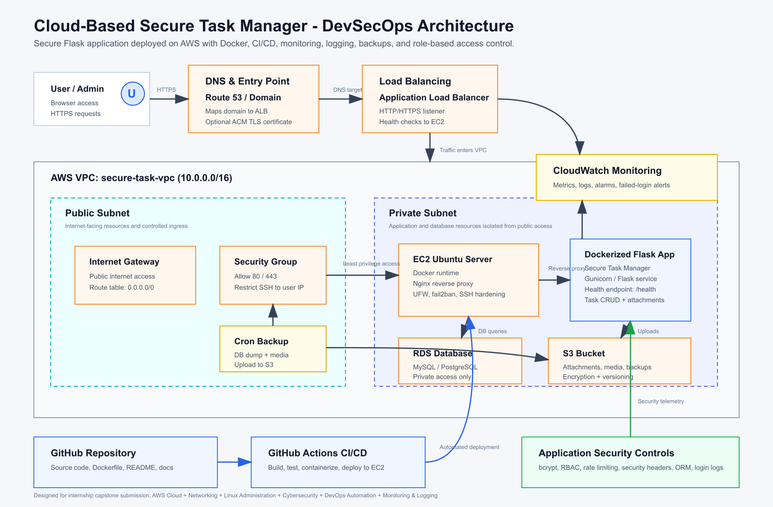

AWS Cloud Infrastructure
AWS Component | Purpose
VPC | Custom VPC created for the project network.
Subnet | Public subnet used for the EC2 web server deployment.
Internet Gateway | Attached to the VPC to allow internet access.
Route Table | Public route table associated with the public subnet.
Security Group | Allowed SSH from administrator IP and HTTP/application access for the web app.
EC2 | Ubuntu 24.04 LTS instance used to host the application.
S3 | Secure bucket used to store backup archive and architecture documentation.
CloudWatch | CPU utilization alarm created for instance monitoring.

Linux Administration
- Connected to the EC2 Ubuntu server using SSH.
- Updated packages and installed Docker, Nginx, Git, UFW, and fail2ban.
- Cloned the project repository from GitHub.
- Built and ran the Docker container on the EC2 server.
- Configured Nginx as a reverse proxy from port 80 to the Flask container on port 5000.
- Enabled UFW firewall and allowed only required services.
- Hardened SSH by disabling root login and password authentication.
- Created a backup script and scheduled it using cron.

Networking Configuration
Network Item | Configuration
Public HTTP | Port 80 allowed through security group and UFW for Nginx.
Application Testing | Port 5000 allowed for direct testing of Flask/Docker deployment.
SSH Administration | Port 22 restricted to administrator IP where possible.
Private IP | EC2 instance assigned a private IP inside the VPC subnet.
Public IP | Application tested through the EC2 public IPv4 address.

Cybersecurity Implementation
Security Control | Evidence / Benefit
Password Hashing | bcrypt hashing protects stored user passwords.
Authentication | Protected routes prevent unauthenticated dashboard access.
Role-Based Access Control | Admin dashboard is restricted to users with admin role.
Rate Limiting | Flask-Limiter reduces repeated request abuse.
Login Logging | Successful and failed login attempts are recorded for review.
Firewall | UFW enabled with OpenSSH and Nginx rules.
fail2ban | Installed to protect against repeated SSH attack attempts.
SSH Hardening | Root login and password authentication disabled.
S3 Protection | Public access blocked, versioning enabled, and encryption enabled.

DevOps and Automation
- GitHub repository used for source code management and version history.
- Dockerfile created to containerize the Flask application.
- Docker Compose file added for repeatable local/container deployment.
- GitHub Actions workflow created to validate application import, install dependencies, build Docker image, run container, and test the /health endpoint.
- Backup script created on EC2 to archive project files into a .tar.gz backup.
- Cron job configured to automate backup creation.

Monitoring and Logging
Monitoring / Logging Item | Purpose
/health Endpoint | Provides service status for testing and monitoring.
Docker Logs | Shows application runtime logs from the container.
Nginx Access Logs | Shows incoming HTTP requests and scanning attempts.
CloudWatch Alarm | Monitors EC2 CPU utilization with an alarm threshold.
UFW Status | Confirms active Linux firewall rules.
fail2ban Status | Confirms SSH protection service status.

Backup and S3 Storage
A full project backup archive was created on the EC2 server and uploaded to Amazon S3. The S3 bucket was configured with secure settings to protect stored artifacts.
Backup Artifact | Purpose
secure-task-manager-full-backup.tar.gz | Compressed backup of the project directory from the EC2 server.
architecture-diagram.png | Architecture documentation artifact stored in S3.

- S3 public access was blocked.
- Bucket versioning was enabled.
- Default encryption was enabled using Amazon S3 managed keys.
- The backup file was uploaded as evidence of cloud backup storage.

Testing and Validation
Test Case | Expected Result | Status
Local Flask Run | Application opens on 127.0.0.1:5000. | Passed
User Registration/Login | User can register and access dashboard. | Passed
Admin Access | Admin can view admin dashboard and logs. | Passed
Task CRUD | Task can be created, edited, deleted, and listed. | Passed
Attachment Upload | Uploaded attachment is visible through View link. | Passed
Docker Local Run | Containerized application opens successfully. | Passed
GitHub Actions | CI workflow completes with green success status. | Passed
AWS EC2 Deployment | Application accessible using EC2 public IP. | Passed
Nginx Reverse Proxy | Application accessible on HTTP port 80 without :5000. | Passed
Health Check | /health returns JSON status ok. | Passed
CloudWatch Alarm | CPU alarm created for EC2 instance. | Passed
S3 Upload | Backup and architecture diagram uploaded to S3. | Passed

Screenshot Evidence Checklist
Project Area | Recommended Screenshot Evidence
Application | local-dashboard.png, admin-dashboard.png, task-attachment.png, health-check.png
DevOps | github-repository-files.png, github-actions-success.png, docker-health-check.png
Architecture | github-architecture-diagram.png, architecture-diagram.png
AWS EC2 | aws-ec2-running.png, aws-app-running-port-5000.png, aws-app-running-nginx-port80.png
Networking | aws-vpc.png, aws-subnets.png, aws-route-table.png, aws-security-group-rules.png
Linux Security | ec2-ufw-firewall-status.png, ec2-fail2ban-status.png, ec2-ssh-hardening.png
Logs | ec2-docker-application-logs.png, ec2-nginx-access-logs.png
Monitoring | cloudwatch-high-cpu-alarm.png
S3 Backup | aws-s3-bucket-created.png, aws-s3-backup-uploaded.png, aws-s3-public-access-blocked.png, aws-s3-versioning-encryption.png

Challenges Faced and Solutions
Challenge | Solution Applied
PowerShell virtual environment activation blocked | Used batch activation and pip commands carefully.
Flask missing module error | Activated virtual environment and installed requirements.
Docker container confusion | Verified running containers using docker ps and tested /health endpoint.
SSH connection issues | Updated security group SSH source and reconnected using .pem key.
Small backup archive | Created a full project backup archive and uploaded it to S3.
Public internet scans in Nginx logs | Used logs as evidence of monitoring and explained 404/bad request entries as bot scanning attempts.

Conclusion
The Cloud-Based Secure Task Manager successfully demonstrates the required internship capstone objectives. The project covers full-stack application development, AWS infrastructure deployment, Linux server administration, secure networking, cybersecurity controls, DevOps automation, monitoring, logging, and S3 backup storage. The final solution is suitable for demonstration because it shows both working application features and operational cloud engineering practices.
Final Highlight
This project is not only a task manager application; it is a complete DevSecOps deployment workflow showing how a secure web application can be built, deployed, monitored, protected, and backed up on AWS.

Appendix A: Key Commands Used
Task | Command
Docker Build | sudo docker build -t secure-task-manager .
Docker Run | sudo docker run -d -p 5000:5000 --name secure-task-manager secure-task-manager
Docker Logs | sudo docker logs secure-task-manager --tail 30
Nginx Test | sudo nginx -t
UFW Status | sudo ufw status
fail2ban Status | sudo systemctl status fail2ban --no-pager
Backup Creation | tar -czf ~/backups/secure-task-manager-full-backup.tar.gz cloud-secure-task-manager

Appendix B: Final Submission Items
- GitHub repository link.
- Final project report document.
- Architecture diagram image.
- Deployment guide and security documentation.
- Application screenshots.
- AWS infrastructure screenshots.
- GitHub Actions success screenshot.
- Monitoring, logging, firewall, and S3 backup screenshots.

