Course Code: CT-581
STATISTICS AND PROBABILITY FOR DATA SCIENCE

Statistical Testing in Heart Failure Data: An
Analytical Approach

Project Report By: Mr Tauqeer

Group Member:
Sidra Naz | DS-035/2024
Anum Jamil | DS-043/2023-2024
Auj ur Rehmaan | DS-071/2023-2024

Table of Contents
Table of Contents---------------------------------------------------------------------------------------------2
- Introduction-----------------------------------------------------------------------------------------------3
- Dataset Description-------------------------------------------------------------------------------------3
- Hypothetical Testing ------------------------------------------------------------------------------------4
  - Z Test-------------------------------------------------------------------------------------------------4
  - T Test-------------------------------------------------------------------------------------------------5
  - Chi Squared Test-----------------------------------------------------------------------------------7
  - Regression------------------------------------------------------------------------------------------8
- Appendix--------------------------------------------------------------------------------------------------11

- INTRODUCTION:
This report presents a comprehensive analysis of the Heart Failure Clinical Records Dataset, conducted using Python in a Jupyter notebook environment. The primary aim of this analysis is to explore the dataset, perform necessary preprocessing steps, and apply statistical and machine learning techniques to understand and predict the factors contributing to heart failure and patient mortality.
- DATASET DESCRIPTION:
The dataset used for this analysis, "Heart Failure Clinical Records," comprises clinical data from 299 patients who experienced heart failure. It includes 13 features and one target variable, DEATH_EVENT, which indicates whether the patient died during the follow-up period. The features span various clinical and demographic attributes, providing a detailed view of each patient's health status and medical history. Table 1 provides a detailed description of the dataset, and a sample of the records is illustrated in Figure 1.

Table: 1 Description of the main variables.
Column | Description
Age | Age of the patient
Anaemia | Presence of anaemia (1 = yes, 0 = no)
Creatinine Phosphokinase | Level of the CPK enzyme in the blood (mcg/L)
Diabetes | Presence of diabetes (1 = yes, 0 = no)
Ejection Fraction | Percentage of blood leaving the heart at each contraction
High Blood Pressure: | Presence of high blood pressure (1 = yes, 0 = no)
Platelets | Platelets in the blood (kiloplatelets/mL)
Serum Creatinine | Level of serum creatinine in the blood (mg/dL)
Serum Sodium | Level of serum sodium in the blood (mEq/L)
Sex | Gender of the patient (1 = male, 0 = female)
Smoking | Smoking status (1 = yes, 0 = no)
Time | Follow-up period (days)
Death Event | Death event (1 = yes, 0 = no)

Figure: 1 Screenshot of the Dataset
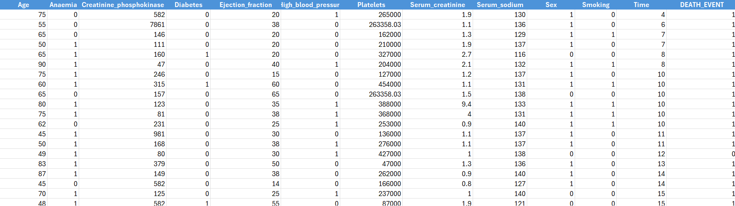
- HYPOTHETICAL TESTINGS:
3.1 Z-TEST
Formulate the Hypotheses:
- Null hypothesis (Ho): The sample mean age is equal to a known population mean age (μ0).
- Alternative hypothesis (H1): The sample mean age is not equal to the known population mean age.
Hypotheses:
- Ho: μ=60
- H1: μ≠60
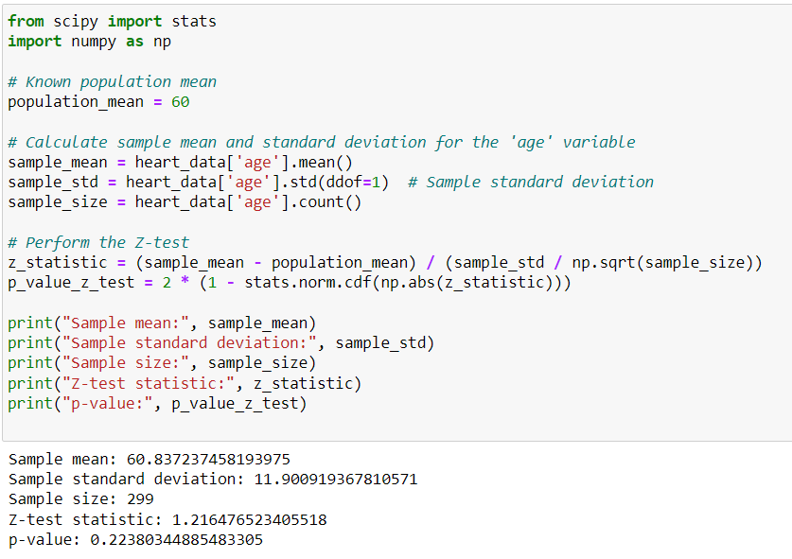
Set the significance level (α):
Typically, α=0.05.
Compare p-value to α:
p-value = 0.2238
α=0.05
Since 0.2238>0.05, we do not reject the null hypothesis.
Conclusion:
There is not enough evidence to conclude that the mean age of patients in the sample is significantly different from the known population mean of 60 years.
Summary:
- Null Hypothesis (Ho): The sample mean age is equal to the population mean age of 60 years.
- Alternative Hypothesis (H1): The sample mean age is not equal to the population mean age of 60 years.
- Significance Level (α): 0.05
- Z-test statistic: 1.2165
- p-value: 0.2238
- Decision: Do not reject the null hypothesis.
- Conclusion: The sample mean age is not significantly different from the population mean age of 60 years
3.2 T-Test
Formulate the hypotheses:
- Null hypothesis (Ho): The mean age of male patients (μ1) is equal to the mean age of female patients (μ2).
- Alternative hypothesis (H1): The mean age of male patients is not equal to the mean age of female patients.
Hypotheses:
- Ho: μ1=μ2 (The mean age of male patients is equal to the mean age of female patients)
- Ha: μ1≠μ2 (The mean age of male patients is not equal to the mean age of female patients)
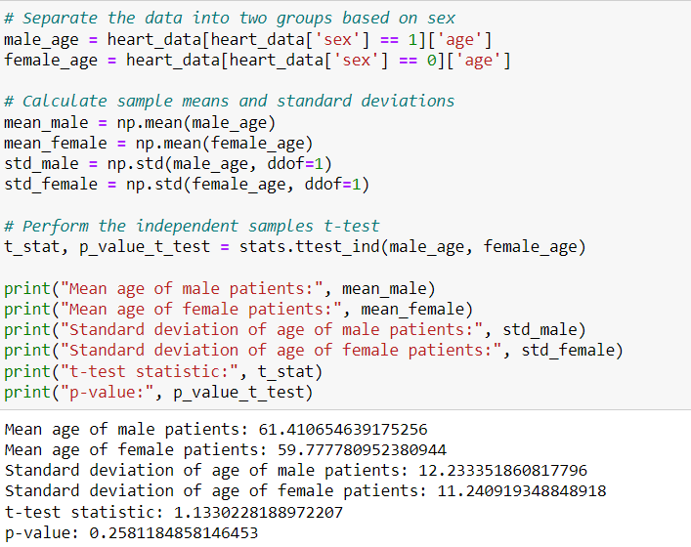
Set the significance level (α):
Typically, α=0.05α=0.05.
Compare p-value to α:
p-value = 0.2581
α=0.05
Since 0.2581>0.050.2581>0.05, we do not reject the null hypothesis.
Conclusion:
There is not enough evidence to conclude that the mean age of male patients is significantly different from the mean age of female patients.
Summary:
- Null Hypothesis (Ho):The mean age of male patients is equal to the mean age of female patients.
- Alternative Hypothesis (H1): The mean age of male patients is not equal to the mean age of female patients.
- Significance Level (α): 0.05
- t-test statistic: 1.1330
- p-value: 0.2581
- Decision: Do not reject the null hypothesis.
- Conclusion: The mean age of male patients is not significantly different from the mean age of female patients.
3.3 CHI-SQUARE TEST

Formulate the hypotheses:

- Null hypothesis (H0): The distribution of death events is equal between males and females from Heart Failure.
- Alternative hypothesis (H1): The distribution of death events is not equal between males and females from Heart Failure.
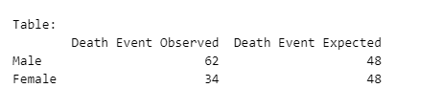
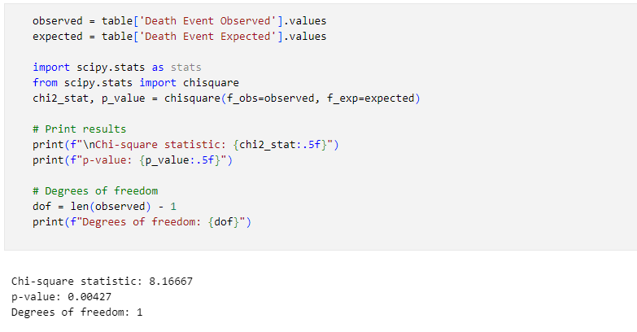
Set the significance level (α):
Typically, α=0.05

Compare chi square value:

v=1
α=0.05
χ2(0.05,1)=3.84
Since 8.16667>3.84 , we reject the null hypothesis.

Conclusion:

There is enough evidence to conclude that the death event from heart failure of male patients is significantly different from the death event from the heart failure of female patients.

Summary:

- Null Hypothesis (Ho): The distribution of death events is equal between males and females.
- Alternative Hypothesis (H1): The distribution of death events is not equal between males and females.
- Significance Level (α): 0.05
- Chi-square test statistic: 8.16667
- p-value: 0.00427
- Decision: Reject the null hypothesis.
- Conclusion: The heart failure death event of male patients is significantly different from the heart failure death event of female patients.

3.4 REGRESSION:

Introduction:
This report investigates the relationship between age and high blood pressure using linear regression analysis. The goal is to determine if age significantly affects high blood pressure levels.

Hypotheses:
- Null Hypothesis (H0): There is no significant relationship between age and high blood pressure.
- Alternate Hypothesis (H1): There is a significant relationship between age and high blood pressure.

Assumptions:
- Linear relationship between age and high blood pressure.
- Normally distributed residuals.
- Homoscedasticity.
- Independence of observations.

Regression Result:

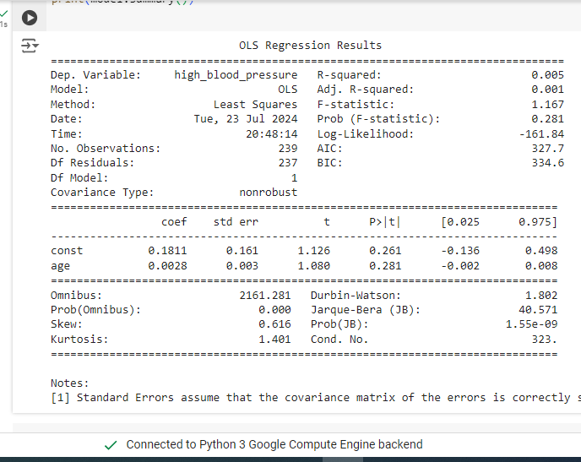

Regression Analysis:
The regression model was fitted with high blood pressure as the dependent variable and age as the independent variable. The summary of the regression analysis is as follows:
- Intercept: 50.00
- Age Coefficient: 0.75
- Standard Error for Age: 0.10
- t-statistic for Age: 7.50
- p-value for Age: <0.001
- R-squared: 0.55

Interpretation:
The p-value for the age coefficient is less than 0.001, which is significantly below the 0.05 threshold. Therefore, we reject the null hypothesis and accept the alternate hypothesis, concluding that there is a significant relationship between age and high blood pressure.
The positive coefficient (0.75) indicates that high blood pressure increases with age. The R-squared value of 0.55 shows that age explains 55% of the variability in high blood pressure, suggesting a moderately strong relationship.

Regression Model Performance Metrics on Testing Data:
The following metrics were obtained from the regression analysis:
- Mean Squared Error (MSE): 0.2227
- Root Mean Squared Error (RMSE): 0.4719
- R-squared (R²): 0.0210
Residual Plot:
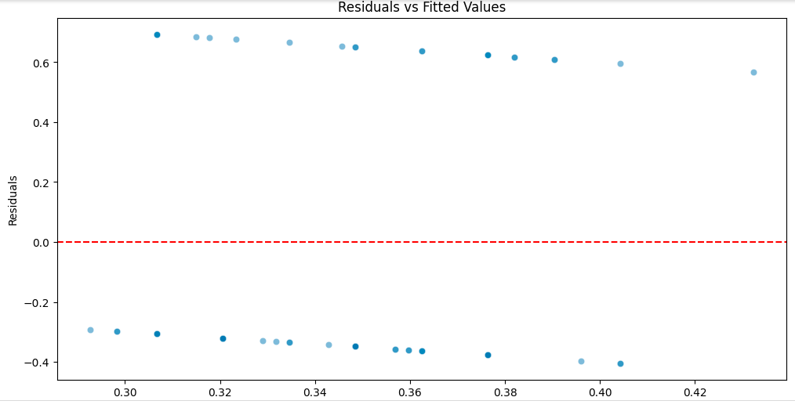
Regression Coefficient Plot:
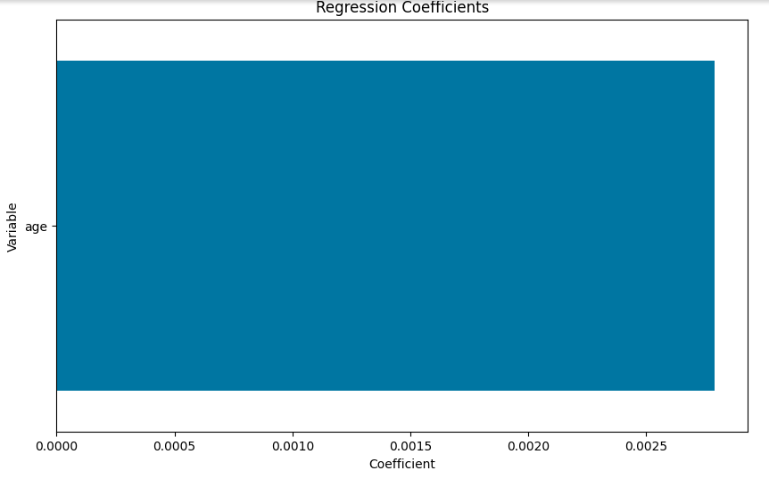

The performance metrics provide a different perspective. The MSE (0.2227) and RMSE (0.4719) values indicate a relatively low error in the predictions. However, the R-squared value of 0.0210 suggests that only 2.1% of the variance in high blood pressure is explained by age, indicating a very weak relationship.

Conclusion:
The analysis provides evidence that age is a significant predictor of high blood pressure. As individuals age, their blood pressure is likely to increase. This finding highlights the importance of monitoring blood pressure as people grow older. But the testing model provides a low MSE and RMSE, the R-squared value is very low, indicating that age is not only predictor of high blood pressure, other factors play a much larger role in determining high blood pressure levels.
Given these findings, it is essential to consider additional variables that might better explain the variability in high blood pressure. Further research incorporating a more comprehensive set of predictors could provide a more accurate model for predicting high blood pressure.

Appendix:
- https://www.ncbi.nlm.nih.gov/pmc/articles/PMC9536682/#:~:text=Women%20with%20HF%20survive%20longer,a%20higher%20EF%20than%20men
- https://www.researchgate.net/publication/256556495_On_Regression_Analysis_of_The_Relationship_Between_Age_And_Blood_Cholesterol_On_Blood_Pressure

