Breast Cancer Detection
A Comparative Machine-Learning Approach to Benign vs. Malignant Classification
Technical Project Report
Prepared by Anum Naveed
AI / ML Engineer — Computer Vision & Applied Machine Learning
August 2026

Abstract

This is among the main conditions in which the early diagnosis and accurate classification of patients could play an important role in the clinical decision-making process. In this study, a breast cancer classifier using machine learning has been developed based on the Wisconsin Diagnostic Breast Cancer Dataset that classifies the data into two classes namely, BENIGN and MALIGNANT according to 30 diagnostic features.
Instead of implementing a unique classifier, the project has used five common classifiers — Logistic Regression, Support Vector Machine (SVM), Random Forest, K-Nearest Neighbor (KNN), and Decision Tree classifiers – trained and compared on an identical 80/20 stratified train/test split dataset. Each of these classifiers' performances has been evaluated using seven metrics including accuracy, precision, recall, sensitivity, specificity, F1-score, and ROC-AUC; ROC-AUC automatically selects the best performing model, saves it for future use, and allows the prediction on new data. According to the current execution, the best performance has been achieved using Random Forest classifier with 97.4% accuracy and a ROC-AUC of 0.998, followed by Logistic Regression (ROC-AUC 0.996) and SVM (ROC-AUC 0.995), while KNN and Decision Trees have a poor performance. The whole pipeline has been converted into a web tool using Streamlit framework under the name of Oncoguard-AI.

Introduction
Determination of breast cancer implies differentiation between benign and malignant lesions/tumors. Machine learning can be applied for the analysis of numeric characteristics of breast cancer based on digitized images of fine needle aspirate of a breast mass, thus allowing to detect the patterns corresponding to two types of cancer without forcing a medical practitioner to compare numerous measurements.
This machine learning project uses the supervised learning technique. Input is provided in the form of numeric attributes taken from Wisconsin Diagnostic Breast Cancer dataset. Target variable corresponds to the diagnosis that was numerically coded as 0 - BENIGN and 1 - MALIGNANT. Instead of choosing one algorithm from the very beginning, the purpose of this project is comparison of several classification algorithms, thus proving the selection of one algorithm over others.

Problem Statement
The goal is to construct an effective machine learning system for classification of breast cancer into either benign or malignant classes according to its diagnostic features. Formally: given a set of diagnostic features of breast cancer, decide which class the example belongs to — benign or malignant.
In addition to building the effective classifier, we should implement evaluation mechanism allowing us to compare performances of various machine learning systems on an equal basis — because in the medical application, not only classification accuracy is important, but also confidence of the decision and calibration of probabilities.

Scope
•Loading the Wisconsin Diagnostic Breast Cancer Dataset.
•Checking for missing values in the dataset.
•Class distribution check.
•Feature and label preparation.
•Splitting data into train and test datasets.
•Feature scaling if required.
•Training of five different machine learning algorithms.
•Performance comparison.
•Evaluation using multiple classification metrics.
•Confusion matrix generation.
•ROC curve generation.
•Selection of best model based on ROC-AUC score.
•Model saving.
•Prediction on new patient feature data.
The present implementation is not an image-based breast tumor detection system; it neither trains nor uses a CNN-based model to classify images from mammograms, ultrasounds, or MRIs.

Related Work
Logistic Regression, Support Vector Machine, Decision Trees, Random Forest, and K-Nearest Neighbor techniques are popular approaches to binary classification tasks using medical data in the form of a structured table, as such algorithms work better on small-sized tabular data sets having a decent amount of good features — which perfectly describes the Wisconsin data set.
A comparative machine learning approach is taken in this project, where several classic machine learning algorithms are trained on the same data set and evaluated using various performance metrics, and not just presenting a single trained algorithm model. This approach was taken on purpose, as it will justify the chosen model, as it will be seen to outperform alternative models.

Objectives
Main Objective: The development of ML classification models for the distinction of benign and malignant breast cancer cases using diagnostic features from the Wisconsin Diagnostic Breast Cancer Dataset.
Supporting Objectives:
•Data preprocessing, which involves missing value detection and distribution among classes analysis.
•Training of several ML algorithms (Logistic Regression, SVM, Random Forest, KNN, Decision Tree) on the same train split.
•Evaluating their performance based on consistent multi-metric evaluation.
•Calculating clinically meaningful classification metrics such as sensitivity and specificity apart from accuracy.
•Automatic selection of the best model based on ROC-AUC metric.
•Saving the trained model for further use without retraining.
•Offering predictive capability for a new patient's feature values with probability estimates for each class instead of just one label.

Dataset
The current assignment will utilize the Wisconsin Diagnostic Breast Cancer Dataset, available in the program as the file named breast_cancer_dataset.csv. The label is the diagnosis column; all other 30 numeric columns, measuring radius, texture, perimeter, area, smoothness, concavity, and symmetry in terms of their average, standard error, and “worst” value are input features.
As the target has two classes, i.e., BENIGN and MALIGNANT, these labels will be turned into numerical labels (0 is BENIGN, and 1 is MALIGNANT) during training. No missing data were found in the dataset on any column, so the imputation step was unnecessary. Training set comprises 80% of the total data, while the test set consists of the other 20%. The dataset will be divided into two parts using stratify (stratify=y) to maintain its class ratio. The random_state parameter has a value of 42. For prediction of the new patient, an exact number of 30 features should be specified.

Dataset Flow
1. Wisconsin Diagnostic Breast Cancer Dataset (CSV File)
2. Data exploration – shape, head, data information
3. Check missing values
4. Check class distribution
5. Separate 30 diagnostic features and the diagnosis variable
6. Encode the diagnosis: BENIGN → 0, MALIGNANT → 1
7. 80% for training and 20% for testing
8. Feature standardization, if necessary
9. Train five machine learning models
10. Evaluation and comparison, and choose the best one using ROC-AUC

6. Methodology
Step 1 — Load Dataset
Firstly, the existence of breast_cancer_dataset.csv file is verified, and the program loads the dataset using pd.read_csv().
Step 2 — Data Analysis
Dataset shape, first five rows, dataset information (data types), number of null values (data.isnull().sum()), and class distribution are analyzed in this step.
Step 3 — Data Preparation
Diagnosis is extracted from the data as target value, while input features are 30 numerical columns.
Step 4 — Label Encoding
Label encoding is used for changing diagnosis text values to numerical: BENIGN → 0, MALIGNANT → 1.
Step 5 — Train-Test Splitting
Stratified 80-20 train-test splitting is performed using train_test_split method with parameters: test_size=0.20, random_state=42, stratify=y.
Step 6 — Model Training
Five ML algorithms (Logistic Regression, SVM, Random Forest, KNN, Decision Tree) are trained on the same training dataset (X_train, y_train).
Step 7 — Prediction
Each trained model makes prediction of held-out testing samples (X_test), which were not used during the training process.
Step 8 — Evaluation
Accuracy, precision, recall, sensitivity, specificity, F1-score, and ROC-AUC metrics are calculated for each model.
Step 9 — Models Comparison
The results of all models are gathered in one comparison table and sorted by ROC-AUC from top to bottom.
Step 10 — Best-Model Selection
Instead of manual choice of the best model, automatic selection of the best one is performed using ROC-AUC

Step 11 – Visualization

A confusion matrix is created along with the ROC curves of all the models and in addition to this, the feature importance graph is also plotted, if the Random Forest classifier is chosen as the best model.

Step 12 – Model Saving

The best model is saved with the help of Joblib and is named as best_breast_cancer_model.pkl.

Implementation Details
The solution has been developed using Python programming language with the use of Scikit-learn library for data preprocessing, training and evaluation of the machine learning model. Image augmentation techniques have not been applied in this case, since the solution involves the analysis of structured numeric data and not the image pixels.

Feature Scaling

StandardScaler is applied to Logistic Regression, SVM, and KNN because all these classifiers are distance-dependent and can be dominated by large numeric ranges. StandardScaler and the model are combined into pipelines within Scikit-learn, where the fit parameters of StandardScaler depend on the training set, and the exact same transformation is applied during predictions. Random Forest and Decision Tree classifiers are not scaled using StandardScaler because their splits do not depend on feature scales.

Model Storage
The selected best model is saved using Joblib as best_breast_cancer_model.pkl, allowing it to be loaded directly for inference without repeating the training pipeline.

Modules and Libraries
Module / Library | Purpose
os | File and path management
joblib | Saving the trained model
numpy | Numerical computation
pandas | Dataset and results handling
matplotlib | Graphs and visualization
train_test_split | Train/test division
StandardScaler | Feature standardization
Pipeline | Combining preprocessing and models
LogisticRegression | Classification
SVC | Support Vector Machine
RandomForestClassifier | Ensemble classification
KNeighborsClassifier | Neighbor-based classification
DecisionTreeClassifier | Tree-based classification
accuracy_score / precision_score / recall_score / f1_score | Core evaluation metrics
confusion_matrix / classification_report | Error analysis and per-class evaluation
roc_auc_score / roc_curve | ROC-AUC scoring and curve visualization

8. Training Strategy and Hyperparameters
The project uses a supervised machine-learning training strategy for binary breast-cancer classification. Five different classifiers are trained on the same training data, each predicts the same held-out test set, and the model with the highest ROC-AUC is automatically selected as the best model — no algorithm is favored by default.
Model | Hyperparameters
Logistic Regression | max_iter = 5000, random_state = 42
SVM | kernel = "rbf", probability = True, random_state = 42
Random Forest | n_estimators = 300, random_state = 42, class_weight = "balanced"
KNN | n_neighbors = 5
Decision Tree | random_state = 42, class_weight = "balanced"
Overall dataset configuration: test_size = 20%, random_state = 42. Class-weight balancing on Random Forest and Decision Tree helps offset any residual class imbalance between benign and malignant cases in the training split, so the models are not biased toward the majority class.

9. Pipeline Overview
The complete pipeline connects data loading through to a saved, reusable model:
1.Load the breast cancer CSV data file.
2.Check for nulls and class distribution.
3.Divide the features and the label and encode the diagnosis(BENIGN = 0, MALIGNANT = 1).
4.Do an 80/20 stratified train/test split.
5.Standardize features if needed (for Logistic regression, SVM, and KNN).
6.Train five classifiers using the same training set: Logistic regression, SVM, Random forest, KNN, and Decision tree.
7.Make predictions using the test set for all the five models.
8.Calculate accuracy, precision, recall, sensitivity, specificity, F1 score, and ROC-AUC for all five models.
9.Rank all five models according to the ROC-AUC and choose the top model.
10.Make a confusion matrix and plot ROC curves for the chosen model.
11.Save the chosen model.
12.Load the model and make prediction for a patient with 30 feature values.

10. Results
The program calculates seven evaluation measures for every model, stores them in a Pandas DataFrame sorted by ROC-AUC in descending order, and saves the comparison as model_comparison_results.csv. The table below reports the values obtained from the executed run:
Model | Accuracy | Precision | Recall | Sensitivity | Specificity | F1-score | ROC-AUC
Random Forest | 0.9737 | 1.0000 | 0.9286 | 0.9286 | 1.0000 | 0.9630 | 0.9980
Logistic Regression | 0.9649 | 0.9750 | 0.9286 | 0.9286 | 0.9861 | 0.9512 | 0.9960
SVM | 0.9737 | 1.0000 | 0.9286 | 0.9286 | 1.0000 | 0.9630 | 0.9947
KNN | 0.9561 | 0.9744 | 0.9048 | 0.9048 | 0.9861 | 0.9383 | 0.9823
Decision Tree | 0.9035 | 0.8974 | 0.8333 | 0.8333 | 0.9444 | 0.8642 | 0.8889
Ranked by ROC-AUC, Random Forest is selected as the best model (ROC-AUC = 0.998), narrowly ahead of Logistic Regression (0.996) and SVM (0.995). KNN follows at 0.982, while Decision Tree is clearly the weakest performer at 0.889 — consistent with a single decision tree being more prone to overfitting and less stable than an ensemble or a margin-based classifier on this dataset.
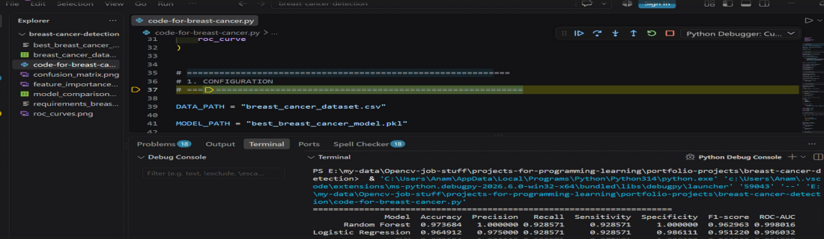
Figure 1. Terminal output showing the per-model comparison table, sorted by ROC-AUC (top two rows: Random Forest and Logistic Regression).

11. Confusion Matrix
A confusion matrix is generated for the selected best model (Random Forest) using its predictions on the 114-case test set. It reports true negatives, false positives, false negatives, and true positives, and is saved as confusion_matrix.png at 300 DPI.
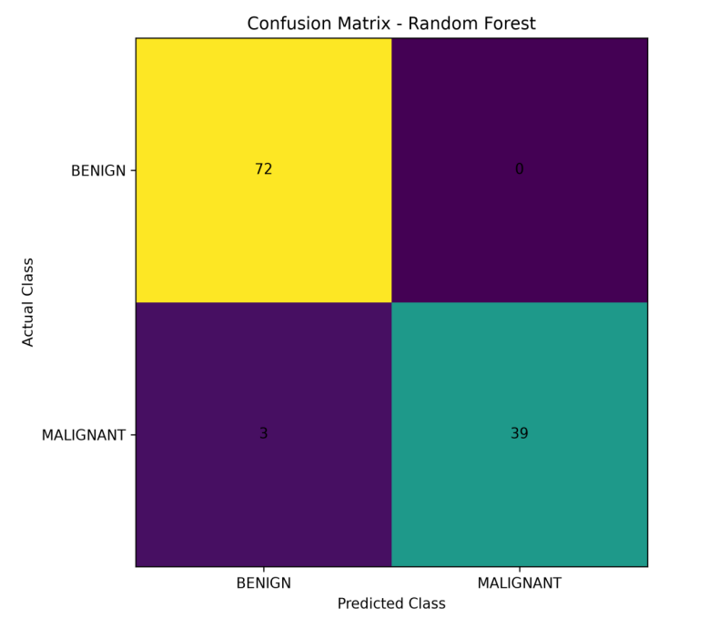
Figure 2. Confusion matrix for the best model (Random Forest). Of 114 test cases, 72 benign and 39 malignant cases were correctly classified, with 3 malignant cases misclassified as benign and 0 benign cases misclassified as malignant.
The confusion matrix is also used to calculate specificity: Specificity = TN / (TN + FP). In this run, Random Forest produced zero false positives (no benign case misclassified as malignant) but 3 false negatives (malignant cases misclassified as benign) — a pattern worth noting, since in a diagnostic-support context, false negatives (missed malignancies) generally carry a higher clinical cost than false positives, and this is exactly the kind of trade-off the confusion matrix makes visible in a way that a single accuracy figure would hide.

12. ROC Curves
This project does not use neural-network epochs, so conventional CNN training curves such as training/validation accuracy or loss versus epoch are not generated. Instead, the most relevant visualization for comparing classical classifiers is the ROC curve, plotted for all five models on the same axes and saved as roc_curves.png.
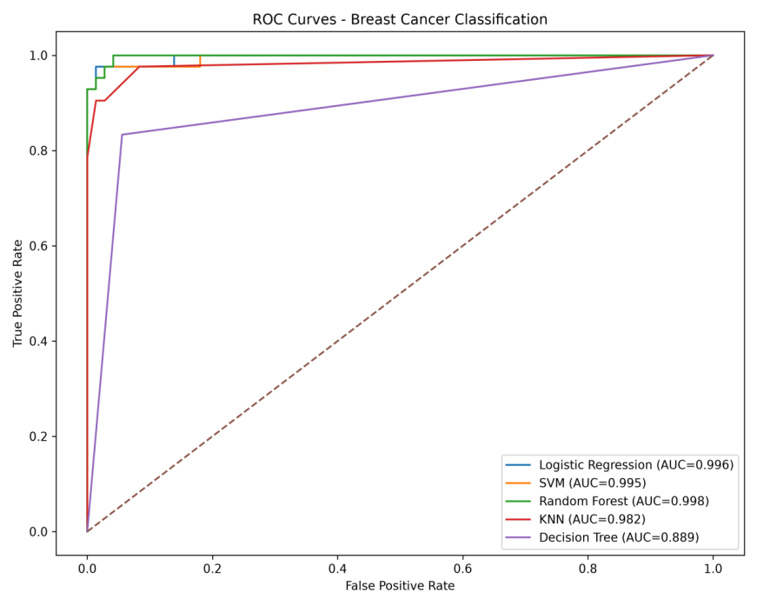
Figure 3. ROC curves for all five models. Random Forest (green, AUC = 0.998), Logistic Regression (blue, AUC = 0.996), and SVM (orange, AUC = 0.995) cluster near the top-left corner; Decision Tree (purple, AUC = 0.889) sits noticeably closer to the diagonal no-skill line.

13. Qualitative Results and Feature Importance
Qualitative visual analysis of medical images is not carried out as the project’s input consists of structured numerical diagnostic data as opposed to image data. Qualitative analysis is done through confusion matrix, ROC curves, model comparison, feature importance and prediction for individual new patient.
Since Random Forest is the model chosen for its better performance, the program will also give the top 10 most important features as feature_importance.png. The system can also give probabilities of benign/malignant for 30 feature values of a new patient in addition to just giving the class label.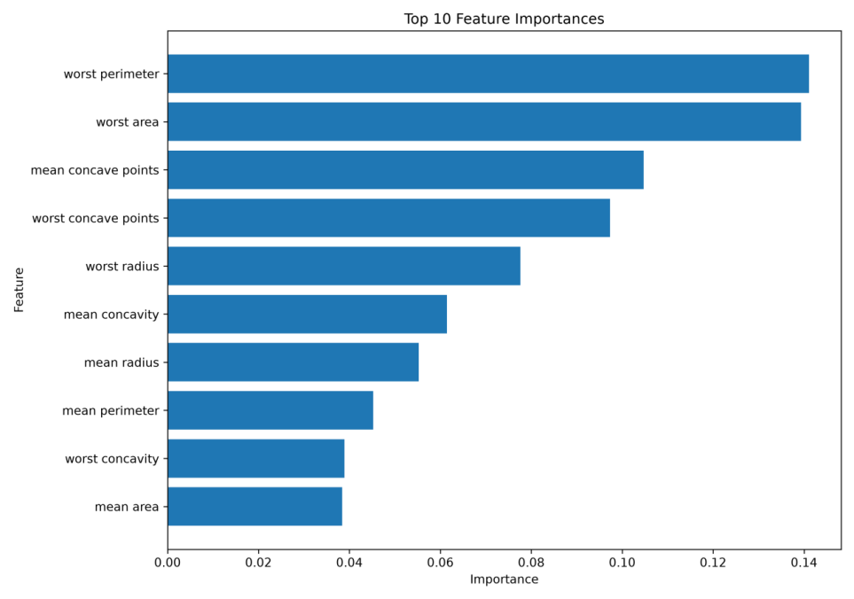
Figure 4. Top 10 feature importances from the Random Forest model. “Worst perimeter” and “worst area” — i.e., the largest observed tumor perimeter/area across cell nuclei in the sample — are the two most influential features, followed by measures of concavity.
The dominance of “worst” measurements (worst perimeter, worst area, worst concave points, worst radius) over their “mean” counterparts is a reasonable pattern clinically: the most extreme cell-nucleus measurements in a sample may be more indicative of malignancy than the average across all nuclei, since malignant regions can be localized within an otherwise more typical-looking sample.

14. Discussion

The analysis allows us to compare various machine learning algorithms for the breast cancer diagnostics task. The comparison is helpful as it allows to analyze different approaches to the decision boundary learning: Logistic Regression gives us a fairly simple linear classifier; SVM employs RBF kernel and thus allows to learn nonlinear relations between the features; Random Forest combines many decision trees and thus allows to learn nonlinear dependencies between features and average out overfitting caused by a single decision tree; KNN classifier uses neighboring samples in feature space for the classification; finally, Decision Tree is a simple sequence of decisions based on individual features.

In the case of this dataset, however, the three best models — Random Forest, Logistic Regression and SVM — are comparable in performance (with ROC-AUC ranging from 0.995 to 0.998), implying that classes are almost completely separable by the 30 features used for the classification using a reasonable classifier. There is, however, a noticeable difference at the bottom of the table: a Decision Tree classifier without averaging out the variance (and thus with higher risk of overfitting) has lower performance (ROC-AUC = 0.889). In terms of interpretability, however, Decision Tree is a winner, though it should not be preferred due to its weaker performance on this dataset.

The best algorithm in this case is selected automatically based on the ROC-AUC criterion.

Deployment — Oncoguard-AI
Aside from the pipeline used for training and testing the program via the command line, the whole project has now been developed into a full-fledged deployable product, named Oncoguard-AI, which is a web app created using Streamlit. The application makes use of the saved model file called best_breast_cancer_model.pkl and presents its features through an internet-based interface, such that the user can make predictions and outputs through interactive means and not just via command line or by saving a CSV file.

Limitations
The project utilizes table-based diagnostics features and not MRI, mammograms, or ultrasounds of the breast tissue – it is not an imaging detection tool.
•The project uses a single 80/20 train/test split and not a cross-validation technique, meaning that the numbers you see here represent just one particular split and not an average across multiple splits; a different split or a random seed may result in slightly different performance.
•The hyperparameters for the algorithms used were not optimized in any way – the values used (such as n_estimators=300 for RF and n_neighbors=5 for KNN) are default choices and not optimal.
•There is no external validation done against other datasets or patient population groups.
•Confidence intervals for all the reported metrics are not calculated by the algorithm implemented in the code; therefore, small differences in the performance of best performing models (e.g. Random Forest vs. Logistic Regression) should not be taken too seriously.
•A prediction provided by machine learning algorithm implemented in this system cannot be used as a medical diagnosis alone.

Conclusion
This solution applies an entire machine learning workflow for binary breast-cancer classification using structured diagnostic data. It reads and analyzes the data, encodes the diagnosis variable, performs stratified training/testing data split, trains five different machine learning algorithms on equal data, and evaluates their performance with seven metrics instead of only accuracy.
In the current execution, the algorithm automatically selected Random Forest as the best model with ROC-AUC of 0.998 and 97.4% accuracy just slightly beating Logistic Regression and SVM and saved it to a reusability-friendly .pkl file. The solution also generates a confusion matrix, ROC-curves comparison plot and, specifically for the Random Forest model, feature importance ranking, and can generate a prediction for a new patient with 30 input variables.
Therefore, the project provides an implemented and tested machine learning system for binary breast cancer classification into benign/malignant and wrapped in an interactive Oncoguard-AI website — but more work would be needed to use this solution clinically.

Key Points
•Project Name: Breast Cancer Detection
•Dataset: Wisconsin Diagnostic Breast Cancer Dataset
•Type of Problem: Binary Classification Problem (BENIGN v MALIGNANT)
•Input: 30 Numerical diagnostic Features
•Training / Testing Split: 80 / 20 Stratified; random_state = 42
•Models to Compare: 5 (Logistic Regression, SVM, Random Forest, KNN, Decision Tree)
•Feature Scaling: StandardScaler for Logistic Regression, SVM and KNN
•Criteria to Select Best Model: ROC-AUC Score
•Best Model Found: Random Forest Classifier — Accuracy 0.9737, ROC-AUC 0.9980
•Metrics of Evaluation: Accuracy, Precision, Recall, Sensitivity, Specificity, F1-Score, ROC-AUC Score
•Graphs and Visualizations:
Confusion Matrix Plot, ROC Plots, Feature Importance Plot (when Random Forest is the best model found)

19. Outputs
The program generates the following files:
Output File | Description
model_comparison_results.csv | Performance of all five models, sorted by ROC-AUC
best_breast_cancer_model.pkl | The saved best-performing trained model
confusion_matrix.png | Confusion matrix for the best model, saved at 300 DPI
roc_curves.png | ROC curve comparison across all five models
feature_importance.png | Top-10 feature importances (generated only when Random Forest is the best model)

