OncoGuard-AI
Breast Cancer Diagnostic Classification & Model Comparison
Technical Project Report
Prepared by Anum Naveed
AI / ML Engineer — Computer Vision & Applied Machine Learning
August 2026

Abstract
Early and accurate diagnosis is one of the strongest levers for improving breast cancer outcomes. This project builds a machine-learning-based classification system on the Wisconsin Diagnostic Breast Cancer (WDBC) dataset that labels a case as BENIGN or MALIGNANT from 30 numerical diagnostic features. Rather than committing to a single algorithm, five classical classifiers — Logistic Regression, SVM, Random Forest, KNN, and Decision Tree — are trained on an identical 80/20 stratified split and compared across seven evaluation metrics. Random Forest was automatically selected as the best model, reaching 97.4% accuracy and a 0.998 ROC-AUC on the held-out test set. The best model, its comparison table, confusion matrix, and ROC curves are saved for reuse, and the pipeline supports probability-based prediction for a new patient's feature values.

Introduction
Breast cancer detection involves determining whether a breast lesion is benign or malignant. Machine learning can analyze numerical diagnostic features and learn the patterns that separate these two classes. This project implements a supervised learning approach: the input is a set of numerical features from the WDBC dataset, and the target is the diagnosis, encoded as 0 = BENIGN and 1 = MALIGNANT. Rather than relying on a single model, the project deliberately compares multiple classification algorithms side by side and lets the data determine the best performer.

Problem Statement
Given a set of diagnostic breast-cancer features, determine whether the corresponding case belongs to the benign or malignant class — and provide a quantitative, multi-metric evaluation so that different machine-learning algorithms can be fairly compared on the same data.

Objective
To develop and compare machine-learning classification models for distinguishing benign and malignant breast cancer cases using diagnostic features from the Wisconsin Diagnostic Breast Cancer Dataset.
- Preprocess and validate the dataset.
- Train multiple ML algorithms on an identical split.
- Compare their performance using clinically relevant metrics.
- Select and save the best-performing model automatically.
- Support prediction for a new patient's feature values.

Scope
- Load the Wisconsin Diagnostic Breast Cancer Dataset and check it for missing values.
- Examine class distribution and prepare features / target labels.
- Split data into stratified training and testing sets, scaling features where required.
- Train five machine-learning algorithms and compare their performance.
- Calculate multiple classification metrics, a confusion matrix, and ROC curves.
- Select the best model by ROC-AUC and save it for reuse.
- Perform prediction for a new patient's feature values.
The current implementation works on structured diagnostic features — it is not an image-based tumor-detection system and does not perform CNN-based image classification.

Dataset
The project uses the Wisconsin Diagnostic Breast Cancer Dataset, supplied as breast_cancer_dataset.csv. It contains 569 patient records, each described by 30 real-valued diagnostic features computed from digitized images of breast mass fine-needle aspirates. The diagnosis column is separated from the remaining feature columns and used as the target.
Property | Value
Total samples | 569
Input features | 30 numerical diagnostic features
Target classes | BENIGN (0), MALIGNANT (1)
Train / test split | 80% / 20%, stratified (test set = 114 samples)
Random state | 42

- The program checks dataset shape, the first five records, dtypes, and missing values before use.
- No missing values were found in any column.
- Stratification (stratify = y) preserves the class balance between the training and testing subsets.
- The new-patient prediction function expects exactly 30 feature values, in the same order as the CSV feature columns.

Methodology
- Dataset loading — read breast_cancer_dataset.csv with Pandas.
- Dataset inspection — shape, head, dtypes, missing values, class distribution.
- Feature / target preparation — separate the diagnosis column from the input features.
- Label encoding — BENIGN → 0, MALIGNANT → 1.
- Dataset splitting — 80/20 stratified train/test split.
- Model training — five classifiers trained independently on the same training data.
- Prediction — each trained model predicts on the held-out test set.
- Evaluation — accuracy, precision, recall, sensitivity, specificity, F1-score, and ROC-AUC.
- Model comparison — results ranked by ROC-AUC, descending.
- Best-model selection — the model with the highest ROC-AUC is chosen automatically.
- Deployment-ready prediction — the selected model accepts 30 feature values for a new case and returns benign/malignant probabilities.

Preprocessing
- Missing-value check across every column via data.isnull().sum() — none found.
- Diagnosis encoded from text to numeric labels: BENIGN → 0, MALIGNANT → 1.
- 80/20 stratified split, using test_size = 0.20, random_state = 42, stratify = y.
There is no image augmentation in this project, since it works with structured numerical features rather than image pixels.

Feature Scaling
StandardScaler is applied to Logistic Regression, SVM, and KNN, combined with each model inside a Scikit-learn Pipeline so that scaling and classification are fit together without leaking test-set information. Random Forest and Decision Tree are tree-based and are used directly, without standardization.

Models & Hyperparameters
Five classifiers are trained independently on the identical training split and evaluated on the identical test split, which keeps the comparison fair:
Model | Key Hyperparameters
Logistic Regression | max_iter = 5000, random_state = 42
SVM | kernel = “rbf”, probability = True, random_state = 42
Random Forest | n_estimators = 300, random_state = 42, class_weight = “balanced”
KNN | n_neighbors = 5
Decision Tree | random_state = 42, class_weight = “balanced”

Tools & Libraries
- Python, with Scikit-learn for preprocessing, model training, and evaluation
- NumPy, Pandas — numerical computation and dataset / results handling
- Matplotlib — confusion matrix, ROC curves, and feature-importance plots
- Joblib — saving the trained model as best_breast_cancer_model.pkl
- Scikit-learn model classes — LogisticRegression, SVC, RandomForestClassifier, KNeighborsClassifier, DecisionTreeClassifier
- Scikit-learn metrics — accuracy_score, precision_score, recall_score, f1_score, confusion_matrix, classification_report, roc_auc_score, roc_curve
- Development environment — Visual Studio Code with the Python debugger

Pipeline Overview
- Load the CSV dataset and inspect it (shape, head, dtypes, missing values, class distribution).
- Separate features from the diagnosis target and encode BENIGN/MALIGNANT as 0/1.
- Split 80% training / 20% testing, stratified by class.
- Standardize features for Logistic Regression, SVM, and KNN inside a Pipeline.
- Train all five classifiers on the training set.
- Predict on the test set and compute accuracy, precision, recall, sensitivity, specificity, F1, and ROC-AUC for each model.
- Rank all models by ROC-AUC and select the best one.
- Generate the confusion matrix and ROC curves for the best model, plus feature importance if it is Random Forest.
- Save the best model as best_breast_cancer_model.pkl and the comparison table as model_comparison_results.csv.
- Use the saved model to predict benign/malignant probabilities for a new patient's 30 feature values.

Results
All five models were trained on the same 455-sample training set and evaluated on the same 114-sample held-out test set. The table below (sorted by ROC-AUC, descending, matching model_comparison_results.csv) reports all seven metrics; the best model is highlighted.
Model | Accuracy | Precision | Recall | Sensitivity | Specificity | F1 | ROC-AUC
Random Forest | 0.9737 | 1.0000 | 0.9286 | 0.9286 | 1.0000 | 0.9630 | 0.9980
Logistic Regression | 0.9649 | 0.9750 | 0.9286 | 0.9286 | 0.9861 | 0.9512 | 0.9960
SVM | 0.9737 | 1.0000 | 0.9286 | 0.9286 | 1.0000 | 0.9630 | 0.9947
KNN | 0.9561 | 0.9744 | 0.9048 | 0.9048 | 0.9861 | 0.9383 | 0.9823
Decision Tree | 0.9035 | 0.8974 | 0.8333 | 0.8333 | 0.9444 | 0.8642 | 0.8889

Random Forest achieved the highest ROC-AUC (0.998) and was selected automatically as the best model. It ties SVM on point-prediction metrics (accuracy, precision, recall, specificity, F1) but ranks predictions more reliably, which is what the AUC captures. Precision is reported for the malignant (positive) class.

Per-Class Report — Best Model (Random Forest)
Class | Precision | Recall | F1-Score | Support
Benign | 0.96 | 1.00 | 0.98 | 72
Malignant | 1.00 | 0.93 | 0.96 | 42
Accuracy |  |  | 0.97 | 114
Macro avg | 0.98 | 0.96 | 0.97 | 114
Weighted avg | 0.97 | 0.97 | 0.97 | 114

Confusion Matrix — Random Forest
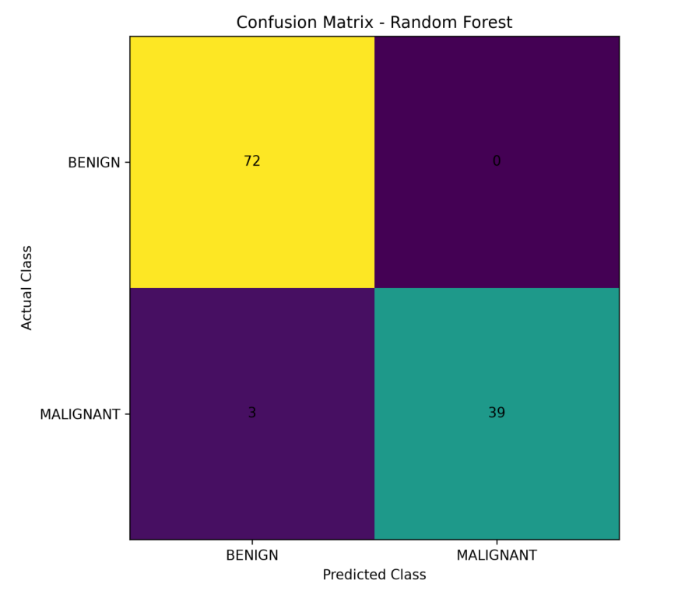
Figure 1. Test-set confusion matrix for the selected best model (114 test cases). Only 3 malignant cases were missed; no benign case was misclassified as malignant.

ROC Curve Comparison
This project uses classical (non-epoch-based) machine-learning algorithms, so conventional CNN-style training curves (accuracy/loss vs. epoch) do not apply. The ROC curve comparison is the equivalent visualization for this pipeline.
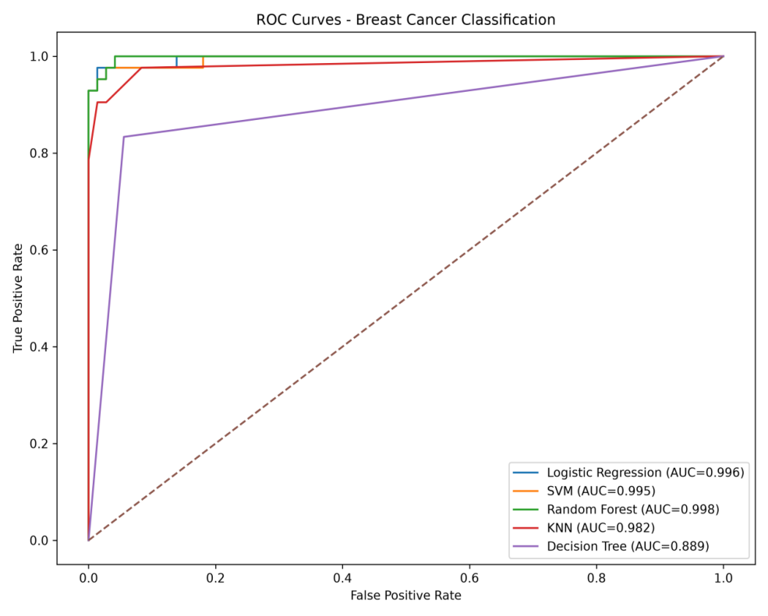
Figure 2. ROC curves for all five models. Random Forest (AUC = 0.998) and Logistic Regression (AUC = 0.996) lead; Decision Tree (AUC = 0.889) trails the rest.

Feature Importance
Because the best model is Random Forest, the pipeline also reports the top 10 most influential features.
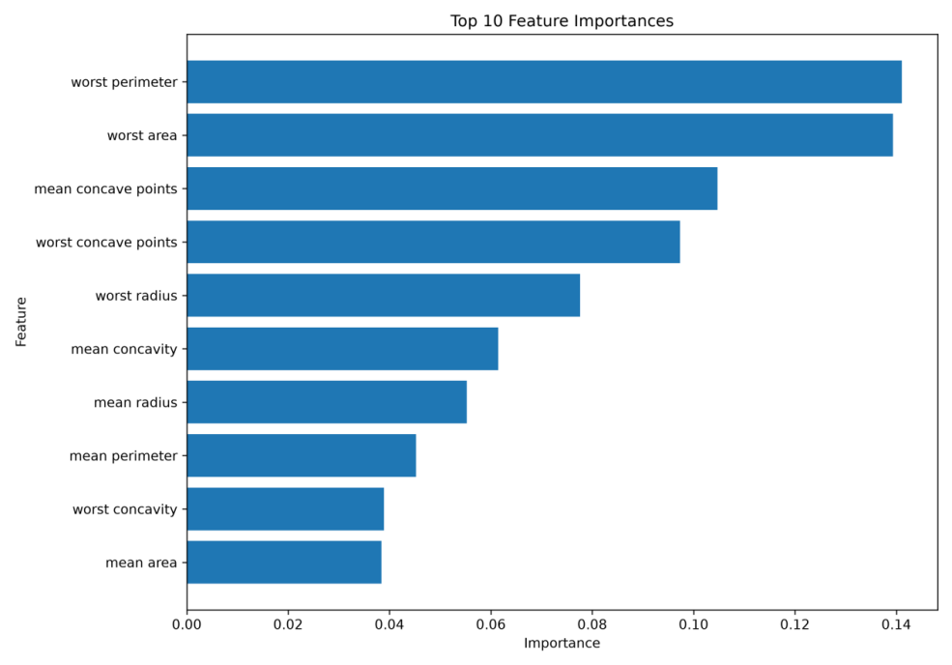
Figure 3. Top 10 feature importances. Worst perimeter and worst area dominate, followed by the concave-point measures — consistent with malignant tumors tending to be larger and less regular in shape.

Qualitative Results
Since the input is tabular diagnostic data rather than images, qualitative interpretation is based on the confusion matrix, ROC curves, and feature importance above, together with individual predictions for new patients. The pipeline also outputs benign/malignant probabilities for a new patient's 30 feature values, rather than a bare class label.

Discussion
- All five models perform well on this dataset, but they are not equivalent — Decision Tree lags noticeably (ROC-AUC 0.889 vs. ≥ 0.98 for the rest), consistent with a single tree overfitting more easily than an ensemble or a margin-based method.
- Random Forest and SVM are tied on point metrics (accuracy, precision, recall, F1), but Random Forest's higher ROC-AUC indicates better-calibrated confidence ranking across thresholds, which matters for triage-style use.
- Recall (sensitivity) for the malignant class is 0.93 for the best model — 3 of 42 malignant cases in the test set were missed. Precision is a perfect 1.00, meaning no benign case was flagged as malignant. In a clinical context the 3 missed cases are the more consequential error, since a false negative delays treatment.
- The best model is chosen automatically by ROC-AUC rather than by manually favoring one algorithm, keeping the selection process objective and reproducible.

Model Comparison
Model | Main Characteristic
Logistic Regression | Linear classification model
SVM | Nonlinear classification using an RBF kernel
Random Forest | Ensemble of 300 decision trees; captures nonlinear feature relationships
KNN | Classifies based on the 5 nearest neighboring samples
Decision Tree | Single rule-based tree; fastest but least robust here

Related Work
Logistic Regression, SVM, Decision Trees, Random Forests, and K-Nearest Neighbors are commonly used for binary classification on structured medical data. This project follows a comparative approach — training several classical algorithms on the same dataset and evaluating them with multiple performance measures — rather than committing to a single method or asserting improvement over specific prior published results.

Deployment — OncoGuard-AI
The classification pipeline was packaged into OncoGuard-AI, a Streamlit web application with a home page for viewing predictions and results, turning the saved model into an interactive, shareable tool rather than a script that only runs from the command line.

Limitations
- Uses tabular diagnostic features, not breast MRI, mammography, or ultrasound images.
- Evaluated with a single 80/20 train/test split rather than cross-validation.
- No automated hyperparameter search or systematic optimization is implemented.
- No external clinical validation, and no confidence intervals are reported for the metrics.
- Real-world clinical data streams may be less balanced than this research dataset.
- A machine-learning prediction should not be interpreted as a standalone medical diagnosis.

Important Disclaimer
- This system is a decision-support research prototype, not a diagnostic device.
- It does not replace a radiologist, oncologist, or pathologist's assessment.
- Trained and evaluated on a single public research dataset only, with no clinical trial validation or regulatory clearance.
- All predictions — for any patient — require qualified clinical review before acting on them.

Conclusion
This project implements a complete machine-learning pipeline for binary breast cancer classification. Five different algorithms were trained on the same 80/20 stratified split and evaluated on accuracy, precision, recall, sensitivity, specificity, F1-score, and ROC-AUC. Random Forest was automatically selected as the best model, reaching 97.4% accuracy and a 0.998 ROC-AUC, and was saved as a reusable .pkl file alongside a confusion matrix, ROC curve comparison, and feature-importance plot. Packaged as the OncoGuard-AI web app, the project provides a practical, comparative machine-learning framework for benign-versus-malignant classification — while actual clinical use would require further validation and expert medical oversight.

Key Points
- Project: Breast Cancer Detection (OncoGuard-AI)
- Dataset: Wisconsin Diagnostic Breast Cancer Dataset — 569 samples, 30 features
- Problem type: Binary classification — BENIGN vs. MALIGNANT
- Train/test split: 80/20, stratified, random_state = 42
- Models compared: 5 (Logistic Regression, SVM, Random Forest, KNN, Decision Tree)
- Best model: Random Forest — Accuracy 0.9737, ROC-AUC 0.9980
- Feature scaling: StandardScaler for Logistic Regression, SVM, and KNN
- Model-selection criterion: highest ROC-AUC
- Visualization: confusion matrix, ROC curves, feature importance
- Model format: .pkl (Joblib) · Framework: Scikit-learn · Execution: CPU-based
- Deployment: Streamlit web app (OncoGuard-AI)

Outputs Generated
File | Contents
model_comparison_results.csv | Performance of all five models across seven metrics
best_breast_cancer_model.pkl | The saved best-performing model (Random Forest)
confusion_matrix.png | Confusion matrix for the best model, saved at 300 DPI
roc_curves.png | ROC curves for all five models
feature_importance.png | Top 10 feature importances (generated when Random Forest is best)

Process Images on visual studio code:

