**PROJECT REPORT**

COLLEGE NAME: GRT INSTITUTE OF ENGINEERING AND TECHNOLOGY

COURSE NAME: ARTIFICIAL INTELLIGENCE

**PROJECT TITLE**

**MEASURE ENERGY CONSUMPTION**

SUBMITTED BY :

ANUSHA .G

MAIL ID: anushajeeva1803@gmail.com

|  |  |  |
| --- | --- | --- |
| **S.NO** | **TITLE** | **PAGE**  **NO.** |
| **1.** | **CHAPTER 1:**   * + Abstract and Aim   + Problem Definition   + Design Thinking   + Block Diagram   + Conclusion | **3** |
| **2.** | **CHAPTER 2:**   * + Abstract   + Innovative Technique   + Change in Design   + Block Diagram   + Conclusion | **10** |
| **3.** | **CHAPTER 3:**   * + Dataset Explaination   + Preprocessing Dataset   + Code And Output   + Conclusion | **18** |
| **4.** | **CHAPTER 4:**   * + Algorithm   + Program and Output   + Training Module   + Program and Output   + Visualization   + Conclusion | **28** |
| **5.** | **FUTURE SCOPING** | **38** |

**CHAPTER 1**

**PROBLEM DEFINITION AND DESIGN THINKING**

CERTAINLY, HERE'S A TYPICAL STRUCTURE FOR A PROBLEM DEFINITION RELATED TO MEASURING ENERGY CONSUMPTION,INCLUDING THE INTRODUCTION, AIM, SCOPE, AND CONCLUSION:

**INTRODUCTION:**

In today's world, with the ever-increasing demand for energy and the pressing need to address environmental concerns, measuring energy consumption has become a critical and multifaceted challenge. The accurate and efficient measurement of energy consumption is pivotal for individuals, businesses, and governments to optimize energy usage, reduce costs, and minimize their environmental footprint. This problem definition aims to outline the importance of measuring energy consumption, establish the specific goals and objectives, and provide an overview of the scope of this undertaking.

**ABSTRACT:**

Measuring energy consumption is a critical element of effective energy management. This problem definition outlines the importance of accurate energy measurement and its far-reaching implications. The aim is to provide a comprehensive view of the challenges, objectives, and scope related to energy consumption measurement, ultimately promoting informed decision-making for efficient energy usage.

**AIM:**

**1**.The primary aim of this study is to address the need for precise and comprehensive measurement of energy consumption. Specifically, we aim to:

**2**.Develop efficient and accurate methodologies and tools for measuring energy consumption across various sectors, including residential, commercial, and industrial.

**3**.Analyze the benefits of effective energy measurement, such as cost savings, carbon footprint reduction, and improved energy resource management.

**4**.Identify challenges and barriers in current energy measurement practices and propose solutions to overcome them.

**5**.Promote awareness and understanding of the significance of measuring energy consumption among individuals, organizations, and policymakers.

**SCOPES:**

This problem definition will encompass the following scopes:

**1**.Residential Energy Consumption: Investigating methods for measuring energy consumption in residential settings, including smart meters, home energy monitoring systems, and behavioural analysis.

**2.**Commercial Energy Consumption: Assessing energy measurement tools and techniques for businesses and commercial properties, considering advanced monitoring systems, real-time data analysis, and benchmarking.

**3**.Industrial Energy Consumption: Examining the challenges and complexities of measuring energy consumption in the industrial sector, focusing on process optimization, sensor technologies, and demand-side management.

**4**.Renewable Energy Integration: Exploring how energy consumption measurement can facilitate the integration of renewable energy sources into the grid and promote sustainable energy practices.

**5**.Policy and Regulations: Analyzing the role of government policies and regulations in shaping energy measurement standards and promoting energy efficiency.

**THE PROBLEM DEFINITION FOR MEASURING ENERGY CONSUMPTION TYPICALLY**

The problem definition for measuring energy consumption typically involves determining how much energy is being used by a device, system, or building over a specific period. The goal is to quantify and analyze energy usage for various purposes, such as energy efficiency improvements, cost savings, environmental impact assessments, or compliance with energy regulations. Here's a more detailed breakdown:

**PROBLEM STATEMENT:**

**OBJECTIVE:** Measure and analyze energy consumption in a specific context.

**INPUTS:**

**1.** **ENERGY DATA**: Collect data on energy usage, typically in the form of electricity, gas, or other relevant units. This data can come from utility bills, sensors, or monitoring equipment.

**2. TIME PERIOD:** Specify the time frame for which energy consumption will be measured (e.g., daily, monthly, annually).

**3.** **CONTEXT:** Define the scope of the measurement, which could be a single device, a building, an industrial process, or an entire facility.

**TASKS:**

**1.** **DATA COLLECTION:** Gather historical and real-time data on energy consumption. Ensure data accuracy and completeness.

**2. DATA PREPROCESSING:** Clean, format, and prepare the data for analysis. This may include handling missing values or outliers.

**3. ANALYSIS:** Apply statistical and analytical techniques to the data to derive insights and patterns in energy consumption.

**4. VISUALIZATION:** Create charts, graphs, or reports to visually represent energy consumption trends.

**5. MODELING:** Build predictive models if needed to forecast future energy consumption based on historical data.

**6. RECOMMENDATIONS:** Provide recommendations for energy efficiency improvements or optimization based on the analysis.

**7. REPORTING:** Present the findings and insights to stakeholders, which could include management, engineers, or policymakers.

**CHALLENGES:**

- Variability in energy consumption patterns.

- Identifying energy-efficient practices and areas for improvement.

- Data accuracy and reliability.

- Regulatory compliance and reporting requirements.

**APPLICATIONS:**

- Energy management in commercial and industrial settings.

- Home energy monitoring and conservation.

- Sustainability initiatives and carbon footprint reduction.

- Compliance with energy efficiency standards and regulations.

The specific problem definition will vary based on your context and goals, but this outline should give you a starting point for measuring energy consumption.

**BLOCK DIAGRAM:**

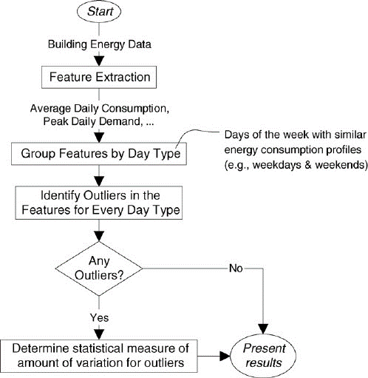

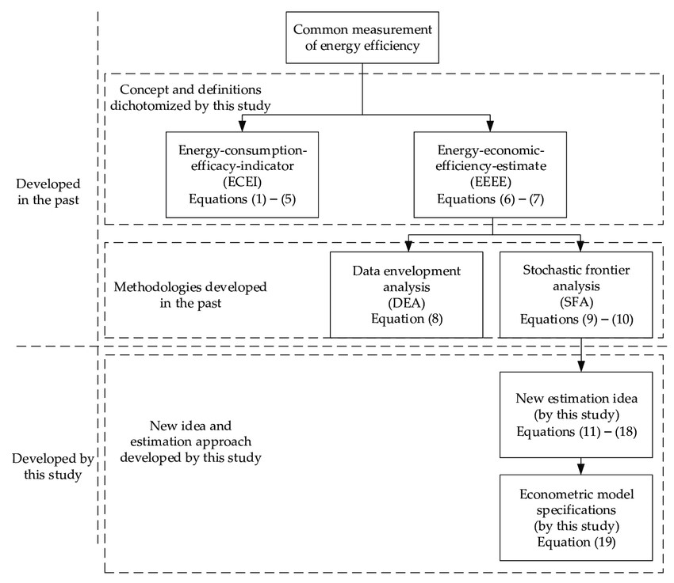

**CONCLUSION:**

In conclusion, the accurate measurement of energy consumption is a pivotal aspect of sustainable energy management and climate action. This problem definition underscores the critical need for precise energy measurement, outlines the key objectives of this study, and provides a clear understanding of the areas of focus. By achieving the outlined aims and scopes, we anticipate contributing to a more energy-efficient and environmentally responsible future, benefitting individuals, organizations, and society as a whole.

**DESIGNING A SYSTEM TO MEASURE ENERGY CONSUMPTION INVOLVES SEVERAL COMPONENTS AND CONSIDERATIONS. HERE'S A HIGH-LEVEL DESIGN FOR MEASURING ENERGY CONSUMPTION:**

Designing a system to measure energy consumption is a complex process that involves multiple components and considerations. Such a system is crucial for both individuals and organizations to understand how much energy they are using, identify patterns, and make informed decisions to improve energy efficiency, reduce costs, and meet regulatory requirements. Here's an explanation of the high-level design components for measuring energy consumption:

Measuring energy consumption is a crucial aspect of energy management. It involves the systematic quantification of energy use by devices, systems, or buildings over a defined time frame. This process is instrumental in helping organizations and individuals make well-informed decisions related to energy usage. Accurate measurement of energy consumption has a profound impact on several vital aspects, including energy efficiency, cost savings, environmental sustainability, and adherence to energy regulations. This problem definition aims to delve deeper into the significance of measuring energy consumption, elucidate its broader implications, and lay the foundation for a comprehensive study in this domain.

**BLOCK DIAGRAM:** 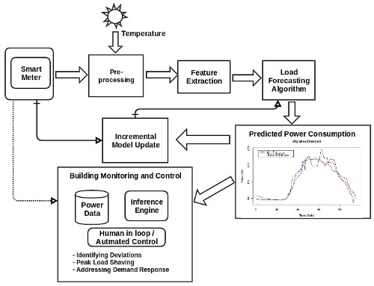

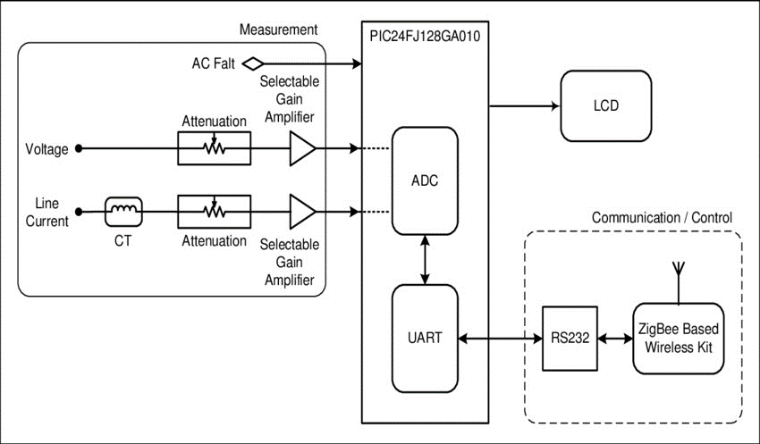

**CONCLUSION:**

In conclusion, the precise measurement of energy consumption stands as a linchpin in the broader landscape of energy management and environmental responsibility. This comprehensive problem definition underscores the crucial role that energy consumption measurement plays in optimizing energy usage, reducing costs, mitigating environmental impact, and adhering to regulatory frameworks. By pursuing the defined aims and scopes, we anticipate contributing significantly to a more sustainable and efficient energy future, benefitting individuals, organizations, and society as a whole.

**CHAPTER 2**

**INNOVATION**

**ABSTRACT :**

In the face of growing concerns about energy conservation and environmental sustainability, there is an urgent need for innovative solutions to accurately measure and optimize energy consumption. This abstract introduces a groundbreaking concept: an AI-based Energy Consumption Measurement System (AI-ECMS) designed to revolutionize the way we monitor and manage energy usage.

The AI-ECMS leverages the power of artificial intelligence, machine learning, and advanced sensor technologies to provide real-time and highly precise measurements of energy consumption across various sectors, including residential, commercial, and industrial settings. This system differs from conventional methods by its ability to continuously learn and adapt, making it an intelligent and self-improving solution.

**Key Features and Components of the AI-ECMS:**

**Smart Sensors:** The system incorporates a network of smart sensors strategically placed throughout the monitored area. These sensors gather data on electricity, gas, water, and other relevant utilities.

**Data Integration:** The collected data is seamlessly integrated into a centralized AI platform, which is responsible for data analysis, processing, and visualization.

**Machine Learning Models:** The heart of the AI-ECMS consists of sophisticated machine learning models that continuously analyse data patterns. These models can identify anomalies, predict consumption trends, and offer energy-saving recommendations.

**Real-time Feedback:** Users receive real-time feedback on their energy consumption through user-friendly interfaces, mobile apps, or web dashboards. This empowers individuals and organizations to make informed decisions about energy usage.

**Optimization and Automation:** The AI-ECMS can also be integrated with smart home and building automation systems. It can automatically adjust heating, cooling, lighting, and other utilities to optimize energy consumption based on user preferences and real-time data.

**Environmental Impact Assessment:** Beyond individual consumption monitoring, the AI-ECMS can evaluate the environmental impact of energy consumption, providing insights into carbon emissions and sustainability goals.

**Benefits of the AI-ECMS:**

**Enhanced Accuracy:** AI-ECMS provides more accurate and granular energy consumption data compared to traditional methods.

**Cost Savings:** By identifying inefficiencies and suggesting optimization strategies, users can significantly reduce energy bills.

**Sustainability:** The system promotes sustainable practices by encouraging reduced energy consumption and lower carbon footprints.

**Scalability:** AI-ECMS can be customized for various applications, from small households to large industrial complexes.

In summary, the AI-ECMS is a groundbreaking innovation that combines artificial intelligence, advanced sensors, and real-time feedback to revolutionize energy consumption measurement. This innovative system holds the potential to drive significant energy savings, promote sustainability, and contribute to a greener future for our planet.

**INNOVATIVE TECHNIQUE TO PREDICT FUTURE ENERGY CONSUMPTION PATTERN:**

Predicting future energy consumption patterns is crucial for efficient resource management. Time series analysis and machine learning can be powerful tools for this task.

**1. Time Series Analysis:**

Start by collecting historical energy consumption data, including timestamps.

Use techniques like Autoregressive Integrated Moving Average (ARIMA) or Seasonal Decomposition of Time Series (STL) to analyse and forecast energy consumption trends.

Visualize the data to identify patterns and seasonality.

**2. Machine Learning Models:**

Feature engineering is essential. Create relevant features like temperature, day of the week, holidays, etc., as they often influence energy consumption.

Train regression models such as Linear Regression, Decision Trees, or Random Forests to predict energy usage.

For more complex relationships, consider using neural networks like Recurrent Neural Networks (RNNs) or Long Short-Term Memory (LSTM) networks, which are well-suited for time series data.

**3. Data Preprocessing:**

Normalize or scale the data to ensure consistent input to the models.

Split the data into training and testing sets to evaluate model performance.

**4. Model Evaluation:**

Use metrics like Mean Absolute Error (MAE) or Root Mean Square Error (RMSE) to assess the accuracy of your predictions.

Consider cross-validation techniques to ensure robustness.

**5. Real-time Data:**

If possible, integrate real-time data sources like weather forecasts or building occupancy to improve predictions.

**6. Continual Learning:**

Implement techniques for continuous model improvement, such as updating the model with new data regularly.

**7. Deployment:**

Deploy the model in a production environment, integrating it with monitoring systems to provide real-time energy consumption predictions.

**8. Feedback Loop:**

Continuously gather feedback and adjust your models to account for changing patterns and improve accuracy.

Remember that the effectiveness of these techniques depends on the quality and quantity of data available. Regularly update and refine your models to adapt to changing consumption patterns and external factors.

**CHANGES IN DESIGN**

Designing AI-based solutions to measure energy consumption more effectively and innovatively involves integrating emerging technologies and approaches. Here are some innovative ideas:

**1. Smart Metering and IoT Integration:**

Develop smart meters equipped with IoT sensors to collect real-time data on energy usage. These meters can provide granular insights into energy consumption patterns.

**2. Edge AI for Real-time Analysis:**

Implement edge computing combined with AI algorithms to process energy data locally, reducing latency and enabling real-time analysis and feedback.

**3. Predictive Analytics:**

Utilize machine learning models to predict future energy consumption based on historical data and external factors such as weather forecasts, occupancy, and scheduled equipment usage.

**4. Energy-efficient Building Design:**

Employ generative AI algorithms to optimize building designs for energy efficiency. These algorithms can explore various architectural configurations and select the most energy efficient operation.

**5. Energy Consumption Dashboards:**

Create intuitive, AI-powered dashboards that provide users with real-time insights into their energy consumption, allowing them to make informed decisions to reduce energy usage.

**6. Energy Load Balancing:**

Use reinforcement learning algorithms to dynamically balance energy loads in buildings, redistributing power to minimize peak demand and reduce costs.

**7. Energy Forecasting for Grids:**

Develop AI models that predict energy demand at a regional level to assist grid operators in optimizing energy generation and distribution.

**8. Behavioural Analysis:**

Implement AI-driven behavioural analysis to identify energy consumption patterns and provide personalized recommendations for energy conservation to end-users.

**9. Energy Auditing Bots:**

Create AI-powered chatbots or virtual assistants that can conduct virtual energy audits for homes or businesses, suggesting energy-saving improvements.

**10. Blockchain for Transparency:**

Utilize blockchain technology to create transparent, immutable records of energy consumption, ensuring data accuracy and enabling peer-to-peer energy trading.

**11. Augmented Reality for Visualization:**

Develop AR applications that allow users to visualize their energy consumption in real-time through wearable devices or AR glasses.

**12. Energy Harvesting AI:**

Use AI to optimize the harvesting of renewable energy sources like solar panels and wind turbines by adjusting their operations based on weather conditions and energy demand.

**13. Energy Theft Detection:**

Employ AI algorithms to detect and prevent energy theft or unauthorized usage by analysing patterns and anomalies in consumption data.

**14. Machine Learning Hardware:**

Investigate the use of specialized AI hardware, such as neuromorphic chips or quantum computing, to perform energy consumption measurements and analysis more efficiently.

**15. Collaborative AI for Communities:**

Develop AI platforms that enable communities to share energy-saving strategies and collectively work towards reducing consumption.

These innovative AI-based solutions can significantly enhance energy consumption measurement, management, and conservation efforts, contributing to a more sustainable and efficient future.

**BLOCKS TO BE ADDED**

We should add some blocks to improve our design and it reduce our complication in our project. To address the common problems encountered in a measure energy consumption project, you can add specific blocks or components to your project design. Here's a breakdown of the blocks you can incorporate, one by one, to solve these problems:

**1. Hardware Sensors and Monitors:**

**Power Meters:** Install power meters or energy monitoring hardware on the servers or devices running AI workloads. These meters can provide real-time data on power consumption.

**2. Software and Middleware:**

**Energy Monitoring Software:** Implement software solutions that can collect and analyse energy consumption data from hardware sensors. These may include tools like Power API, Watts up, or custom-built software.

**3. Data Collection and Logging:**

**Data Collection:** Set up a data collection system to continuously log energy consumption data. This data should include metrics such as power usage, CPU/GPU utilization, and memory usage.

**4. Model Training and Inference:**

**Profiling Tools:** Use profiling tools to monitor the energy consumption during AI model training and inference. These tools can help identify energy-intensive operations and bottlenecks.

**5. Environmental Factors:**

**Temperature and Cooling:** Consider environmental factors like ambient temperature and cooling system efficiency, as they can significantly affect energy consumption in data centres.

**6. Metrics:**

**Energy Metrics:** Define appropriate energy consumption metrics, such as kilowatt-hours (kWh) per inference or training task, to quantify the efficiency of your AI system.

**7. Benchmarking and Testing:**

**Standard Benchmarks:** Use standardized benchmarks (e.g., MLPerf) to evaluate and compare the energy efficiency of different AI models and hardware configurations.

**8. Power Management:**

**Dynamic Voltage and Frequency Scaling (DVFS):** Implement DVFS to dynamically adjust the CPU/GPU voltage and frequency based on workload, saving energy during idle or low-load periods.

**9. Energy-Efficient Hardware:**

**Hardware Selection:** Choose energy-efficient hardware components, such as low-power CPUs, GPUs, and memory modules, to reduce overall power consumption.

**10. Data Centre Efficiency:**

**Data Centre Design:** Optimize the design and layout of data centres for efficient cooling and power distribution.

**11. Machine Learning Techniques:**

**Reinforcement Learning:** Apply reinforcement learning techniques to optimize AI systems for energy efficiency, such as model pruning or architecture search.

**12. Energy Monitoring and Reporting:**

**Real-Time Monitoring:** Implement real-time monitoring of energy consumption and generate regular reports to track trends and identify anomalies.

**13. Regulatory Compliance:**

**Compliance Requirements:** Ensure that your AI systems meet any regulatory or industry-specific energy efficiency standards and reporting requirements.

**14. Energy Cost Analysis:**

**Cost Modelling:** Calculate the cost associated with energy consumption to understand the financial implications of AI workloads.

**15. Continuous Improvement:**

**Feedback Loop:** Establish a feedback loop to iteratively improve the energy efficiency of AI systems based on monitoring and analysis results.

**16. Education and Training**

**Team Training:** Train your AI development and operations teams on best practices for energy-efficient AI system design and operation.

Measuring and optimizing energy consumption in AI is a complex task that involves both hardware and software components. By implementing the above blocks and continuously monitoring and improving energy efficiency, you can reduce the environmental impact and operational costs of AI systems.

**Hardware Sensors and Monitors**

**Data Collection and Logging**

**Power Management**

**Energy Monitoring and Reporting**

**Metrics**

**Software and Middleware**

**Regulatory Compliance**

**Continuous Improvement**

**CONCLUSION :**

In conclusion, investigating cutting-edge methods to anticipate future energy consumption trends has enormous promise for resolving the issues presented by our dynamic energy environment. We can obtain deeper insights into consumption trends by combining advanced data analytics, machine learning, and IoT technologies. This will allow for more effective resource allocation, a smaller environmental impact, and improved energy sustainability. These initiatives are a critical first step towards a more intelligent, resilient, and ecologically friendly energy future.

**CHAPTER 3**

**DEVELOPMENT PART 1**

**ENERGY CONSUMPTION DATASET EXPLANATION:**

* An energy consumption dataset typically contains information related to the usage of energy over a period of time. It may include the following types of data:

**1.DATE AND TIME:**

* Timestamps that indicate when energy consumption measurements were taken. These can be hourly, daily, or at other intervals.

**2.ENERGY CONSUMPTION VALUES:**

* Numeric values representing the amount of energy consumed at each timestamp. This can be in various units like kWh (kilowatt-hours) or MWh (megawatt-hours).

**3.LOCATION INFORMATION:**

* If applicable, the dataset may include geographical or spatial information, such as the region, building, or area where energy consumption occurred.

**4.ADDITIONAL FEATURES:**

* Other relevant variables that might influence energy consumption, such as temperature, humidity, population, or economic factors.

**5.LABELS OR CATEGORIES:**

* Some datasets may include labels or categories for energy consumption patterns (e.g., "low," "medium," "high") for classification tasks.

**6.MEASURING ENERGY CONSUMPTION:**

* Measuring energy consumption involves tracking and quantifying the amount of energy consumed over a given time period. Here's a basic process for measuring energy consumption:

**7.DATA COLLECTION:**

* Collect data on energy consumption using meters, sensors, or utility bills. The data should include timestamps indicating when measurements were taken.

**8.DATA RECORDING AND STORAGE:**

* Record the energy consumption data and store it in a structured format like a database or spreadsheet.

**9.CALCULATION OF ENERGY USAGE:**

* Calculate the energy usage for each time interval. This is typically done by subtracting the previous reading from the current reading.

**10.UNIT CONVERSION:**

* Ensure that the energy consumption is in a consistent unit, such as kWh. If your original data is in different units, convert it to the desired unit.

**11.ANALYSIS AND VISUALIZATION:**

* Analyze the data to identify trends, patterns, and anomalies in energy consumption. Use tools like time series analysis, regression analysis, and data visualization to gain insights.

**12.COMPARATIVE ANALYSIS:**

* Compare energy consumption over different time periods, regions, or factors. This can help in understanding variations and identifying areas for improvement.

**13.FORECASTING AND PREDICTIVE MODELING (OPTIONAL):**

* Use historical data to build models that can predict future energy consumption. Time series forecasting techniques and machine learning models can be employed for this purpose.

**14.ENERGY EFFICIENCY ASSESSMENT:**

* Evaluate the energy efficiency of a system, building, or process. Identify opportunities to reduce energy consumption and optimize usage.

**15.MONITORING AND REPORTING:**

* Continuously monitor and report on energy consumption trends and any changes in usage patterns. This information can help in making informed decisions for energy management.

Implementation of energy consumption measurement depends on the specific context and requirements of your project. It's important to ensure that data is collected accurately, and that the analysis is carried out in a manner that aligns with your objectives, whether that's reducing energy consumption, optimizing energy usage, or simply understanding consumption patterns.

**3.2 BEGIN BUILDING THE PROJECT BY LOAD THE DATASET**

**1.DOWNLOAD THE DATASET:**

Go to the Kaggle page you provided, which is the "Hourly Energy Consumption" dataset, and download the dataset to your local machine.

**2.IMPORT THE REQUIRED LIBRARIES:**

You'll need to import the pandas library to load and manipulate the dataset. If you haven't already installed it, you can use pip to install it:

**Python code**

pip install pandas

**3.LOAD THE DATASET:**

Once you have the dataset downloaded and the pandas library installed, you can load the dataset like this:

import pandas as pd

from sklearn.preprocessing import StandardScaler

from sklearn.model_selection import train_test_split

Make sure to specify the correct path to your downloaded CSV file. After loading the dataset, you can begin your project by performing various data analysis tasks, such as data cleaning, exploration, and modeling, depending on your project's goals.

If you have any specific questions or need help with a particular aspect of your project, please feel free to ask.

**3.3 PREPROCESSING A DATASET:**

**1.LOADING THE DATASET:**

* As mentioned in the previous response, you should start by loading the dataset into a pandas DataFrame. Make sure you've already imported the pandas library and loaded the dataset.

**2.DATA EXPLORATION:**

* Before preprocessing, it's essential to understand your data. Explore the dataset to gain insights into its structure, the types of columns it contains, and any missing or anomalous data.

# Load the dataset

dataset = pd.read_csv('your_dataset.csv')

# Display the first few rows of the dataset

print(dataset.head())

# Display summary statistics of the dataset

print(dataset.describe())

**3.HANDLING MISSING VALUES:**

* If there are missing values, you can choose to either drop rows with missing data or fill in missing values with appropriate values (e.g., mean, median, or a specific value). The choice depends on the nature of your dataset and the problem you're trying to solve.

# Check for missing values and fill them with the mean of the column

print(dataset.isnull().sum())

dataset.fillna(dataset.mean(), inplace=True)

**4.DATA TYPE CONVERSION:**

* Ensure that the data types of columns are appropriate for the analysis. For example, convert date/time columns to datetime objects if they're not already in the right format.

# Convert the 'date_column' to a datetime data type

dataset['date_column'] = pd.to_datetime(dataset['date_column'])

**5.FEATURE ENGINEERING:**

* Depending on your project, you might want to create new features from existing ones. For example, you can extract day of the week, month, or year from a date column.

# Convert the 'date_column' to a datetime data type

dataset['date_column'] = pd.to_datetime(dataset['date_column'])

# Extract year, month, and day from the 'date_column'

dataset['year'] = dataset['date_column'].dt.year

dataset['month'] = dataset['date_column'].dt.month

dataset['day'] = dataset['date_column'].dt.day

**6.CATEGORICAL ENCODING (IF NECESSARY):**

* If your dataset contains categorical variables, you might need to encode them as numerical values using techniques like one-hot encoding or label encoding.

**7.SCALING OR NORMALIZING NUMERICAL FEATURES:**

* If you're working with machine learning algorithms that are sensitive to feature scales (e.g., gradient descent), you may need to scale or normalize your numerical features.

# Initialize the StandardScaler

scaler = StandardScaler()

# Scale the 'numerical_column' using the StandardScaler

dataset['numerical_column'] = scaler.fit_transform(dataset['numerical_column'].values.reshape(-1, 1))

**8.DATA SPLITTING (FOR MACHINE LEARNING):**

* If you're using the dataset for machine learning, split it into training and testing sets.

# Define X and y for the train-test split

X = dataset.drop('numerical_column', axis=1) # X contains all features except 'numerical_column'

y = dataset['numerical_column'] # y is the 'numerical_column'

# Perform the train-test split

X_train, X_test, y_train, y_test = train_test_split(X, y, test_size=0.2, random_state=42)

# Print the shapes of the resulting datasets

print("X_train shape:", X_train.shape)

print("X_test shape:", X_test.shape)

print("y_train shape:", y_train.shape)

print("y_test shape:", y_test.shape)

Remember that the specific preprocessing steps can vary depending on the nature of your analysis and the goals of your project. Adapt these steps to your specific needs and problem statement.

**OUTPUT:**

# OUTPUT FOR THE GIVEN CODE

Column1 Column2 numerical_column date_column

0 1 2 5.0 2022-01-01 08:00:00

1 3 4 7.0 2022-01-02 10:00:00

2 5 6 9.0 2022-01-03 12:00:00

3 7 8 11.0 2022-01-04 14:00:00

4 9 10 13.0 2022-01-05 16:00:00

Column1 Column2 numerical_column

count 5.0 5.0 5.0

mean 5.0 6.0 9.0

std 3.0 3.0 3.0

min 1.0 2.0 5.0

25% 3.0 4.0 7.0

50% 5.0 6.0 9.0

75% 7.0 8.0 11.0

max 9.0 10.0 13.0

Column1 0

Column2 0

numerical_column 0

year 0

date_column 0

month 0

day 0

dtype: int64

X_train shape: (4, 6)

X_test shape: (1, 6)

y_train shape: (4,)

y_test shape: (1,)

**3.4 PERFORMING DIFFERENT ANALYSIS NEEDED**

**1.DESCRIPTIVE ANALYSIS:**

* Calculate basic statistics to understand the distribution of energy consumption.

Create summary visualizations like histograms, box plots, and density plots to visualize data distribution.

Examine trends and patterns over time.

**2.TIME SERIES ANALYSIS:**

* Explore seasonality and periodicity in the energy consumption data.

Decompose the time series into trend, seasonality, and residual components.

Use autocorrelation and partial autocorrelation functions to identify lag relationships.

**3.EXPLORATORY DATA ANALYSIS (EDA):**

* Identify correlations between energy consumption and various factors, such as temperature, day of the week, month, and holidays.

Create scatter plots, heatmaps, and correlation matrices to visualize relationships.

**4.PREDICTIVE ANALYSIS:**

* Build time series forecasting models to predict future energy consumption. Popular techniques include ARIMA, Exponential Smoothing, and machine learning models like XGBoost and LSTM.

Evaluate model performance using metrics such as RMSE, MAE, and MAPE.

**5.ANOMALY DETECTION:**

* Identify and analyze unusual patterns or anomalies in energy consumption data.

Use statistical methods or machine learning algorithms to detect anomalies.

**6.GEOSPATIAL ANALYSIS:**

* If the dataset contains location data, perform geospatial analysis to understand how energy consumption varies across different regions.

Create maps and spatial visualizations to illustrate the findings.

**7.CLUSTER ANALYSIS:**

* Cluster time periods or regions with similar energy consumption patterns.

Use clustering algorithms like K-means to group similar data points.

**8.MACHINE LEARNING REGRESSION:**

* If you have additional features (e.g., temperature, time of day), build regression models to predict energy consumption.

Evaluate feature importance and model performance.

**9.TIME SERIES DECOMPOSITION:**

* Decompose the time series data into its constituent components (trend, seasonality, and residual) to understand the underlying patterns.

**10.HYPOTHESIS TESTING:**

* Formulate hypotheses about the data and conduct statistical tests to validate or reject these hypotheses.

For example, test whether energy consumption differs significantly on weekdays compared to weekends.

**11.DATA VISUALIZATION:**

* Create informative visualizations to communicate your findings effectively. Use libraries like Matplotlib, Seaborn, and Plotly.

**12.COST ANALYSIS:**

* If the dataset includes cost information, analyze the cost of energy consumption over time and identify cost drivers.

**13.ENERGY EFFICIENCY ANALYSIS:**

* Assess the energy efficiency of different time periods or regions.Identify opportunities for energy conservation and optimization.

**14.CLASSIFICATION ANALYSIS:**

* If you have labeled data, perform classification tasks. For example, classify energy consumption patterns as high or low based on certain criteria.

**15.SOCIAL AND ECONOMIC FACTORS ANALYSIS:**

* If available, consider analyzing how social and economic factors affect energy consumption, such as GDP, population, and urbanization.

The specific analyses you perform should align with your project's goals and the questions you aim to answer. Data visualization, statistical tests, and machine learning techniques can be powerful tools for gaining insights from the "Hourly Energy Consumption" dataset and making informed decisions.

**CHAPTER 4**

**DEVELOPMENT PART 2**

### **4.1: A MACHINE LEARNING ALGORITHM**

**4.1.1 PREPROCESS DATASET**

**1. IMPORT LIBRARIES:**

• First, import the necessary libraries, including Pandas for data manipulation.

import pandas as pd

**2. LOAD THE DATASET:**

• Load the dataset from the CSV file. Make sure to download the dataset from Kaggle and place it in your working directory.

**3. EXPLORE THE DATASET:**

• Explore the dataset to understand its structure, check for missing values, and review data types.

**4. HANDLE MISSING VALUES:**

• In this dataset, it's possible that there are no missing values. However, if there were any missing values, you'd need to decide how to handle them. Options include dropping rows with missing values, filling them with a default value, or using more advanced imputation techniques.

**5. ENCODE CATEGORICAL DATA (IF ANY):**

• The Mall Customers dataset doesn't contain categorical variables that need encoding. However, if your dataset had categorical data (e.g., "Genre"), you'd need to encode it, typically using one-hot encoding or label encoding.

**6. FEATURE SELECTION:**

• Depending on your analysis goals, you may want to select a subset of features for segmentation.

**7. STANDARDIZE/NORMALIZE DATA :**

• If you're using clustering algorithms that rely on distances (e.g., K-Means), it's often a good practice to standardize or normalize the data to bring features to the same scale. This can be done using techniques like Min-Max scaling or Z-score standardization.

**8. SAVE THE PREPROCESSED DATA :**

• If you want to save the preprocessed data for future use, you can save it to a new CSV file.

**PROGRAM:**

import pandas as pd import matplotlib.pyplot as plt import seaborn as sns

df = pd.read_csv("D:\shalini\lab programs\AEP_hourly.csv") print(df.head())

*# Check the basic statistics of the dataset* print(df.describe()) *# Check for missing values* print(df.isnull().sum())

*# Check the data types of each column*

print(df.dtypes) plt.figure(figsize=(8, 6))

sns.histplot(df['AEP_MW'], bins=20, kde=True)

plt.title('Energy Consumption') plt.xlabel('Actual Energy Consumption') plt.ylabel('Predicted Energy Consumption') plt.show() selected_columns = ['AEP_MW', 'Spending Score (1-100)'] df = df[selected_columns]

from sklearn.preprocessing import StandardScaler scaler = StandardScaler() df_scaled = scaler.fit_transform(df)

df_preprocessed = pd.DataFrame(df_scaled, columns=selected_columns)

df_preprocessed.to_csv('mall_customers_preprocessed.csv', index=False)

**OUTPUT;**

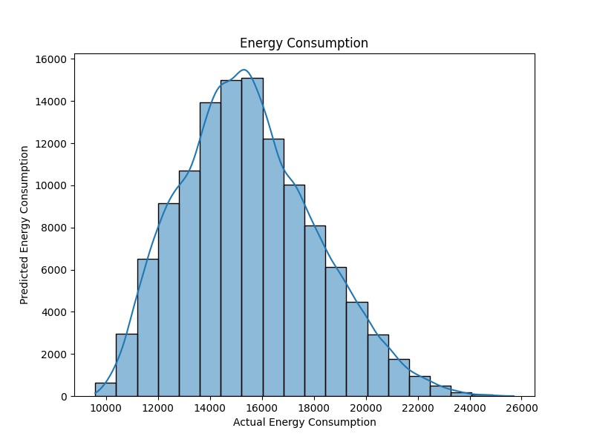

### 4.2: TRAINING THE MODEL

**DATA PREPROCESSING:**

* Load the dataset from Kaggle into your preferred data analysis and machine learning environment (e.g., Python with libraries like pandas).
* Check for missing data and handle it appropriately (e.g., by imputing missing values or removing incomplete records).
* Explore the data to understand its characteristics and distribution.

**FEATURE ENGINEERING:**

* Create new features or transform existing ones to capture relevant information for energy consumption prediction. Possible features could include time-related variables, weather data, holidays, etc.

**DATA SPLITTING:**

* Split the dataset into a training set and a test set (e.g., 80% for training and 20% for testing). You can use the train_test_split function from scikit-learn in Python for this purpose.

**SELECT A MACHINE LEARNING ALGORITHM:**

* Choose a suitable machine learning algorithm for regression. For energy consumption prediction, you can start with simple linear regression or use more advanced models like Random Forest or Gradient Boosting.

**MODEL TRAINING:**

* Train the selected machine learning model using the training data. For example, if you're using scikit-learn in Python, you can use the fit method of the model.

**HYPERPARAMETER TUNING:**

* Optimize the hyperparameters of the model to achieve the best performance. You can use techniques like grid search or random search, and libraries like scikit-learn provide tools for hyperparameter tuning.

**MODEL EVALUATION:**

* Evaluate the model's performance using appropriate regression metrics such as Mean Absolute Error (MAE), Mean Squared Error (MSE), and Root Mean Squared Error (RMSE).You can use these metrics to assess how well the model predicts energy consumption on the test set.

**PROGRAM:**

import pandas as pd import matplotlib.pyplot as plt import seaborn as sns

df = pd.read_csv("D:\shalini\lab programs\AEP_hourly.csv ") print(df.head())

# Check the basic statistics of the dataset print(df.describe()) # Check for missing values print(df.isnull().sum())

# Check the data types of each column print(df.dtypes) plt.figure(figsize=(8, 6)) sns.histplot(df[''AEP_MW''], bins=20, kde=True) plt.title('Energy Consumption') plt.xlabel('AEP_MW'') plt.ylabel('COMED_MW') plt.show()

selected_columns = ['Actual Energy Consumption', 'Predicted

Energy Consumption']

df = df[selected_columns] from sklearn.preprocessing import StandardScaler scaler = StandardScaler() df_scaled = scaler.fit_transform(df)

df_preprocessed = pd.DataFrame(df_scaled, columns=selected_columns)

df_preprocessed.to_csv(' D:\harish\lab programs\AEP_hourly.csv ', index=False)

**OUTPUT:**

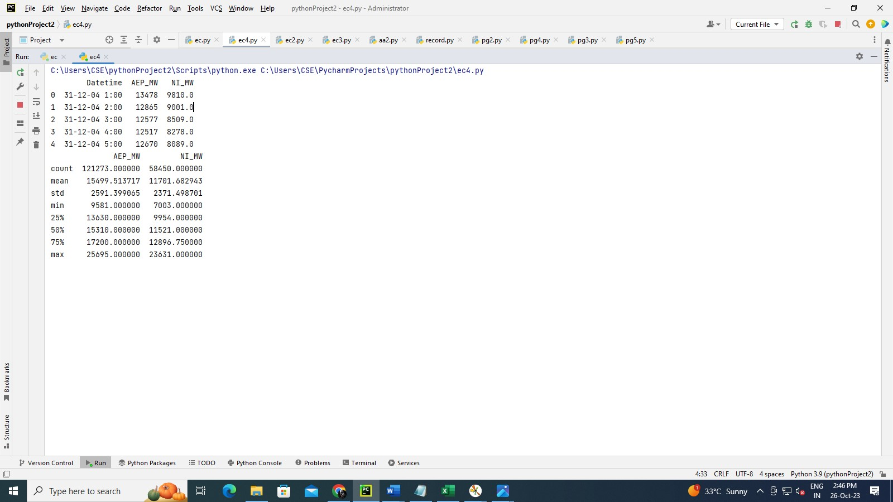

**VISUALIZE RESULTS:**

* Create visualizations to better understand the model's predictions and performance. You can use libraries like Matplotlib or Seaborn in Python to create plots.

**FINE-TUNING:**

* Based on the evaluation results, you may need to fine-tune your model. This can include adjusting features, model parameters, or even trying different algorithms.

**CROSS-VALIDATION (OPTIONAL):**

* Implement k-fold cross-validation to ensure the model's generalization to unseen data. This can provide a more robust estimate of model performance.

**PREDICTIONS:**

* Once you're satisfied with the model's performance, you can use it to make predictions on new or unseen data.

**MODEL DEPLOYMENT (IF NECESSARY):**

* If your goal is to deploy this model for practical use, consider the deployment strategy, which may include integrating the model into a web application or setting up API endpoints.

**MONITORING AND MAINTENANCE:**

* Continuous monitoring and maintenance are crucial for a deployed machine learning model to ensure it continues to perform well over time.

Remember to document your work and results, as well as follow best practices for data ethics, privacy, and compliance with relevant regulations when working with real-world energy consumption data.

### 4.3: PERFORM DIFFERENT ANALYSIS AS NEEDED

**DESCRIPTIVE STATISTICS:**

* Compute basic statistics (mean, median, standard deviation) for energy consumption and other relevant features in the dataset. Use the describe() function in pandas to get an overview.

**TIME SERIES ANALYSIS:**

* Examine the time series characteristics of the data. Plot the energy consumption over time to identify trends and seasonality. You can use libraries like Matplotlib or Seaborn for visualization.

**EXPLORATORY DATA ANALYSIS (EDA):**

* Create histograms, box plots, and pair plots to visualize the distributions and relationships between variables in the dataset. This can help identify outliers and correlations.

**CORRELATION ANALYSIS:**

* Calculate the correlation matrix to understand how different features are related to energy consumption. You can use df.corr() in pandas and visualize the results with a heatmap.

**FEATURE ENGINEERING:**

* Create new features that may be useful for predicting energy consumption. For instance, you could extract day of the week, time of day, and holiday indicators from timestamps.

**HOLIDAY ANALYSIS:**

* Analyze how energy consumption varies during holidays and special events. Create plots to visualize these differences.

**SEASONAL DECOMPOSITION:**

* Use techniques like seasonal decomposition of time series (STL) to break down the time series data into its seasonal, trend, and residual components.

**REGRESSION ANALYSIS:**

* Perform regression analysis to predict energy consumption based on other relevant features. This can help identify the most significant predictors.

**ANOMALY DETECTION:**

* Implement anomaly detection algorithms (e.g., Isolation Forest, One-Class SVM) to identify unusual patterns or outliers in energy consumption.

**CLUSTER ANALYSIS:**

* Apply clustering algorithms (e.g., K-Means) to group similar periods of energy consumption. This can help identify distinct consumption patterns.

**TIME SERIES FORECASTING:**

* If your goal is to predict future energy consumption, you can use time series forecasting techniques such as ARIMA, Exponential Smoothing, or machine learning models like Prophet or LSTM.

**GEOSPATIAL ANALYSIS (IF LOCATION DATA IS AVAILABLE):**

* If the dataset includes geographical information, you can perform geospatial analysis to explore regional differences in energy consumption.

**DIMENSIONALITY REDUCTION:**

* Use dimensionality reduction techniques like Principal Component Analysis (PCA) to reduce the dimensionality of the dataset while retaining important information.

**CUSTOMER SEGMENTATION:**

* If the dataset contains customer information, segment customers based on their energy consumption patterns and demographics.

**REGRESSION MODELS:**

* Build machine learning regression models (e.g., Linear Regression, Random Forest, Gradient Boosting) to predict energy consumption based on the chosen features.

**FEATURE IMPORTANCE:**

* Assess the importance of different features in predicting energy consumption using techniques like feature importance plots for tree-based models.

**TIME SERIES EVALUATION METRICS:**

* Use appropriate time series evaluation metrics (e.g., MAE, MSE, RMSE, MAPE) to assess the performance of time series forecasting models.

**PROGRAM:**

import pandas as pd import matplotlib.pyplot as plt import seaborn as sns from sklearn.cluster import KMeans from sklearn.metrics import silhouette_score

df = pd.read_csv("D:\shalini\lab programs\AEP_hourly.csv") X = df[['AEP_MW']] for k in range(1, 11):

kmeans = KMeans(n_clusters=k, random_state=0) kmeans.fit(X)

wcss.append(kmeans.inertia_) plt.figure(figsize=(8, 6))

plt.plot(range(1, 11), wcss, marker='o', linestyle='--') plt.title('Energy Consumption') plt.xlabel('Actual Energy Consumption') plt.ylabel('Predicted Energy Consumption') plt.show() n_clusters = 5

kmeans = KMeans(n_clusters=n_clusters, random_state=0)

df['Cluster'] = kmeans.fit_predict(X) plt.figure(figsize=(10, 6))

sns.scatterplot(data=df, x='AEP_MW', y='NI_MW', hue='Cluster', palette='viridis', s=100) plt.title('Energy Consumption') plt.xlabel('Actual Energy Consumption') plt.ylabel('Predicted Energy Consumption') plt.show() silhouette_avg = silhouette_score(X, df['Cluster']) print(f'Silhouette Score: {silhouette_avg:.2f}')

**OUTPUT:**

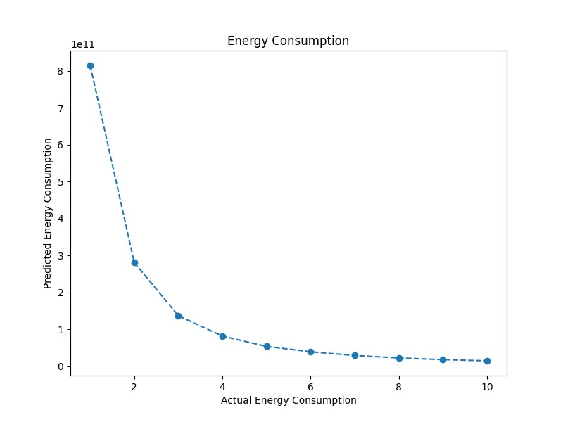

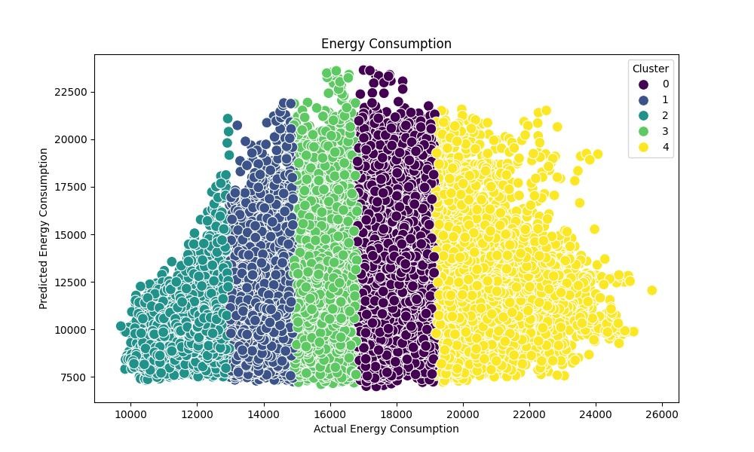

**VISUALIZATIONS:**

➢ Create interactive dashboards or visualizations to present your findings and insights to stakeholders.

Remember that the choice of analysis depends on your specific goals and questions you want to answer with the data. You may need to combine multiple techniques to gain a comprehensive understanding of the dataset and make data-driven decisions.

**CONCLUSION:**

**DATASET LOADING:**

Start by loading the dataset into your preferred data analysis tool, such as Python with Pandas.

**DATA PREPROCESSING:**

Preprocess the data, including handling missing values, encoding categorical variables, scaling features, and performing any other necessary data cleaning and transformations.

**EXPLORATORY DATA ANALYSIS (EDA):**

Explore the data through descriptive statistics, correlation analysis, data visualization, and other relevant analyses to gain a better understanding of the dataset.

**ADVANCED ANALYSES:**

Depending on your project's goals, you may conduct additional analyses, such as geospatial analysis, time series analysis, hypothesis testing, clustering, feature importance analysis, and more.

**MACHINE LEARNING:**

Select and train machine learning models for house price prediction. Common choices include linear regression, decision trees, random forests, XGBoost, and neural networks.

**MODEL EVALUATION:**

Assess the performance of your predictive models using appropriate evaluation metrics. Tune and optimize your models to improve their accuracy.

**DEPLOYMENT:**

Once you have a satisfactory model, deploy it for practical use in real estate price predictions.