# ANNAMALAI UNIVERSITY

# FACULTY OF ENGINEERING AND TECHNOLOGY

**DEPARTMENT OF COMPUTER SCIENCE AND ENGINEERING**

**B.E. COMPUTER SCIENCE AND ENGINEERING**

**(ARTIFICIAL INTELLIGENCE AND MACHINE LEARNING)**

**V – SEMESTER**

## AICP509 - NEURAL COMPUTING LAB

**LAB MANUAL**

## Table of Contents

|  |  |  |
| --- | --- | --- |
| **S. No.** | **Title** | **Page** |
| 1. | 1. **Perceptron Algorithm on Randomly Generated Dataset** 2. **Implementation of OR Gate using Perceptron Algorithm** | 1 |
| 2. | **Back Propagation Neural Network** | 8 |
| 3. | **Radial Basis Function Neural Network** | 13 |
| 4. | 1. **Support Vector Machine on Ads Dataset** 2. **Implementation of XOR Gate Support Vector Machine** | 18 |
| 5. | **Self-Organizing Map** | 24 |
| 6. | **Fuzzy Set Operations** | 27 |
| 7. | **Fuzzy Set Properties** | 30 |
| 8. | **Fuzzy Membership Functions** | 36 |
| 9. | **Fuzzy Inference System** | 38 |
| 10. | **Defuzzification Methods** | 43 |
| 11. | **Fuzzy Controller System** | 46 |

### Ex. No. 1(a) Perceptron Algorithm on Randomly Generated Dataset

**Date:**

#### Aim:

To implement perceptron algorithm using Python programming.

#### Perceptron Learning:

The [Perceptron algorithm](https://en.wikipedia.org/wiki/Perceptron) is a two-class (binary) classification machine learning algorithm. It is the simplest type of neural network model. It consists of a single node or neuron that takes a row of data as input and predicts a class label. This is achieved by calculating the weighted sum of the inputs and a bias (set to 1). The weighted sum of the input of the model is called the activation given as

**Activation** = Weights * Inputs + Bias

If the activation is above 0.0, the model will output 1.0; otherwise, it will output 0.0 given as:

**Predict 1**: If Activation > 0.0

**Predict 0**: If Activation <= 0.0

The Perceptron is a linear classification algorithm. This means that it learns a decision boundary that separates two classes using a line (called a hyperplane) in the feature space. The coefficients of the model are referred to as input weights and are trained using the stochastic gradient descent optimization algorithm.

Examples from the training dataset are shown to the model one at a time, the model makes a prediction, and error is calculated. The weights of the model are then updated to reduce the errors for the example. This is called the Perceptron update rule. This process is repeated for all examples in the training dataset, called an [epoch.](https://machinelearningmastery.com/difference-between-a-batch-and-an-epoch/) This process of updating the model using examples is then repeated for many epochs.

Model weights are updated with a small proportion of the error each batch, and the proportion is controlled by a hyperparameter called the learning rate, typically set to a small value as shown below.

weights(t + 1) = weights(t) + learning_rate * (expected_i – predicted_) * input_i

Training is stopped when the error made by the model falls to a low level or no longer improves, or a maximum number of epochs is performed. The initial values for the model weights are set to small random values.

#### Algorithm:

1. Set a threshold value
2. Multiply all inputs with their weights
3. Sum all the results
4. Activate the output and return true if greater than the threshold.

#### Program:

import numpy as np

from sklearn import datasets

import matplotlib.pyplot as plt

X, y = datasets.make_blobs(n_samples=150,n_features=2, centers=2,cluster_std=1.05,

random_state=2)

#Plotting

fig = plt.figure(figsize=(10,8))

plt.plot(X[:, 0][y == 0], X[:, 1][y == 0], 'r^')

plt.plot(X[:, 0][y == 1], X[:, 1][y == 1], 'bs')

plt.xlabel("feature 1")

plt.ylabel("feature 2")

plt.title('Random Classification Data with 2 classes')

def step_func(z):

return 1.0 if (z > 0) else 0.0

def perceptron(X, y, lr, epochs):

# X --> Inputs.

# y --> labels/target.

# lr --> learning rate.

# epochs --> Number of iterations.

# m-> number of training examples

# n-> number of features

m, n = X.shape

# Initializing parameters(theta) to zeros.

# +1 in n+1 for the bias term.

theta = np.zeros((n+1,1))

# Empty list to store how many examples were

# misclassified at every iteration.

n_miss_list = []

# Training.

for epoch in range(epochs):

# variable to store #misclassified.

n_miss = 0

# looping for every example.

for idx, x_i in enumerate(X):

# Insering 1 for bias, X0 = 1.

x_i = np.insert(x_i, 0, 1).reshape(-1,1)

# Calculating prediction/hypothesis.

y_hat = step_func(np.dot(x_i.T, theta))

# Updating if the example is misclassified.

if (np.squeeze(y_hat) - y[idx]) != 0:

theta += lr*((y[idx] - y_hat)*x_i)

# Incrementing by 1.

n_miss += 1

# Appending number of misclassified examples

# at every iteration.

n_miss_list.append(n_miss)

return theta, n_miss_list

def plot_decision_boundary(X, theta):

# X --> Inputs

# theta --> parameters

# The Line is y=mx+c

# So, Equate mx+c = theta0.X0 + theta1.X1 + theta2.X2

# Solving we find m and c

x1 = [min(X[:,0]), max(X[:,0])]

m = -theta[1]/theta[2]

c = -theta[0]/theta[2]

x2 = m*x1 + c

# Plotting

fig = plt.figure(figsize=(10,8))

plt.plot(X[:, 0][y==0], X[:, 1][y==0], "r^")

plt.plot(X[:, 0][y==1], X[:, 1][y==1], "bs")

plt.xlabel("feature 1")

plt.ylabel("feature 2")

plt.title('Perceptron Algorithm')

plt.plot(x1, x2, 'y-')

theta, miss_l = perceptron(X, y, 0.5, 100)

plot_decision_boundary(X, theta)

#### Output:

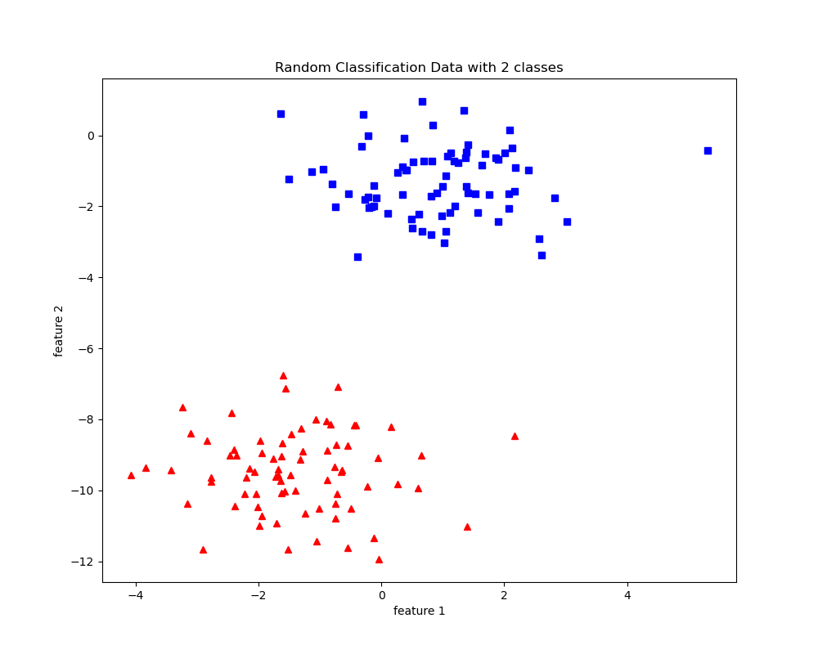

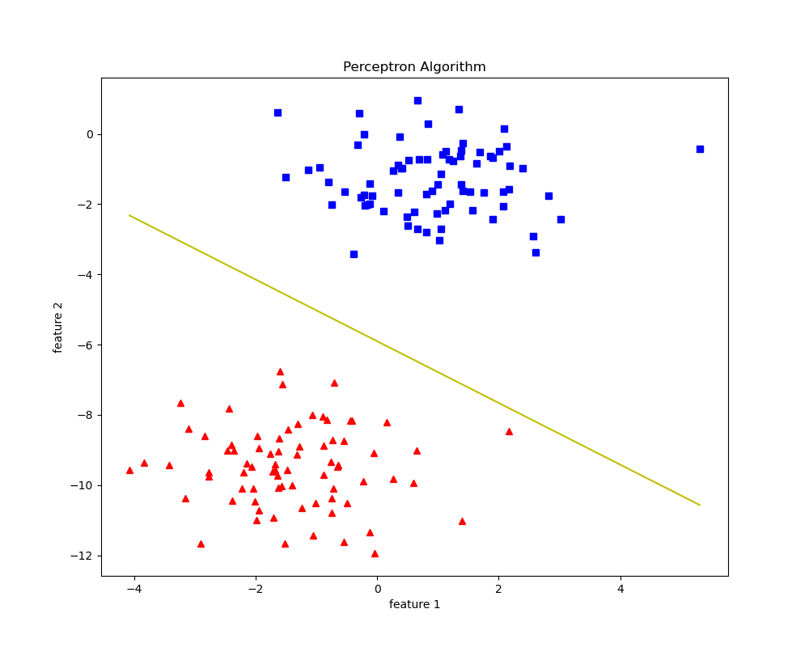

#### Result:

Thus a python program has been written and executed to implement perceptron algorithm.

### Ex. No. 1(b) Implementation of OR Gate using Perceptron Algorithm

**Date:**

#### Aim:

To implement OR gate using perceptron algorithm in Python programming.

#### Program:

import numpy as np

class Perceptron:

def __init__(self) -> None:

self.weights = np.zeros((2, 1))

self.bias = 0

def predict(self, x: np.array) -> np.array:

return np.where(np.dot(x, self.weights) + self.bias > 0, 1, 0)

def fit(self, x: np.array, y: np.array, epoch:int = 100, learning_rate: float= 0.1) -> None:

for _ in range(epoch):

for x_i, y_i in zip(x, y):

y_hat = self.predict(x_i).squeeze()

self.weights += learning_rate * (y_i - y_hat) * x_i.reshape(-1, 1)

self.bias += learning_rate * (y_i - y_hat)

def score(self, x: np.array, y: np.array) -> float:

y_hat = self.predict(x).squeeze()

return np.mean(y_hat == y)

if __name__ == '__main__':

X = np.array([[0, 0], [0, 1], [1, 0], [1, 1]])

y = np.array([0, 1, 1, 1])

perceptron = Perceptron()

print("OR Gate: ")

for x, y_i in zip(X, y):

print(x, y_i)

print("Initial Weights:")

print(perceptron.weights, perceptron.bias)

perceptron.fit(X, y, epoch=3)

print("Trained Weights:")

print(perceptron.weights, perceptron.bias)

print("OR Gate(predicted): ")

for x in X:

print(x, perceptron.predict(x))

print("Accuracy:", perceptron.score(X, y))

#### Output:

OR Gate:

[0 0] 0

[0 1] 1

[1 0] 1

[1 1] 1

Initial Weights:

[[0.]

[0.]] 0

Trained Weights:

[[0.1]

[0.1]] 0.0

OR Gate(predicted):

[0 0] [0]

[0 1] [1]

[1 0] [1]

[1 1] [1]

Accuracy: 1.0

#### Result:

Thus the python program to implement OR gate with perceptron algorithm is successfully executed and the output is verified.

## Ex. No. 2 BACKPROPAGATION NEURAL NETWORK

**Date:**

#### Aim:

To implement Backpropagation Neural Network using Python programming.

#### Algorithm:

The Back propagation algorithm in neural network computes the gradient of the loss function for a single weight by the chain rule. It efficiently computes one layer at a time, unlike a native direct computation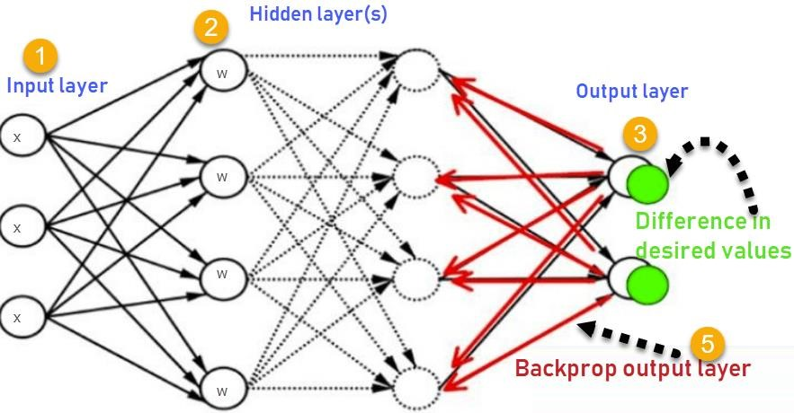

Consider the following Back propagation Neural Network.

1. Inputs X, arrive through the preconnected path.
2. Input is modeled using real weights W. The weights are usually randomly selected.
3. Calculate the output for every neuron from the input layer, to the hidden layers, to the output layer.
4. Calculate the error in the outputs   
    Error= Actual Output – Desired Output
5. Travel back from the output layer to the hidden layer to adjust the weights such that the error is decreased.

Keep repeating the process until the desired output is achieved.

#### Program:

import numpy as np

# X = (hours sleeping, hours studying), y = score on test

X = np.array(([2, 9], [1, 5], [3, 6]), dtype=float)

y = np.array(([92], [86], [89]), dtype=float)

print(X)

print(y)

# scale units

X = X/np.amax(X, axis=0) # maximum of X array

y = y/100 # max test score is 100

print(X)

print(y)

class Neural_Network(object):

def __init__(self):

#parameters

self.inputSize = 2

self.outputSize = 1

self.hiddenSize = 3

#weights

self.W1 = np.random.randn(self.inputSize, self.hiddenSize) # (3x2) weight matrix from input to hidden layer

self.W2 = np.random.randn(self.hiddenSize, self.outputSize) # (3x1) weight matrix from hidden to output layer

def forward(self, X):

#forward propagation through our network

self.z = np.dot(X, self.W1) # dot product of X (input) and first set of 3x2 weights

self.z2 = self.sigmoid(self.z) # activation function

self.z3 = np.dot(self.z2, self.W2) # dot product of hidden layer (z2) and second set of 3x1 weights

o = self.sigmoid(self.z3) # final activation function

return o

def sigmoid(self, s):

# activation function

return 1/(1+np.exp(-s))

def sigmoidPrime(self, s):

#derivative of sigmoid

return s * (1 - s)

def backward(self, X, y, o):

# backward propgate through the network

self.o_error = y - o # error in output

self.o_delta = self.o_error*self.sigmoidPrime(o) # applying derivative of sigmoid to error

self.z2_error = self.o_delta.dot(self.W2.T) # z2 error: how much our hidden layer weights contributed to output error

self.z2_delta = self.z2_error*self.sigmoidPrime(self.z2) # applying derivative of sigmoid to z2 error

self.W1 += X.T.dot(self.z2_delta) # adjusting first set (input --> hidden) weights

self.W2 += self.z2.T.dot(self.o_delta) # adjusting second set (hidden --> output) weights

def train(self, X, y):

o = self.forward(X)

self.backward(X, y, o)

NN = Neural_Network()

for i in range(1000): # trains the NN 1,000 times

print ("Input: \n" + str(X))

print ("Actual Output: \n" + str(y))

print ("Predicted Output: \n" + str(NN.forward(X)))

print ("Loss: \n" + str(np.mean(np.square(y - NN.forward(X))))) # mean sum squared loss

print ("\n")

NN.train(X, y)

#### Output:

**Input Data in First epoch:**

[[ 0.66666667 1. ]

[ 0.33333333 0.55555556]

[ 1. 0.66666667]]

**Actual Output:**

[[ 0.92]

[ 0.86]

[ 0.89]]

**Predicted Output:**

[[ 0.64293334]

[ 0.64778178]

[ 0.63319242]]

**Loss:**

0.0625842148581

**Input in second epoch:**

[[ 0.66666667 1. ]

[ 0.33333333 0.55555556]

[ 1. 0.66666667]]

**Actual Output:**

[[ 0.92]

[ 0.86]

[ 0.89]]

**Predicted Output:**

[[ 0.66685628]

[ 0.67120326]

[ 0.65596939]]

**Loss:**

0.0514987603276

………

……….

……………

**Input after 1000 epochs**

[[ 0.66666667 1. ]

[ 0.33333333 0.55555556]

[ 1. 0.66666667]]

**Actual Output:**

[[ 0.92]

[ 0.86]

[ 0.89]]

**Predicted Output after 1000 epochs**

[[ 0.90015511]

[ 0.8766163 ]

[ 0.89265864]]

**Loss:**

0.000225663124995

#### 

#### 

#### 

#### 

#### 

#### 

#### 

#### 

#### 

#### 

#### 

#### 

#### 

#### 

#### 

#### 

#### Result:

Thus a python program has been written and executed to implement Backpropagation Neural Network model.

## Ex. No. 3 RADIAL BASIS FUNCTION NEURAL NETWORK

**Date:**

#### Aim:

To implement Radial Basis Function Neural Network using Python Programming.

#### Radial Basis Function Neural Network (RBFNN):

A Radial Basis Function Network is a particular type of neural network. In this article, An RBFNN performs classification by measuring the input’s similarity to examples from the training set. Each RBFNN neuron stores a “prototype”, which is just one of the examples from the training set. When we want to classify a new input, each neuron computes the Euclidean distance between the input and its prototype. If the input more closely resembles the class A prototypes than the class B prototypes, it is classified as class A.

#### RBFNN Architecture:

The above figure shows the typical architecture of an RBF Network. It consists of an input vector, a layer of RBF neurons, and an output layer with one node per category or class of data.

**The Input Vector**

The input vector is the *n*-dimensional vector that you are trying to classify. The entire input vector is shown to each of the RBF neurons.

**The RBF Neurons**

Each RBF neuron stores a “prototype” vector which is just one of the vectors from the training set. Each RBF neuron compares the input vector to its prototype, and outputs a value between 0 and 1 which is a measure of similarity. If the input is equal to the prototype, then the output of that RBF neuron will be 1. As the distance between the input and prototype grows, the response falls off exponentially towards 0. The shape of the RBF neuron’s response is a bell curve, as illustrated in the network architecture diagram.The neuron’s response value is also called its “activation” value. The prototype vector is also often called the neuron’s “center”, since it’s the value at the center of the bell curve.

**The Output Nodes**

The output of the network consists of a set of nodes, one per category that we are trying to classify. Each output node computes a sort of score for the associated category. Typically, a classification decision is made by assigning the input to the category with the highest score.

The score is computed by taking a weighted sum of the activation values from every RBF neuron. By weighted sum we mean that an output node associates a weight value with each of the RBF neurons, and multiplies the neuron’s activation by this weight before adding it to the total response.

Because each output node is computing the score for a different category, every output node has its own set of weights. The output node will typically give a positive weight to the RBF neurons that belong to its category, and a negative weight to the others.

#### RBF Neuron Activation Function

Each RBF neuron computes a measure of the similarity between the input and its prototype vector (taken from the training set). Input vectors which are more similar to the prototype return a result closer to 1. There are different possible choices of similarity functions, but the most popular is based on the Gaussian. Below is the equation for a Gaussian with a one-dimensional input.

Where x is the input, mu is the mean, and sigma is the standard deviation. This produces the familiar bell curve shown below, which is centered at the mean, mu (in the below plot the mean is 5 and sigma is 1). The RBF neuron activation function is slightly different, and is typically written as:

In the Gaussian distribution, refers to the mean of the distribution. Here, it is the prototype vector which is at the center of the bell curve.

#### Program:

import numpy as np

import matplotlib.pyplot as plt

from sklearn.cluster import KMeans

from sklearn.datasets import make_classification

from sklearn.model_selection import train_test_split

from sklearn.metrics import accuracy_score

from scipy.spatial.distance import cdist

from sklearn.linear_model import LogisticRegression

X, y = make_classification(n_samples=1000, n_features=2, n_classes=2, n_clusters_per_class=2, random_state=42, n_redundant=0)

print("X and y\n")

print(X[:5], y[:5], sep="\n\n")

X_train, X_test, y_train, y_test = train_test_split(X, y, test_size=0.2)

num_neurons = 10

kmeans = KMeans(n_clusters=num_neurons, random_state=42, n_init=10)

kmeans.fit(X_train)

centers = kmeans.cluster_centers_

print("Center:", centers)

std_dev = np.mean(cdist(centers, centers, 'euclidean')) / np.sqrt(2*num_neurons)

print("Standard Deviation:", std_dev)

def rbf_activation(X, centers, std_dev):

return np.exp(-cdist(X, centers, 'sqeuclidean') / (2 * std_dev**2))

rbf_train = rbf_activation(X_train, centers, std_dev)

rbf_test = rbf_activation(X_test, centers, std_dev)

rbf_train = np.hstack([rbf_train, np.ones((rbf_train.shape[0], 1))])

rbf_test = np.hstack([rbf_test, np.ones((rbf_test.shape[0], 1))])

clf = LogisticRegression()

clf.fit(rbf_train, y_train)

y_pred = clf.predict(rbf_test)

accuracy = accuracy_score(y_pred, y_test)

print("Model Accuracy: ", accuracy*100)

# Visualization

def plot_result(X, y, centers=None):

plt.scatter(X[y==0, 0], X[y==0, 1], label="0")

plt.scatter(X[y==1, 0], X[y==1, 1], label="1")

if centers is not None:

plt.plot(centers[:, 0], centers[: ,1],'rx', label="centers")

plt.legend(loc="upper right")

rbf_x = rbf_activation(X, centers=centers, std_dev=std_dev)

activated_x = np.hstack([rbf_x, np.ones((rbf_x.shape[0], 1))])

plt.figure(figsize=(12, 6))

plt.subplot(121)

plt.title("Original")

plot_result(X, y)

plt.subplot(122)

plt.title("Predicted")

plot_result(X, clf.predict(activated_x), centers=centers)

#### Output:

X and y

[[-0.99910178 -0.66386 ]

[ 1.24668618 1.15359685]

[ 0.96277683 0.85939747]

[-2.95744095 2.03364529]

[ 1.14116527 1.05944863]]

[1 1 1 1 1]

Center:

[[-0.8692364 -0.65864468]

[ 2.53446783 2.35687357]

[ 1.98458412 -1.101229 ]

[-2.16151064 2.60967372]

[-0.13595674 0.47263506]

[-1.41909706 -2.21144242]

[-1.89697275 0.99213769]

[ 1.23312034 1.21393961]

[ 0.61193541 -1.041979 ]

[-0.16678152 2.0800995 ]]

Standard Deviation: 0.6120404511235887

Model Accuracy: 85.0

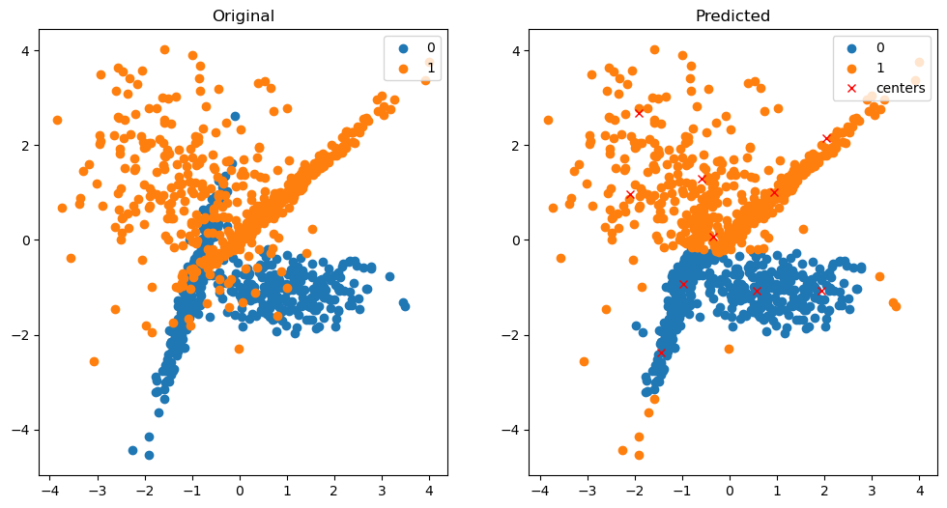

#### Result:

Thus a python program has been written and executed to implement Radial Basis function Neural Network model.

## Ex. No. 4(a) SUPPORT VECTOR MACHINE ON SOCIAL MEDIA ADS DATASET

**Date:**

#### Aim:

To implement a Support Vector Machine on Social Media Ads dataset using Python programming.

#### Support Vector Machine(SVM):

Support vector machines (SVMs) are powerful yet flexible supervised machine learning algorithms that are used both for classification and regression. But generally, they are used in classification problems. In the 1960s, SVMs were first introduced but later they got refined in 1990. SVMs have their unique way of implementation as compared to other machine learning algorithms. Lately, they are extremely popular because of their ability to handle multiple continuous and categorical variables.

**Working of SVM**

An SVM model is basically a representation of different classes in a hyperplane in multidimensional space. The hyperplane will be generated iteratively by SVM so that the error can be minimized. The goal of SVM is to divide the datasets into classes to find a maximum marginal hyperplane (MMH).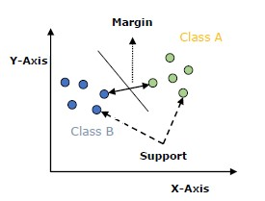

The following are important concepts in SVM:

* **Support Vectors** − Datapoints that are closest to the hyperplane are called support vectors. Separating lines will be defined with the help of these data points.
* **Hyperplane** − As we can see in the above diagram, it is a decision plane or space which is divided between a set of objects having different classes.
* **Margin** − It may be defined as the gap between two lines on the closet data points of different classes. It can be calculated as the perpendicular distance from the line to the support vectors. A large margin is considered as a good margin and a small margin is considered as a bad margin.

The main goal of SVM is to divide the datasets into classes to find a maximum marginal hyperplane (MMH) and it can be done in the following two steps −

* First, SVM will generate hyperplanes iteratively that segregate the classes in the best way.
* Then, it will choose the hyperplane that separates the classes correctly.

#### Program:

import numpy as np

import pandas as pd

import matplotlib.pyplot as plt

from matplotlib.colors import ListedColormap

from sklearn.preprocessing import StandardScaler

from sklearn.model_selection import train_test_split

from sklearn.metrics import confusion_matrix, accuracy_score

from sklearn.svm import SVC

from sklearn import datasets, svm, metrics

df = pd.read_csv('datasets/Social_Network_Ads.csv')

display(df.head())

X = df.iloc[:, [2, 3]].values

y = df.iloc[:, 4].values

x_train, x_test, y_train, y_test = train_test_split(X, y, test_size=0.25, random_state=0)

sc = StandardScaler()

x_train = sc.fit_transform(x_train)

x_test = sc.transform(x_test)

classifier = SVC(kernel='rbf', random_state=0)

classifier.fit(x_train, y_train)

y_pred = classifier.predict(x_test)

cm = confusion_matrix(y_pred, y_test)

accuracy = accuracy_score(y_pred, y_test)

print("Confusion Matrix:\n", cm)

print("Accuracy:", accuracy)

X1, X2 = np.meshgrid(

np.arange(start=x_test[:, 0].min()-1, stop=x_test[:, 0].max() + 1, step=0.01),

np.arange(start=x_test[:, 1].min()-1, stop=x_test[:, 1].max() + 1, step=0.01)

)

plt.contourf(

X1, X2,

classifier.predict(np.array([X1.ravel(), X2.ravel()]).T).reshape(X1.shape),

alpha=0.75,

cmap = ListedColormap(('red', 'green'))

)

plt.xlim(X1.min(), X1.max())

plt.xlim(X2.min(), X2.max())

for i , j in enumerate(np.unique(y_test)):

plt.scatter(x_test[y_test==j, 0], x_test[y_test==j, 1], color=ListedColormap(('red', 'green'))(i), label=j)

plt.title('SVM(Test set)')

plt.xlabel('Age')

plt.xticks(())

plt.yticks(())

plt.ylabel('Estimated Salary')

plt.legend()

plt.show()

#### Output:

|  | **Users** | **Gender** | **Age** | **EstimatedSalary** | **Purchased** |
| --- | --- | --- | --- | --- | --- |
| 25 | 15631159 | Male | 47 | 20000 | 1 |
| 26 | 15792818 | Male | 49 | 28000 | 1 |
| 27 | 15633531 | Female | 47 | 30000 | 1 |
| 28 | 15744529 | Male | 29 | 43000 | 0 |
| 29 | 15669656 | Male | 31 | 18000 | 0 |

Confusion Matrix:

[[64 3]

[ 4 29]]

Accuracy: 0.93

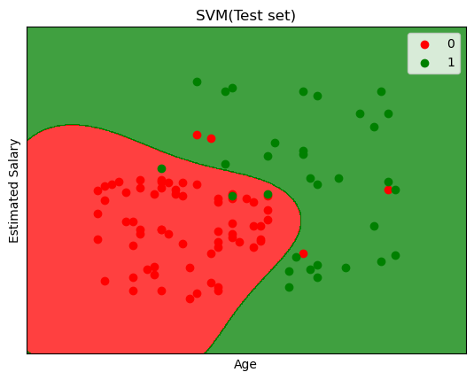

#### Result:

Thus a python program to implement Support Vector Machine on Social Media Ads Dataset has been written and executed.

### Ex. No. 4(b) IMPLEMENTATION OF XOR GATE USING SUPPORT VECTOR MACHINE

### Date:

### Aim:

To implement XOR gate with Support Vector Machine using Python programming.

#### Program:

import numpy as np

import matplotlib.pyplot as plt

from sklearn.metrics import classification_report

from sklearn.svm import SVC

from sklearn.model_selection import train_test_split

np.random.seed(0)

print("X:")

X = np.random.randn(200, 2)

print(X[:5])

y_xor = np.logical_xor(X[:, 0] >0, X[:, 1]>0)

def plot_gate(X, y, title):

plt.title(title)

plt.scatter(X[y==1, 0], X[y==1, 1], c='b', marker='x', label='1')

plt.scatter(X[y==0, 0], X[y==0, 1], c='r', marker='x', label='1')

plt.show()

plot_gate(X, y_xor, "XOR")

(train_data, test_data, train_labels, test_labels) = train_test_split(X, y_xor, test_size=0.25, random_state=42)

model = SVC(kernel='poly', degree=2, coef0=1)

model.fit(train_data, train_labels)

print("Classification Report")

print(classification_report(test_labels, model.predict(test_data)))

#### Output:

Classification Report: 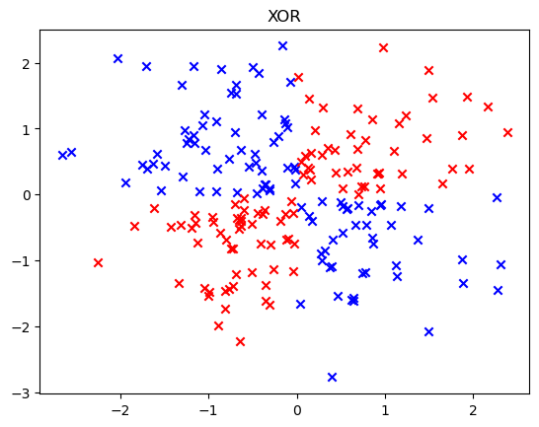

precision recall f1-score support

False 0.92 1.00 0.96 22

True 1.00 0.93 0.96 28

accuracy 0.96 50

macro avg 0.96 0.96 0.96 50

weighted avg 0.96 0.96 0.96 50

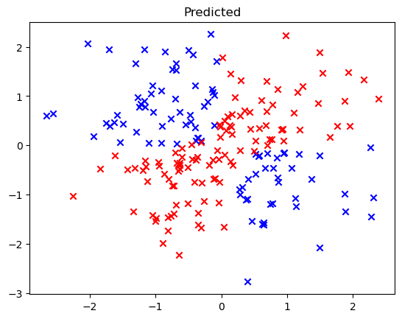

#### Result:

Thus a python program to implement XOR gate using Support Vector Machine has been written and executed.

## Ex. No. 5 SELF-ORGANIZING MAP

**Date:**

#### Aim:

To implement a Self-Organizing Map using Python Programming.

#### Self-Organizing Maps:

It is a type of Artificial Neural Network which is also inspired by biological models of neural systems from the 1970s. It follows an unsupervised learning approach and trained its network through a competitive learning algorithm. SOM is used for clustering and mapping (or dimensionality reduction) techniques to map multidimensional data onto lower-dimensional which allows people to reduce complex problems for easy interpretation. SOM has two layers, one is the Input layer and the other one is the Output layer. The architecture of the Self Organizing Map with two clusters and n input features of any sample is given below:

**Working Principle of SOM:**

Let’s say an input data of size (m, n) where m is the number of training examples and n is the number of features in each example. First, it initializes the weights of size (n, C) where C is the number of clusters. Then iterating over the input data, for each training example, it updates the winning vector (weight vector with the shortest distance (e.g. Euclidean distance) from training example). Weight updation rule is given by:

wij = wij(old) + alpha(t) * (xik - wij(old))

where alpha is a learning rate at time t, j denotes the winning vector, i denotes the ith feature of training example and k denotes the kth training example from the input data. After training the SOM network, trained weights are used for clustering new examples. A new example falls in the cluster of winning vectors.

#### Algorithm:

1. Weight initialization
2. For 1 to N number of epochs
3. Select a training example
4. Compute the winning vector
5. Update the winning vector
6. Repeat steps 3, 4, 5 for all training examples.
7. Clustering the test sample

#### Program:

import math

class SOM :

# Function here computes the winning vector by Euclidean distance

def winner( self, weights, sample ) :

D0 = 0

D1 = 0

for i in range(len(sample)):

D0 += (sample[i] - weights[0][i]) ** 2

D1 += (sample[i] - weights[1][i]) ** 2

If D0 < D1:

return 0

return 1 # Else Return 1

# Function here updates the winning vector

def update(weights, sample, j, alpha ) :

for i in range(len(sample)):

weights[j][i] = weights[j][i] + alpha * (sample[i] - weights[j][i])

return weights

# Driver code

if __name__ == "__main__":

# Training Examples ( m, n )

T = [ [ 1, 1, 0, 0 ], [ 0, 0, 0, 1 ], [ 1, 0, 0, 0 ], [ 0, 0, 1, 1 ] ]

m, n = len( T ), len( T[0] )

# weight initialization ( n, C )

weights = [ [ 0.2, 0.6, 0.5, 0.9 ], [ 0.8, 0.4, 0.7, 0.3 ] ]

# training

ob = SOM()

epochs = 3

alpha = 0.5

for i in range( epochs ) :

for j in range( m ) :

# training sample

sample = T[j]

# Compute winner vector

J = ob.winner( weights, sample )

# Update winning vector

weights = ob.update( weights, sample, J, alpha )

# classify test sample

s = [ 1, 1, 0, 1 ]

J = ob.winner( weights, s )

print( "Test Sample s belongs to Cluster : ", J )

print( "Trained weights : ", weights )

#### Output:

Test sample s belongs to: 1

Trained weights: [[0.003125, 0.009375, 0.6640625, 0.9984375], [0.996875, 0.334375, 0.0109375, 0.0046875]]

#### Result:

Thus a python program has been written and executed to implement Self Organizing Map.

## Ex. No. 6 FUZZY SET OPERATIONS

**Date:**

#### Aim:

To write a MATLAB program to find the algebraic sum, algebraic subtraction, algebraic product, bounded sum, bounded subtraction, and bounded product of two fuzzy sets.

#### Algorithm:

1. Read the values of the two fuzzy sets.
2. Perform the algebraic sum operation by,

A + B= (a + b) – (a * b)

1. Perform the algebraic subtraction operation by,

A – B = (a + b`) where b`= 1- b

1. Perform the algebraic product operation by,

A * B = (a * b)

1. Perform the bounded sum operation by,

A ⊕B = min [1, (a + b)]

1. Perform bounded subtraction operation by,

A ⊝B= max [0, (a - b)]

1. Perform bounded product operation by,

A ⊙B = max [0, (a + b - 1)]

1. Display the results

#### Program:

a= input(‘Enter the fuzzy set a’ )

b= input(‘Enter the fuzzy set b’)

c= a + b

d= a .* b

as= c – d

e= 1 – b

ad= a + e

f= a – b

bs= min (1, c)

bd= max (0, f)

g= c – 1

bp= max (0,g)

disp(‘The algebraic sum’)

disp(as)

disp(‘The algebraic difference’)

disp(ad)

disp(‘The algebraic product’)

disp(d)

disp(‘The bounded sum’)

disp(bs)

disp(‘The bounded difference’)

disp (bd)

disp(‘The bounded product’)

disp(bp)

#### Output:

Enter fuzzy set a [1 0.5]

Enter fuzzy set b [0.4 0.2]

The algebraic sum

[1.0000 0.6000 ]

The algebraic difference

[1 0.9000]

The algebraic product

[0.4000 0.1000]

The bounded sum

[1.0000 0.7000]

The bounded difference

[0.6000 0.3000]

The bounded product

[0.4000 0]

#### Result:

Thus, a MATLAB program to perform simple fuzzy set operations has been executed and successfully verified.

## Ex. No. 7 FUZZY SET PROPERTIES

**Date:**

#### Aim:

To write a program in MATLAB to verify the properties of fuzzy sets.

**Algorithm:**

#### To Verify the following Fuzzy Set Properties:

**Commutative property**

A ∪ B = B ∪ A

A ∩ B = B ∩ A

**Associative property**

(A ∪ B) ∪ C = A ∪ (B ∪ C)

(A ∩ B) ∩ C = A ∩ (B ∩ C)

**Distributive property**

A ∪ (B ∩ C) = (A ∪ B) ∩ (A ∪ C)

A ∩ (B ∪ C) = (A ∩ B) ∪ (A ∩ C)

**Absorption property**

A ∪ (A ∩ C) = A

A ∩ (A ∪ C) = A

**Idempotency property**

A ∪ A = A

A ∩ A = A

**De Morgan’s law**

( A ∪ B )’ = A‘ ∩ B‘

( A ∩ B )’ = A’ ∪ B‘

**Identity property**

A ∪ ϕ = A

A ∩ X = A

**Axiom of Excluded Middle**

A ∩ ϕ = ϕ

**Axiom of Contradiction**

A ∪ X = X

#### Program:

a = [1.0, 0.4, 0.2];

b = [0.2,0.43,0.44];

c = [0.2,0.93,0.24];

e = [1 1 1];

o = [0,0,0];

disp('A: ');

disp(a);

disp('B: ');

disp(b);

disp('C: ');

disp(c);

a_U_b = max(a, b);

a_N_b = min(a, b);

disp('A U B: ');

disp(a_U_b);

disp('A N B: ');

disp(a_N_b);

% Commutative Property

disp('Commutative Property: ');

disp('A U B: '); disp(a_U_b); disp('B U A: '); disp(max(b, a));

disp('A N B: '); disp(a_N_b); disp('B N A: '); disp(min(b, a));

% Associative Property

disp('Associative Property: ');

disp('(A U B) U C:' ); disp(max(max(a, b), c)); disp('A U (B U C):' ); disp(max(a, max(b, c)));

disp('(A N B) N C:' ); disp(min(min(a, b), c)); disp('A N (B N C):' ); disp(min(a, min(b, c)));

% Distributive Property

disp('Distributive Property: ');

disp('A U (B N C): '); disp(max(a, min(b, c))); disp('(A U B) N (A U C):' );

disp(min(max(a,b) , max(a, c)));

disp('A N (B U C):' ); disp(min(a, max(b, c))); disp('(A N B) U (A N C):' );

disp(max(min(a,b) , min(a, c)));

% Absorption Property

disp('Absorption Property: ');

disp('A U (A N B): '); disp(max(a, min(a, b))); disp('A: '); disp(a);

disp('A N (A U B): '); disp(min(a, max(a, b))); disp('A: '); disp(a);

% Idempotent Property

disp('Idempotent Law: ');

disp('A U A: '); disp(max(a, a)); disp('A: '); disp(a);

disp('A N A: '); disp(min(a, a)); disp('A: '); disp(a);

% Involution Property

disp('Involution: ');

disp('(A_i)_i: '); disp(1-(1- a)); disp('A: '); disp(a);

% De Morgan's Law

disp("De Morgan's Law: ");

disp('(A U B)_i: '); disp( 1 - a_U_b); disp('A_i N B_i: '); disp(min(1-a, 1-b));

disp('(A N B)_i: '); disp( 1 - a_N_b); disp('A_i U B_i: '); disp(max(1-a, 1-b));

% Identity Property

disp('Identity Property:');

disp('A U o: '); disp(max(a, o)); disp('A: '); disp(a);

disp('A N o: '); disp(min(a, o)); disp('o: '); disp(o);

% Axiom of Excluded middle

disp('Axiom of Excluded middle:')

disp('A U A_i'); disp(max(a, 1-a)); disp('E:' ); disp(e);

% Axiom of Contradiction

disp('Axiom of Contradiction:')

disp('A N A_i'); disp(min(a, 1-a)); disp('o:' ); disp(o);

#### Output:

A:   
 1.0000 0.4000 0.2000  
B:   
 0.2000 0.4300 0.4400  
C:   
 0.2000 0.9300 0.2400  
A U B:   
 1.0000 0.4300 0.4400  
A N B:   
 0.2000 0.4000 0.2000

Commutative Property:   
A U B:   
 1.0000 0.4300 0.4400  
B U A:   
 1.0000 0.4300 0.4400  
A N B:   
 0.2000 0.4000 0.2000  
B N A:   
 0.2000 0.4000 0.2000

Associative Property:   
(A U B) U C:  
 1.0000 0.9300 0.4400  
A U (B U C):  
 1.0000 0.9300 0.4400  
(A N B) N C:  
 0.2000 0.4000 0.2000  
A N (B N C):  
 0.2000 0.4000 0.2000

Distributive Property:

A U (B N C):   
 1.0000 0.4300 0.2400  
(A U B) N (A U C):  
 1.0000 0.4300 0.2400  
A N (B U C):  
 0.2000 0.4000 0.2000  
(A N B) U (A N C):  
 0.2000 0.4000 0.2000

Absorption Property:   
A U (A N B):   
 1.0000 0.4000 0.2000  
A:   
 1.0000 0.4000 0.2000  
A N (A U B):   
 1.0000 0.4000 0.2000  
A:   
 1.0000 0.4000 0.2000

Idempotent Law:   
A U A:   
 1.0000 0.4000 0.2000  
A:   
 1.0000 0.4000 0.2000  
A N A:   
 1.0000 0.4000 0.2000  
A:   
 1.0000 0.4000 0.2000

Involution Property:   
(A_i)_i:   
 1.0000 0.4000 0.2000  
A:   
 1.0000 0.4000 0.2000

De Morgan's Law:   
(A U B)_i:   
 0 0.5700 0.5600  
A_i N B_i:   
 0 0.5700 0.5600  
(A N B)_i:   
 0.8000 0.6000 0.8000  
A_i U B_i:   
 0.8000 0.6000 0.8000

Identity Property:  
A U o:   
 1.0000 0.4000 0.2000  
A:   
 1.0000 0.4000 0.2000  
A N o:   
 0 0 0  
o:   
 0 0 0  
Axiom of Excluded middle:  
A U A_i  
 1.0000 0.6000 0.8000  
E:  
 1 1 1  
  
Axiom of Contradiction:  
A N A_i  
 0 0.4000 0.2000  
o:  
 0 0 0

#### Result:

Thus, a MATLAB program to verify fuzzy set properties has been executed and successfully verified.

## Ex. No. 8 FUZZY MEMBERSHIP FUNCTIONS

**Date:**

#### Aim:

To write a program in MATLAB to plot triangular, trapezoidal and bell shaped membership functions.

#### Algorithm:

* 1. Set the limits of x-axis.
  2. Calculate y using trimf() function with three parameters for triangular membership function.
  3. Calculate y using trapmf() function with four parameters for trapezoidal membership function.
  4. Calculate y using gbellmf() function with three parameters for bell shaped membership function.
  5. Plot x and y values.

#### Program:

%Triangular membership function

x=(0.0:1.0:10.0)’;

y1= trimf(x, [1 3 5]);

subplot(311 )

plot(x,[y1]);

%Trapezoidal membership function

x=(0.0:1.0:10.0)’;

y1= trapmf(x, [1 3 5 7]);

subplot(312)

plot(x, [y1] );

%Bell-shaped membership function

x=(0.0:0.2:10.0);

y1=gbellmf (x,[3 57]);

subplot(313)

plot(x, [y1]);

#### Output:

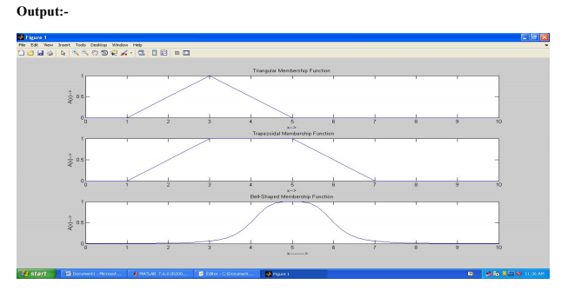

#### Result:

Thus, the MATLAB program for plotting membership functions has been executed successfully and the output is verified.

## Ex. No. 9 FUZZY INFERENCE SYSTEM

**Date:**

#### Aim:

To implement a Fuzzy Inference System (FIS) using MATLAB.

**Inputs:** Temperature and Cloud Cover

**Temperature:** {Freeze, Cool, Warm and Hot}

**Cloud Cover:** {Sunny, Partly Cloud, and Overcast}

**Output:** Speed

**Speed :** {Fast and Slow}

**Rules:**

1. If cloud cover is Sunny and temperature is warm, then drive Fast

Sunny (Cover) and Warm (Temp) -> Fast (Speed)

1. If the cloud cover is cloudy and the temperature is cool, then drive Slow

Cloudy (Cover) and Cool (Temp) -> Slow (Speed)

#### Procedure:

1. Go to the command window in Matlab and type fuzzy.
2. Now, a new Fuzzy Logic Designer window will be opened.
3. Input / Output Variable
   1. Go to Edit Window and click Add variable.
   2. As per our requirements create two input variables, Temperature and Cloud Cover.
   3. Create one output variable, Speed.
4. Temperature:
   1. Double click the Temperature input variable in the Fuzzy Logic Designer window.
   2. A new window will be opened and remove all the Membership Functions.
   3. Now, Go to Edit, Click Add MFs and select the 4 Parameters for Temperature Class.
   4. Change the following fields as mentioned data in the given below table.

|  |  |  |  |
| --- | --- | --- | --- |
| Inputs : Temperature 🡪 Freezing, Cool, Warm and Hot | | | |
| MF1:  Range : [0 110]  Name : Freezing  Type :trapmf  Parameter [0 0 30 50] | MF2:  Range : [0 110]  Name : Cool  Type :trimf  Parameter [30 50 70] | MF3:  Range : [0 110]  Name : Warm  Type :trimf  Parameter [50 70 90] | MF4:  Range : [0 110]  Name : Hot  Type :trapmf  Parameter [70 90 110 110] |

1. Similarly, add the datas to the Cloud Cover variables and Speed variables.
2. Cloud Cover:

|  |  |  |
| --- | --- | --- |
| Inputs : Cloud Cover 🡪 Sunny, Partly Cloud and Overcast | | |
| MF1:  Range : [0 100]  Name : Sunny  Type :trapmf  Parameter [0 0 20 40] | MF2:  Range : [0 100]  Name : Partly Cloud  Type :trimf  Parameter [20 50 80] | MF3:  Range : [0 100]  Name : Overcast  Type :trapmf  Parameter [60 80 100] |

1. Speed:

|  |  |
| --- | --- |
| Output : Speed 🡪 Slow and Fast | |
| MF1:  Range : [0 100]  Name : Slow  Type :trapmf  Parameter [0 0 25 75] | MF2:  Range : [0 100]  Name : Fast  Type :trapmf  Parameter [25 75 100 100] |

1. Goto Rules: Edit 🡪 Rules
2. Add the Rules

Rule-1: Sunny (Cover) and Warm (Temp) -> Fast (Speed)

Rule-2: Cloudy (Cover) and Cool (Temp) -> Slow (Speed)

10. Go to view 🡪 Rules

11. Exit.

#### Output:

**Membership functions for Temperature variable**

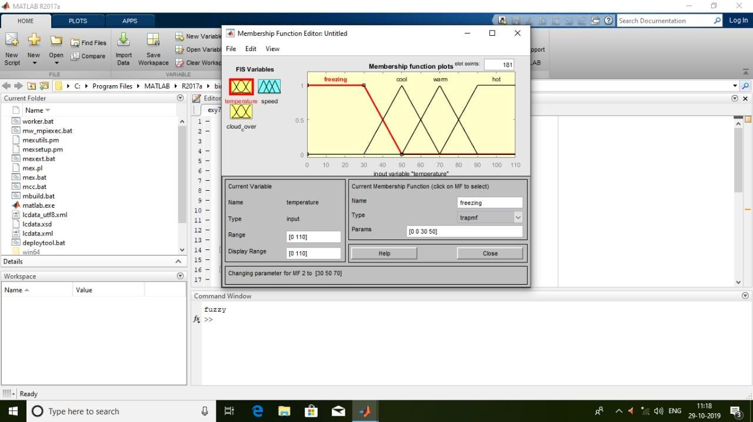

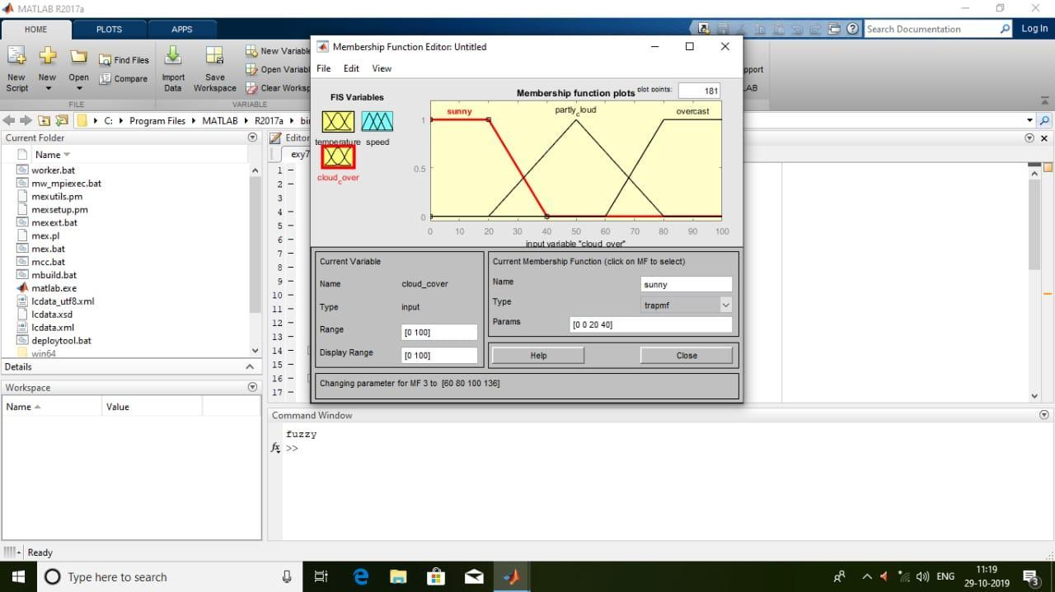

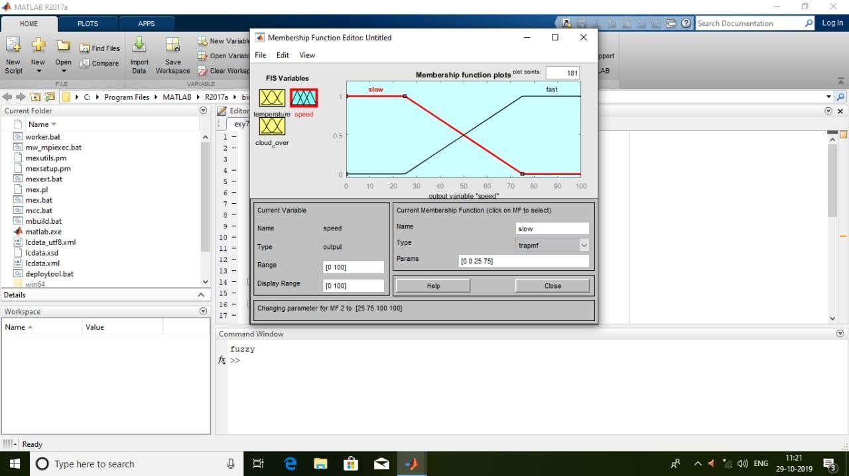

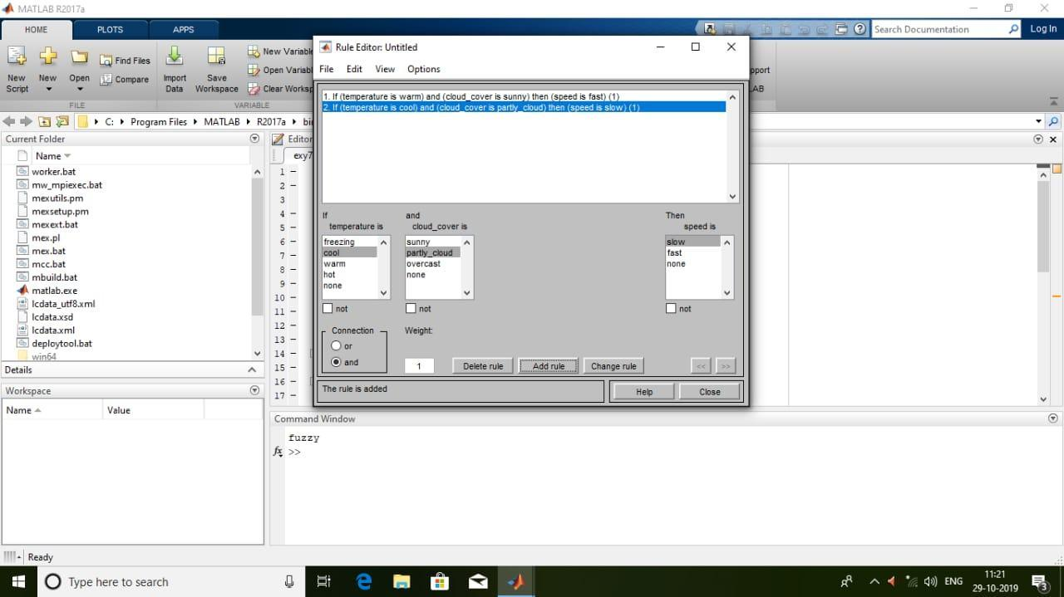

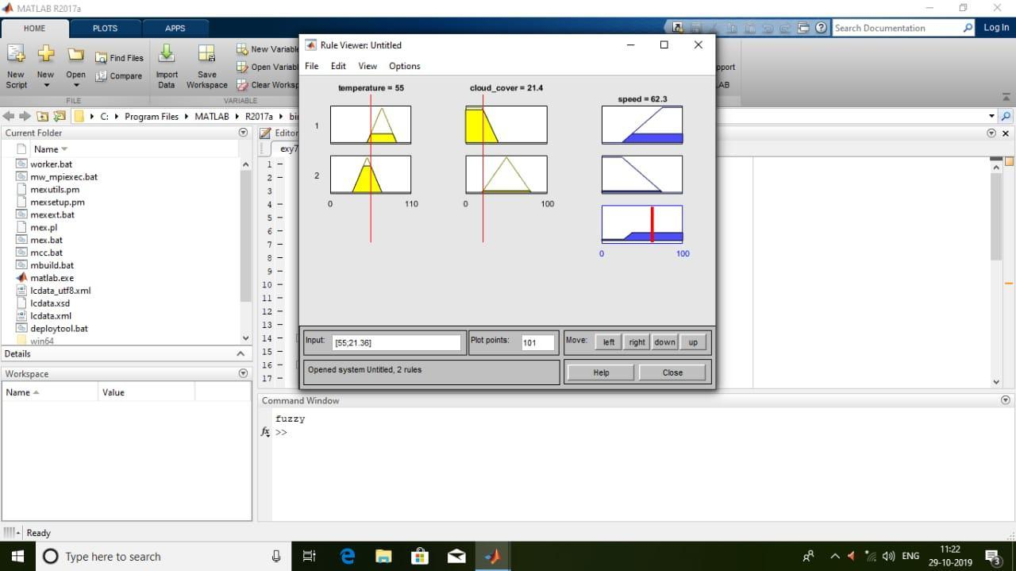

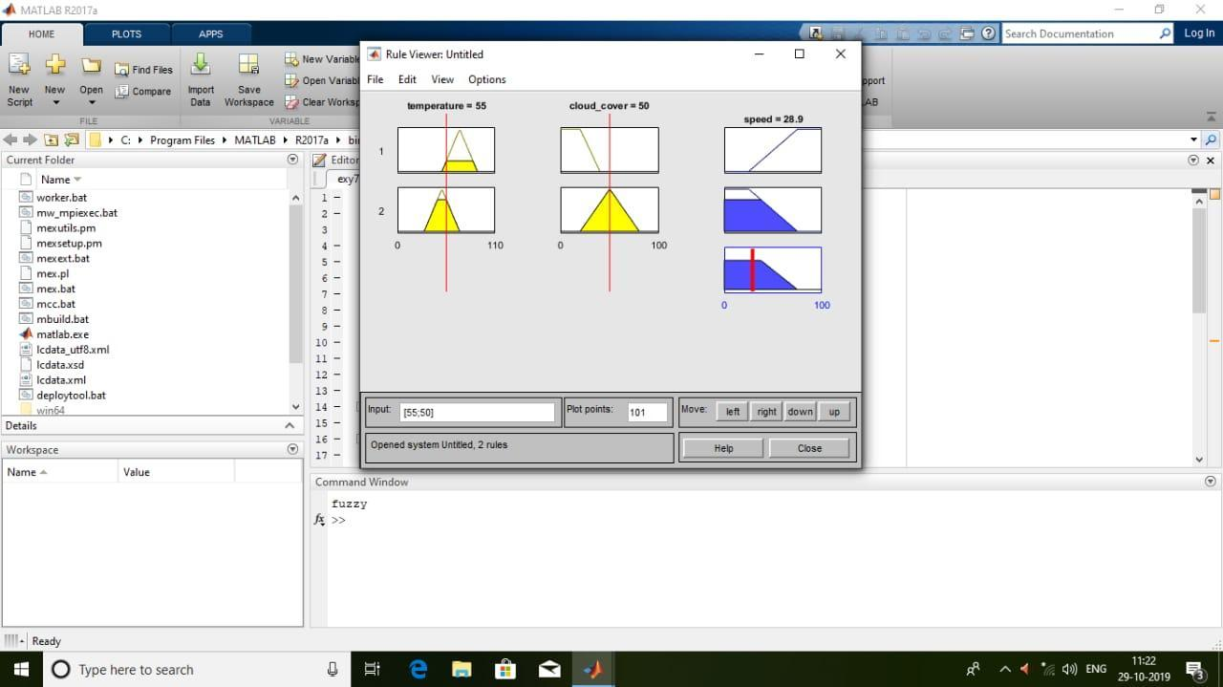

#### Result:

Thus a Fuzzy Inference System is successfully executed using MATLAB.

## Ex. No. 10 Defuzzification Methods

**Date:**

#### Aim:

To write a program in Python to implement defuzzification methods using fuzzy toolbox.

#### Algorithm:

1. Import numpy, matplotlib and skfuzzy packages.
2. Trapezoidal membership function on range [0, 1] using trapmf function with four parameters.
3. Defuzzify trapezoidal membership function by using fuzzy toolbox functions centroid, bisector, mom, Som and lom.
4. Plot the defuzzified values using matplotlib.

#### Program:

import numpy as np

import matplotlib.pyplot as plt

import skfuzzy as fuzz

# Generate trapezoidal membership function on range [0, 1]

x = np.arange(0, 5.05, 0.1)

mfx = fuzz.trapmf(x, [2, 2.5, 3, 4.5])

# Defuzzify this membership function five ways

defuzz_centroid = fuzz.defuzz(x, mfx, 'centroid')

defuzz_bisector = fuzz.defuzz(x, mfx, 'bisector')

deuzz_mom = fuzz.defuzz(x, mfx, 'mom')

defuzz_som = fuzz.defuzz(x, mfx, 'som')

defuzz_lom = fuzz.defuzz(x, mfx, 'lom')

# Collect info for vertical lines

labels = ['centroid', 'bisector', 'mean of maximum', 'min of maximum', 'max of maximum']

xvals = [defuzz_centroid, defuzz_bisector, defuzz_mom, defuzz_som, defuzz_lom]

colors = ['r', 'b', 'g', 'c', 'm']

ymax = [fuzz.interp_membership(x, mfx, i) for i in xvals]

# Display and compare defuzzification results against membership function

plt.figure(figsize=(8, 5))

plt.plot(x, mfx, 'k')

for xv, y, label, color in zip(xvals, ymax, labels, colors):

plt.vlines(xv, 0, y, label=label, color=color)

plt.ylabel('Fuzzy membership')

plt.xlabel('Universe variable (arb)')

plt.ylim(-0.1, 1.1)

plt.legend(loc=2)

plt.show()

#### Output:

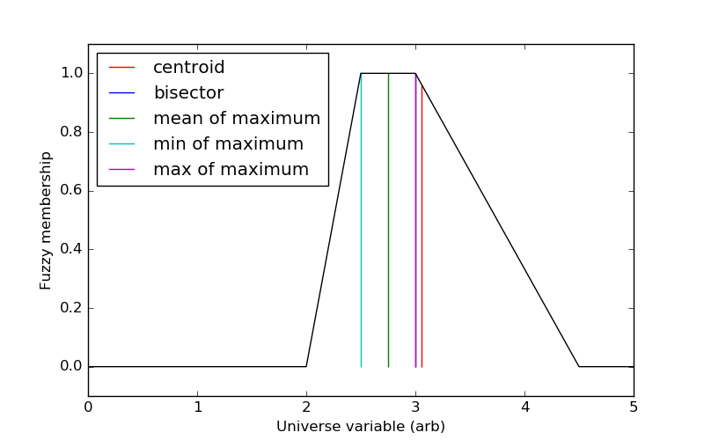

#### Result:

Thus, the Python program for implementing defuzzification methods has been executed successfully and the output is verified.

## Ex. No. 11 THE TIPPING PROBLEM

**Date:**

#### Aim:

To develop a fuzzy controller for the Tipping problem using Python programming.

**The Tipping Problem:**

The 'tipping problem' is commonly used to illustrate the power of fuzzy logic principles to generate complex behavior from a compact, intuitive set of expert rules.

A fuzzy control system is created to model how you might choose to tip

at a restaurant. When tipping, the service and food quality are considered and rated between 0 and 10. A tip of between 0 and 25% is suggested.

**Problem Formulation:**

* Antecednets (Inputs)

- `service`

* Universe (ie, crisp value range): How good was the service of the wait

staff, on a scale of 0 to 10?

* Fuzzy set (ie, fuzzy value range): poor, acceptable, amazing

- `food quality`

* Universe: How tasty was the food, on a scale of 0 to 10?

* Fuzzy set: bad, decent, great

* Consequents (Outputs)

- `tip`

* Universe: How much should we tip, on a scale of 0% to 25%

* Fuzzy set: low, medium, high

* Rules

- IF the *service* was good *or* the *food quality* was good,

THEN the tip will be high.

- IF the *service* was average, THEN the tip will be medium.

- IF the *service* was poor *and* the *food quality* was poor

THEN the tip will be low.

* Usage

- If I tell this controller that I rated:

* the service as 9.8, and

* the quality as 6.5,

- it would recommend I leave:

* a 20.2% tip.

#### Creating the Tipping Controller Using the skfuzzy control API

import numpy as np

import skfuzzy as fuzz

from skfuzzy import control as ctrl

# New Antecedent/Consequent objects hold universe variables and membership

# functions

quality = ctrl.Antecedent(np.arange(0, 11, 1), 'quality')

service = ctrl.Antecedent(np.arange(0, 11, 1), 'service')

tip = ctrl.Consequent(np.arange(0, 26, 1), 'tip')

# Auto-membership function population is possible with .automf(3, 5, or 7)

quality.automf(3)

service.automf(3)

# Custom membership functions can be built interactively with a familiar,

# Pythonic API

tip['low'] = fuzz.trimf(tip.universe, [0, 0, 13])

tip['medium'] = fuzz.trimf(tip.universe, [0, 13, 25])

tip['high'] = fuzz.trimf(tip.universe, [13, 25, 25])

# You can see how these look with .view()

quality['average'].view()

service.view()

tip.view()

rule1 = ctrl.Rule(quality['poor'] | service['poor'], tip['low'])

rule2 = ctrl.Rule(service['average'], tip['medium'])

rule3 = ctrl.Rule(service['good'] | quality['good'], tip['high'])

rule1.view()

tipping_ctrl = ctrl.ControlSystem([rule1, rule2, rule3])

tipping = ctrl.ControlSystemSimulation(tipping_ctrl)

# Pass inputs to the ControlSystem using Antecedent labels with Pythonic API

# Note: if you like passing many inputs all at once, use .inputs(dict_of_data)

tipping.input['quality'] = 6.5

tipping.input['service'] = 9.8

# Crunch the numbers

tipping.compute()

print(tipping.output['tip'])

tip.view(sim=tipping)

#### Output:

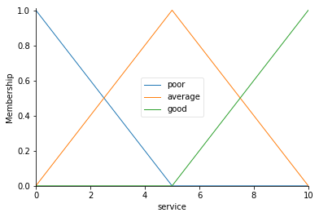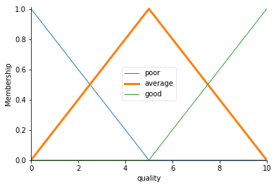

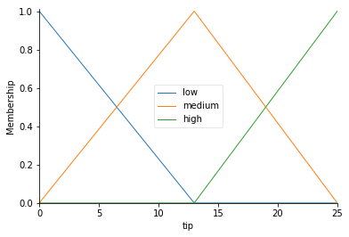

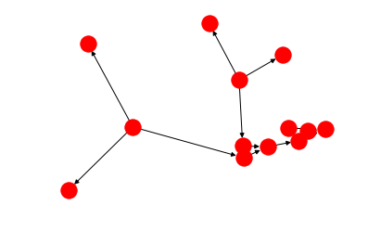

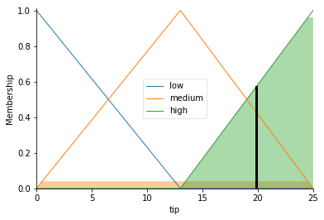

The resulting suggested tip is 20.24%.

#### Result:

Thus, the Python program for developing a fuzzy controller for the Tipping problem has been executed successfully and the output is verified.