PROPOSAL PROJECT ON PING PONG GAME

Sandip Jha

00176432

Computing Project

Level 5 Diploma in Computing

Softwarica College of IT and E-commerce

Kathmandu, Nepal

4th July, 2019

Submitted to: SUDEEP LAL BAJIMAYA

Contents

1.1 Introduction 3

1.2 Background 3

1.2.1 Problems identification 3

1.3 Justification of the system 3

2.Scope 4

2.1 Aims 4

2.2 objectives 4

2.3 Features 4

2.Registration and login system 4

3. Time limit has been added to complete the level 4

4. Multi players features will be added. 4

**2.4 Overview:** 4

3. Development 5

3.1 Methodology to be used 5

3.2 Design Pattern 7

3.3 System Architecture 7

4. Scheduling 8

4.1 Work Breakdown Structure 8

4.2 Milestone 9

4.3 Gantt chart: 10

**5. Risk Management** 12

6. Configuration Management 13

7. Conclusion 14

References: 14

1. overview

# 1.1 Introduction

Ping pong game is a game console, that consist of one ball and two players. One will be operated by the computer and the other will played manually controlling through keyboard. The ball movement is determined on the logically depending on the physically implemented in the software. Player controls an in-game paddle by moving it horizontally across the screen. Points are earned when one fails to return the ball to the opponent.

# 1.2 Background

As we know ping pong game is already available in play store or in different sites but they are not too much interactive and also a dull looking UI. our system works in that factor make it more improved so that gamer or user will be enjoyed while they will play our game.

# 1.2.1 Problems identification

As we know user/gamer face problem like they don’t have option to select level. The UI of the game is also complex so they don’t have idea how to play. Another problem due to the large space vacant on their system due to that user have problem to save any other data and also while playing it hanged time to time due to that they cannot enjoyed too much while playing. I would minimize all the problems and improved the game so that user will never feel bored while playing and they will not have to face how to play the game because I will add help feature about how to use the application and play the game.

# 1.3 Justification of the system

The application will have a web UI to visualize the database with the feature of sorting and filtering.Our system fits the role here because it has an easy to use interface. Our game also has features to record the score of players. It will have also time limit features on level so players will enjoy. It will also occupy less space in the system so the user will not hesitate to download and the requirements needed for this system are minimum. It also contains multiplayer option so players can play with their friends.

# 2.Scope

# 2.1 Aims

The aim of this proposal is to provide an interactive interface to the gamers/users for better gaming experience. While developing this game I will also experienced and learned C# and also it will help to develop my skills and help me to face the real time problem of the society.

# 2.2 objectives

This project intends to introduce more user-friendliness in the game involved in using the interface. Maintain a proper database of the gamer/user so that player can see their score whenever they want to see it and compared with other players. Provide feedback system within the application and UI so further improvements can be done on game.

# 2.3 Features

1. Select the level of the as user want

### 2.Registration and login system

### 3.Time limit has been added to complete the level

### 4. Multi players features will be added.

# **2.4 Overview:**

My project will be a virtual ping-pong game that could be played in multi-player or single-player modes. In the single-player mode, the game will resemble virtual squash. The interface will display a three-dimensional room populated with a ball. This ball elastically bounces off of walls and is affected by gravity. When the ball reaches the "front" of the screen, the user will have to swing a paddle to hit the ball back into the screen as in squash. The system will be able to detect paddle tilt and speed to make the ball return realistically. Our project will also have a multi-player component. In this mode the back wall will be replaced by a video image from the camera pointing at the other player. Players will volley the ball back and forth. The first player to miss a return loses the game.

# 

# 3. Development

# 3.1 Methodology to be used

For developing the ping pong game waterfall model will be used. The waterfallmodel is a breakdown of project activities into linear sequential phases, where each phase depends on the deliverables of the previous one and corresponds to a specialization of tasks.The phases of**Conception, Initiation, Analysis, Design, Construction, Testing, Production/Implementation and Maintenance.**

In waterfall, development of one phase starts only when the previous phase is complete. Because of this nature, each phase of waterfall model is quite precise well defined. Since the phases fall from higher level to lower level, like a waterfall, it’s named as waterfall model.

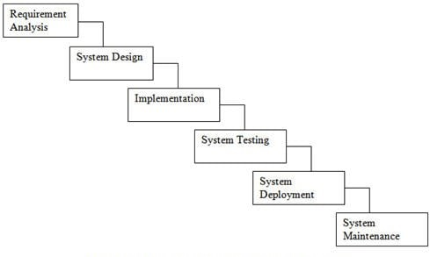

Figure 1 waterfall model

**Requirements:** The first phases are to gather all the requirements of the software understand and run through the requirements that have been gather and also run the feasibility test of the system and also be ensure to the requirements are testable or not.

**System design:** as analyzing the data from the first phase the design will be created in this phase which helps them to capture the hardware and software requirements and also help to design the whole system architecture.

**Implementation:**With inputs from the system design, the system is first developed in little programs referred to as units, which area unit integrated in the next part. Each unit is developed and tested for its practicality, which is referred to as Unit Testing.

**Integration and Testing:**

This stage is usually a subset of all the stages as in the modern SDLC models, the testing activities are mostly involved in all the stages of SDLC. However, this stage refers to the testing only stage of the product where product defects are reported, tracked, fixed and retested, until the product reaches the quality standards defined in the SRS.

**Deployment of System:**Once the product is tested and ready to be deployed it is released formally in the appropriate market. Sometimes product deployment happens in stages as per the business strategy of that organization. The product may first be released in a limited segment and tested in the real business environment (UAT- User acceptance testing).

**Maintenance:**There are some issues which come up in the client environment. To fix those issues, patches are released. Also, to enhance the product some better versions are released. After the product is released in the market, its maintenance is done for the existing customer base.

While using waterfall model there are some advantages and disadvantages which are mentioned below:

**Advantages:**

* It is simple and easy to understand.
* Easy to manage due to the rigidity of the model. Each phase has specific deliverables and a review process.
* Phases are processed and completed one at a time.
* Works well for smaller projects where requirements are very well understood.
* Well understood milestones.

**Disadvantages:**

* No working software is produced until late during the life cycle.
* High amounts of risk and uncertainty.
* Not a good model for complex and object-oriented projects.
* Poor model for long and ongoing projects.
* Not suitable for the projects where requirements are at a moderate to high risk of changing. So, risk and uncertainty are high with this process model.

# 3.2 Design Pattern

Design patterns are solutions to software design problems you find again and again in real-world application development MVC design pattern is one of the oldest architectural patterns for web application. MVC stands for Model View Controller. MVC design pattern is used to separate the logic of different layers in a program in independent units.

With MVC design pattern, we have following components on which our design depends:

* The model which is transferred from one layer to the other.
* The View which is responsible to show the data present in the application.
* The controller is responsible to accept a request from a user, modify a model and send it to the view which is shown to the user.

The idea behind MVC pattern is a very clear separation between domain objects which represents real-world entities and the presentation layer we see on the screen. Domain objects should be completely independent and should work without a View layer as well.

# 3.3 System Architecture

In this project 3-tier architecture will be used. A 3-tier application architecture is a modular client-server architecture that consists of a presentation tier, an application tier and a data tier. The data tier stores information, the application tier handles logic and the presentation tier is a graphical user interface (GUI) that communicates with the other two tiers. The three tiers are logical, not physical, and may or may not run on the same physical server.

Architecture layers:

* The **Presentation tier** - the part of the application which is visible to the user; it enables the input of requirements and the presentation of results. It is dependent on the platform (e.g. web-application, Windows applications, Android applications, etc.). It may therefore be different for different devices or platforms.
* The **Application tier** (also functional) - the middle layer of the model (middleware), it assures the calculations and operations performed between input-output requirements and data. Also known as the application-server.
* The **Data tier** (also database) - the lowest layer of the model, it ensures all operations with data, i.e. database management system and basic data-base operations for functional storage, selection, aggregation, processing, integrity, and data audit.

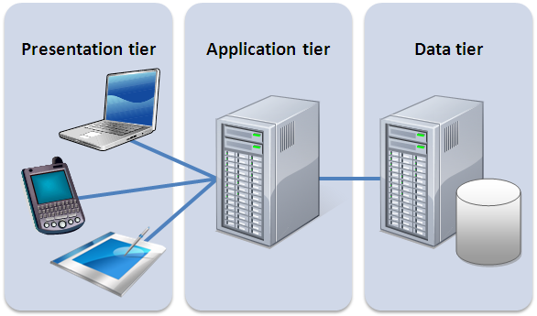

Figure 2 3-tier system architecture

# 4. Scheduling

# 4.1 Work Breakdown Structure

Ping Pong game

Design

Testing and Integration

Coding

Analysis

Project Management

Database Design

Database

Overview

Requirement Gathering

Maintenance

UI design

UI

Development Methodology

Use Case Diagram

Unit Testing

Scheduling

Class Diagram

Integration Testing

Risk Management

Activity Diagram

Black Box Testing

Configuration Management

Architecture

Submission

# 4.2 Milestone

|  |  |
| --- | --- |
| Milestones | Date |
| Project Management   1. Overview 2. Development Methodology 3. Scheduling 4. Risk Management 5. Configuration Management 6. Submission | June 16 to July 1st 2019 |
| Analysis   1. Requirement Gathering 2. Use Case Diagram 3. Class Diagram 4. Activity Diagram 5. Architecture | July 2nd to July 29th |
| Design   1. Structural Model 2. Database Design 3. UI Design | July 30th to Aug 29th |
| Implementation   1. Database Coding 2. Web UI Coding 3. Application Coding | Aug 30th to September 20th |
| Testing and Integration   1. Unit Testing 2. Integration Testing 3. Black Box Testing 4. Deployment | September 21st to September 30th |
| Deployment and Maintenance | October 1- |

# 4.3 Gantt chart:

**A Gantt chart is a horizontal bar chart that visually represents a project plan over time.**

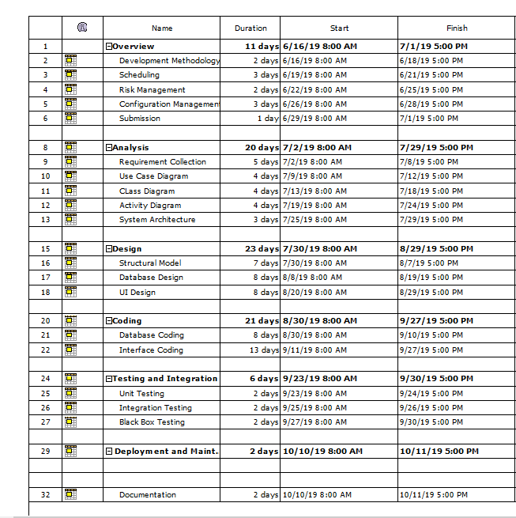

Figure 3 time estimation

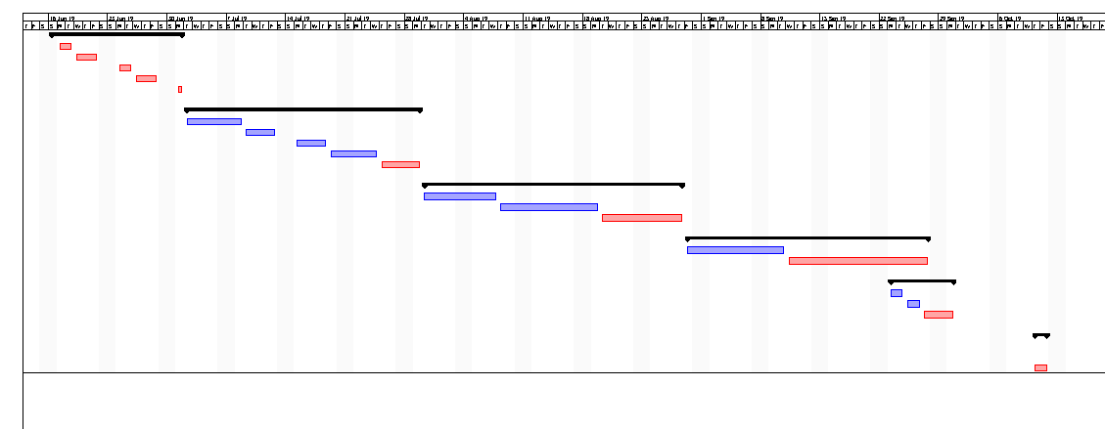

Figure 4Gantt chart

# **5. Risk Management**

|  |  |
| --- | --- |
| Likelihood | Value |
| Low | 1 |
| Medium | 2 |
| High | 3 |

Occurrence Table

The Impact to the system can be high or low which on numbers can be shown in table below.

|  |  |
| --- | --- |
| Consequence | Value |
| Very Low | 1 |
| Low | 2 |
| Medium | 3 |
| High | 4 |
| Very High | 5 |
|  |  |

**Risk Table**

|  |  |  |  |  |  |
| --- | --- | --- | --- | --- | --- |
| S. No | Risk | Likelihood | Consequence | Impact | Action |
| 1 | Hardware failure | 2 | 5 | 10 | Frequent analysis and repair of hardware |
| 2 | Crashing of software | 3 | 4 | 12 | Proper backup should be maintained |
| 3 | Time and budget shortage | 3 | 3 | 9 | Proper allocation of time and budget |
| 4 | Resources not met | 1 | 3 | 3 | Requirements should be taken carefully |
| 5 | Natural calamities | 1 | 5 | 5 | Backup in cloud or google drives |

# 6. Configuration Management

A configuration management (CM) system is used to keep track of an organization’s hardware, software and related information.

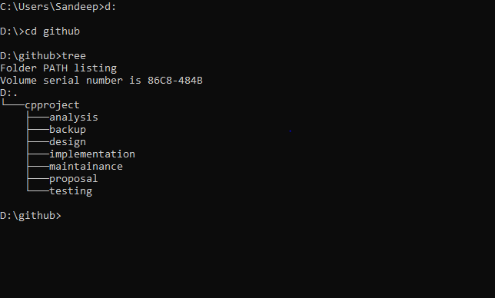

Figure 5 tree of folder structure

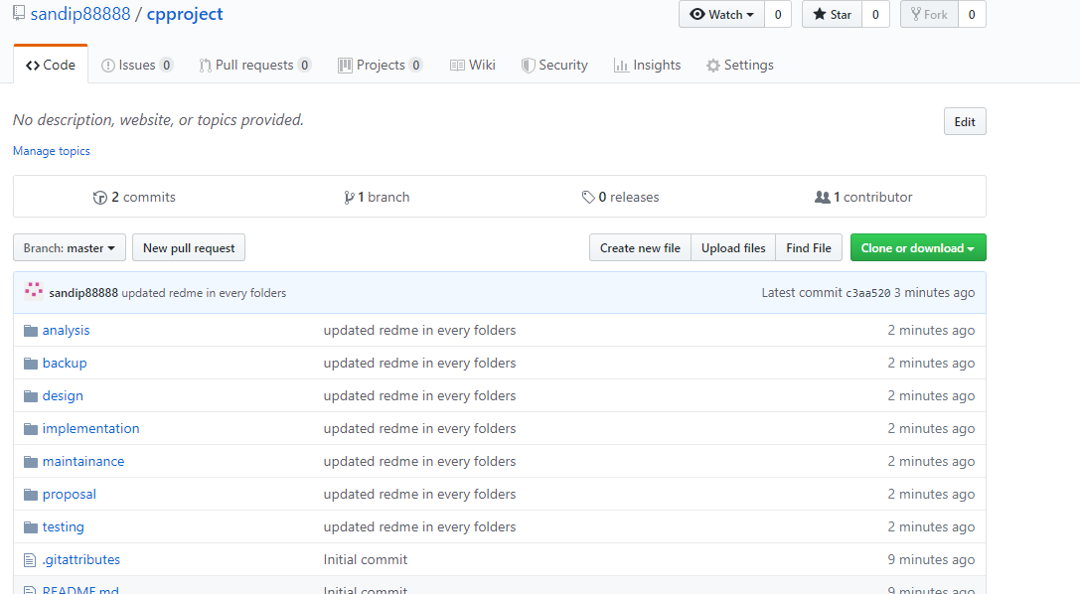

Figure 6GitHub

# 7. Conclusion

Therefore, the proposal has included all the plans, design, implementation, analysis which makes this project to achieve the target. The features of the game have been clearly listed as well as aim too. Scheduling have been done properly so that we have enough time to complete our project. This project is going to be built using MVC design pattern and waterfall model.

# References:

* 1. www.tutorialspoint.com. (2019). *MVC Framework Introduction*. [online] Available at: https://www.tutorialspoint.com/mvc_framework/mvc_framework_introduction.htm [Accessed 1 Jul. 2019].
  2. Google.com. (2019). *ping pong game on visual basic proposal - Google Search*. [online] Available at: https://www.google.com/search?q=ping+pong+game+on+visual+basic+proposal&oq=ping+&aqs=chrome.0.69i59j69i57j69i59j0l3.3182j0j4&sourceid=chrome&ie=UTF-8 [Accessed 4 Jul. 2019].
  3. JReport. (2019). *3-Tier Architecture: A Complete Overview - JReport*. [online] Available at: https://www.jinfonet.com/resources/bi-defined/3-tier-architecture-complete-overview/ [Accessed 1 Jul. 2019].
  4. Google.com. (2019). *ping pong game on visual basic proposal - Google Search*. [online] Available at: https://www.google.com/search?q=ping+pong+game+on+visual+basic+proposal&oq=ping+&aqs=chrome.0.69i59j69i57j69i59j0l3.3182j0j4&sourceid=chrome&ie=UTF-8 [Accessed 4 Jul. 2019].