Generative Safety Culture in PAF: the long, hard and winding road

Let’s suppose a workplace accident takes place. What’s your response? Analyze the accident, create a report, and put safety measures in place, right? This would seem pretty normal to anyone reading this. However, this is the wrong attitude to go about safety. What we need to do is to focus on changing the ideology of our workforce by implementing generative safety culture, as it completely determines how our attitude should be towards safety practices.

Now the question arises that what is basically safety culture and why it is so important? Safety culture is basically the uniformity of thoughts, norms, behavior and values related to safety, practiced and articulated by majority of people in an organization. Coming towards the why part, as we all know that humans by their very nature usually resist being changed and tend to stay in their comfort zone, 95% of the time they act what they are habitual of doing. They follow their safety culture norms which are already set by their seniors. So, in order to improve the safety standards and prevent any occurrence for longer run, it is mandatory to change organization attitude and inculcate these safety values and practices as part of their culture.

The attitudes of technicians and personnel working on various technical systems are prescribed by overall organizational influences. Safety culture is about instilling the importance of safety in the personnel from the start of their training. Before we can truly understand what, generative safety culture is, and how can we shift our organizational behavior in light of it, it is important to learn about other safety cultures and see why they need to change.



*Image Source: https://www.freepik.com/free-vector/plane-service-isolated-flat-vector-illustration-cartoon-mechanics-repairing-airplane-before-flight-adding-fuel-aircraft-maintenance-aviation-concept_10613414.htm#page=1&query=airline%20safety&position=0*

A few managements believe that workplace accidents result due to negligence of their staff. For them, safety is more like an afterthought and the emphasis is on getting the job done. The mindset of ‘who’ instead of ‘why’ prevails in such workplaces. This is **pathological safety culture** and we can clearly see how inefficient and unproductive it is.

Some organizations don’t have any safety measures in place to prevent an accident. However, after an unfortunate incident, safety becomes a priority for them and their staff. For a short while, safety remains their priority and then everything goes back to the way it was. This **reactive safety culture** is a wrong approach towards ensuring the safety of equipment as well as personnel.

Another approach towards safety is to put a few safety systems and processes in place and regularly check whether they are still in place or not. We have seen that even when such systems were in place, workplace accidents didn’t stop. The reason is that this **calculative safety culture** focuses more on metrics and data instead of on knowledge and insight.

In an organization that practices **proactive safety culture**, teams use systems to anticipate the issues before they arise. The proactive management of safety problems is indeed a good approach and probably the best amongst the ones we have discussed so far.

The best possible scenario would be the one in which safety and work are considered inseparable. Once this awareness permeates through the organization that safety and normal operations are two faces of the same coin, it is unlikely that the safety standards of that organization would not increase. This attitude is termed the **generative safety culture**.

The system of quality and safety goes hand in hand in all organizations. In PAF we have numerous safety measures and defenses already in place. Typically, these include pre-mission risk analysis, risk management programs, safety factors training, etc. However, there is a need to shift from reactive safety towards generative safety. There needs to be an equal amount of focus on accident investigation and safety audits that focus on normal ‘non-accident’ day-to-day operations.

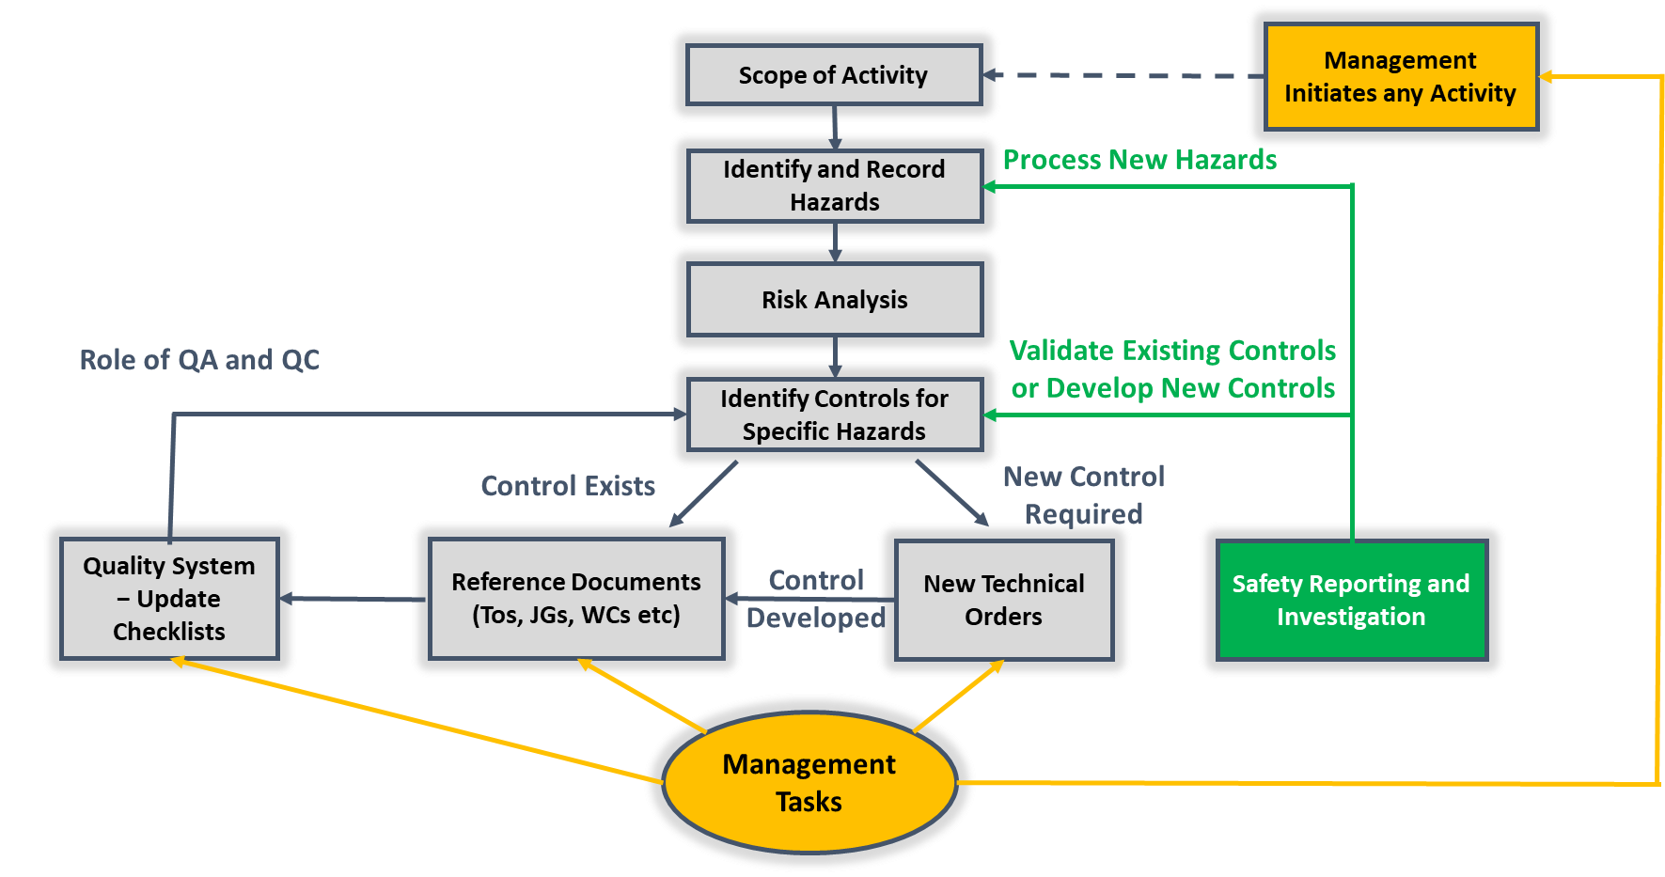

**Quality and Safety Management System System**

Now comes the million-dollar question: How to create a generative safety culture? There are a few things that have the utmost importance when it comes to building a sustainable safety culture. The style and level of management commitment are one of the important factors. Does the top-management lead through example or by issuing decrees and orders? Are they accessible to the staff or remain isolated in their executive offices? Do workers in your section talk about their beliefs regarding safety?

In order to answer all these questions an iterative problem-solving method known as PDSA cycle can be adopted to improve the safety cultural system and ultimately achieving generative safety environment. Within a section supervisors or seniors will first plan and then practically implement what was planned, after that they will take feedback and analyze the outcomes of their actions. Finally, they will conclude and decide what should be done next. This cycle keeps on repeating till the time section achieve their goal of implementing generative safety culture. Before implementing this cycle, few things should be clear like in this case seniors should be knowing about:

* What safety culture they want to achieve?
* Which safety culture their workforce is following in their respective sections?
* What are their weak areas? Or Where they need to put in efforts?
* What possible measures can be taken to overcome those weak areas?

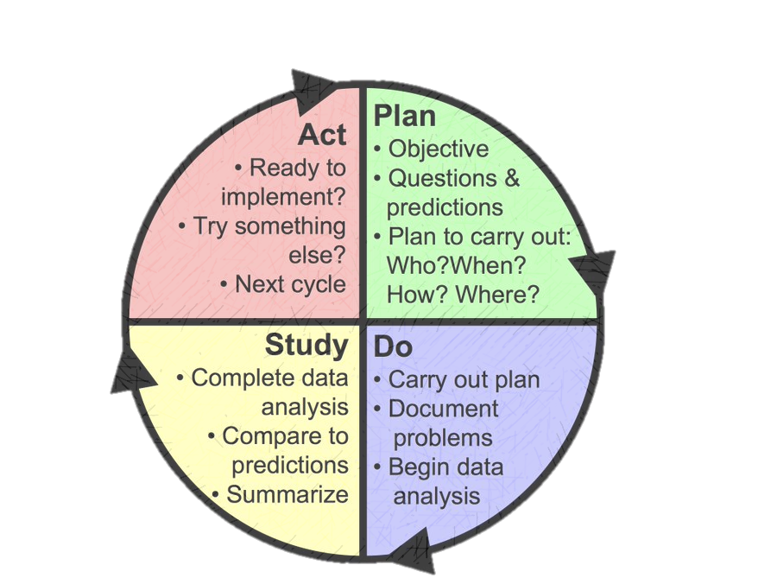

**Let’s try it!**

**Did it work?**

**What’s next?**

**What will happen if we try something different?**

**The PDSA cycle**

PAF clearly know that their main goal is to achieve generative safety culture in which everyone should be well aware of their duties. They should be “Self-motivated for doing the right things in the right and honest way”. Every worker should have enough moral integrity and courage to speak truth and communicate whenever required. In order to attain such an environment, one must know about his section very well.

“**You can’t manage what you can’t measure” − Drucker**

It is a very famous saying which means that in order to manage something better, it is necessary to find out a way in which we can measure how that system is working as this would give us an insight that where we stand and what steps we should follow in order to improve that system. For this purpose, a survey sheet has been designed, which helps in categorizing workers individually at a workplace\section that at which level of safety they lie. Once all the statistics is collected, then they can easily analyze about the overall culture of that workplace\section. This survey will also highlight the weak areas of each work center that should be targeted.

|  |  |  |  |  |
| --- | --- | --- | --- | --- |
| **Pathological** | **Reactive** | **Calculative** | **Proactive** | **Generative** |
| Practice safety only under supervision  Gives no feedback  No ownness for people under command and PAF assets  Not willing to take responsibility  He does not CARE and does not KNOWS  Never thought about bringing innovation or improvement  Hides mistakes  No trust in seniors or juniors  Don’t care about safety knowledge collect what is legally required  Environment of punishing or blaming | Practice safety only after any issue or occurrence  No ownness for people under command and PAF assets  Put blame on juniors but still have to take responsibility  Top-down flow of information  He KNOWS but not always CARES  Lack of trust by juniors  Overreacts on all issues  Lack knowledge about safety  Focus only on deriving procedures to prevent previous accidents  Collects statistics and don’t follow up | Environment of command and control  Little feedback  Safety procedures exist but are practiced very rarely  Collects statistics and study them too but less follow up  Workforce is involved more, adopting quantitative methods  He CARES but not always KNOWS  Believe they are doing well  Divide the blame and take responsibility for his share only  Seems obsessed with safety procedures but don’t follow them in true letter and spirit  Reward and punishment system | He goes out and seek the WHY part of accidents  Ready to deal with an expected activity, operation or difficulty  Practice safety and know its significance  Know what to change and how to manage  Completes the feedback loop  His involvement is promoted but ruled by supervisors  Works for improvement even if there are no accidents  He CARES and KNOWS as well  Safety is given priority over production  Time and resources are available to improve safety before hazard | Visible leadership and commitment  Have complete trust in seniors  Safety is fully integrated and so practice it at every level during each task  Ownness for people under command and PAF assets  Willingness to take responsibility  Punctual and well disciplined  Eager to improve and so fix failures identified by workforce  Have courage to accept mistakes and report them too  Increasing knowledge about safety due to intrinsic motivation  Empowered with the necessary resources and authority to find and fix safety related problems |

After completing the whole statistics, it is concluded that there are some tangible and some intangible steps that are necessary to be carried out in order to move towards generative safety culture. Talking about the abstract elements of safety culture which are very critical and need more emphasis include changing people beliefs and perspective towards safety. As we all know that our belief decides how we behave and how we behave ultimately becomes part of our habit and then these habits define our culture. This ladder basically describes our way forward, that in order to implement this generative safety culture we as seniors should focus at the root of this ladder. Significance of generative safety culture should be inculcated in every individual’s belief so that this culture should flourish in our prestigious organization, PAF.

Culture

Habits

Behaviors

Beliefs

**Development of Culture in an Organization**

In order to work on changing people’s belief towards safety few practices that can be done include:

* Informal interactions between workers and supervisors to build trust and relationship
* Taking care of the physical and psychological health of your workers
* Avoiding the blame game and just focusing towards improvement
* Celebrating success often and appreciating the one who is doing an excellent job

Moving towards the tangible practices the very first step towards the creation of generative safety culture is to ensure that the workers who manage and operate systems have updated information about the various factors that undermine the safety of a particular system, be it human, technical, or environmental. This can be done by adding certain safety subjects in trainees (both officers and airmen) curriculum and also by introducing different safety courses on regular intervals.

It is human nature to be afraid and scared when they have made a mistake. It is the duty of the section head and senior management to create an environment in which workers are not scared to report errors and mistakes on their part. They should be well aware of the difference between error and violation. Moreover, staff involvement needs to be encouraged. If they have any ideas or concerns regarding safety, their feedback should be welcomed. This is step two.

Once the staff starts to trust the management and an atmosphere of trust and justice is created, it's time to shift the hierarchical structure from a rigid, vertical one to a flexible, horizontal one in terms of safety. Everyone, irrespective of their position or rank, needs to play their role in ensuring safety culture and should be held accountable for any errors on their part. An organizational environment that is open to comments, feedback, and criticism; is the one that progresses the most.

Another step that could be taken is to train and educate the personnel about various safety hazards and damage-prevention rules via presentations, lectures and magazines. Safety information needs to be readily accessible to the workforce. Moreover, the safety managers (FSO, QAEs, QCOs etc.) have to communicate all the safety concerns both up and down the work chain effectively. If there is a small safety budget, there is an increased likelihood of accidents. Instead of having to spend millions once an accident has occurred, there is a need to spend thousands right now on safety measures to prevent future damages.

Rome wasn’t built in a day and an organization can’t start practicing generative safety culture overnight either. An effective and long-lasting culture change is a process that can take years. This change needs to come from within. It’s a trickle-down effect and has to come from the top management and then permeate to the masses. Safety is not something that can be slapped on at the end of a process. Safety needs to be a part of every step of the process itself. Human beings by their very nature tend to make mistakes; therefore, it is unreasonable to expect error-free human performance. We as a part of PAF, should focus on approaching generative safety culture, where everyone works together with full dedication to minimize the errors.

With the right amount of motivation, focus, and action, the results will start to show slowly, but surely!

Remember, a little safety goes a long way!