*I phone mobile*

I phone X

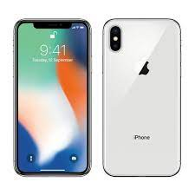

Apple iPhone X · Released 2017, November 03 · **174g, 7.7mm thickness** · iOS 11.1.1, up to iOS 16.6.1 · 64GB/256GB storage, no card slot.

**PRICE / 70,000 PRK**