Game Design Document

Fill up the following document

OK

1. Write the title of your project.

T-rex Runner

1. What is the goal of the game?

It is an infinite runner game so the goal is to avoidthe obstucles and create a high score

1. Write a brief story of your game.

The story of the game is that the T-rex is running and we need to help

the t-rex to jump over the obstucles and make sure it does not gets

hurt

1. Which are the playing characters of this game?

* Playing characters are the ones who respond to the user based on the input from the user.
* Cars, monkeys, dinos, wizards, etc., are the playing characters in the game.

|  |  |  |
| --- | --- | --- |
| Number | Character Name | What can this character do? |
| 1 | T-rex | Jumps over the obstucles |
| 2 |  |  |
| 3 |  |  |
| 4 |  |  |
| 5 |  |  |
| 6 |  |  |
| 7 |  |  |
| 8 |  |  |

1. Which are the Non-Playing Characters of this game?

* Non-Playing characters are the ones that don't have an action or behavior when the user interacts with the game.
* Hurdles, stones, bananas, coins, etc., are non-playing characters in the game.

|  |  |  |
| --- | --- | --- |
| Number | Character Name | What can this character do? |
| 1 | Obstucles | Try to stop the main character and kill it when the character thouches it |
| 2 | clouds | background |
| 3 | score | Thells the time limit how much you played |
| 4 | High score | Tells the highest score |
| 5 | Reset Button | Resets the game |
| 6 |  |  |
| 7 |  |  |
| 8 |  |  |

Draw your imagination of this game. What does this game look like?

* Draw the game either on your computer or on paper.
* Add images of the game scenes to show each of the playing and non-playing characters at least once.

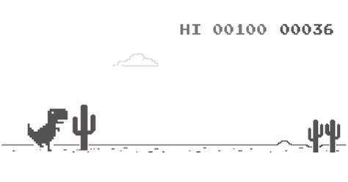

How do you plan to make your game engaging?

I plan to make the game engaging by increasing the speed and diffuculty of the game after a

certain time