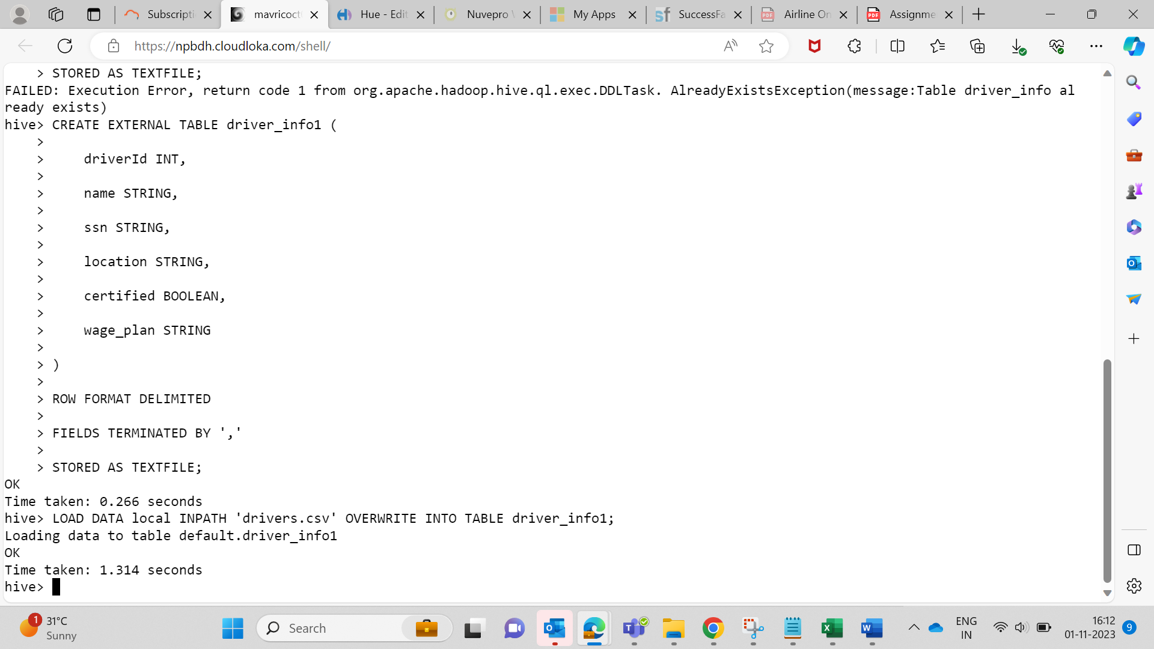  
  
  
**Q1How many total hours and miles logged by each driver?**  
  
  
  
**Q2.Print the name of the driver in the above query**  
  
**3Query: Write the above query output in to hdfs directory**  
  
