create_namespace 'anup'  
  
create 'anup:stock_comments', 'info'  
  
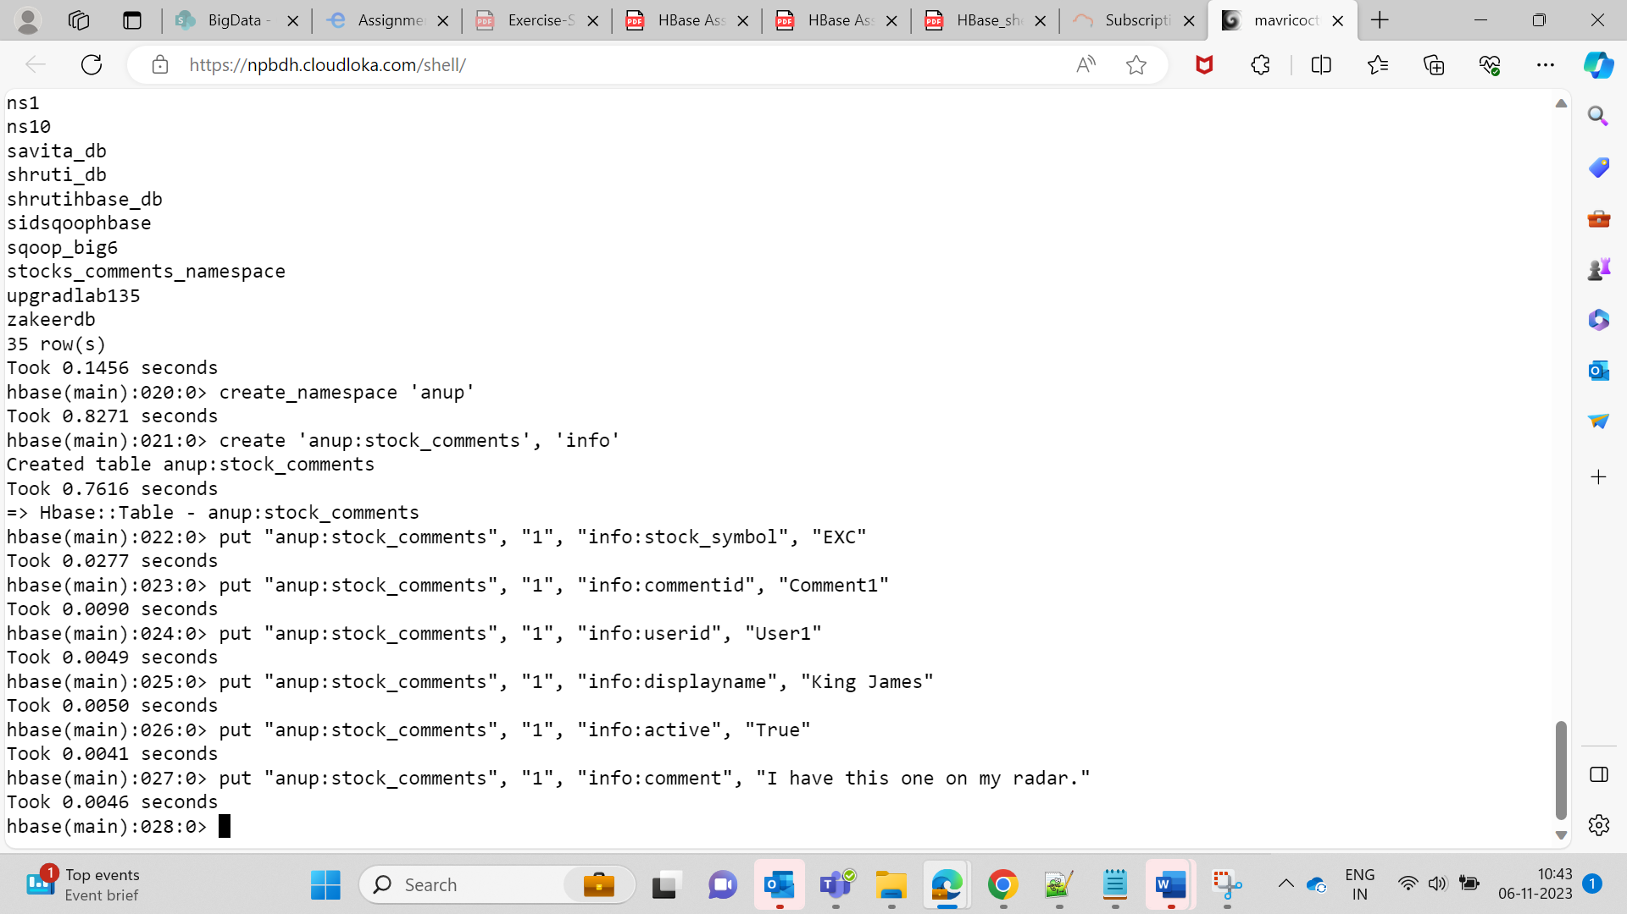  
  
  
Q1.What are the various comments given by all the users?

scan 'anup:stock_comments', {COLUMNS => 'info:comment'}

Q2.What are the comments by user3?

scan 'anup:stock_comments', {FILTER => "ValueFilter (=,'binaryprefix:User3') "}

Q3.Which users have inactive comments?  
  
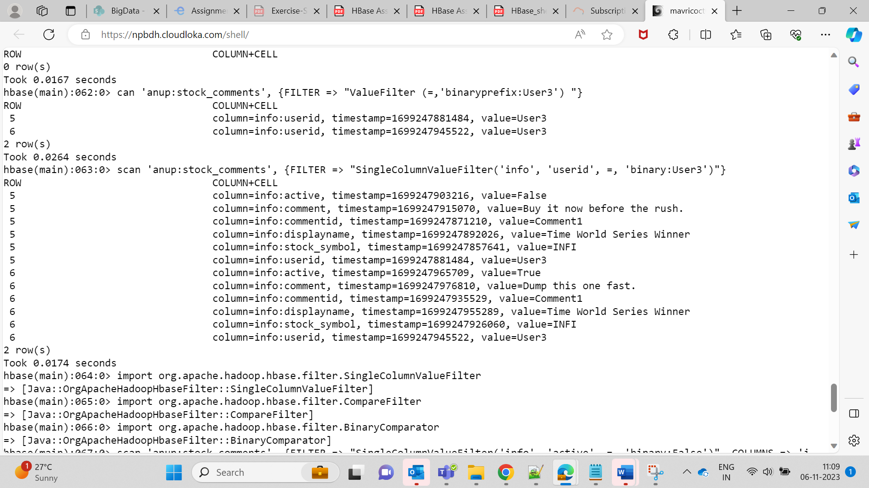  
import org.apache.hadoop.hbase.filter.SingleColumnValueFilter

import org.apache.hadoop.hbase.filter.CompareFilter

import org.apache.hadoop.hbase.filter.BinaryComparator

scan 'anup:stock_comments', {FILTER => "SingleColumnValueFilter('info', 'active', =, 'binary:False')", COLUMNS => 'info:userid'}  
