GIT:

1. Create two separate branches from master

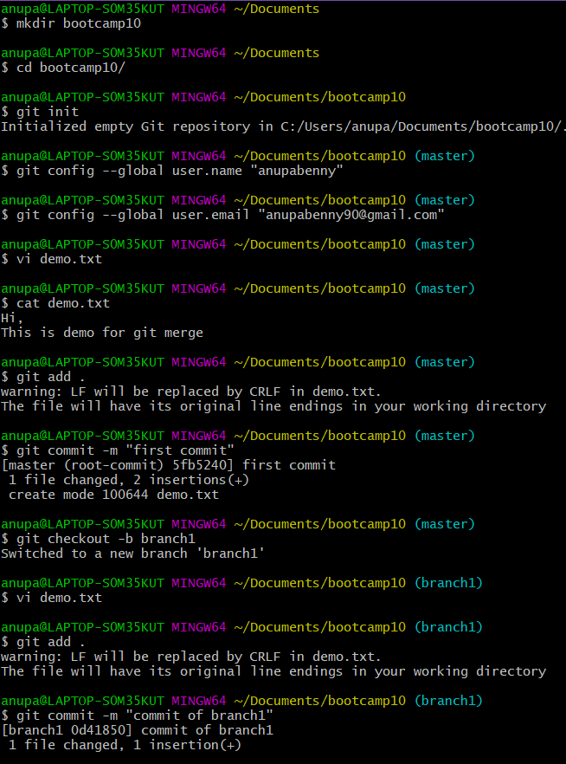

1. Make changes in the same function of the source code in both the branches

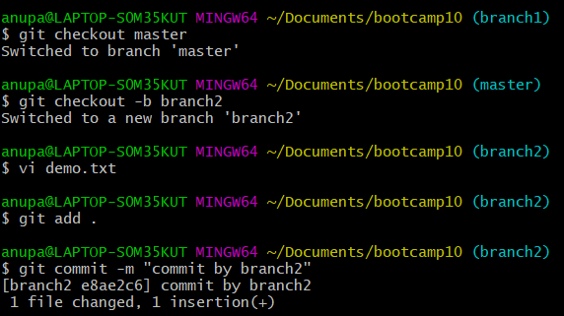

1. Merge branch1 into the master

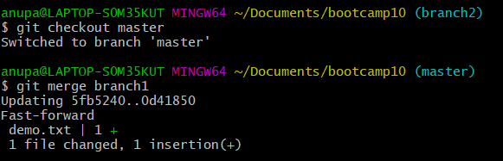

1. Try and merge branch2 into the master (merge conflict should arise)

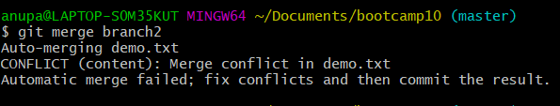

1. Install a merge tool of your choice and resolve the merge conflict using merge tool command



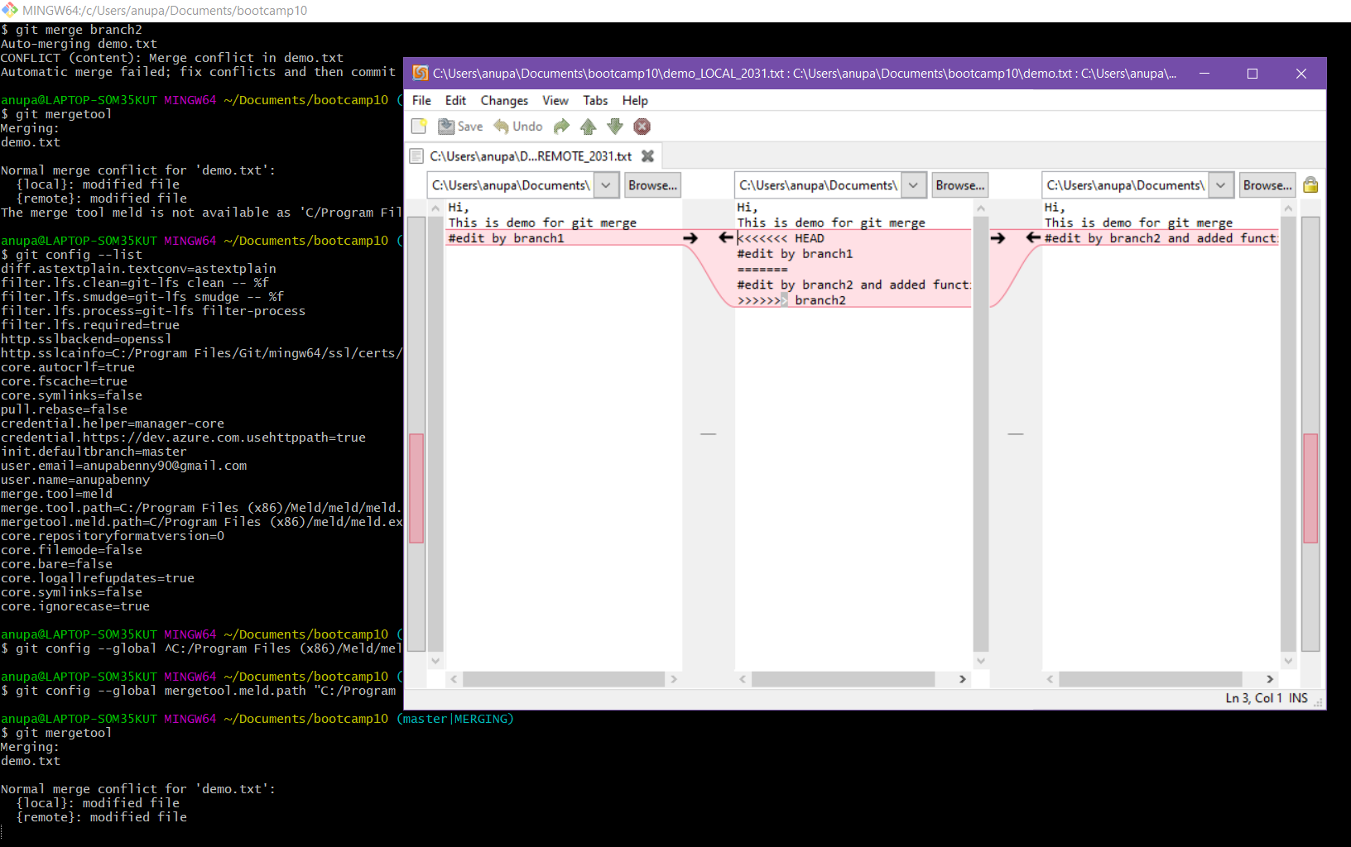

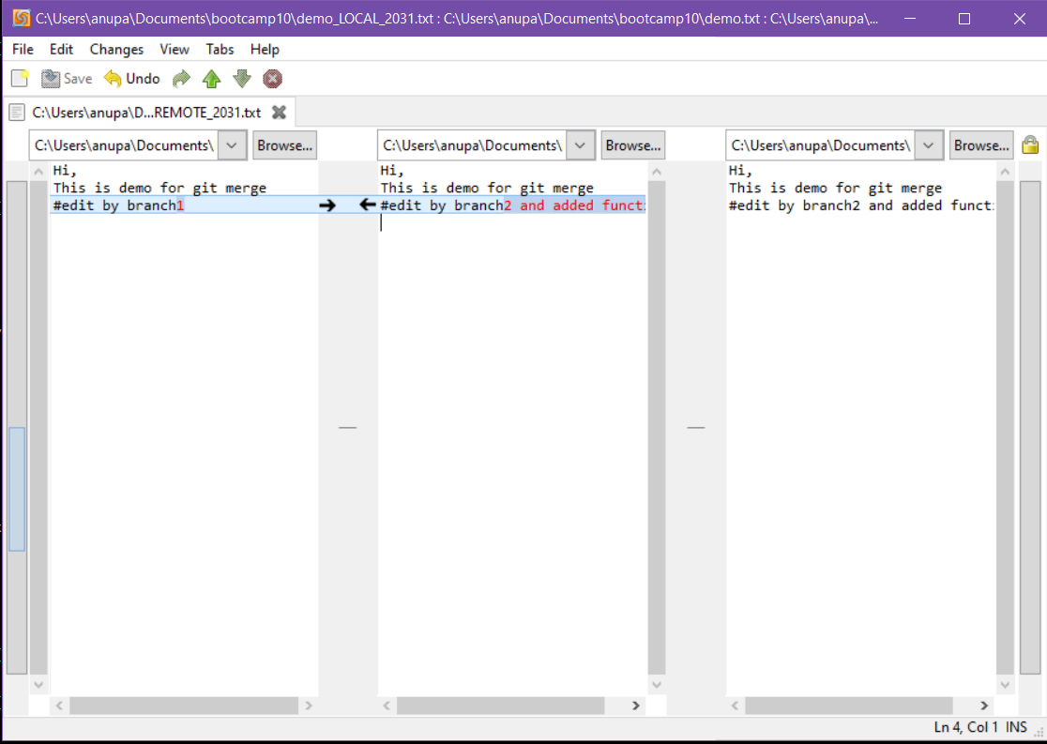

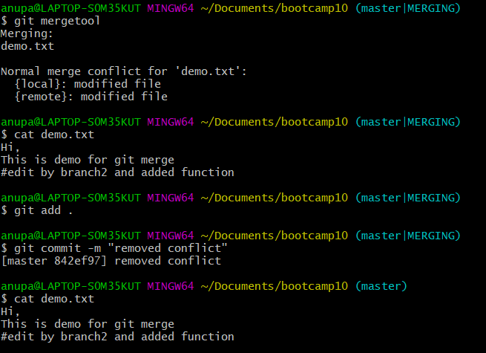

Jenkins

1. Create multiple freestyle project in Jenkins to checkout, build, test, package and deploy the web application in tomcat9 server.

1.**code checkout configuration and console output**

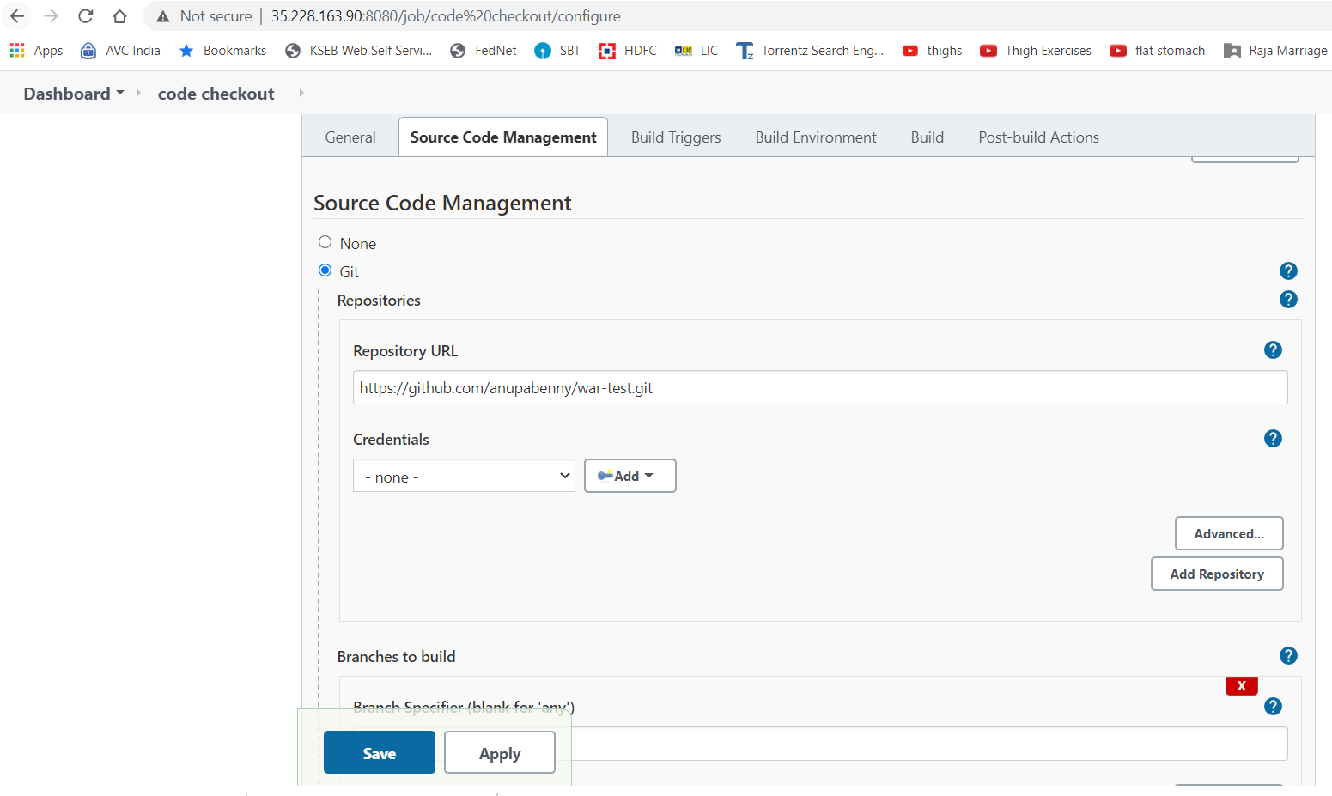

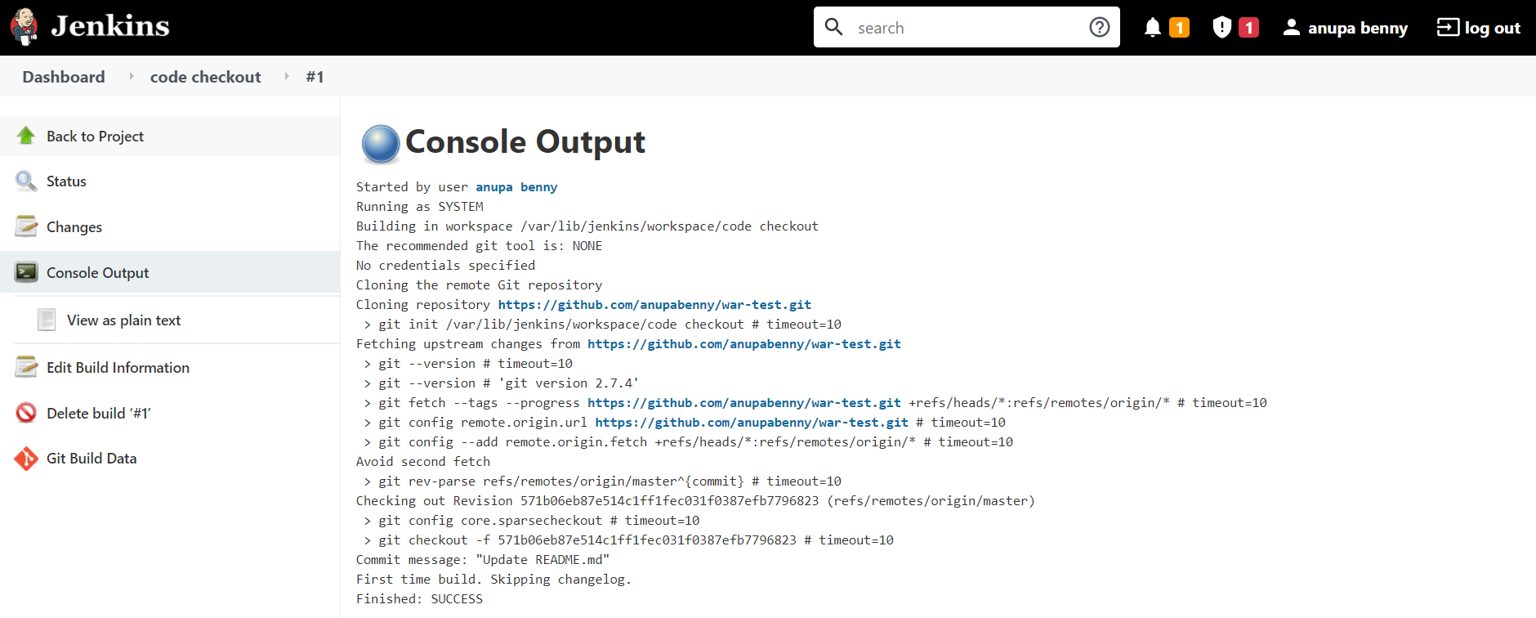

**2.package job configuration and console output**

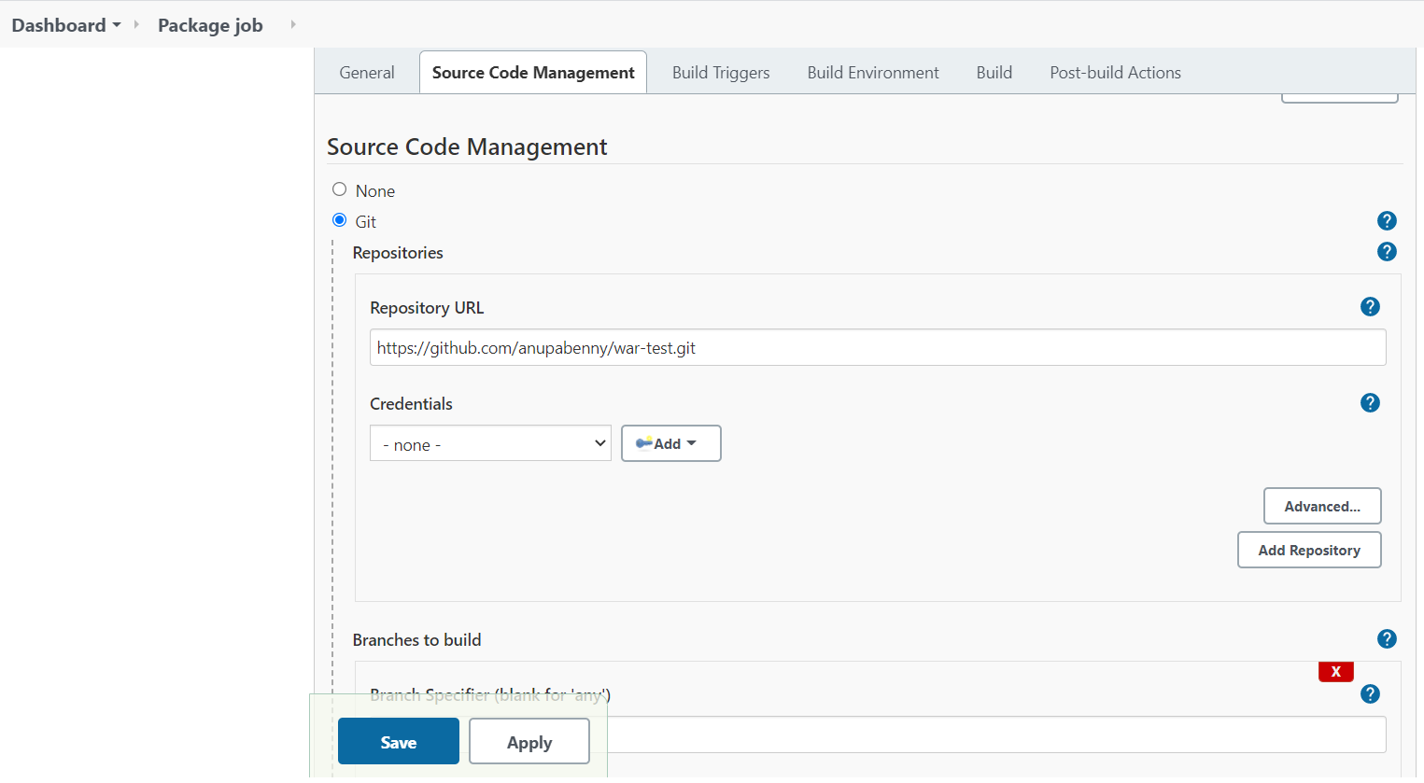

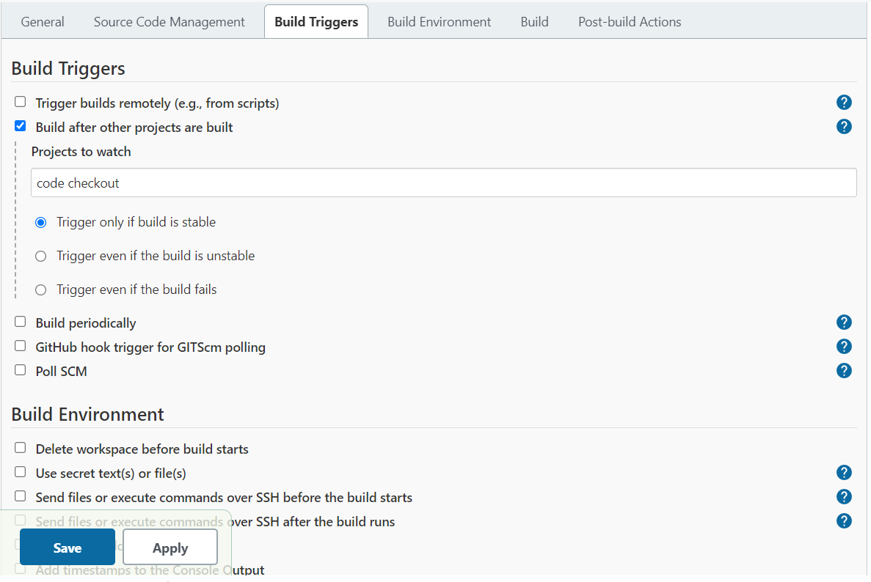

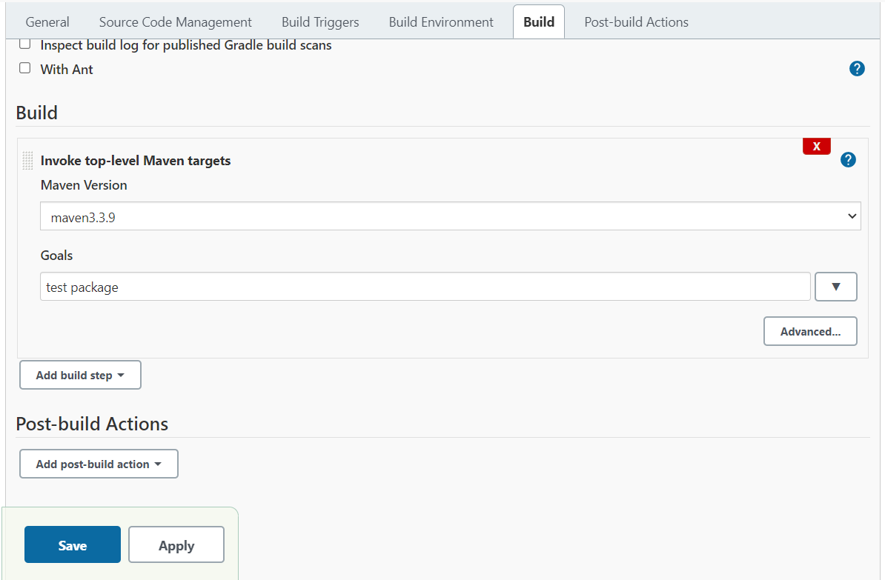

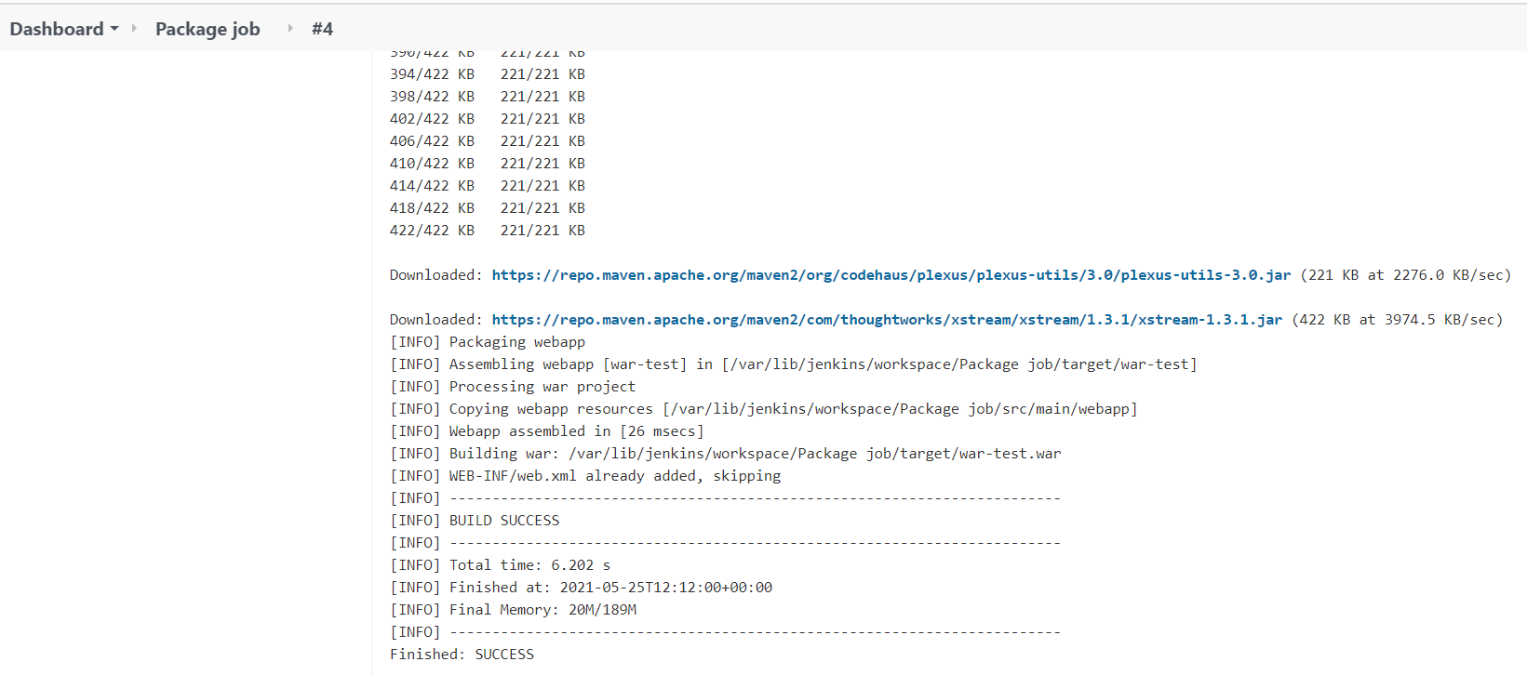

**3.Deploy job configuration and console output**

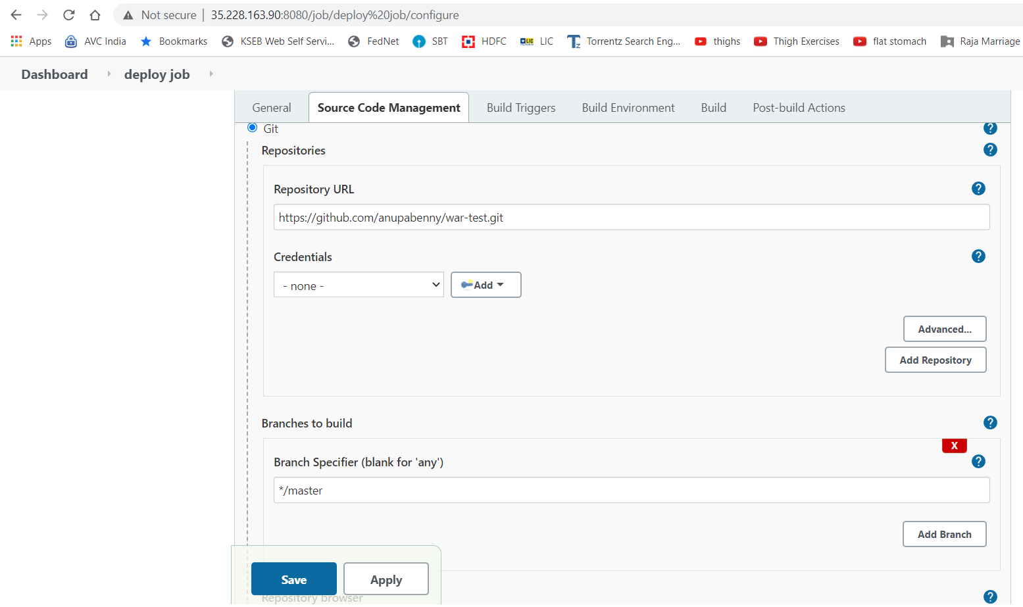

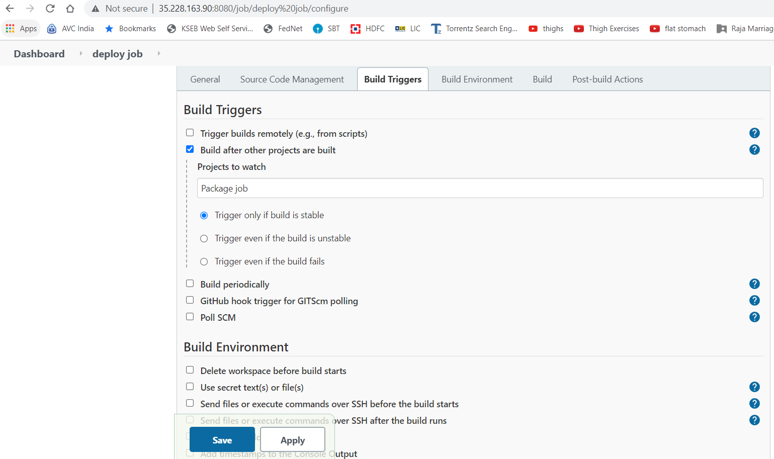

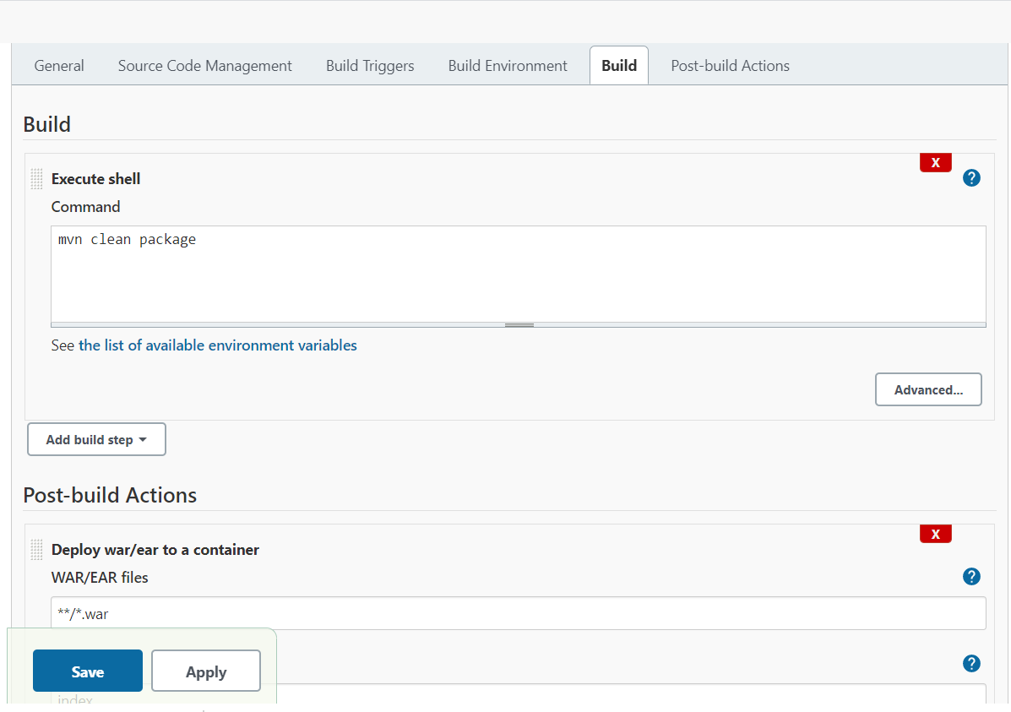

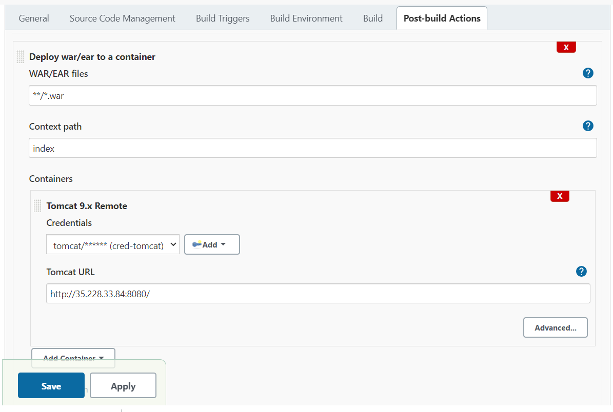

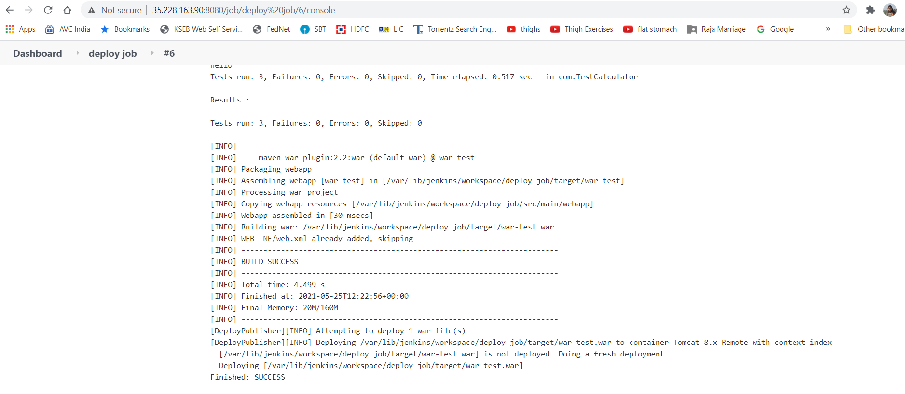

**4.Pipeline view of above jobs**

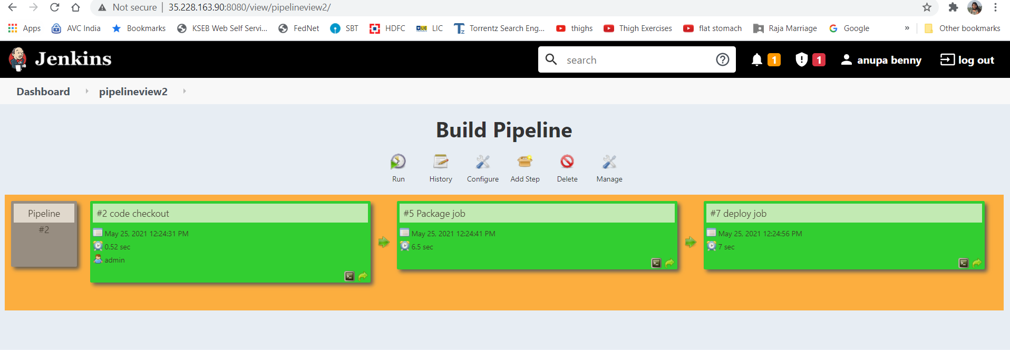

1. Create a pipeline job and write the script to achieve the same tasks. Pipeline must be triggered with a Github webhook upon every commit.

**Webhook added**

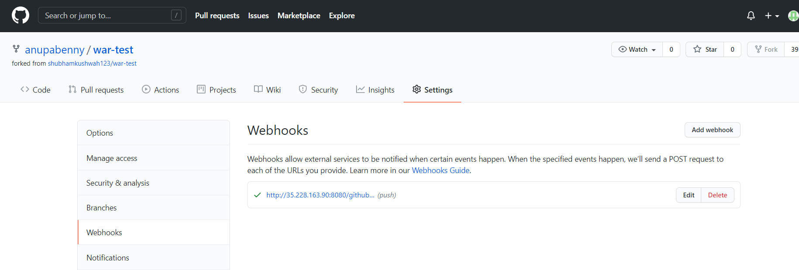

**Edited and committed README.md file which triggered 2nd build in pipeline project as below**

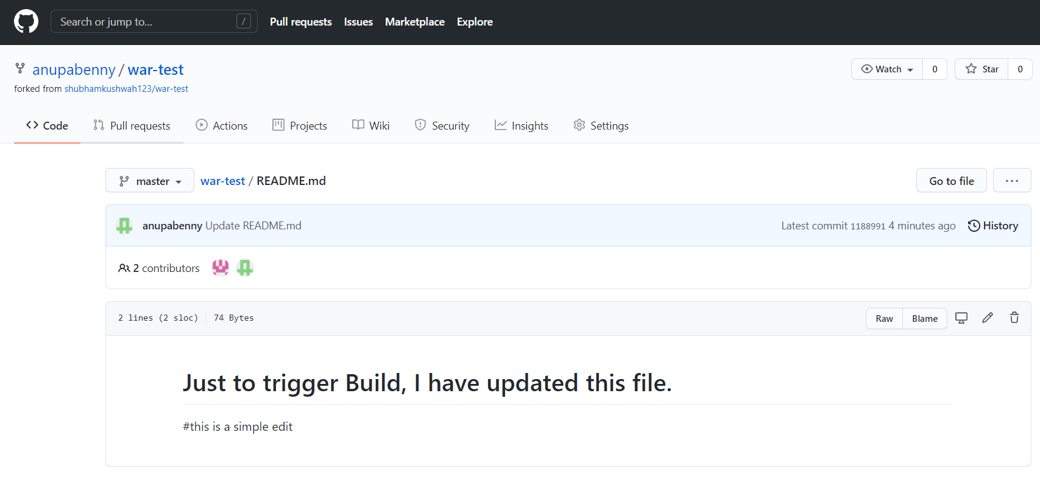

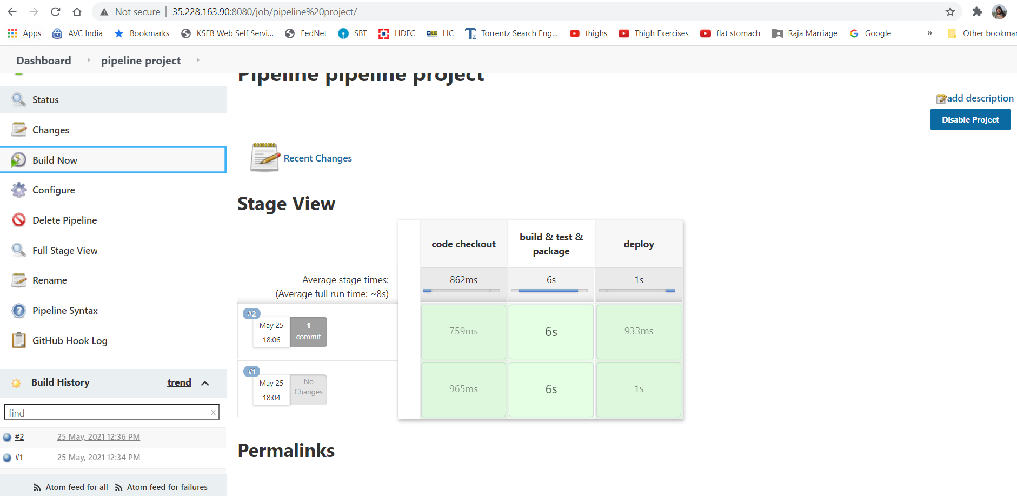

Tomcat page in tomcat server

