1. Write a docker file to create a docker image for this application using nginx as the base image

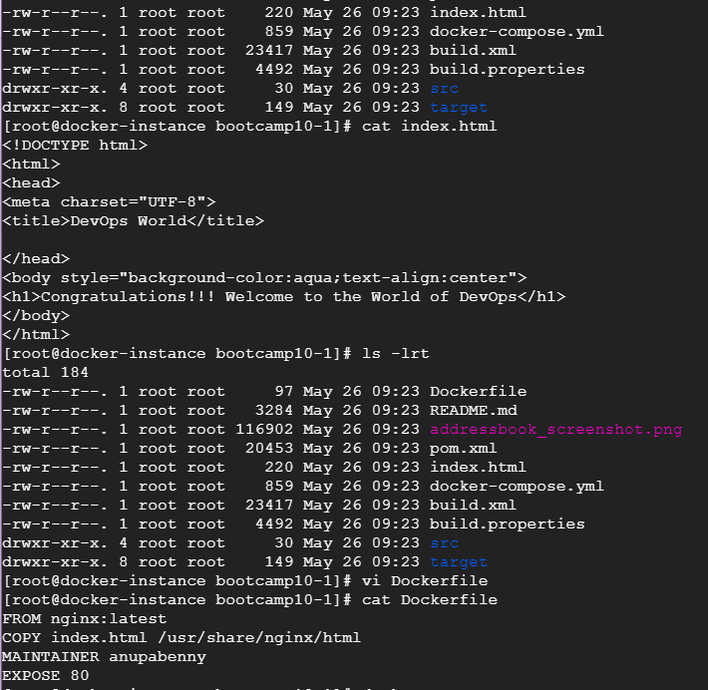

1. Push the docker image to the Docker Hub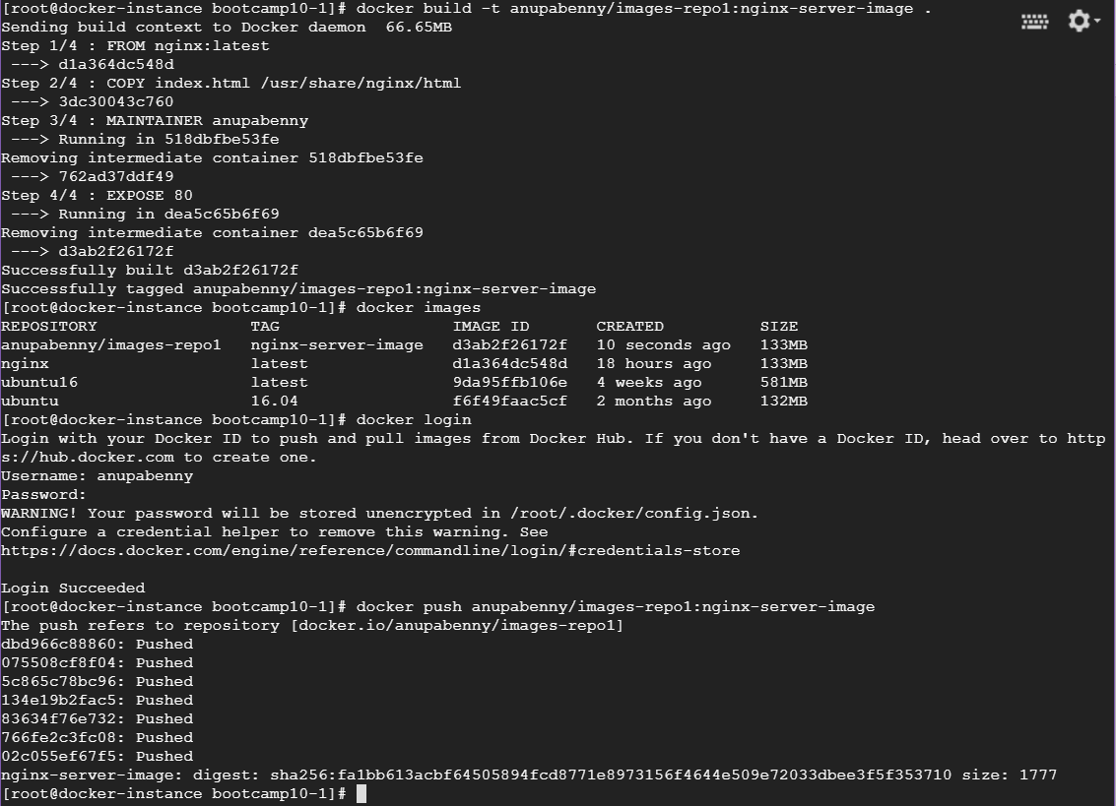

My docker hub URL and pushed image is present in it

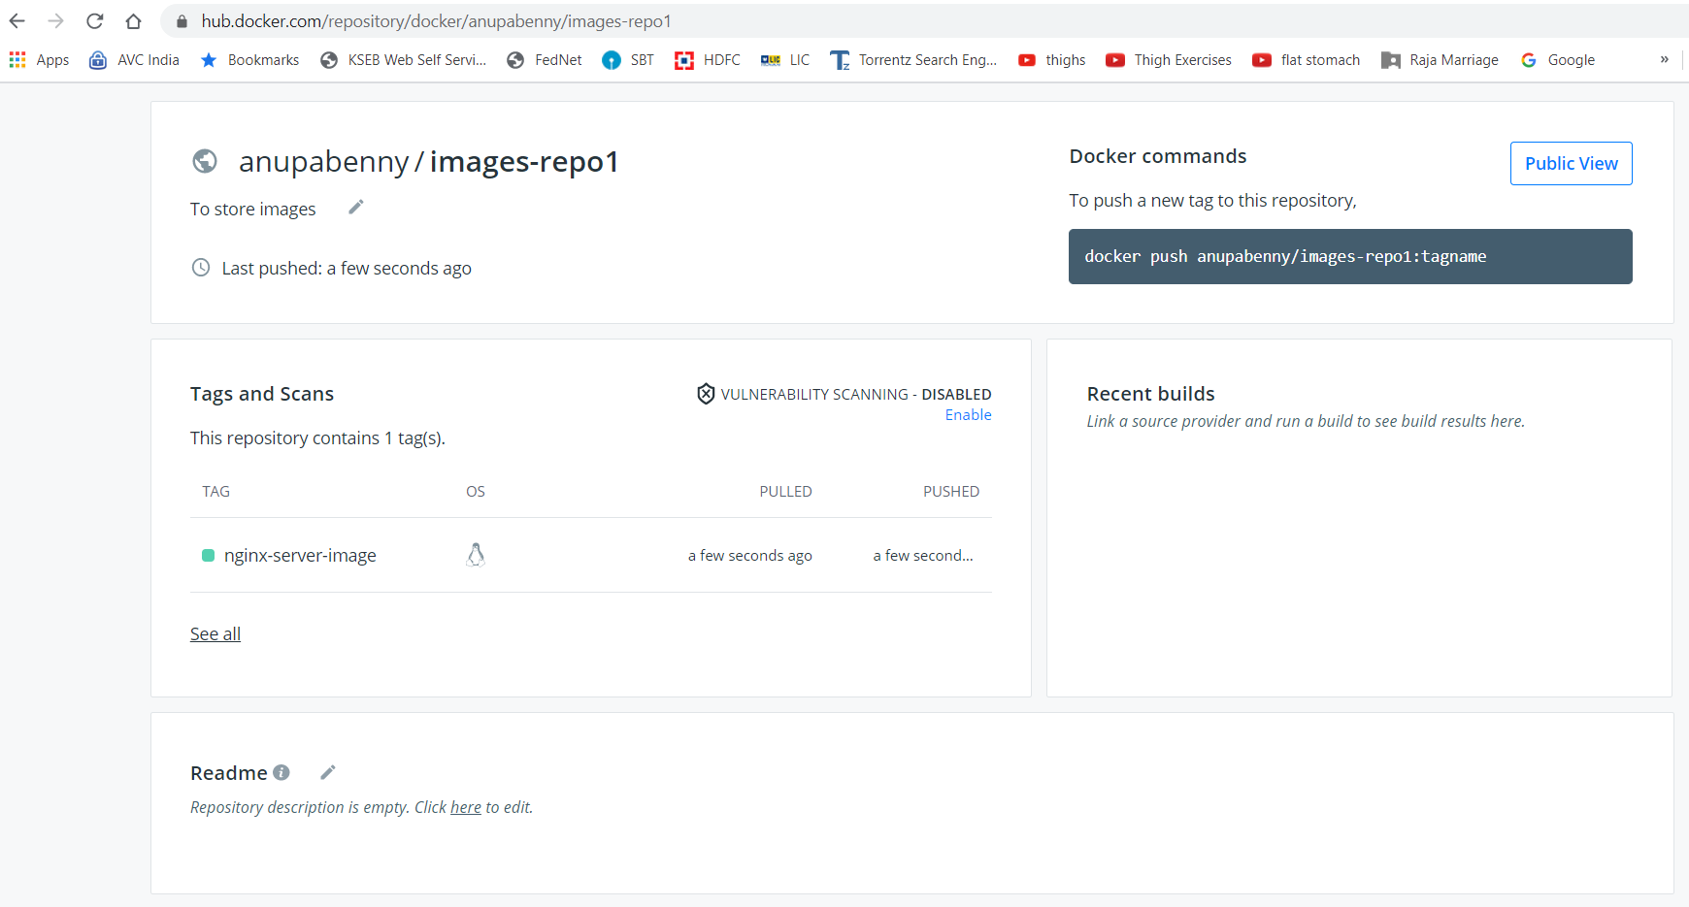

1. Pull and run the docker containers on any remote instance

This is another remote GCP machine and pulled docker image from dockerhub as below,

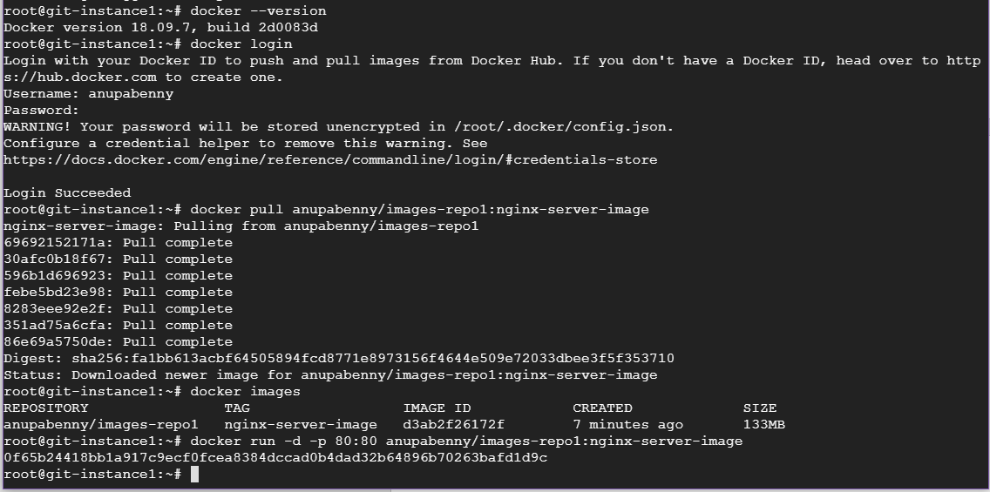

1. Access the application from the browser using appropriate url and port(80 here)

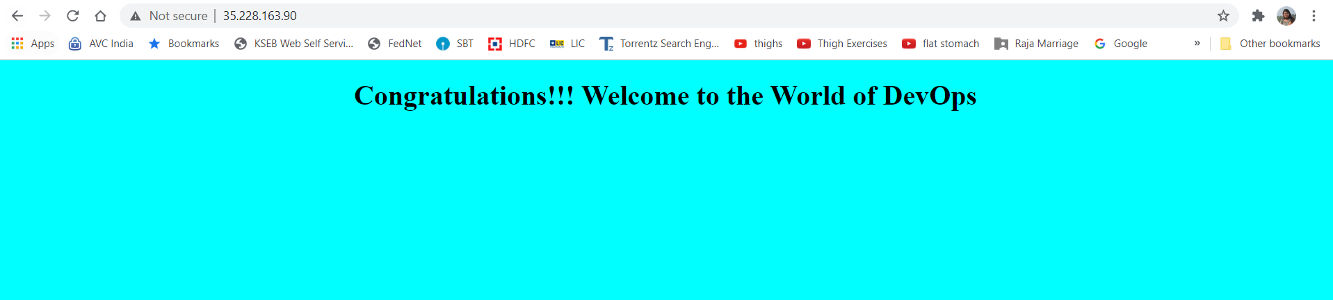

Docker-Compose:

1. Write a docker-compose.yml file to run the above application container along with mysql database container together.

Created docker-compose.yml with mysql container name as docker-mysql and created database as app_data , also created another container which is pulled from dockerhub(created in above steps) and named this container as web-app(port 8082) and also it depends on docker-mysql

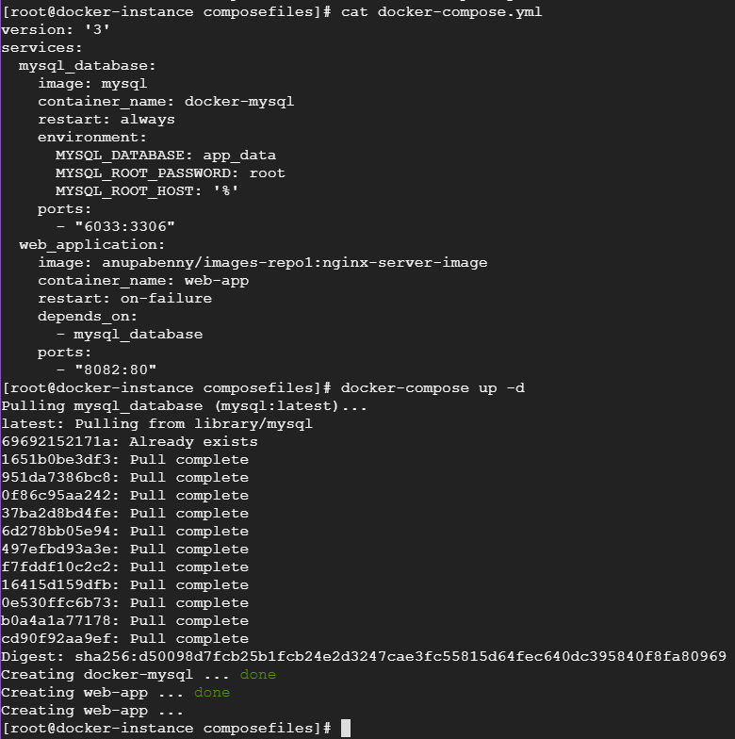



Application is accessible

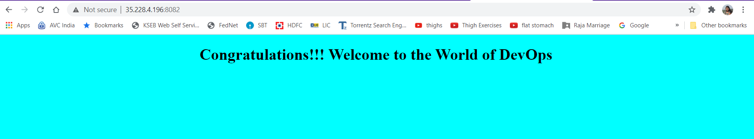

1. Connect to the mysql database container in the -it mode and create a table named test having id, name and age as attributes.

