1. **Create 2 nodes, One is the master one and another is slave one.**

Master node name= master-ansible

Slave node name = slave-ansible

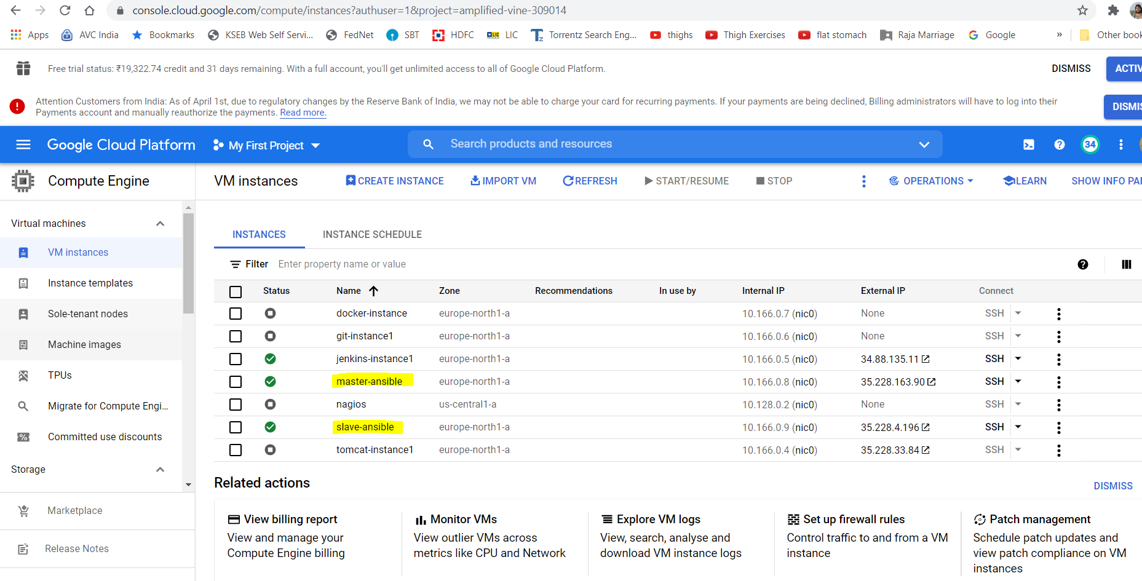

1. **Configure the master node to enable password less authentication**

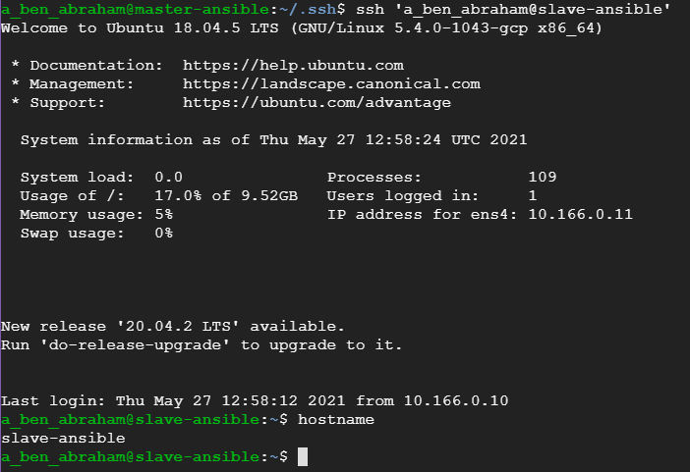

1. **Install ansible on master node**

Ansible is installed and created entry in hosts file with slave-ansible host and ping is working fine as below

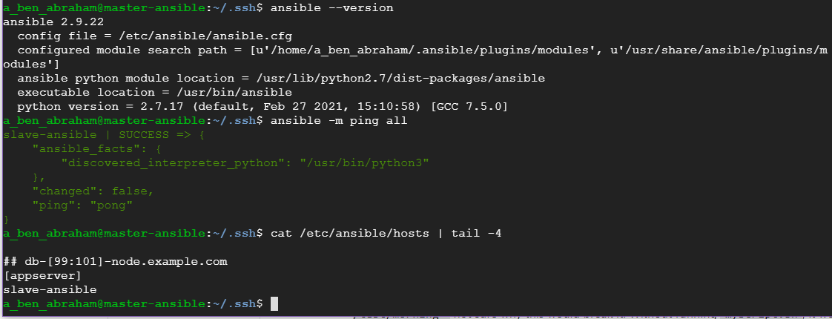

1. **Write a playbook to install following software in the slave node**
2. **Java**
3. **Maven**
4. **Nginx**
5. **Docker**

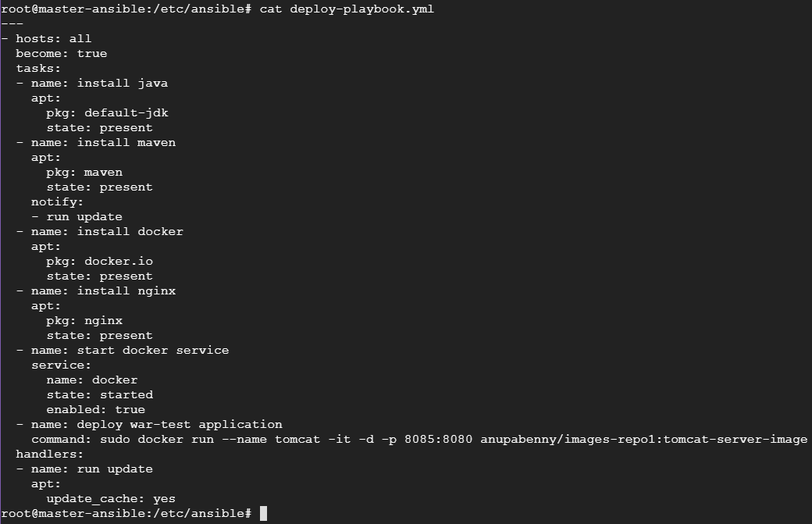

1. **Configure playbook to deploy the application available in the below repository as docker container in the slave node.**

Created one tomcat image with war-test.war deployed and pushed it already to my dockerhub.

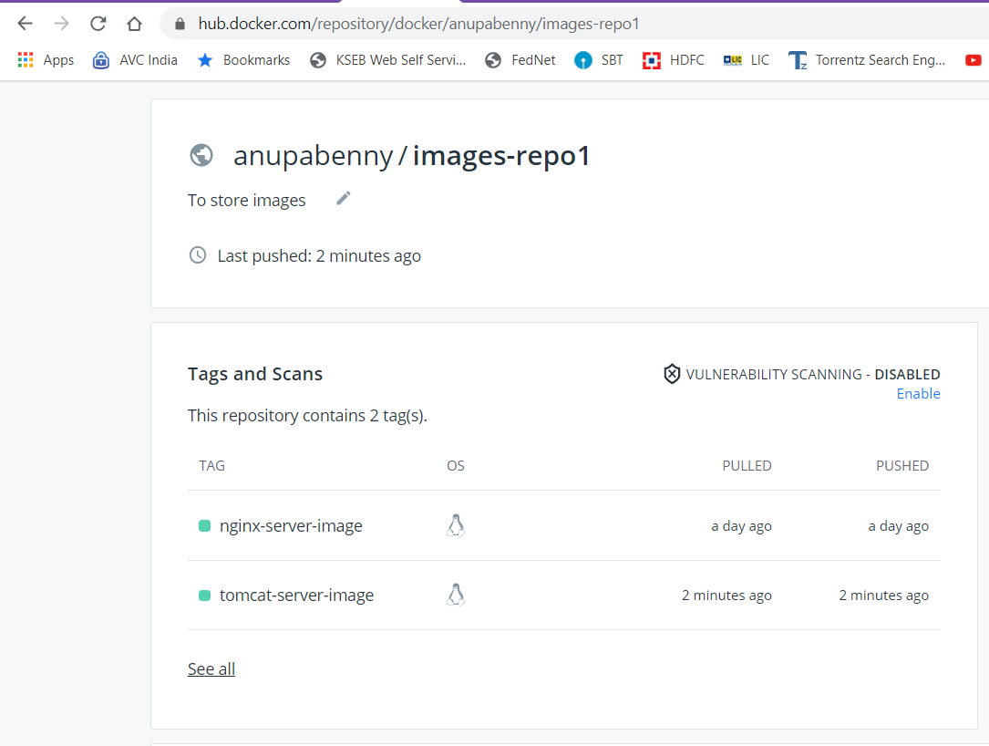

Created this task inside same playbook to download and run the above tomcat image



1. **Run playbook and attach the screenshots of the playbook yml and output of the playbook execution**

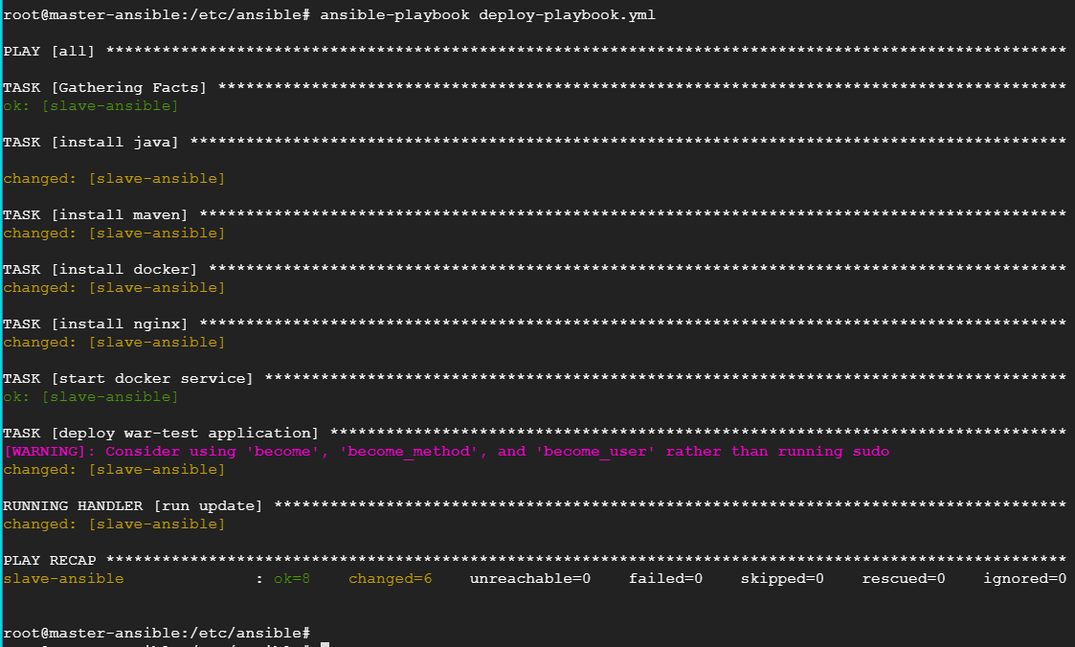

Please find below the version of installed packages (java, maven, nginx and docker) in slave node

Also output of docker images and docker ps

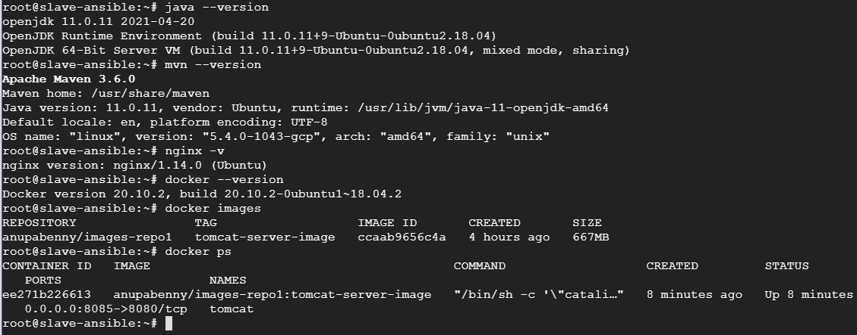

Application is accessible in slave node

