1. Create a local git repository developerA and create 3 files into it. (demo1,2 and 3)

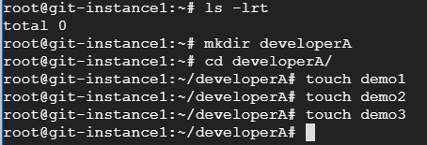

1. Add all the 3 files into staging area and commit it into the local repository

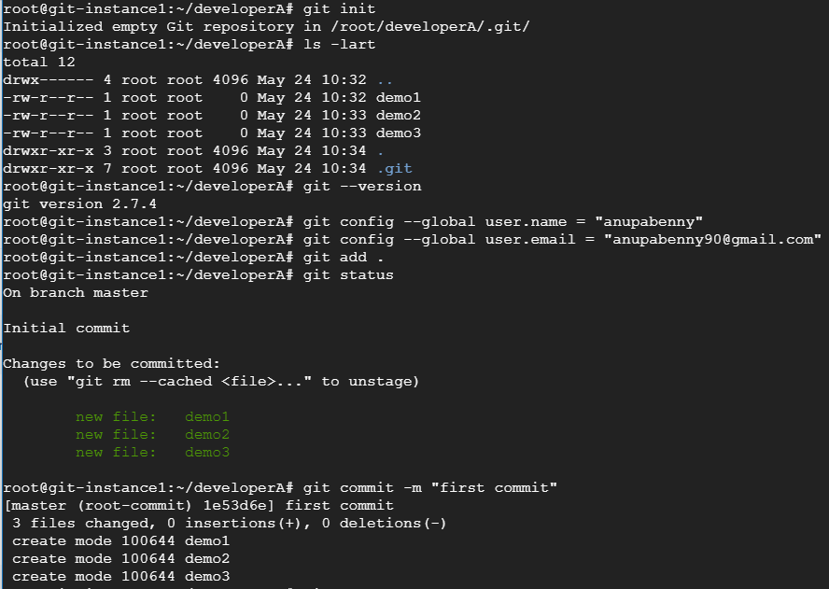

1. Create a remote repository

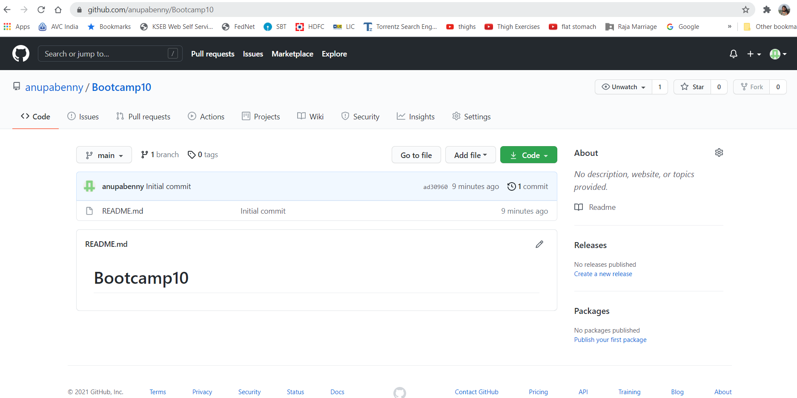

1. Add the remote repository to the local repository and push the changes to the remote repository from local repository

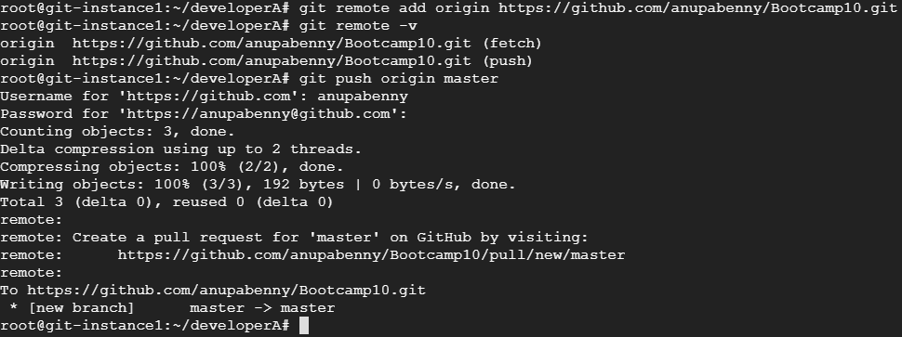

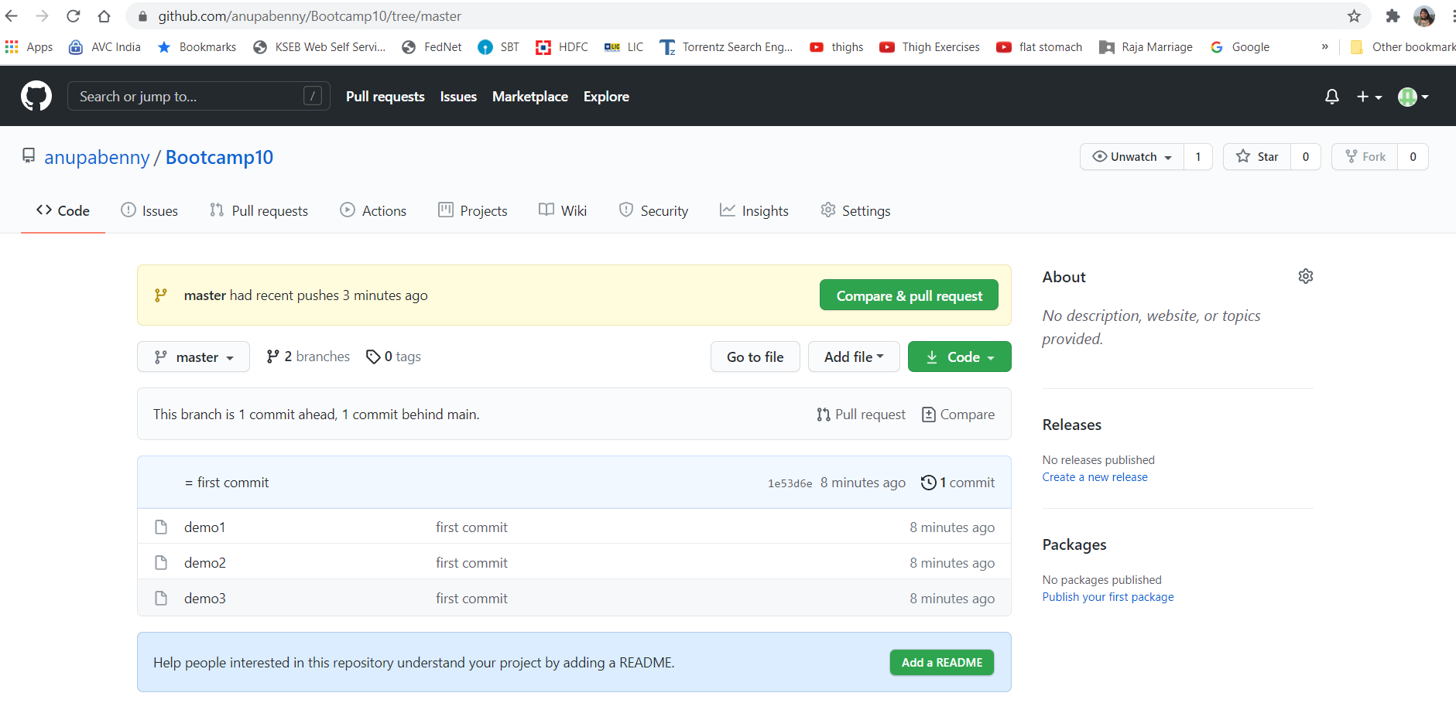

1. Clone the remote repository to another folder developerB

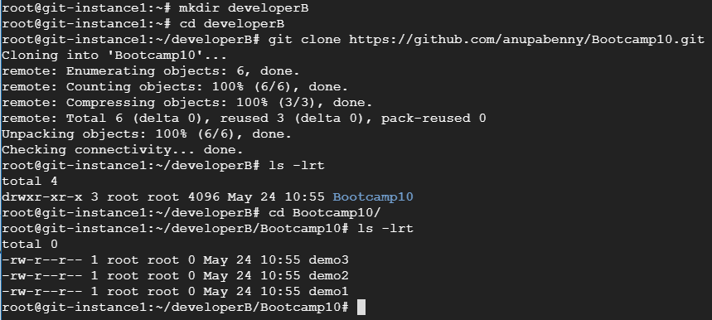

1. Make and commit the changes via developerB and synchronize the changes in developerA repository

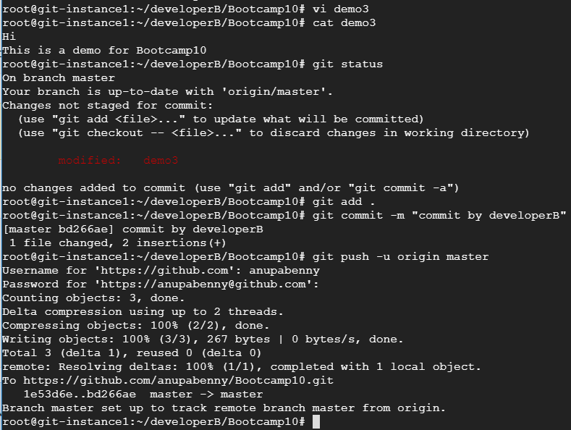

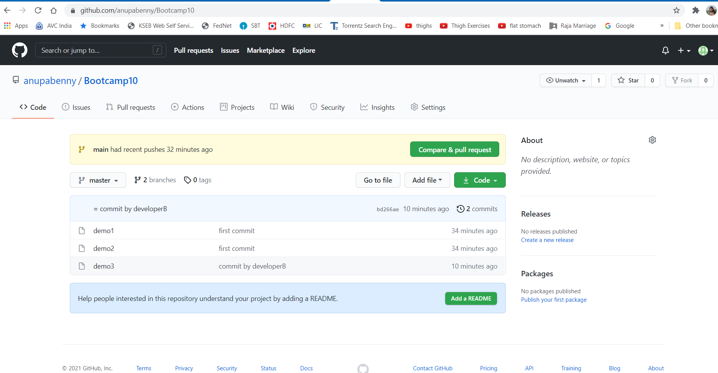

1. Create a new branch for the new feature you want to add to the application (say feature1) and change the files

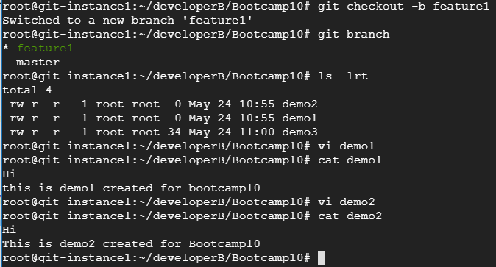

1. Merge back the created branch with the master branch

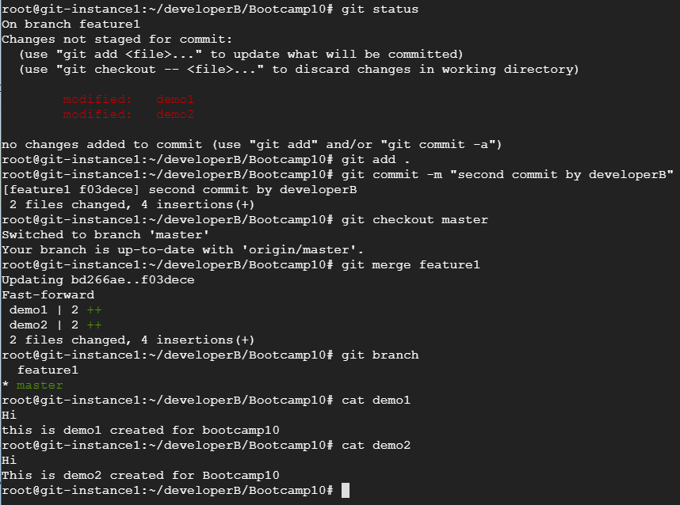

1. Delete the feature1 branch after merging

