**Tribhuwan University**

Institute of Engineering

**Pashchimanchal Campus**

Lamachaur, Pokhara

|  |  |
| --- | --- |
|  |  |
|  |  |
|  |  |

Presentation on Study of Electronics and Communication Engineering

|  |  |
| --- | --- |
|  |  |
|  |  |
|  |  |

Subject : Mr. Anup Adhikari

December 2015

# About Us:

Pokhara is not only a famous tourism destination but also an academic hub. It has many prestigious educational institutes students from different parts of Nepal have gathered to seek knowledge and learn technology. Scholars from different parts of Nepal as well as overseas are contributing to the academic endeavors of Pokhara. Paschimanchal Campus is one of the leading institutions of this area. It is an institution of national and international renown.

The scenic Paschimanchal Campus, formerly also known as Western Region Campus (WRC), is located in the northern part of mega-scenic city of Pokhara. It enjoys the continuous roaring music of Seti River flowing nearby and the heavenly view of Machhapuchchhre and many other mountains of Annapurna range. Campus is surrounded by many green hills and the greenery inside the campus itself is envy for anyone.

The establishment of Paschimanchal Campus under the Institute of Engineering, Tribhuvan University can be considered as a revolutionary step towards meeting the demand of technical manpower in the field of engineering for the development of the nation.

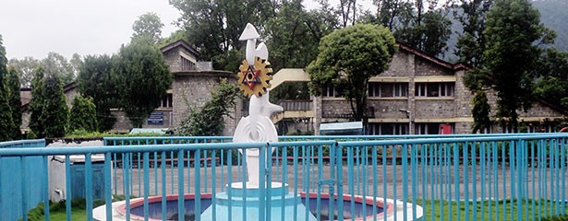

Paschimanchal Campus is located about 200km west of Kathmandu. It spreads on 312 ropanis of land in a scenic section of Pokhara valley in the Western Development Region of Nepal. Paschimanchal Campus was established with assistance from the World Bank and UNDP/ILO. It became operational from 1987. Initially, various trade and technician courses were offered along with diploma (overseer) level courses. At present, it is offering bachelor level courses in Civil, Electronics, Electrical, Mechanical, Geomatics and Computer engineering. From the first batch of BE program in Civil engineering which started in the academic year 1999/2000, we are proud to state that our students have shown encouraging performances. They have achieved excellent academic records and they have shown their skills in many extra-curricular activities too.

Paschimanchal Campus is a part of IOE-TU whose products have come out to be the toppers in their graduate studies at different educational institutions. We are proud to say that IOE has placed itself as one of the top technical education institutes in Asia.

**Features**

**Special Features:**

* Excellent academic environment with highly qualified, experienced and devoted teaching professionals
* Well ventilated, lighted and well furnished classrooms with latest teaching facilities
* Excellent library with more than 70,000 books, journals, course manuals and other references.
* Frequent excursion, tour and field activities to enhance the practical knowledge and concepts of sophisticated technology.

**Hostel and Mess:**

* Boys’ hostel having the capacity of 408 students
* Girls’ hostel having the capacity of 70students.

Both of the hostels have mess, providing hygienic and nutritious food for students of respective hostels.

**Cafeteria:**

Paschimanchal Campus cafeteria serves snacks and Tiffin at reasonable cost from early in the morning to late afternoon.

**Sports Facilities:**

The campus provides sports facilities including football cum cricket ground, volleyball courts, basketball court and badminton courts.

**Auditorium and Meeting Halls:**

Paschimanchal Campus auditorium hall has the capacity of 350 person.

* 5 seminar and meeting halls of different capacities

**Other Facilities:**

* Health Center
* Transportation

# Message from Campus Chief

[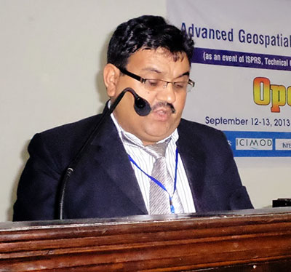](http://www.wrc.edu.np/wp-content/uploads/2015/08/Campus-Chief.jpg)The **Pashchimanchal campus** founded in 2038 BS as constituent campus of **institute of engineering** under Tribhuvan University is located at northern part of gorgeous city Pokhara. Committed for development of highly skilled engineering manpower in various disciplines we are offering six Bachelor level engineering programs (Civil, Electronics and communication, Electrical, Mechanical, Computer and Geomatics engineering) and are planning to run master level program in near future. To catch up with ever- changing need of the students in the engineering profession, five years strategic plan has also been formulated to establish policy, plan and direction ahead to fulfill the need of the country by mobilizing the limited resources to the quality higher education.

Pashchimanchal campus envisioned to become a premier engineering educational institution with global standards and becoming the center of excellence in Geomatics engineering which can be achieved only on background mission of quality engineering education, professionalism and research works in relevant engineering fields .By staying focused on this quintessence campus dreams to produce capable and competitive human resources and by doing research to find solution to unresolved engineering problem by enhancing academic programs as nation demands, our teaching and learning is strengthened by developing proper working environment, skilled human resources and proper planning and management of   resource, faculties and staffs.

[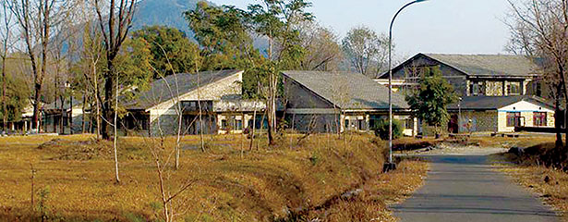](http://www.wrc.edu.np/wp-content/uploads/2015/08/side-view-off-electronics.jpg)Finally, I would like to thanks all the members who have devoted their precious time and effort in preparation of this prospectus. It’s my great pleasure and privilege to work as a team with the students, staff and teachers of this campus and I hope that it will continue in future.

**Er. Narayan Prasad Gautam**  
Campus chief  
Pashchimanchal campus, Pokhara

# Electronics and Computer Engineering

[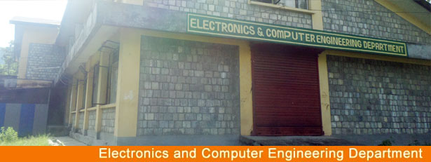](http://www.wrc.edu.np/wp-content/uploads/2015/08/electronics-computer-engineering.jpg)The invention and fast growth of information and communication technology has changed all walks of lives. There are new opportunities and challenges that need to be faced to place our country in the global map of ICT. This department was established in 2053 with the motto of providing quality technical education in the field of electronics, communication and computer engineering where as four years bachelor program was conducted in 2062 B.S. The youngest Bachelor program is Computer Engineering which was conducted in 2069 B.S.

**Course Offered:**

* Bachelor’s Degree in Electronics & and Communication Engineering ( 4 years)
* Bachelor’s Degree in Computer Engineering (4 years)

**Laboratories / Workshops:**

* Digital Electronics lab
* Communication lab
* Computer Lab ( Advanced computer lab, Basic Computer Lab, Computer Repair &  maintenance lab, Internet Lab, Multimedia Lab)
* Basic Electronics Lab
* Repair & maintenance workshop.

**Project Works:**

The students of the department perform various real time project works in the field of electronics and computer engineering. Project works are incorporated as the part of the syllabus to enable the students to tackle the real world problems.

**RTCU Services**

[](http://www.wrc.edu.np/wp-content/uploads/2015/08/electronics-rtcu.jpg)Electronics and Communication Department has separate Research Training and Consultancy works, training and consultancy services in following area.

* Computer programming (C, C++, VB, Java), Oracle, Linux, Windows Advance Server,
* Computer Repair and Maintenance, Computer Networking, Radio and TV maintenance
* Electronics Project Design, Micro- controller interfacing

## Key Officials of Paschimanchal Campus

|  |  |
| --- | --- |
| **Name** | **Post** |
| **Mr. Narayan Prasad Gautam** | **Campus Chief** |
| Mr. Chhabendra Bdr Thapa | Asst. C.C. (Facilities) |
| Mr. Krishna Adhikari | Asst. C.C. (Academic) |
| Mr. Deepak Thapa | Asst. C.C. (Administration) |
| Mr. |  |
| Mr. Kosh Raj Subedi  Mr. Tanka Nath Upadhaya | HoD. Science & Humanities  Dpty.H.O.D. |
| Mr. Nirmal Prasad Baral  Mr. Kishor Kumar Shrestha  Mr. Narayan Prasad Dawadi | HOD. Civil  Co-ordinator Msc Program  Dpty.H.O.D. |
| Mr. Ram Prasad Poudel Mr. Bijendra Prajapati | HOD. Automobile/Mechanical Dpty. HOD Automobile/Mechanical |
| Dr. Basanta Kumar Gautam  Mr. Ishwor K.C | HOD.  Electrical/ Co-ordinator Msc Program  Dpty. HOD Electrical |
| Mr. Hari Prasad Baral  Mr. Bidur Devkota  Mr. Ramesh Thapa | HoD. Electronics & Computer  Msc Co-ordinator  Dpty. HOD |
| Dr. Krishna Prasad Bhandari | RMU Co-ordinator |
| Mr. Gopal Kafle | Administration Chief |
| Mr. Hareram Timilsina | Liaison Officer |
| Mr. | TACS Co-ordinator |
| Mr. Rajendra Tamrakar | Hostel Warden (Boy’s) |
| Mr. Laxmi Timilsina | Hostel Warden (Girl’s) |
| Mr. Bhim Lal Timilsina | General Administration |
| Mr. Puspa Raj Paudyal | Account Section Chief |
| Mr. Raj Kumar Shrestha | Store Section Chief |
| Mr. Keshab Ranjit | Chief of Student Welfare & Sport. |
| Mrs. Shuva Sharma Khanal | Examination Section Chief |
| Mr. Chiranjibi Chapagain | Academic Section Chief |
| Mrs. Nira Shrestha | Library Section Chief |

# Brief Information about Mr. Anup Adhikari as our campus student

Mr. Anup Adhikari came to study in Pashchimanchal Campus by passing the IOE Entrance Examination 2009 AD of Tribhuwan University. Various students from Science faculty and Overseer students applied for the Electronics and Communication Engineering course. The selection was based on paper examination in Physics, Mathematics, Chemistry and English. Many students all around the country competed for the place to study here and he became successful among few other students to study in our campus.

Mr. Adhikari is a good student who attended all of his classes and submitted the lab reports and assignments whenever demanded. He has practically good skills in programming and understanding the work of electronics. He is particularly creative in his projects which involved making the best concepts from existing knowledge. Again his voracious nature to understand the very fundamental matters of working of things is his major attribute.

We also provided him scholarship to study in our campus from his second year till 4th year funded by Nepal Government based on his previous qualifications and his campus records. He performed well in all subjects and was a favorite among various teachers.

He was quick in the first year to make friends and have his seniors aid the knowledge and skills. He also became member in different student societies like NESS (Nepal Engineering Society, SOKES etc and was involved in understanding the non-academical activities. As he underwent his academic career he became a founding member of “Skyne Creative Group” which conducted various academic activities inside and outside the college. They also founded a magazine “ENSCITECH” which published articles on engineering, science and technology. This group also organized career counselling for class 12 students in Parbat and Baglung in engineering.

He graduated from our college by attending a grand graduation ceremony in 2014. He got his graduation record handed by Tribhuwan University itself and we are proud to have him as our student.