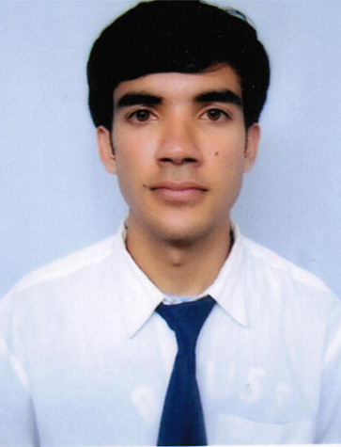
CURRICULUM -VITAE

PROFESSION : ENGINEER

NAME : Anup Adhikari

DATE OF BIRTH : 9th Decemeber, 1992

SEX : Male

MARITAL STATUS : Unmarried

NATIONALITY : Nepali

PERMANENT ADDRESS : Dhital-8, Kaski, Pokhara

CONTACT ADDRESS : anupadhik@gmail.com
PHONE NO : +977-9856070774/+977-61-532385

EDUCATION : Bachelor’s Degree in Electronics and Communication Engineering from Tribhuvan University, Institute of Engineering, Pashchimanchal Campus, Lamachaur, Pokhara, Nepal, 2009-2013, in first Division.
: Intermediate in Science from HSEB, Sagarmatha Higher Secondary School, 2007-2009, in first Division.

Professional Experiences
: Employer Name: Office of District Development Committee Parbat, Kushma, Nepal
Duration:- September 2013 - to Date

Responsibility Taken:
            - Coordinate with Local Development Officer, District Engineer, Information Officer, Governance Expert and other Development Officers.
            - ICT Survey on Requirement of ICT infrastructures to the district.
            - Introduce the social media reach of DDC
            - Design the improved network of existing infrastructure.
            - Provide ICT trainings to Local body staffs and VDC staffs.
            - Develop custom software and applications required for DDC.

OTHER TRAININGS/SEMINARS
& IMPLEMENTATION
: Server Training
: GIS Training
: VDC Accounting Software Training (LGCDP)
: Managerial Skills training (TITI)
: Android Application Development Training (Young’s Innovation)
: Raspberry Pi Application Development board Training

COMPUTER KNOWLEDGE
MATLAB/octave, Python, JAVA, PHP, SQL, HTML5, C++, GIS, Linux
DEVELOPMENT BOARDS
Raspberry Pi, ATMEL 8051, Arduino Board.

LANGUAGE AND DEGREE OF
PROFICIENCY
Speak Read Write
Nepali Excellent Excellent Excellent
English Good Good Good
Hindi Good Good Good
Gurung Good Good Good

IELTS: 7 (Listening: 8.5, Reading: 7, Speaking: 6.5, Writing: 6.5)

FINAL YEAR ELECTIVES & PROJECT
Avionics – Elective I
Remote Sensing – Elective II

LED Matrix Display – Minor Project
Speech Operated System for Home Appliances- Major Project

MAIN RESPONSIBILITY & EFFORTS
Editor – ENSCITECH (Engineering Science and Technology) 2011-2013.
Founding Member – Skyne Creative Group (2011-2013)
Member - Society of Kaski Engineering Students (SOKES), 2009-2013.
Member- Nepal Engineering Council (2014)
PUBLICATIONS
Various Articles published in ENSCITECH, Creative Science and other magazines published by Students organizations in Nepal.

References;
1. Associate Prof. Narayan Gautam
Campus Chief
Tribhuvan University
Institute of Engineering (IOE)
Pashchimanchal Campus
E-mail: npgautam@wrc.edu.np
Contact Phone: 0977-9856026571

2. Mr. Shiva Prasad Rijal
Local Development Officer
Office of District Development Office Parbat
Kushma, Nepal
Email: shivarijal1972@gmail.com
Contact Phone: 0977-9857630430
0977-067 420144, 0977-067 420530

3. Er. Ekendra Lamsal
ICT Expert
UN Volunteer
Local Governance and Community Development Programme (LGCDP), Regional Coordination Unit
Pokhara, Nepal
Email: mail@ekendraonline.com
Contact Phone- 0977-9851176084

