Improvement of animals design and sketches : A new approach

Ronaldinho Gaucho

2019



Tools and softwares

**Supervisor**  
Mané Garrincha

*This Thesis is carried out as a part of the education at the University of Bidauras and is therefore approved as a part of this education. However, this does not imply that the University answers for the methods that are used or the conclusions that are drawn.*

University of Bidauras,  
School Malaquias of Engineering  
Department Bertan of Electrical Engineering

# 

*To my beloved dead fish Nemo*

# Abstract

Your abstract goes here. The abstract is a very brief summary of the dissertation’s contents. It should be about half a page long. Somebody unfamiliar with your project should have a good idea of what it’s about having read the abstract alone and will know whether it will be of interest to them. Your abstract goes here. The abstract is a very brief summary of the dissertation’s contents. It should be about half a page long. Somebody unfamiliar with your project should have a good idea of what it’s about having read the abstract alone and will know whether it will be of interest to them.

# Résumé

Your abstract goes here. The abstract is a very brief summary of the dissertation’s contents. It should be about half a page long. Somebody unfamiliar with your project should have a good idea of what it’s about having read the abstract alone and will know whether it will be of interest to them. Your abstract goes here. The abstract is a very brief summary of the dissertation’s contents. It should be about half a page long. Somebody unfamiliar with your project should have a good idea of what it’s about having read the abstract alone and will know whether it will be of interest to them.

# Acknowledge

Its here that you give thanks to the people you hate less. Just kidding, we love everybody and "la vie est belle".

Thanks to my parents who have always supported me and specially the moments that they used to give me hot milk when it was time to sleep.

Thanks to my teachers who always lied to me saying that Santos Dumont was the inventor of the airplane.

Thanks to my friends who have been always drinking with me to forget all the suffering of this world.

# Introduction

## Background

Finding the interaction of drugs and proteins based simply on primary structure information of drugs and proteins is one of the many challenges faced in drug-synthesis process.

With the advent of new machine learning techniques and along with the rise of deep-learning techniques, we are closer to create a good prediction of analogy. However, the chemical properties of drugs and the targets complicate the situation as they react differently with slight change in protein sequence. Moreover, the complexes tend to behave similarly even when the protein sequences are distantly related, one of the results of tertiary structures that the proteins are form of.

The deep learning methods are quite good at predicting the molecular behaviour of the drug. However they present no good means when predicting the behaviour of proteins. The major fallback being that the simple encoding techniques don’t incorporate the proteins behaviour related to hydrophobicity, acidity, secondary and tertiary structures information.

The Stacked Generalized Prediction on the other hand works by basing the prediction guesses based on a number of prediction functions. Here, we use the sequence information of proteins to calculate the predictions on different feature transformation techniques and generalize those predictions using a stack of dense layers.

The Dataset we used scores the interaction of proteins and drugs based on Kb scores. We use 2111 drugs from CHEMBL and 229 proteins from UniProt to get an interaction of 118254, by removing the unrecognized interactions. The interactions are based on Kb score, collected from KEGG(​Kyoto Encyclopedia of Genes and Genomes)​ dataset.

For citations, use the function \cite. The references file is the sample.bib one. Google Scholar provides almost all the references in LaTeX form.

To insert a footnote, use the following command. [1] When necessary to use a nomenclature, define it on the same page for a better organization. Dont create NSN (Non-sense nomenclatures).

For figures, tables, equations and further information, open the file "tips.tex". If what you need is not found there, Google it.

## Statement of Problem

## Objectives

## Scope of Work

## Organization of Report

# Theorical Background

## No Free Lunch Algorithm

## Stacking Generalization

## Literature Review

# Methodology

## System Block Diagram

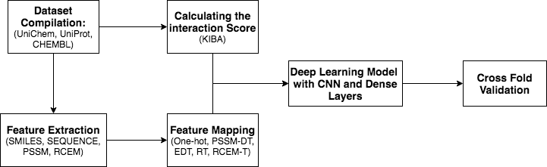

System Block Diagram

## Dataset

### KEGG

### UniProt, CHEMBL, UniCHEM

## Deep Learning Model

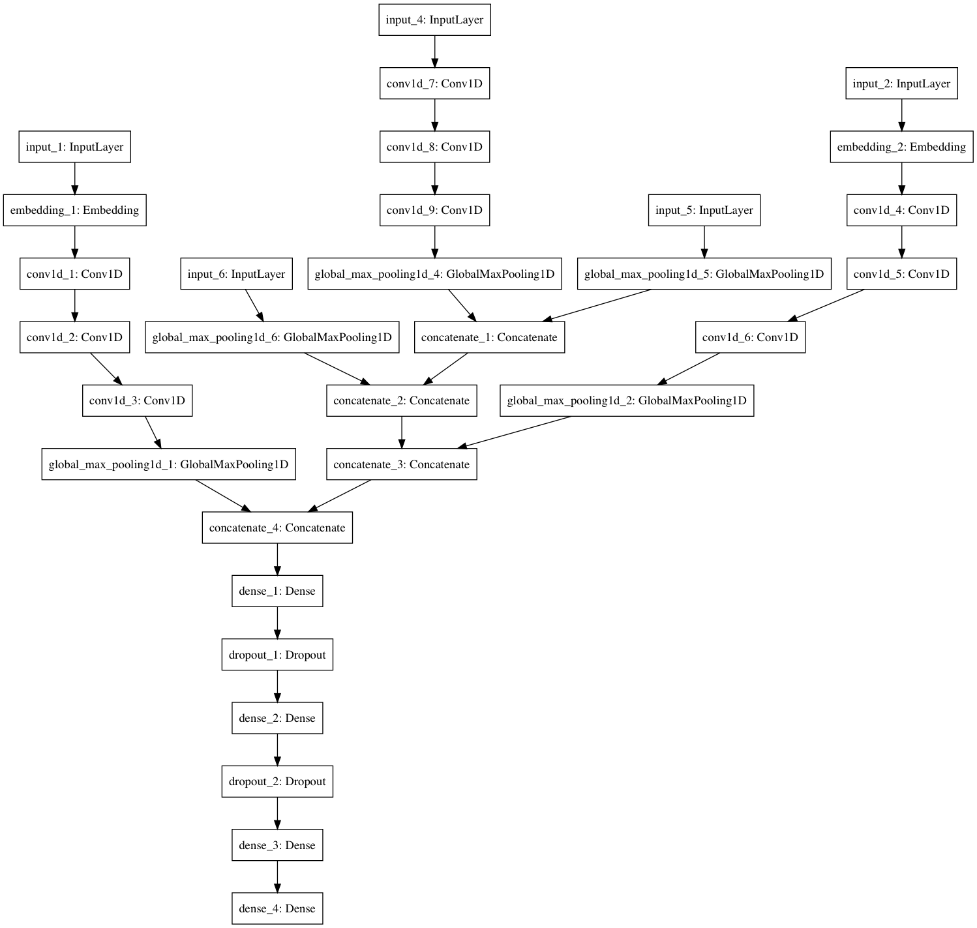

Deep Learning Model

# Results

## First Section

# Conclusion

## First Section

# First Appendix

The appendices contain information which is peripheral to the main body of the dissertation. Information typically included are things like program listings, complex circuit diagrams, tables, proofs, graphs or any other material which would break up the theme of the text if it appeared in situ.

1. This is a footnote.