PZEM-004T AC Digital Meter MODULE

The PZEM-004T is a compact, single-phase AC power monitoring module designed to measure electrical parameters such as voltage (80–260V), current (up to 100A via external CT), active power, energy consumption (kWh), frequency, and power factor.
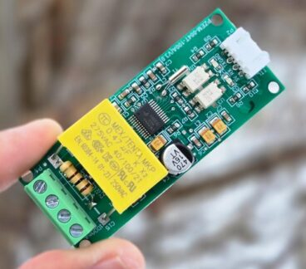
Fig: PZEM-004T V3.0
It communicates via Modbus-RTU protocol over TTL serial (), making it easy to interface with microcontrollers like Arduino or ESP32. With built-in galvanic isolation and a non-invasive current transformer, it prioritizes safety. It is widely used in IoT applications, smart metering, and home automation projects.

PZEM-004T V3.0 Feature
- Voltage: 80–260V, 0.1V resolution, 0.5% accuracy
- Current: 0–10A (10A model), 0–100A (100A model), 0.001A resolution, 0.5% accuracy
- Active Power: 0–2.3kW (10A model), 0–23kW (100A model), 0.1W resolution, 0.5% accuracy
- Power Factor: 0.00–1.00, 0.01 resolution, 1% accuracy
- Frequency: 45–65Hz, 0.1Hz resolution, 0.5% accuracy
- Active Energy: 0–9999.99kWh, 1Wh resolution, 0.5% accuracy, resettable via software
- Over Power Alarm: Settable threshold, triggers alarm on exceedance
- Communication: RS485 (UART to RS485), 9600 baud, 8N1

Open CT & Close CT
Both Close CT and Open CT are 100A current transformers (Class 1.5 accuracy) compatible with the PZEM-004T module.
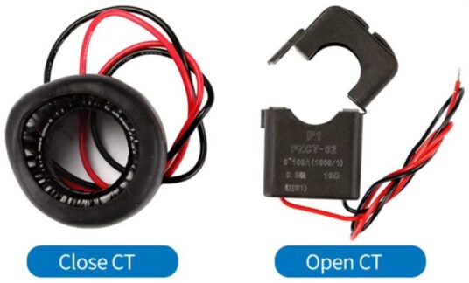Fig: PZEM-004T Open CT & Close CT
The Closed Current Transformer (CT) version of the PZEM-004T comes with a built-in, non-detachable CT, ensuring accurate and stable measurements. It is ideal for fixed installations where the sensor remains permanently connected to the measured circuit.
The Open Current Transformer (CT) version features a detachable clamp-type CT, allowing easy installation without disconnecting wires. This is useful for retrofitting or temporary monitoring applications where quick and flexible deployment is required.

Pinout of PZEM-004T V3.0
The PZEM-004T is an energy monitoring module that communicates via UART (RS485) and has the following pin configuration:
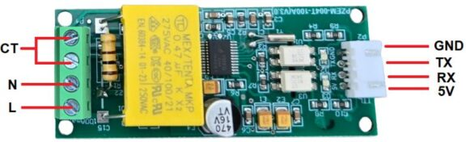
1. Power & Measurement Pins:
- L (Live) & N (Neutral): Connect to AC mains for voltage measurement and module power.
- CT+ & CT-: Connect to the current transformer (CT) for current measurement.
2. Communication Pins (TTL Serial or RS485):
- 5V: Power supply for the module (external 5V required).
- GND: Ground reference for communication.
- TX (Transmit): Sends data to the microcontroller.
- RX (Receive): Receives data from the microcontroller.
Module TTL Interface Note: This module’s TTL interface is passive and requires an external 5V power supply. All four pins (5V, RX, TX, GND) must be connected for proper communication. Operating temperature range: -20°C to +60°C.

Communication Protocol of PZEM-004T V3.0
1. Physical Layer Protocol
- Uses UART to RS485 communication interface
- Baud rate: 9600, 8 data bits, 1 stop bit, no parity
2. Application Layer Protocol
- Uses Modbus-RTU protocol
- Supported function codes:
  - 0x03 (Read Holding Register)
  - 0x04 (Read Input Register)
  - 0x06 (Write Single Register)
  - 0x41 (Calibration – internal use only, requires password 0x3721)
  - 0x42 (Reset Energy)
3. Addressing
- Slave address range: 0x01 – 0xF7
- 0x00: Broadcast address (slave does not reply)
- 0xF8: General address (for single-slave environments and calibration)
4. Reading Measurement Results
- Master command format (8 bytes):
Slave Address + 0x04 + Register Address (High + Low) + No. of Registers (High + Low) + CRC (High + Low)
- Correct Reply:
Slave Address + 0x04 + No. of Bytes + Register Data + CRC
- Error Reply:
Slave Address + 0x84 + Error Code + CRC
  - 0x01: Illegal function
  - 0x02: Illegal address
  - 0x03: Illegal data
  - 0x04: Slave error
5. Register Mapping
Register Address | Description | Resolution
0x0000 | Voltage | 0.1V
0x0001-0x0002 | Current (Low & High) | 0.001A
0x0003-0x0004 | Power (Low & High) | 0.1W
0x0005-0x0006 | Energy (Low & High) | 1Wh
0x0007 | Frequency | 0.1Hz
0x0008 | Power factor | 0.01
0x0009 | Alarm status (0xFFFF = Alarm, 0x0000 = No Alarm)
For example, to read 10 registers from slave address 0x01, the master sends:
0x01 + 0x04 + 0x00 + 0x00 + 0x00 + 0x0A + CRC

Indicator Lights of PZEM-004T V3.0
The module has multiple LEDs to indicate power, pulse, and communication status:
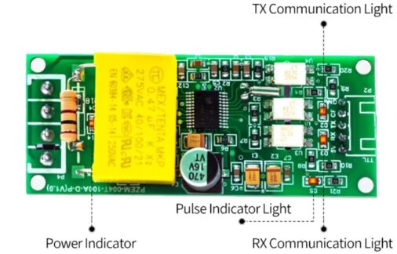Fig: Indicator Lights of PZEM-004T V3.0
- Power Indicator Light: Shows that the module is powered and operational.
- Pulse Indicator Light: It blinks based on active energy measurement. The higher blinking rate indicates higher power consumption.
- TX Communication Light: Blinks when the module transmits data via RS485.
- RX Communication Light: Blinks when the module receives data from the master device (e.g., Arduino, ESP32).
Refer to PZEM-004T Datasheet for more information.

Interfacing PZEM-004T with ESP32 Microcontroller
Lets interface the PZEM-004T AC Energy Meter Module with ESP32 Microcontroller and read the energy meter data. For that, we will first connect the PZEM-004T with ESP32 and then write a C++ Code to fetch the PZEM-004T data.

Circuit Diagram & Connections
The following is the connection diagram between PZEM-004T & ESP32 which looks simple and straightforward.
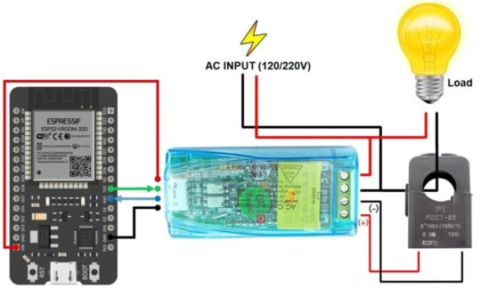Fig: PZEM-004T & ESP32 Circuit & Connection
Connect the PZEM-004T’s 5V and GND to ESP32’s 5V and GND for power. Link TX (PZEM) → RX2 (ESP32 pin 16) and RX (PZEM) → TX (ESP32 pin 17) for serial communication.
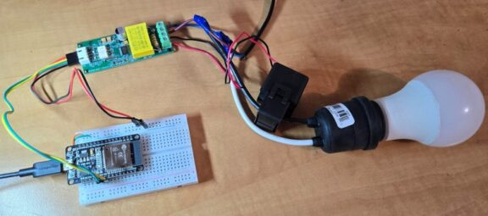Fig: Interfacing PZEM-004T with ESP32
Connect the circuit on breadboard as per circuit diagram above.
Wire the live (L) and neutral (N) of your AC supply (120V/220V) to the PZEM’s AC input terminals (labeled “L” and “N”).
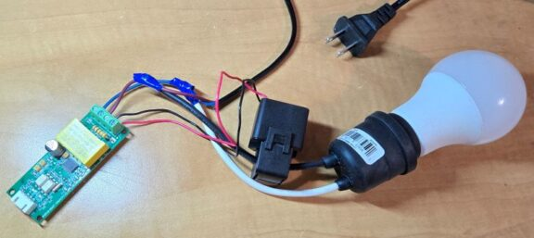Fig: Current Transformer Connection
For Open CT (split-core): Clamp the CT around the live wire of the AC circuit you want to monitor (do NOT clamp neutral).
For Close CT (solid-core): Disconnect the circuit, thread the live wire through the CT’s core, and reconnect.
Caution: Isolate AC input (120/220V) wiring from Arduino circuits for safety.

