**Anupam Tiwari 2020510065**

**LAB1 : Machine Learning**

List of Programs:

1.To merge two list and find second largest element in the list using bubble sort.

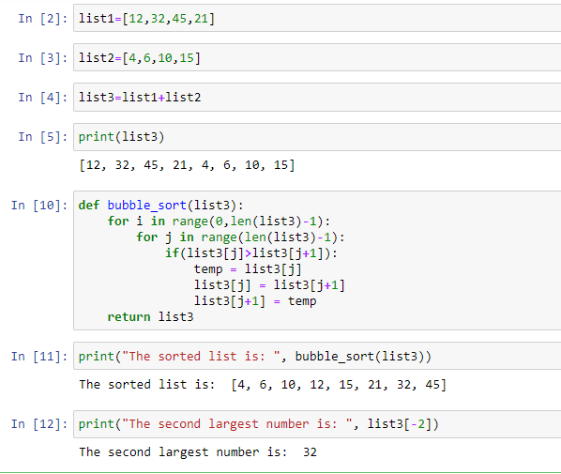

2.To calculate the no of uppercase ,lowercase letters and digits, spaces in a string.

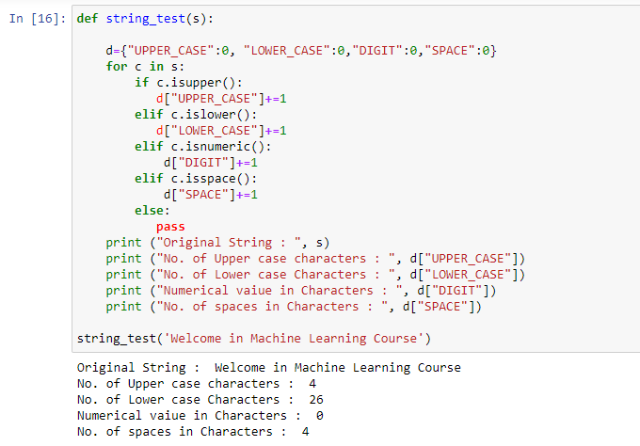

3. Create one dictionary of 5 students with their name, address, age, class and marks of 5 subjects. Perform all the operations on the created dictionary.

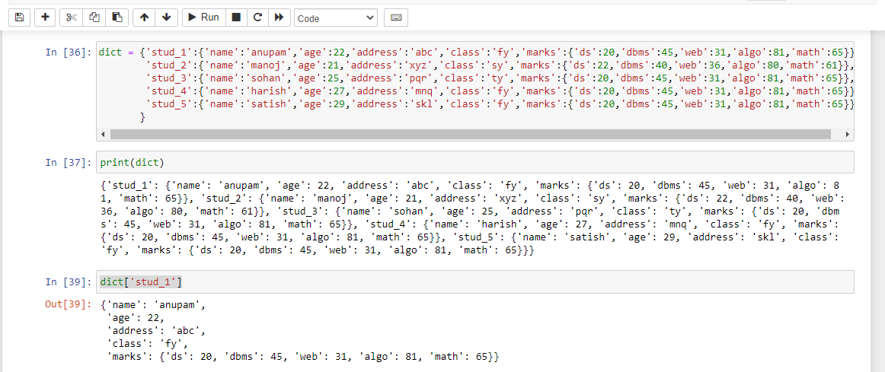

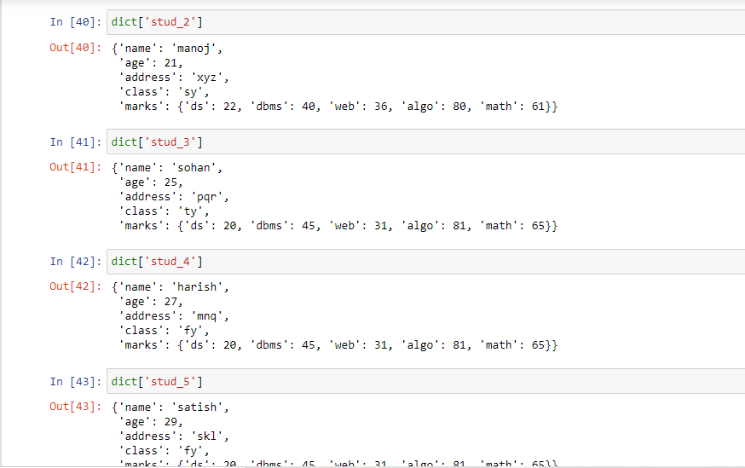

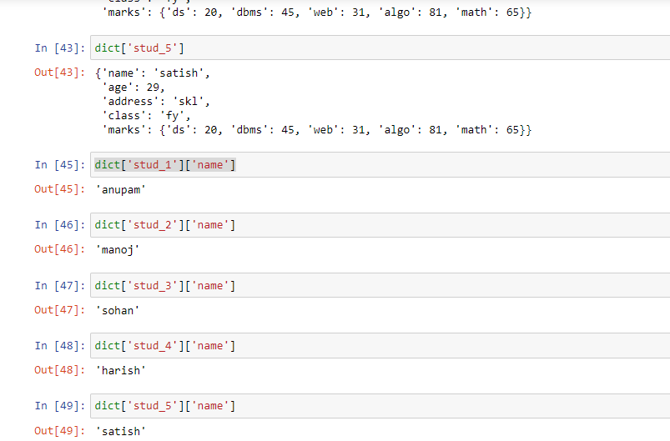

4.To concatenate two dictionaries and find sum of all values in dictionary.

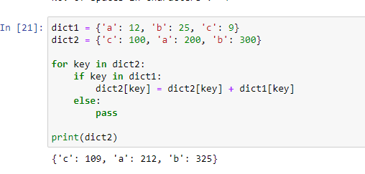

1. To add and remove elements from set and perform all the set operations like Union, Intersection, Difference and Symmetric Difference.

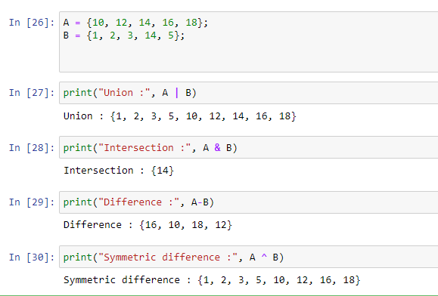

1. Read and write in to CSV file using pandas.

* Reading csv data

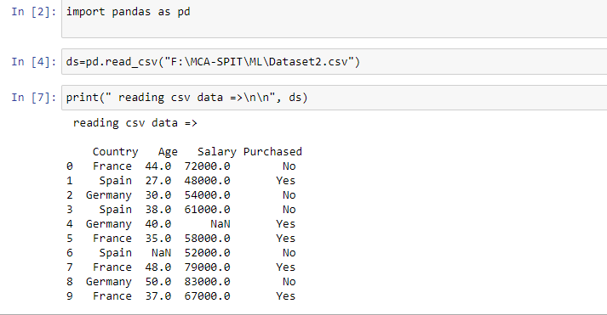

* Writing csv data

