**Anupam Tiwari 2020510065**

**Title-**Data Visualization in python

**LAB3** :Machine Learning

List of Programs:

1.Use Titanic dataset and perform data manipulation on it

* Get summary of dataset

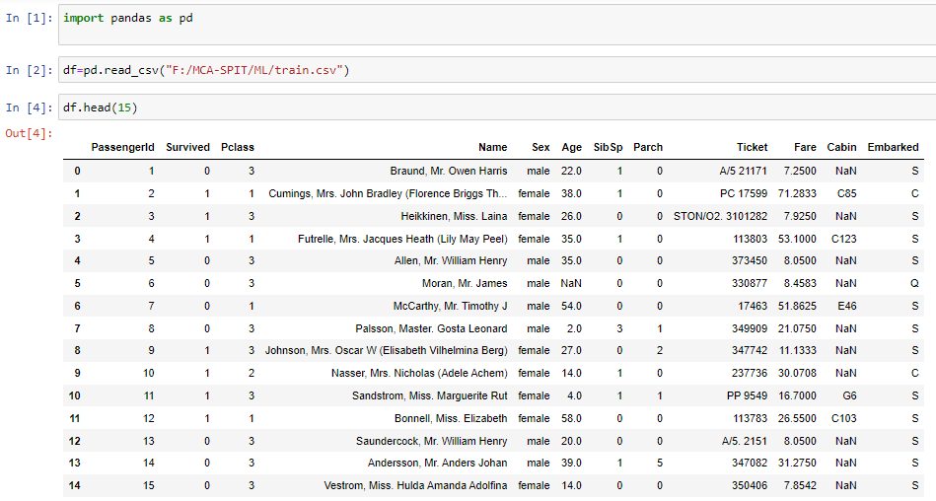

* Heatmap on p-class data set

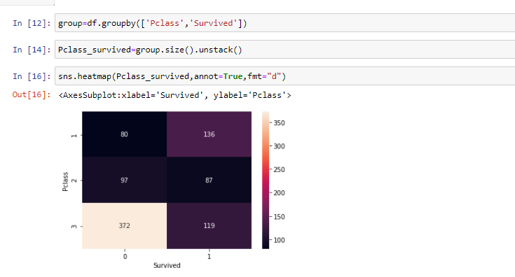

**Observation:**

From the above dataset we can conclude that survived data is more on (1,1) coordinate i.e. 136 andperished data is on (0,3) coordinate i.e. 372

* Bar plot on Fare Range dataset

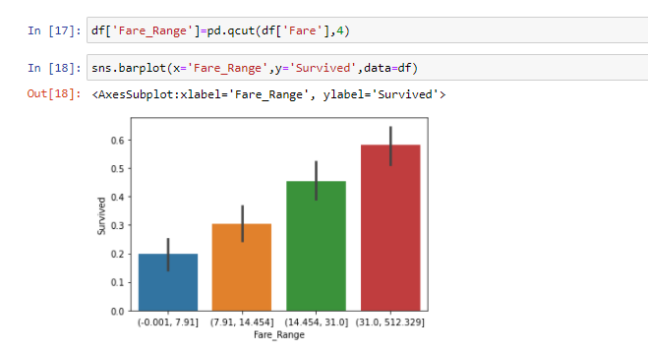

**Observation:**

From the above dataset we can conclude that survived data is more in the range between (31.0,512.329) and less in range (-0.0001,7.91)

* Count plot on gender dataset

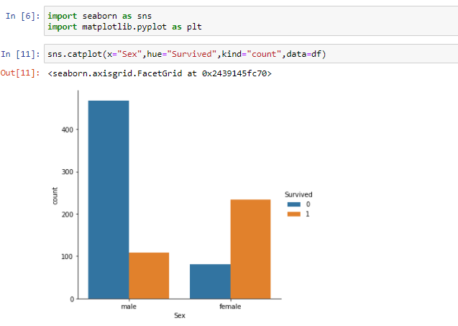

**Observation:**

From the above graph which is based on gender dataset ,we can conclude that survived male ratio is more than female and perished male ratio is less than female.

* Count plot on Embarked

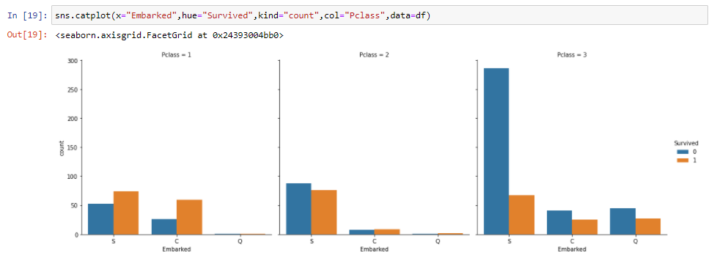

**Observation :**

From the above dataset we can conclude that survived data is highest in pclass=3 on ‘S’ class and lowest in pclass=1 and pclass=2 on ‘Q’ class , and perished data is highest in pclass=1 on ‘S’ class and lowest in pclass=1 in Q and pclass=2 in Q.

* Histogram based on Age dataset

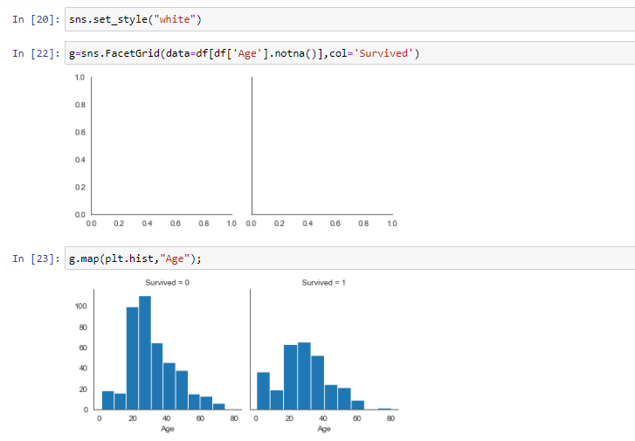

**Observation**

From the above dataset we can conclude that survived Age value is highest between 20-40 and perished Age value is highest between 20-40.