**Experiment No. 5**

**Title:** To Implement Logistic Regression

**Tools Required:** Anaconda Navigator

1. **Load the data**

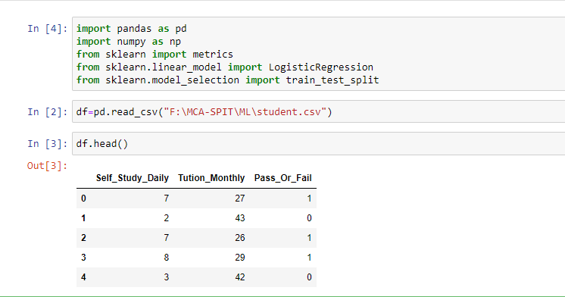

1. **Separate Features**:-

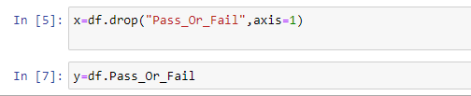

1. **Exploratory Data Analysis:** Exploratory Data Analysis is a very important step before training the model. In this section, we will use some visualizations to understand the relationship of the target variable with other features.

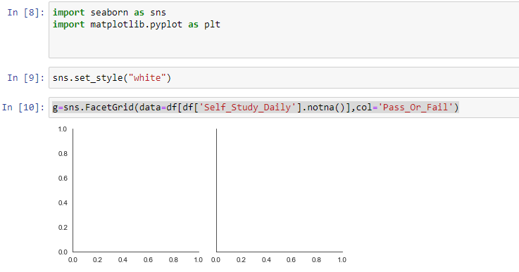

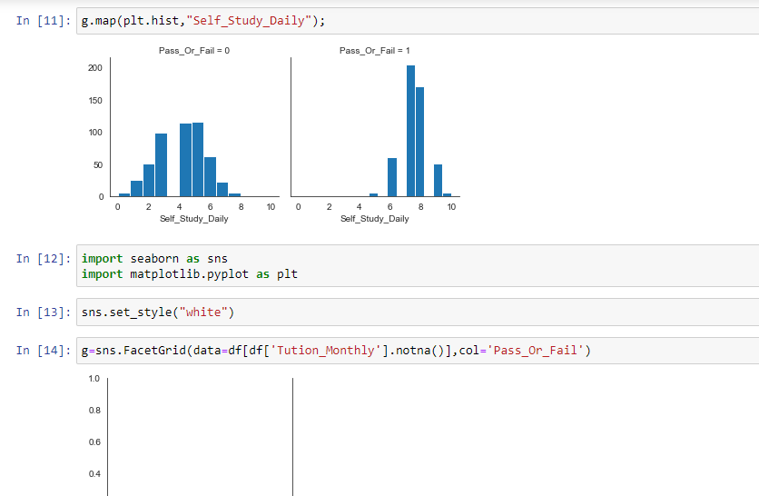

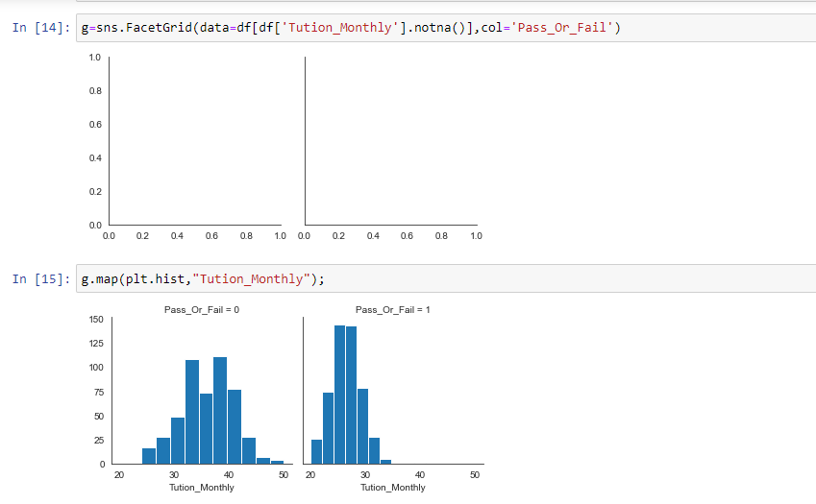

1. **Splitting and Training the Model:**

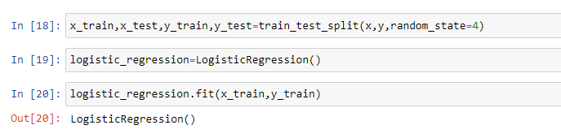

1. **Predict the data using Model**

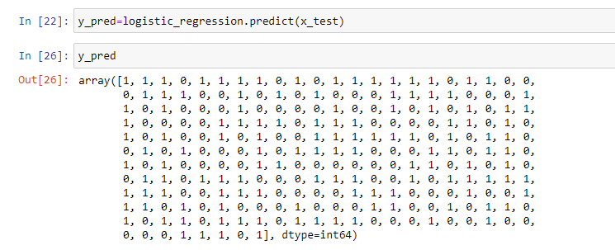

1. **Finding Accuracy**

