**Title: To install ionic and its development environment and run the basic default application**

**to understand the files used.**

**1) COVID -19 App**

**a)**  HTML file and other file if used

-> loginpage.html

<ion-content>

  <ion-card-content>

    <p style="text-align: center;"><img src="/assets/Login.png" alt=""></p>

    <h1 style="text-align: center;"> Welcome!</h1>

    <h3 style="text-align: center;"> Vaccinator & Verifier</h3><br>

    &nbsp;&nbsp;&nbsp;&nbsp;&nbsp;<b>Mobile Number</b><br>

       <ion-item>

      <ion-input type="number" placeholder="Enter your contact "></ion-input>

      </ion-item><br>

      &nbsp;&nbsp;&nbsp;&nbsp;<b> Password</b><br>

    <ion-item>

      <ion-input type="password" placeholder="enter your password "></ion-input>

    </ion-item><br>

    &nbsp;&nbsp;&nbsp;&nbsp;<ion-button style="text-align: center;" color="success" (click)="LogMeIn()">Login</ion-button>

  </ion-card-content>

</ion-content>

**->login.page.ts**

import { Component, OnInit } from '@angular/core';

import {Router} from '@angular/router';

@Component({

  selector: 'app-login',

  templateUrl: './login.page.html',

  styleUrls: ['./login.page.scss'],

})

export class LoginPage implements OnInit {

  constructor(private router: Router) { }

  ngOnInit() {

  }

  LogMeIn(){

    this.router.navigate(['/home'])

  }

}

**->home.page.html**

<ion-content>

  <div class="top-section ion-padding">

    <div class="top menu">

      <img src=" " alt="">

      <img src="/assets/home.png" alt="bell">

    </div>

    <div class="title">

      <ion-searchbar search-icon="d-search"></ion-searchbar>

      <h1><b>Covid-19</b></h1>

      <ion-select [interfaceOptions]="customActionSheetOptions" value="india"

      interface="action-sheet" placeholder="Select one">

      <ion-select-option value="india">India</ion-select-option>

      <ion-select-option value="USA">USA</ion-select-option>

      <ion-select-option value="Russia">Russia</ion-select-option>

    </ion-select>

    </div>

    <div class="sub-title">

      <h3>Are you feeling sick ?</h3>

      <p>If you feel sick with any of covid-19 symptops please call or SMS immediately</p>

    </div>

    <div class="action-buttons">

      <ion-button class="call">

        <ion-icon name="call"></ion-icon>Call now

      </ion-button>

      <ion-button class="sms">

        <ion-icon name="chatbubble"></ion-icon>Send SMS

      </ion-button>

    </div>

  </div>

  <div class="middle-section ion-padding">

    <h3>Prevention</h3>

    <div class="content">

      <ion-row>

        <ion-col size="4">

          <img src="/assets/p4.png" alt="">

          <p>Avoid close contact</p>

        </ion-col>

        <ion-col size="4">

          <img src="/assets/p2.png" alt="">

          <p>Clean your hands </p>

        </ion-col>

        <ion-col size="4">

          <img src="/assets/p3.png" alt="">

          <p>Wear a face mask</p>

        </ion-col>

      </ion-row>

    </div>

  </div>

  <ion-card>

    <ion-card-header>

      <img src="/assets/p1.png">

      <ion-card-subtitle >Do your own test </ion-card-subtitle>

      <ion-card-title><p>Follow the instruction to do your own test</p></ion-card-title>

      <div>

      <img src="/assets/s1.png">

      <p>If you make a first or a second degree contact with a COVID-19 positive person,

         Aarogya Setu alerts you and gets you timely medical help. The self-assessment test

         also helps you in identifying possibilities of infection.</p>

         </div>

          <div>

          <img src="/assets/s2.png">

          <p>By early identification and prevention of potential risk of infection in you and others,

             Aarogya Setu enables better safety for those around you, acting as a shield of protection for

              all your loved ones.</p>

              </div>

    </ion-card-header>

    </ion-card>

    <ion-card>

      <ion-card-content>

        <h2><b>Peronal Details</b> </h2><br>

        &nbsp;&nbsp;&nbsp;&nbsp;&nbsp;Name<br>

        <ion-item>

       <ion-input type="name" placeholder="Enter your name "></ion-input>

       </ion-item><br>

       &nbsp;&nbsp;&nbsp;&nbsp;Email<br>

     <ion-item>

       <ion-input type="email" placeholder="enter your email "></ion-input>

     </ion-item><br>

     &nbsp;&nbsp;&nbsp;&nbsp;Gender<br>

     <ion-item>

      <ion-select placeholder="Select One">

        <ion-select-option value="f">Female</ion-select-option>

        <ion-select-option value="m">Male</ion-select-option>

      </ion-select>

     </ion-item><br>

     &nbsp;&nbsp;&nbsp;&nbsp;Address<br>

     <ion-item>

      <ion-textarea></ion-textarea>

     </ion-item><br>

     &nbsp;&nbsp;&nbsp;&nbsp;<ion-button style="text-align: center;" color="success" shape="round" (click)="showToast()">Submit</ion-button>

      </ion-card-content>

    </ion-card>

</ion-content>

**->**[**home.page.spec.ts**](http://home.page.spec.ts)

import { ComponentFixture, TestBed, waitForAsync } from '@angular/core/testing';

import { IonicModule } from '@ionic/angular';

import { HomePage } from './home.page';

describe('HomePage', () => {

  let component: HomePage;

  let fixture: ComponentFixture<HomePage>;

  beforeEach(waitForAsync(() => {

    TestBed.configureTestingModule({

      declarations: [ HomePage ],

      imports: [IonicModule.forRoot()]

    }).compileComponents();

    fixture = TestBed.createComponent(HomePage);

    component = fixture.componentInstance;

    fixture.detectChanges();

  }));

  it('should create', () => {

    expect(component).toBeTruthy();

  });

});

**->**[**home.page.ts**](http://home.page.ts)

import { Component, OnInit } from '@angular/core';

import { ToastController } from '@ionic/angular';

@Component({

  selector: 'app-home',

  templateUrl: 'home.page.html',

  styleUrls: ['home.page.scss'],

})

export class HomePage implements OnInit {

  constructor(public toastcontroller:ToastController) {}

  ngOnInit(){}

  async showToast()

  {

    const toast=await this.toastcontroller.create(

      {

        color:'success',

        message:'Your personal details successfully submitted',

        duration:2000

      });

      toast.present();

  }

}

**b)** Screenshot of the UI made.

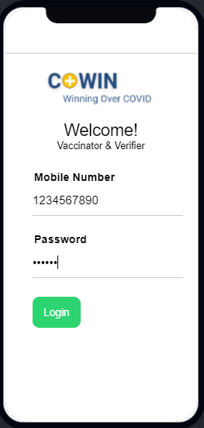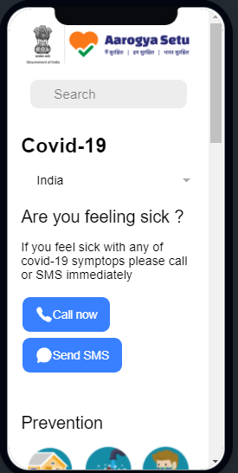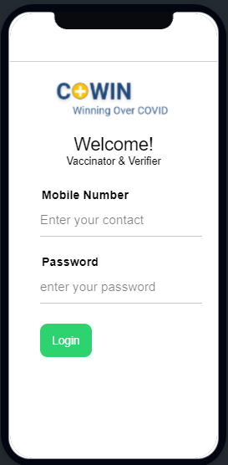

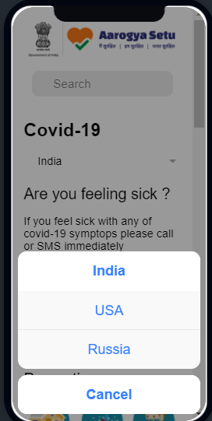

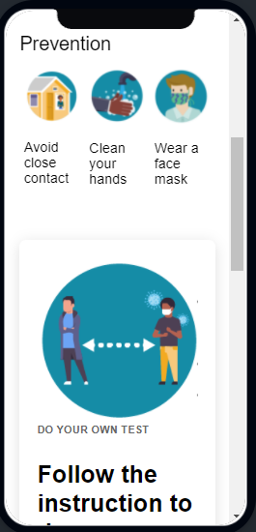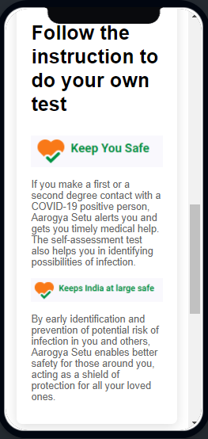

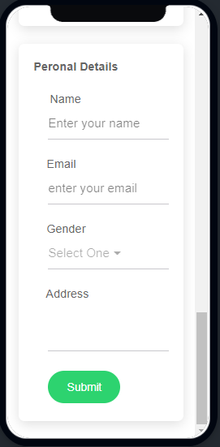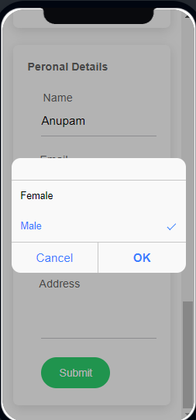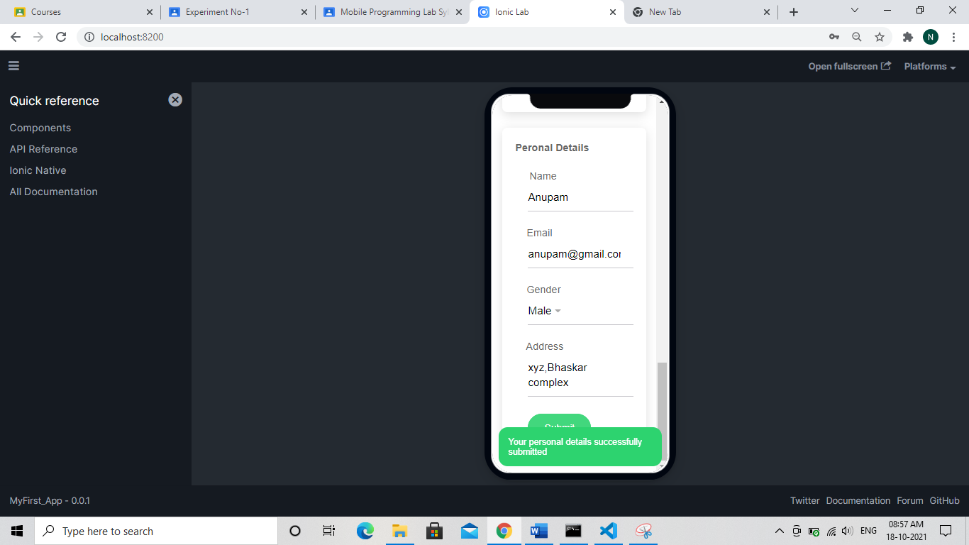

**2) Questions and Answers:**

a) Difference between typescript and javascript.

* TypeScript is known as an Object-oriented programming language whereas JavaScript is a scripting language.
* TypeScript has a feature known as Static typing but JavaScript does not have this feature.
* TypeScript gives support for modules whereas JavaScript does not support modules.
* TypeScript has Interface but JavaScript does not have an Interface.

b) Core building blocks of IONIC

Components in Ionic are reusable UI elements that serve as the building blocks for your mobile app. Components are made up of **HTML, CSS, and sometimes JavaScript**. Every Ionic component adapts to the platform on which your app is running. We call this Platform Continuity and go more in depth on how it works in Theming.

**c)** Use of nodejs

It is used **for server-side programming**, and primarily deployed for non-blocking, event-driven servers, such as traditional web sites and back-end API services, but was originally designed with real-time, push-based architectures in mind. Every browser has its own version of a JS engine, and node.

d) Use of Cordova and Capacitor

Like Capacitor, Cordova is **an open source project that runs web apps across multiple platforms**, though not Electron nor web as a Progressive Web App. ... Capacitor, released in 2018, also uses many new modern APIs that were not available when Cordova was created back in 2009.

e) Difference between ionic and react native.

Ionic React is web-first, meaning that it implements native iOS and Android UI patterns using cross-platform, standards-based web technology instead of accessing platform UI controls directly. In contrast, React Native **provides an abstraction through React that controls platform** UI controls directly.

f) Steps to create ionic project and run it.

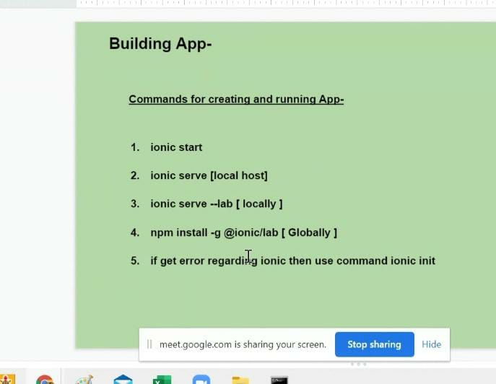

g) Files which are required to be installed before starting ionic project.

Angular js, Node js and any text editor like sublime text or visual code etc.

h) What is ionic lab?

Ionic Labs allows you to preview your application working on the Android and iOS at the same time on the browser on the very same screen. ... This allows you to visualize changes on your app on all platforms at the same time so that you can quickly catch little quirks here and there.

To get started with Ionic Lab, make sure to update to the latest version of Ionic in NPM:

-> npm install -g ionic

We’ve extended the serve command to open the new Lab UI:

-> ionic serve --lab

i) What is the use of app component in ionic project?

ionic apps are made of high-level building blocks called components. Components **allow you to quickly construct an interface for your app**.