**Exp 10**

**Create an app for feedback of students along with the ratings and store and retrieve from firebase**

**Following files needed to be uploaded for the submission of practical:  
1) Document file consisting of the following:  
           a) HTML file and other file if used**

**//tab1.page.html**

<ion-header [translucent]="true">

  <ion-toolbar>

    <ion-title>

      Information

    </ion-title>

  </ion-toolbar>

</ion-header>

<ion-content [fullscreen]="true">

  <ion-header collapse="condense">

    <ion-toolbar>

      <ion-title size="large">Info</ion-title>

    </ion-toolbar>

  </ion-header>

<p>{{user}}</p>

<ion-button type="submit" (click)="authService.SignOut()" expand="block">Logout</ion-button>

 <ion-list lines="full">

    <form [formGroup]="studentForm" (ngSubmit)="formSubmit()">

      <ion-item>

        <ion-label position="floating">Name</ion-label>

        <ion-input formControlName="name" type="text" required></ion-input>

      </ion-item>

      <ion-item>

        <ion-label position="floating">Email</ion-label>

        <ion-input formControlName="email" type="text" required>

        </ion-input>

      </ion-item>

      <ion-item>

        <ion-label position="floating">Mobile</ion-label>

        <ion-input formControlName="mobile" type="text" required>

        </ion-input>

      </ion-item>

       <ion-item>

        <ion-label position="floating">Class</ion-label>

        <ion-input formControlName="class" type="text" required>

        </ion-input>

      </ion-item>

       <ion-item>

        <ion-label position="floating">UID</ion-label>

        <ion-input formControlName="uid" type="text" required>

        </ion-input>

      </ion-item>

       <ion-item>

        <ion-label position="floating">course</ion-label>

        <ion-input formControlName="course" type="text" required>

        </ion-input>

      </ion-item>

      <ion-row>

        <ion-col>

          <ion-button type="submit" color="primary" shape="full" expand="block">Submit</ion-button>

        </ion-col>

      </ion-row>

    </form>

  </ion-list>

</ion-content>

**//tab2.page.html**

<ion-header>

  <ion-toolbar>

    <ion-title>

      Data

    </ion-title>

  </ion-toolbar>

</ion-header>

<ion-content>

  <ion-list class="ios list-ios hydrated">

    <ion-list-header class="ios hydrated">

      Students

    </ion-list-header>

    <ion-item *ngFor="let student of Studentss"   class="user-list">

      <ion-label>

        <h5>

          <ion-icon name="person"></ion-icon> {{student.name}}

        </h5>

        <p>

          <ion-icon name="call"></ion-icon> {{student.mobile}}

        </p>

      </ion-label>

      <div class="item-note" item-end>

        <button ion-button clear [routerLink]="['/view-student/', student.$key]">

          <ion-icon name="eye" style="zoom:2.0"></ion-icon>

        </button>

        <button ion-button clear [routerLink]="['/edit-student/', student.$key]">

          <ion-icon name="create" style="zoom:2.0"></ion-icon>

        </button>

        <button ion-button clear (click)="deleteStudent(student.$key)">

          <ion-icon name="trash" style="zoom:2.0"></ion-icon>

        </button>

      </div>

    </ion-item>

  </ion-list>

**//tab3.page.html**

<ion-header>

  <ion-toolbar>

    <ion-title>Feedback</ion-title>

  </ion-toolbar>

</ion-header>

<ion-content>

  <form [formGroup]="feedbackForm" (ngSubmit)="formSubmit()">

  <ion-item>

    <ion-label>Enter your Name :</ion-label>

    <ion-input formControlName="name" placeholder="Name"></ion-input>

  </ion-item>

  <ion-item>

    <ion-label>Date of Birth</ion-label>

    <ion-datetime displayFormat="DD MM YY" formControlName="dob" placeholder="Select Date"></ion-datetime>

  </ion-item>

  <ion-list>

    <ion-radio-group formControlName="gender">

      <ion-list-header>

        <ion-label>Gender</ion-label>

      </ion-list-header>

      <ion-item>

        <ion-label>Female</ion-label>

        <ion-radio slot="start" value="female"></ion-radio>

      </ion-item>

      <ion-item>

        <ion-label>Male</ion-label>

        <ion-radio slot="start" value="male"></ion-radio>

      </ion-item>

      <ion-item>

        <ion-label>Others</ion-label>

        <ion-radio slot="start" value="others"></ion-radio>

      </ion-item>

    </ion-radio-group>

  </ion-list>

  <ion-item >

    <ion-label>Rating</ion-label>

    <ion-range formControlName="rate" min="0" max="5" step="1" snaps="true" ticks="true" pin="true" color="secondary"></ion-range>

  </ion-item>

  <ion-item>

    <ion-label position="floating">Suggestions</ion-label>

    <ion-textarea formControlName="suggestion"></ion-textarea>

  </ion-item>

  <ion-button type="submit" expand="full" fill="outline">Submit</ion-button>

  </form>

</ion-content>

**//tabs.page.html**

<ion-tabs>

  <ion-tab-bar slot="bottom">

    <ion-tab-button tab="tab1">

      <ion-icon name="id-card-outline"></ion-icon>

      <ion-label>Info</ion-label>

    </ion-tab-button>

    <ion-tab-button tab="tab2">

      <ion-icon name="clipboard-outline"></ion-icon>

      <ion-label>Data</ion-label>

    </ion-tab-button>

    <ion-tab-button tab="tab3">

      <ion-icon name="pencil-outline"></ion-icon>

      <ion-label>Feedback</ion-label>

    </ion-tab-button>

  </ion-tab-bar>

</ion-tabs>

**//edit-student.page.html**

<ion-header>

  <ion-toolbar>

    <ion-buttons slot="start">

      <ion-back-button></ion-back-button>

    </ion-buttons>

    <ion-title>

      Edit Student

    </ion-title>

  </ion-toolbar>

</ion-header>

<ion-content>

  <ion-list lines="full">

    <form [formGroup]="updateStudentForm" (ngSubmit)="updateForm()">

      <ion-item>

        <ion-label position="floating">Name</ion-label>

        <ion-input formControlName="name" type="text" required></ion-input>

      </ion-item>

      <ion-item>

        <ion-label position="floating">Email</ion-label>

        <ion-input formControlName="email" type="text" required>

        </ion-input>

      </ion-item>

      <ion-item>

        <ion-label position="floating">Mobile</ion-label>

        <ion-input formControlName="mobile" type="text" required>

        </ion-input>

      </ion-item>

         <ion-item>

        <ion-label position="floating">Class</ion-label>

        <ion-input formControlName="class" type="text" required>

        </ion-input>

      </ion-item>

         <ion-item>

        <ion-label position="floating">UID</ion-label>

        <ion-input formControlName="uid" type="text" required>

        </ion-input>

      </ion-item>

         <ion-item>

        <ion-label position="floating">Course</ion-label>

        <ion-input formControlName="course" type="text" required>

        </ion-input>

      </ion-item>

      <ion-row>

        <ion-col>

          <ion-button type="submit" color="primary" shape="full" expand="block">Update Student</ion-button>

        </ion-col>

      </ion-row>

    </form>

  </ion-list>

</ion-content>

**//feedback-detail.page.html**

<ion-header>

  <ion-toolbar>

    <ion-buttons slot="start">

      <ion-back-button></ion-back-button>

    </ion-buttons>

    <ion-title>

      Feedback

    </ion-title>

  </ion-toolbar>

</ion-header>

<ion-content>

  <ion-list lines="full">

    <form [formGroup]="updateFeedbackForm">

      <ion-item>

        <ion-label position="floating">Name</ion-label>

        <ion-input formControlName="name" type="text" readonly></ion-input>

      </ion-item>

      <ion-item>

        <ion-label position="floating">Gender</ion-label>

        <ion-input formControlName="gender" type="text" readonly>

        </ion-input>

      </ion-item>

      <ion-item>

        <ion-label position="floating">DOB</ion-label>

        <ion-input formControlName="dob" type="text" readonly>

        </ion-input>

      </ion-item>

      <ion-item>

        <ion-label position="floating">Rated</ion-label>

        <ion-input formControlName="rate" type="text" readonly>

        </ion-input>

      </ion-item>

         <ion-item>

        <ion-label position="floating">Suggestions</ion-label>

        <ion-input formControlName="suggestion" type="text" readonly>

        </ion-input>

      </ion-item>

      <ion-row>

      </ion-row>

    </form>

  </ion-list>

</ion-content>

**//login.page.html**

<ion-header>

  <ion-toolbar>

    <ion-buttons slot="start">

      <ion-back-button></ion-back-button>

    </ion-buttons>

    <ion-title>Sign in</ion-title>

  </ion-toolbar>

</ion-header>

<ion-content>

  <form>

    <ion-item lines="full">

      <img src="assets/SPIT_logo.jpg" alt="SPIT-logo" class="center">

  <ion-card-title class="login">S.P.I.T</ion-card-title>

      <ion-label position="floating">Email</ion-label>

      <ion-input type="text" #email required></ion-input>

    </ion-item>

    <ion-item lines="full">

      <ion-label position="floating">Password</ion-label>

      <ion-input type="password" #password required></ion-input>

    </ion-item>

    <ion-row>

      <ion-col>

      <ion-button type="submit" (click)="logIn(email, password)" expand="block">Login</ion-button>

     <ion-button type="submit" (click)="Signup()" expand="block">Register</ion-button>

      </ion-col>

    </ion-row>

  </form>

</ion-content>

**//register.page.html**

<ion-header>

  <ion-toolbar>

    <ion-buttons slot="start">

      <ion-back-button></ion-back-button>

    </ion-buttons>

    <ion-title>Register</ion-title>

  </ion-toolbar>

</ion-header>

<ion-content>

  <form>

    <ion-item lines="full"><img src="assets/SPIT_logo.jpg" alt="SPIT-logo" class="center">

      <ion-card-title class="login">S.P.I.T</ion-card-title>

      <ion-label position="floating">Email</ion-label>

      <ion-input type="text" #email required></ion-input>

    </ion-item>

    <ion-item lines="full">

      <ion-label position="floating">Password</ion-label>

      <ion-input type="password" #password required></ion-input>

    </ion-item>

    <ion-row>

      <ion-col>

      <ion-button type="submit" (click)="signUp(email, password)" expand="block">Register</ion-button>

      </ion-col>

    </ion-row>

  </form>

</ion-content>

**b) Screenshot of the UI made.**

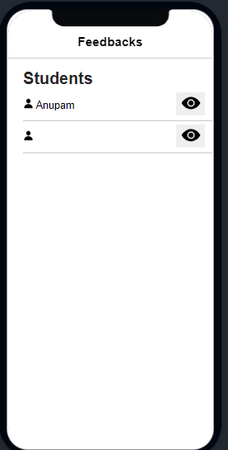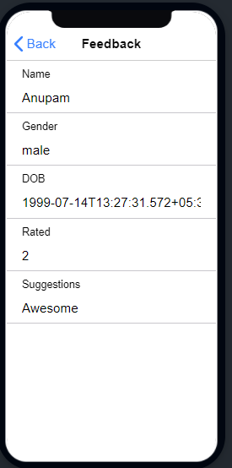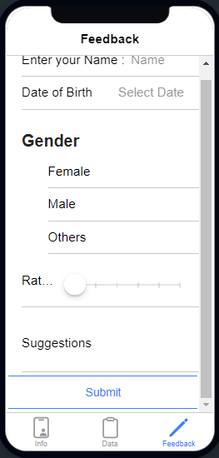

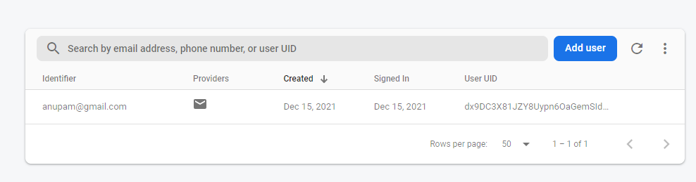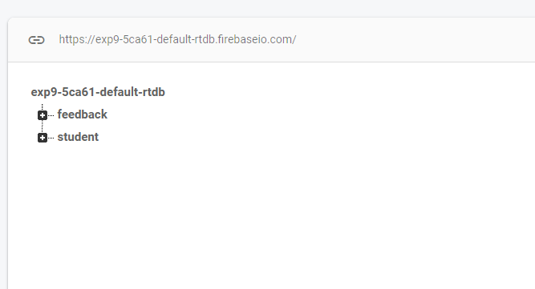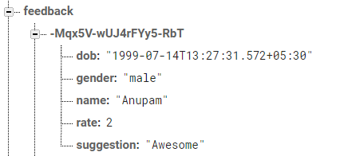

2) Document consisting of the following questions and answers:  
  
  
**A)  which method do we use for re-authenticate the email-id and password?**

**->** This is used to enable the verification of the user form the credentials present in the database.

**B)  What is the use of AngularFirestoreModule?**

* This module is used to import the functionalities from the firebase module, and to enable ethe app to use the functionalities in the app.

import { AngularFireModule } from '@angular/fire/compat';

import { AngularFireAuthModule } from '@angular/fire/compat/auth';

import { AngularFireDatabaseModule } from '@angular/fire/compat/database/';

import { AngularFirestoreModule } from '@angular/fire/compat/firestore';

import { AngularFireStorageModule } from '@angular/fire/compat/storage';

import { environment } from '../environments/environment';

import * as  firebase from 'firebase/compat';

**C)  what is the use of angular router?**

* The following command uses the Angular CLI to generate a basic Angular application with an application routing module, called AppRoutingModule, which is an NgModule where you can configure your routes.