**Title:** To create an Museum app using basic UI components and SASS

**1.Files which are used for the application (.html, .scss, .ts etc)**

->**apps->tabs->tabs.page.html**

<ion-tabs>

  <ion-tab-bar slot="bottom">

    <ion-tab-button tab="tab1">

      <ion-icon name="home-outline"></ion-icon>

      <ion-label>Home</ion-label>

    </ion-tab-button>

    <ion-tab-button tab="tab2">

      <ion-icon name="color-palette-outline"></ion-icon>

      <ion-label>Painting</ion-label>

    </ion-tab-button>

    <ion-tab-button tab="tab3">

      <ion-icon name="location-outline"></ion-icon>

      <ion-label>Location</ion-label>

    </ion-tab-button>

    <ion-tab-button tab="feedback">

      <ion-icon name="clipboard-outline"></ion-icon>

      <ion-label>Feedback</ion-label>

    </ion-tab-button>

  </ion-tab-bar>

</ion-tabs>

->**apps->tabs->tabs-routing.module.ts**

import { NgModule } from '@angular/core';

import { RouterModule, Routes } from '@angular/router';

import { TabsPage } from './tabs.page';

const routes: Routes = [

  {

    path: 'tabs',

    component: TabsPage,

    children: [

      {

        path: 'tab1',

        loadChildren: () => import('../tab1/tab1.module').then(m => m.Tab1PageModule)

      },

      {

        path: 'tab2',

        loadChildren: () => import('../tab2/tab2.module').then(m => m.Tab2PageModule)

      },

      {

        path: 'tab3',

        loadChildren: () => import('../tab3/tab3.module').then(m => m.Tab3PageModule)

      },

      {

        path: 'feedback',

        loadChildren: () => import('../feedback/feedback.module').then( m => m.FeedbackPageModule)

      },

      {

        path: '',

        redirectTo: '/tabs/tab1',

        pathMatch: 'full'

      }

    ]

  },

  {

    path: '',

    redirectTo: '/tabs/tab1',

    pathMatch: 'full'

  }

];

@NgModule({

  imports: [RouterModule.forChild(routes)],

})

export class TabsPageRoutingModule {}

->**apps->tab1->tab1.page.html**

<ion-content>

  <div class="top-section ion-padding">

    <ion-tab-button tab="">

      <ion-icon name="list-outline"></ion-icon>

      <ion-label><b>Indian Museum</b></ion-label>

    </ion-tab-button>

    <div>

      <br/>

      <img style="text-align: center;" src="/assets/home.png" alt="">

      </div><br/>

      </div>

      <div class="action-buttons">

        <ion-button class="call" color="primary" >

          <ion-icon name="call"></ion-icon>Call Now

        </ion-button>&nbsp;&nbsp;&nbsp;&nbsp;&nbsp;&nbsp;

        <ion-button class="sms" Color="secondary">

          <ion-icon name="chatbubble"></ion-icon>Send SMS

        </ion-button>&nbsp;&nbsp;&nbsp;&nbsp;&nbsp;&nbsp;

        <ion-button class="book" color="success">

          <ion-icon name="book"></ion-icon>Book A Ticket

        </ion-button>

      </div>

      <div class="center">

        <p style="color:yellowgreen;text-align: center;">WELCOME TO INDIAN MUSEUM </p>

        <img src="/assets/common.png" alt="">

      <ion-card>

        <ion-card-header>

          <img src="/assets/museum.png" alt="">

          <ion-card-subtitle ><p style="color: gold;">WELCOME TO INDIAN MUSEUM KOLKATA</p> </ion-card-subtitle>

          <ion-card-title>HISTORY OF THE MUSEUM</ion-card-title>

        </ion-card-header>

        <ion-card-content>

          Founded in 1814 at the cradle of the Asiatic Society of Bengal (at the present building

           of the Asiatic Society, 1 Park Street, Kolkata), Indian Museum is the earliest and the

           largest multipurpose Museum not only in the Indian subcontinent but also in the Asia-Pacific

           region of the world. With the foundation of Indian Museum in 1814, the Museum movement started

            rolling in India and through  the year.....<a href="#" style="color: rgb(61, 47, 255);">Read More</a>

        </ion-card-content>

      </ion-card>

      </div>

</ion-content>

->**apps->tab2->tab2.page.html**

<link rel="stylesheet" href="https://cdnjs.cloudflare.com/ajax/libs/font-awesome/4.7.0/css/font-awesome.min.css">

<ion-content>

  <div class="center">

  <ion-card>

    <ion-card-header>

      <ion-card-subtitle ><p style="color: gold;text-align: center;"> ABOUT OUR COLLECTIONS</p> </ion-card-subtitle>

      <ion-card-title><h3 style="text-align: center;"><b>MUSEUM GALLERY</b></h3></ion-card-title>

      <img src="/assets/common.png" alt="">

    </ion-card-header>

  <ion-card>

    <ion-card-header>

      <ion-card-title><h3 style="text-align: center;"><b>BIRD GALLERY</b></h3></ion-card-title>

    </ion-card-header>

    This section exhibits birds and their ecosystem relationship / behaviour are displayed.

     Moreover, specimens of foreign birds from different continents are also on display.

    <ion-card-content>

      <img src="/assets/common.png" alt="">

      <div class="container">

        <img src="/assets/b1.png" style="width:100%">

        <ion-button ><p style="font-size:24px;color: #00ffcc;">View More</p> <i class="fa fa-external-link"></i></ion-button>

      </div>

    </ion-card-content>

  </ion-card>

  <ion-card>

    <ion-card-header>

      <ion-card-title><h3 style="text-align: center;"><b>BHARHUT GALLERY</b></h3></ion-card-title>

    </ion-card-header>

    The gallery shows the architectural remains - railings and the only surviving gateway;

    the Eastern gateway known as “Torana” from a place called Bharhut in the Satna district, Madhya Pradesh.

    <ion-card-content>

      <img src="/assets/common.png" alt="">

      <div class="container">

        <img src="/assets/b2.png" style="width:100%">

        <ion-button ><p style="font-size:24px;color: #00ffcc;">View More</p> <i class="fa fa-external-link"></i></ion-button>

      </div>

    </ion-card-content>

  </ion-card>

  <ion-card>

    <ion-card-header>

      <ion-card-title><h3 style="text-align: center;"><b> BRONZE GALLERY</b></h3></ion-card-title>

    </ion-card-header>

    Indian Museum, Kolkata possesses a sizeable number of metal images in its repository the dates

     of which range from 8th to 14th century CE. Based upon the nature of its collection, the collection

      can be broadly classified into a number of regional characters that sometimes highlight the features

       of particular schools once developed under the patronage of various political powers.

    <ion-card-content>

      <img src="/assets/common.png" alt="">

      <div class="container">

        <img src="/assets/b3.png" style="width:100%">

        <ion-button ><p style="font-size:24px;color: #00ffcc;">View More</p> <i class="fa fa-external-link"></i></ion-button>

      </div>

    </ion-card-content>

  </ion-card>

  </ion-card>

  </div>

</ion-content>

->**apps->tab3->tab3.page.html**

<ion-content>

  <ion-card>

        <ion-card-header>

          <ion-card-subtitle ><p style="color: gold;text-align: center;"> ABOUT INDIAN MUSEUM</p> </ion-card-subtitle>

      <ion-card-title><h3 style="text-align: center;"><b>LOCATION OF MUSEUM</b></h3></ion-card-title>

      <img src="/assets/common.png" alt="">

        </ion-card-header>

        <ion-card-content>

         The Indian Museum is the largest and oldest museum in India and

          has rare collections of antiques, armour and ornaments, fossils,

           skeletons, mummies, and Mughal paintings.

        </ion-card-content>

        <img src="/assets/loc1.png" alt="">

        <ion-card-title><h3 style="color: gold;text-align: center;"><b>Museum Building</b></h3></ion-card-title>

        <ion-card-content>

          The Museum is known by different names like Asiatic Society Museum, Imperial Museum,

           and then later as Indian Museum Kolkata.

         </ion-card-content>

         <img src="/assets/loc3.png" alt=""><br><br>

         <img src="/assets/loc.png" alt="">

      </ion-card>

</ion-content>

->**apps->feedback->feedback.page.html**

<ion-content>

  <ion-card>

    <ion-card-header>

      <ion-card-title><h3 style="text-align: center;color: #00ffff;"><b>Feedback</b></h3></ion-card-title>

     <br><img src="/assets/common.png" alt="">

    </ion-card-header>

    <ion-card-content>

      <div class="feedback">

        <ion-item>

        <ion-input type="name" placeholder="Enter your name "><h3 style="color:#0099ff;">Name&nbsp;&nbsp;&nbsp;&nbsp;</h3></ion-input>

      </ion-item>

      <ion-item>

        <ion-input type="email" placeholder="enter your email "><h3 style="color:#0099ff;">Email&nbsp;&nbsp;&nbsp;&nbsp;</h3></ion-input>

      </ion-item>

      <ion-item>

        <ion-input type="number" placeholder="Enter your contact "><h3 style="color:#0099ff;">Contact&nbsp;&nbsp;&nbsp;&nbsp;</h3></ion-input>

      </ion-item>

        <ion-item>

          <h3 style="color:#0099ff;">Gender&nbsp;&nbsp;&nbsp;&nbsp;&nbsp;&nbsp;&nbsp;&nbsp;&nbsp;</h3>

          <ion-select placeholder="Select One">

            <ion-select-option value="f">Female</ion-select-option>

            <ion-select-option value="m">Male</ion-select-option>

          </ion-select>

        </ion-item>

        <ion-item>

          <ion-range dualKnobs="true" min="21" max="72" step="3" snaps="true"><h3 style="color:#0099ff;">Rating&nbsp;&nbsp;&nbsp;&nbsp;</h3></ion-range>

        </ion-item>

        <ion-item>

          <ion-label position="floating"><h3 style="color:#0099ff;">Suggestions</h3></ion-label>

          <ion-textarea></ion-textarea>

        </ion-item><br>

            <ion-button >

             Submit

            </ion-button>

      </div>

    </ion-card-content>

  </ion-card>

</ion-content>

**2. Screenshot of the app made.**

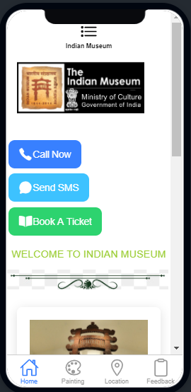

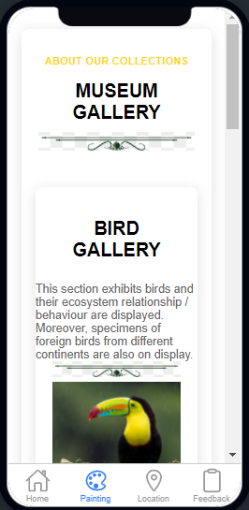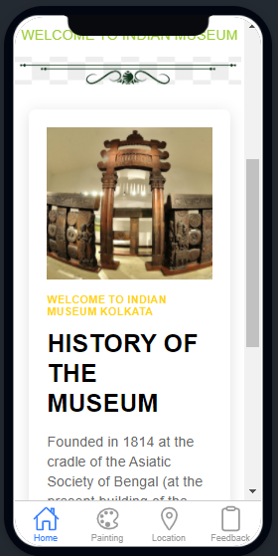

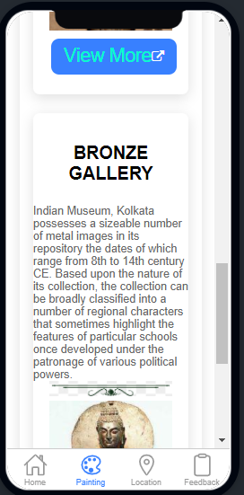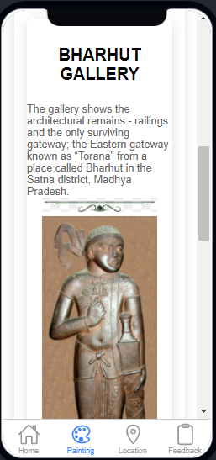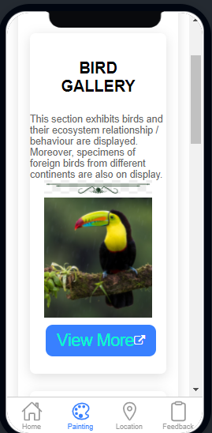

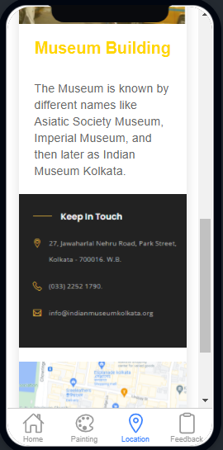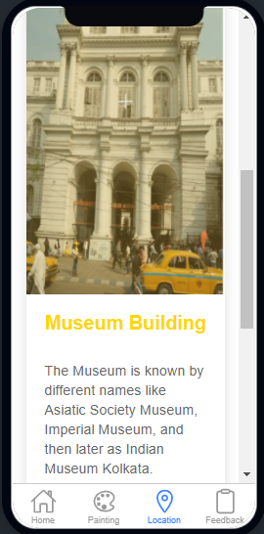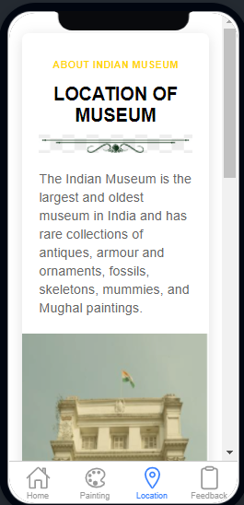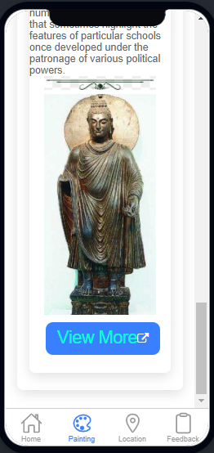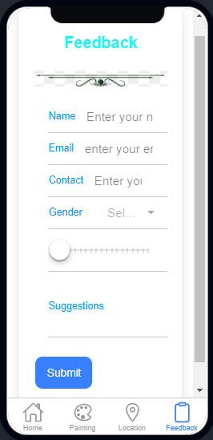

**3. Answers to the following questions:**

a) List and explain the features of SASS.

-> **7 Sass features**

Reference symbol ( & ) You might be familiar with the reference symbol, which allows you to reference a parent element as such: ...

* Partials and @import directive. ...
* Interpolation. ...
* @content directive. ...
* %placeholders. ...
* Functions. ...
* Lists and @each directive.

b) What is @mixin, @include, @extend, @import in SASS.

When a mixin is included, arguments can be passed by name in addition to passing them by their position in the argument list.

**@mixin** **order**($height**,** $selectors**...**) {

**@for** $i **from** 0 **to** **length**($selectors) {

#{**nth**($selectors**,** $i **+** 1)} {

**position**: absolute;

**height**: $height;

**margin-top**: $i **\*** $height;

}

}

}

**@include** **order**(150px**,** "input.name"**,** "input.address"**,** "input.zip");

It’s written @extend <selector>, and it tells Sass that one selector should inherit the styles of another.

**.error** {

**border**: 1px #f00;

**background-color**: #fdd;

**&**--serious {

**@extend** **.error**;

**border-width**: 3px;

}

}

When Sass imports a file, that file is evaluated as though its contents appeared directly in place of the @import. Any [mixins](https://sass-lang.com/documentation/at-rules/mixin), [functions](https://sass-lang.com/documentation/at-rules/function), and [variables](https://sass-lang.com/documentation/variables) from the imported file are made available, and all its CSS is included at the exact point where the @import was written.

**@import** 'foundation/code'**,** 'foundation/lists';

c) What is the use of routerlink ?

RouterLink. When applied to an element in a template, makes that **element a link that initiates navigation to a route**. Navigation opens one or more routed components in one or more <router-outlet> locations on the page.

d) What is the difference between component and page.

-> A page and a component are the same thing. “Page” is just terminology to identify a component that is being used as a screen in your Ionic application, there is nothing special that differentiates a page to a normal Angular component.

A component has a template and is used to add a completely new element to the app. Your “pages” for example might have a selector of page-home and would be embedded into your application with the tag:

<page-home></page-home>

e) List down the ways in which we can route between pages?

app.**routing**.module.ts (**Routing** Module) const itemRoutes: **Routes** = [ { path: 'item', component: ItemListComponent}, { path: 'DetailsPage/:id' }]

f) What is the difference between declaration,import,use component,export in module.ts file?

1. **declarations**: This property tells about the Components, Directives and Pipes that belong to this module.
2. **exports**: The subset of declarations that should be visible and usable in the component templates of other NgModules.
3. **imports**: Other modules whose exported classes are needed by component templates declared in this NgModule.

g) How do we add component in a specific page?

To create a new component manually:

1. Navigate to your Angular project directory.
2. Create a new file, <component-name>.component.ts.
3. At the top of the file, add the following import statement.

import { Component } from '@angular/core';

1. After the import statement, add a @[Component](https://angular.io/api/core/Component) decorator.

@Component({

})

1. Choose a CSS selector for the component.

@Component({

selector: 'app-component-overview',

})

1. Define the HTML template that the component uses to display information. In most cases, this template is a separate HTML file.

@Component({

selector: 'app-component-overview',

templateUrl: './component-overview.component.html',

})

1. elect the styles for the component's template. In most cases, you define the styles for your component's template in a separate file.

@Component({

selector: 'app-component-overview',

templateUrl: './component-overview.component.html',

styleUrls: ['./component-overview.component.css']

})

1. Add a class statement that includes the code for the component.

export class ComponentOverviewComponent {

}