**Exp-3: Create an app for MCA department using Tabs Navigation.**

1) Document file consisting of the following:  
   a) HTML file and other file if used

**->app->tabs->tabs.page.html**

<ion-tabs>

  <ion-tab-bar slot="bottom">

    <ion-tab-button tab="tab1">

      <ion-icon style="size: small;" name="home-outline"></ion-icon>

      <ion-label>Home</ion-label>

    </ion-tab-button>

    <ion-tab-button tab="tab2">

      <ion-icon style="size: small;" name="person-add-outline"></ion-icon>

      <ion-label>Faculty</ion-label>

    </ion-tab-button>

    <ion-tab-button tab="tab3">

      <ion-icon style="size: small;" name="cog-outline"></ion-icon>

      <ion-label>Web</ion-label>

    </ion-tab-button>

    <ion-tab-button tab="events">

      <ion-icon name="calendar-number-outline"></ion-icon>

      <ion-label>Events</ion-label>

    </ion-tab-button>

    <ion-tab-button tab="feedback">

      <ion-icon style="size: small;" name="bulb-outline"></ion-icon>

      <ion-label>Feed<br>back</ion-label>

    </ion-tab-button>

  </ion-tab-bar>

</ion-tabs>

**->app->tabs->tabs-routing.module.ts**

import { NgModule } from '@angular/core';

import { RouterModule, Routes } from '@angular/router';

import { TabsPage } from './tabs.page';

const routes: Routes = [

  {

    path: 'tabs',

    component: TabsPage,

    children: [

      {

        path: 'tab1',

        loadChildren: () => import('../tab1/tab1.module').then(m => m.Tab1PageModule)

      },

      {

        path: 'tab2',

        loadChildren: () => import('../tab2/tab2.module').then(m => m.Tab2PageModule)

      },

      {

        path: 'tab3',

        loadChildren: () => import('../tab3/tab3.module').then(m => m.Tab3PageModule)

      },

      {

        path: 'events',

        loadChildren: () => import('../events/events.module').then( m => m.EventsPageModule)

      },

      {

        path: 'feedback',

        loadChildren: () => import('../feedback/feedback.module').then( m => m.FeedbackPageModule)

      },

      {

        path: '',

        redirectTo: '/tabs/tab1',

        pathMatch: 'full'

      }

    ]

  },

  {

    path: '',

    redirectTo: '/tabs/tab1',

    pathMatch: 'full'

  }

];

@NgModule({

  imports: [RouterModule.forChild(routes)],

})

export class TabsPageRoutingModule {}

**->app->tab1->tab1.page.html**

<ion-content>

  <div class="top-section ion-padding">

    <ion-tab-button tab="">

      <ion-icon name="list-outline"></ion-icon>

      <img style="text-align: center;" src="/assets/logo.png" alt="">

      <h3><b>Department of MCA</b></h3>

      <ion-searchbar search-icon="d-search"></ion-searchbar>

    </ion-tab-button>

    </div>

    <div class="action-buttons">

      <ion-button class="call" color="primary" >

        <ion-icon name="call"></ion-icon>Call Now

      </ion-button>

      <ion-button class="sms" Color="secondary">

        <ion-icon name="chatbubble"></ion-icon>Send SMS

        </ion-button>

    </div>

      <div class="center">

      <ion-card>

        <ion-card-header>

          <ion-card-title><p style="color: gold;">Sardar Patel Institute of Technology</p></ion-card-title>

          <img src="/assets/college.png" alt="">

        </ion-card-header>

        <ion-card-content>

          The institute is located in 47 acres of green campus at Andheri (W), the fastest growing suburb

           of Mumbai. The campus also houses four Bhavan’s Institutions of great repute namely Bhavan’s College

            (the arts, commerce and science college), Sardar Patel College of Engineering secondary school......<a href="https://www.spit.ac.in/about/" style="color: rgb(61, 47, 255);">Read More</a>

        </ion-card-content>

      </ion-card>

      <ion-card>

      <ion-card-header>

        <ion-card-title><h2 style="color: gold;"><b>Vision</b></h2></ion-card-title>

        <ion-card-subtitle ><p >To be a university globally trusted for technical excellence where learning and research integrate to sustain society and industry. </p> </ion-card-subtitle>

      </ion-card-header>

      <ion-card-header>

        <ion-card-title><h2 style="color: gold;"><b>Mission</b></h2></ion-card-title>

        <ion-card-subtitle ><p >-> To offer undergraduate, postgraduate, doctoral and modular programmes in multi-disciplinary / inter-disciplinary and emerging areas.

         <br><br> -> To create a converging learning environment to serve a dynamically evolving society.

         <br><br> ->To promote innovation for sustainable solutions by forging global collaborations with academia and industry in cutting-edge research.

         <br><br> -> To be an intellectual ecosystem where human capabilities can develop holistically.</p> </ion-card-subtitle>

      </ion-card-header>

    </ion-card>

      </div>

    <ion-fab vertical="bottom" horizontal="end" slot="fixed">

    <ion-fab-button>

      <ion-icon name="share"></ion-icon>

    </ion-fab-button>

    <ion-fab-list side="start">

      <ion-fab-button><ion-icon name="logo-facebook" href="https://www.facebook.com/S.P.I.T.andheri/"></ion-icon></ion-fab-button>

    </ion-fab-list>

    <ion-fab-list side="top">

      <ion-fab-button><ion-icon name="logo-instagram" href="https://www.instagram.com/explore/tags/spit/?hl=en"></ion-icon></ion-fab-button>

    </ion-fab-list>

  </ion-fab>

</ion-content>

**->app->tab2->tab2.page.html**

<ion-content>

  <ion-card>

    <ion-card-header>

      <h2 style="text-align: center;">FACULTY</h2>

      <img src="/assets/f1.png" alt="">

      <ion-button class="call" color="primary" ><ion-icon name=""></ion-icon>Dr. Pooja Raundale

      </ion-button>

      <ion-card-title><h5 style="text-align: center;"><b>Professor and Head of Department</b></h5></ion-card-title>

      <ion-card-subtitle ><p style="color: gold;text-align: center;"><b style="color: black;"> Research Interests :</b> <br>C programming, Artificial Intelligence, Computer Graphics, Object Oriented Programming in C++, Data Structures

       <br><b style="color: black;"> Phone :</b><br> 022-26708520, 022-26706640

       <br><b style="color: black;">Email :</b><br> pooja@spit.ac.in</p> </ion-card-subtitle>

    </ion-card-header>

    <ion-card-header>

      <img src="/assets/f2.png" alt="">

      <ion-button class="call" color="primary" ><ion-icon name=""></ion-icon>Prof.Harshil Kanakia

      </ion-button>

      <ion-card-title><h5 style="text-align: center;"><b>Assistant Professor</b></h5></ion-card-title>

      <ion-card-subtitle ><p style="color: gold;text-align: center;"><b style="color: black;">Research Interests :</b> <br>Software Engineering, Advanced Microprocessor, Data Structures, Database Management Systems

        <br><b style="color: black;">Phone :</b><br> 022-26708520, 022-26706640

        <br><b style="color: black;">Email :</b><br> harshil_kanakia@spit.ac.in </p> </ion-card-subtitle>

    </ion-card-header>

    <ion-card-header>

      <img src="/assets/f3.png" alt="">

      <ion-button class="call" color="primary" ><ion-icon name=""></ion-icon>Prof.Sampat Vaidya

      </ion-button>

      <ion-card-title><h5 style="text-align: center;"><b>Assistant Professor</b></h5></ion-card-title>

      <ion-card-subtitle ><p style="color: gold;text-align: center;"> <br><b style="color: black;">Research Interests :</b><br>Engineering Mathematics, Numerical Analysis, Operation Research, Computer Programming,

        <br><b style="color: black;">Phone :</b><br> (M) 9820031384, 9819369868

        <br><b style="color: black;">Email :</b><br> vaidya.sampat@gmail.com </p> </ion-card-subtitle>

    </ion-card-header>

</ion-card>

</ion-content>

<ion-fab vertical="bottom" horizontal="end" slot="fixed">

  <ion-fab-button>

    <ion-icon name="share"></ion-icon>

  </ion-fab-button>

  <ion-fab-list side="start">

    <ion-fab-button><ion-icon name="logo-facebook" href="https://www.facebook.com/S.P.I.T.andheri/"></ion-icon></ion-fab-button>

  </ion-fab-list>

  <ion-fab-list side="top">

    <ion-fab-button><ion-icon name="logo-instagram" href="https://www.instagram.com/explore/tags/spit/?hl=en"></ion-icon></ion-fab-button>

  </ion-fab-list>

</ion-fab>

**->app->tab3->tab3.page.html**

<iframe src=" http://mca.spit.ac.in/" title="Web view" width="100%" height="100%" style="border:1px solid black;"></iframe>

**->app->events->events.page.html**

<ion-header>

  <ion-toolbar>

    &nbsp;&nbsp;&nbsp;&nbsp;&nbsp;&nbsp;&nbsp;&nbsp;&nbsp;&nbsp;&nbsp;&nbsp;&nbsp;&nbsp;&nbsp;&nbsp;

    <ion-button  class="call"  color="success" ><ion-icon name="events"></ion-icon>Events&nbsp;&nbsp;&nbsp;&nbsp;</ion-button>

  </ion-toolbar>

</ion-header>

<ion-content>

<ion-card>

<ion-card-header>

  <ion-card-title><h3 style="text-align: center;"><b>ACE COMMITEE (2021-22)</b></h3></ion-card-title>

  <ion-card-subtitle ><p style="color: rgb(55, 0, 255);text-align: center;">Session On Interview Skills</p> </ion-card-subtitle>

  <img src="/assets/e4.png" alt="">

  <ion-button style="width: 100%;">Participate Now !!! </ion-button>

</ion-card-header>

</ion-card>

<ion-card>

  <ion-card-header>

    <ion-card-title><h3 style="text-align: center;"><b>E-cell SPIT and IIC SPIT(2021-22)</b></h3></ion-card-title>

    <ion-card-subtitle ><p style="color: rgb(55, 0, 255);text-align: center;">Session On Business Quiz</p> </ion-card-subtitle>

    <img src="/assets/e1.png" alt="">

    <ion-button style="width: 100%;">Participate Now !!! </ion-button>

  </ion-card-header>

  </ion-card>

  <ion-card>

    <ion-card-header>

      <ion-card-title><h3 style="text-align: center;"><b>IEEE SPIT &nbsp;&nbsp; (2021-22)</b></h3></ion-card-title>

      <ion-card-subtitle ><p style="color: rgb(55, 0, 255);text-align: center;">Session On Technical Writing Workshop</p> </ion-card-subtitle>

      <img src="/assets/e3.png" alt="">

      <ion-button style="width: 100%;">Participate Now !!! </ion-button>

    </ion-card-header>

    </ion-card>

    <ion-card>

      <ion-card-header>

        <ion-card-title><h3 style="text-align: center;"><b>ACE COMMITEE (2021-22)</b></h3></ion-card-title>

        <ion-card-subtitle ><p style="color: rgb(55, 0, 255);text-align: center;">Session On Continuous Integration and Deployment Tools</p> </ion-card-subtitle>

        <img src="/assets/e2.png" alt="">

        <ion-button style="width: 100%;">Participate Now !!! </ion-button>

      </ion-card-header>

      </ion-card>

</ion-content>

<ion-fab vertical="bottom" horizontal="end" slot="fixed">

  <ion-fab-button>

    <ion-icon name="share"></ion-icon>

  </ion-fab-button>

  <ion-fab-list side="start">

    <ion-fab-button><ion-icon name="logo-facebook" href="https://www.facebook.com/S.P.I.T.andheri/"></ion-icon></ion-fab-button>

  </ion-fab-list>

  <ion-fab-list side="top">

    <ion-fab-button><ion-icon name="logo-instagram" href="https://www.instagram.com/explore/tags/spit/?hl=en"></ion-icon></ion-fab-button>

  </ion-fab-list>

</ion-fab>

**->app->feedback->feedback.page.html**

<ion-content>

  <ion-card>

    <ion-card-header>

      <ion-card-title><h3 style="text-align: center;color: #00ffff;"><b>Feedback</b></h3></ion-card-title>

     <br><img src="/assets/common.png" alt="">

    </ion-card-header>

    <ion-card-content>

      <div class="feedback">

        <ion-item>

        <ion-input type="name" position="floating" placeholder="Enter your name "><h3 style="color:#0099ff;">Name&nbsp;&nbsp;&nbsp;&nbsp;</h3></ion-input>

      </ion-item>

      <ion-item>

        <ion-input type="email" position="floating" placeholder="enter your email "><h3 style="color:#0099ff;">Email&nbsp;&nbsp;&nbsp;&nbsp;</h3></ion-input>

      </ion-item>

      <ion-item>

        <ion-input type="number" position="floating" placeholder="Enter your contact "><h3 style="color:#0099ff;">Contact&nbsp;&nbsp;&nbsp;&nbsp;</h3></ion-input>

      </ion-item>

        <ion-item>

          <h3 style="color:#0099ff;">Gender&nbsp;&nbsp;&nbsp;&nbsp;&nbsp;&nbsp;&nbsp;&nbsp;&nbsp;</h3>

          <ion-select placeholder="Select One">

            <ion-select-option value="f">Female</ion-select-option>

            <ion-select-option value="m">Male</ion-select-option>

          </ion-select>

        </ion-item>

        <ion-item>

          <ion-label position="floating"><h2 style="color:#0099ff;">Date(MM/DD/YYYY)</h2></ion-label>

          <ion-datetime displayFormat="MM/DD/YYYY" min="1994-03-14" max="2012-12-09" value="2002-09-23T15:03:46.789"></ion-datetime>

        </ion-item>

        <ion-item>

          <ion-icon name="sunny-outline"></ion-icon>

        <ion-range dualKnobs="true" min="21" max="72" step="3" snaps="true"><h3 style="color:#0099ff;">Rating&nbsp;&nbsp;&nbsp;&nbsp;<br><br></h3></ion-range><br>

      </ion-item>

      &nbsp;&nbsp;&nbsp;&nbsp;&nbsp;<ion-icon size="large" name="star-outline"></ion-icon><ion-icon size="large" name="star-outline"></ion-icon><ion-icon size="large" name="star-outline"></ion-icon><ion-icon size="large" name="star-outline"></ion-icon><ion-icon size="large" name="star-outline"></ion-icon>

        <ion-item>

          <ion-label position="floating"><h3 style="color:#0099ff;">Any Suggestions ?</h3></ion-label>

          <ion-textarea></ion-textarea>

        </ion-item><br>

        &nbsp;&nbsp;&nbsp;

            <ion-button > Submit  </ion-button>

      </div>

    </ion-card-content>

  </ion-card>

</ion-content>

<div>

  <ion-icon name="star" *ngFor="let num of [1,2,3,4,5]" (click)="rate(num)" [ngStyle]="{'color':getColor(num)}"></ion-icon>

</div>

<ion-fab vertical="bottom" horizontal="end" slot="fixed">

  <ion-fab-button>

    <ion-icon name="share"></ion-icon>

  </ion-fab-button>

  <ion-fab-list side="start">

    <ion-fab-button><ion-icon name="logo-facebook" href="https://www.facebook.com/S.P.I.T.andheri/"></ion-icon></ion-fab-button>

  </ion-fab-list>

  <ion-fab-list side="top">

    <ion-fab-button><ion-icon name="logo-instagram" href="https://www.instagram.com/explore/tags/spit/?hl=en"></ion-icon></ion-fab-button>

  </ion-fab-list>

</ion-fab>

 b) Screenshot of the UI made.

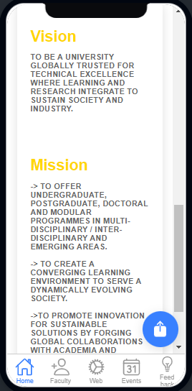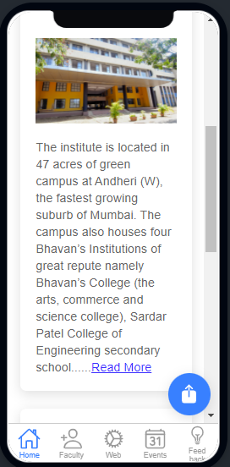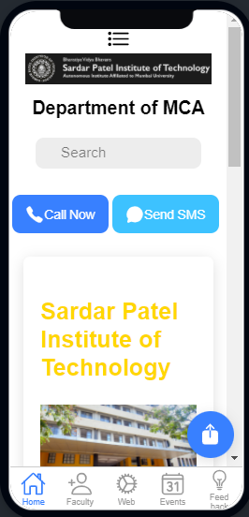

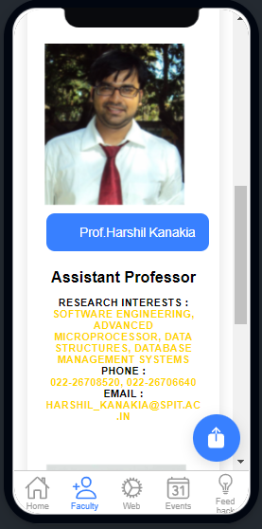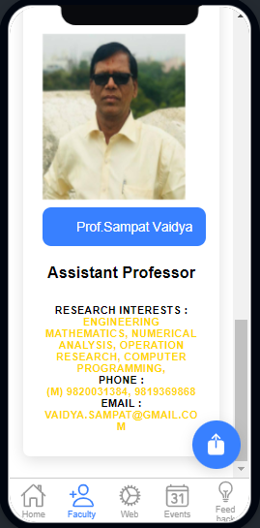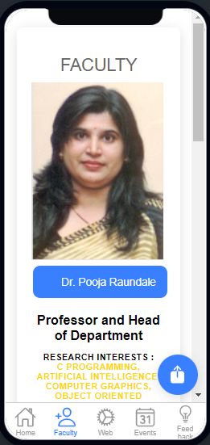

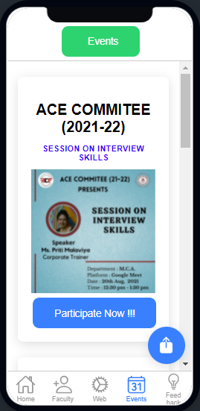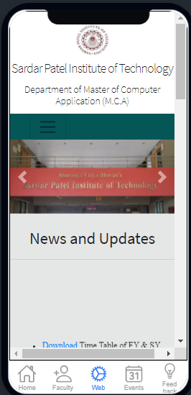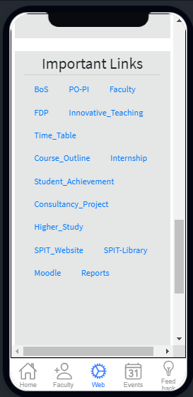

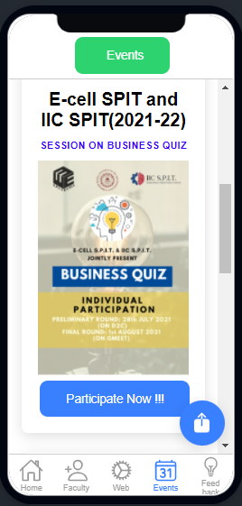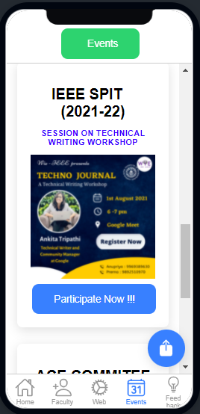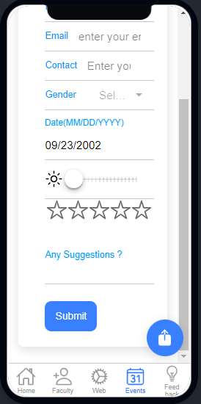

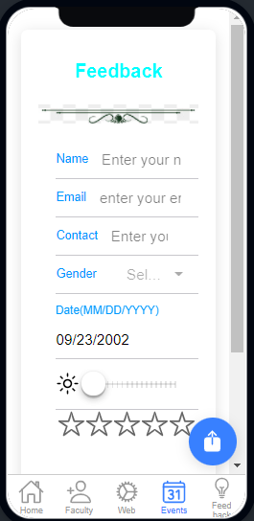

2) Document consisting of the following questions and answers:

* How to add WebView to the tab for viewing any website.

->By using

<iframe src=" “title="Web view" width="100%" height="100%" style="border:1px solid black;"></iframe>

* How to add notification event.

->

import { LocalNotifications } from '@ionic-native/local-notifications/ngx';

constructor(private localNotifications: LocalNotifications) { }

// Schedule a single notification

this.localNotifications.schedule({

id: 1,

text: 'Single ILocalNotification',

sound: isAndroid? 'file://sound.mp3': 'file://beep.caf',

data: { secret: key }

});

* How to add fab button and give click function to it.

->

As the name suggests, FABs generally float over the content in a fixed position. This is not achieved exclusively by using an <ion-fab-button>FAB</ion-fab-button>. They need to be wrapped with an <ion-fab> component in order to be fixed over the content.

* How to add material Design.

->

We can integrate Angular Material in Ionic easily, we have to follow Configuration certain steps.

**Step 1: Let first create an Ionic angular project.**

With the release of ionic version 4, the Ionic framework is no longer limited to angular, we can create the ionic projects in different front-end frameworks like Angular, Vue, and React. Let first create a blank Ionic Angular project.

ionic start

select angular framework

project name: ionicMaterialApps

template: blank

### Step 2: Integrage angular material in Ioinc 5.

Once we have created our Ionic angular project, we will now install and integrate angular material in our project.

ng add @angular/material

* Name the material design component you have used.

1.form controls (input, select, checkbox, date picker and sliders etc.),

2.navigation patterns (menus, sidenav and toolbar)

3.layout components (grids, cards, tabs and lists )

4.buttons.