**Experiment No.-4**

**Create SPIT app using side navigation drawer and Tabs navigation.**

**1.Files which are used for the application (.html, .scss, .ts etc)**

->**app.component.html**

<ion-app>

  <ion-menu side="start" menuId="menu-content" contentId="menu-content" class="my-custom-menu">

    <ion-header>

      <ion-toolbar color="tertiary">

        <ion-title>SPIT</ion-title>

      </ion-toolbar>

    </ion-header>

    <ion-content>

      <ion-list>

        <ion-menu-toggle menu="menu-content">

          <ion-item [routerLink]="['/home']">

            <ion-icon name="home" color="primary" slot="start"></ion-icon>

            <ion-label > Home</ion-label>

          </ion-item>

        </ion-menu-toggle>

        <ion-menu-toggle menu="menu-content">

          <ion-item [routerLink]="['/profile']">

            <ion-icon name="body-outline" color="danger" slot="start"></ion-icon>

            <ion-label > Profile</ion-label>

          </ion-item>

        </ion-menu-toggle>

        <ion-menu-toggle menu="menu-content">

          <ion-item [routerLink]="['/college']">

            <ion-icon name="planet-outline" color="success" slot="start"></ion-icon>

            <ion-label > College</ion-label>

          </ion-item>

        </ion-menu-toggle>

        <ion-menu-toggle menu="menu-content">

          <ion-item [routerLink]="['/faculty']">

            <ion-icon name="cog-outline" color="success" slot="start"></ion-icon>

            <ion-label>Faculty</ion-label>

          </ion-item>

        </ion-menu-toggle>

        <ion-menu-toggle menu="menu-content">

          <ion-item [routerLink]="['/placement']">

            <ion-icon name="paper-plane-outline" color="secondary" slot="start"></ion-icon>

            <ion-label>Placement</ion-label>

          </ion-item>

        </ion-menu-toggle>

        <ion-menu-toggle menu="menu-content">

          <ion-item [routerLink]="['/events']">

            <ion-icon name="speedometer-outline" color="success" slot="start"></ion-icon>

            <ion-label>Events</ion-label>

          </ion-item>

        </ion-menu-toggle>

        <ion-menu-toggle menu="menu-content">

          <ion-item [routerLink]="['']">

            <ion-icon name="log-out-outline" color="danger" slot="start"></ion-icon>

            <ion-label>Logout</ion-label>

          </ion-item>

        </ion-menu-toggle>

      </ion-list>

    </ion-content>

  </ion-menu>

  <ion-router-outlet id="menu-content"></ion-router-outlet>

</ion-app>

**->app-routing.module.ts**

import { NgModule } from '@angular/core';

import { PreloadAllModules, RouterModule, Routes } from '@angular/router';

const routes: Routes = [

  {

    path: 'home',

    loadChildren: () => import('./home/home.module').then( m => m.HomePageModule)

  },

  {

    path: '',

    redirectTo: 'home',

    pathMatch: 'full'

  },

  {

    path: 'college',

    loadChildren: () => import('./pages/college/college.module').then( m => m.CollegePageModule)

  },

  {

    path: 'faculty',

    loadChildren: () => import('./pages/faculty/faculty.module').then( m => m.FacultyPageModule)

  },

  {

    path: 'placement',

    loadChildren: () => import('./pages/placement/placement.module').then( m => m.PlacementPageModule)

  },

  {

    path: 'events',

    loadChildren: () => import('./pages/events/events.module').then( m => m.EventsPageModule)

  },

  {

    path: 'logout',

    loadChildren: () => import('./pages/logout/logout.module').then( m => m.LogoutPageModule)

  },

  {

    path: 'profile',

    loadChildren: () => import('./pages/profile/profile.module').then( m => m.ProfilePageModule)

  },

  {

    path: 'meet',

    loadChildren: () => import('./pages/meet/meet.module').then( m => m.MeetPageModule)

  },

  {

    path: 'tab1',

    loadChildren: () => import('./pages/tab1/tab1.module').then( m => m.Tab1PageModule)

  },

  {

    path: 'tab2',

    loadChildren: () => import('./pages/tab2/tab2.module').then( m => m.Tab2PageModule)

  },

  {

    path: 'tab3',

    loadChildren: () => import('./pages/tab3/tab3.module').then( m => m.Tab3PageModule)

  },

];

@NgModule({

  imports: [

    RouterModule.forRoot(routes, { preloadingStrategy: PreloadAllModules })

  ],

  exports: [RouterModule]

})

export class AppRoutingModule { }

->**home.page.html**

<ion-header>

  <ion-toolbar>

    <ion-title>S.P.I.T.</ion-title>

    <ion-button  slot="start">

      <ion-menu-button></ion-menu-button>

    </ion-button>

       <ion-button (click)="profile()" style="color: pink;"expand="block" fill="clear" shape="round">

        <h1> Side Navigation</h1>

       </ion-button>

       <br><br><br>

  </ion-toolbar>

</ion-header>

<ion-tabs>

  <ion-tab-bar slot="bottom">

    <ion-tab-button tab="tab1">

      <ion-icon name="people-circle-outline" color="danger"></ion-icon>

      <ion-label>About Us</ion-label>

    </ion-tab-button>

    <ion-tab-button tab="tab2">

      <ion-icon name="logo-react" color="success"></ion-icon>

      <ion-label>Vision & Mission</ion-label>

    </ion-tab-button>

    <ion-tab-button tab="tab3">

      <ion-icon name="apps-outline" color="secondary"></ion-icon>

      <ion-label>Contact Us</ion-label>

    </ion-tab-button>

  </ion-tab-bar>

</ion-tabs>

**->home-routing.module.ts**

import { NgModule } from '@angular/core';

import { RouterModule, Routes } from '@angular/router';

import { HomePage } from './home.page';

const routes: Routes = [

  {

    path: '',

    component: HomePage,

    children:[

    {

      path: 'tab1',

      children:[

        {

          path:'',

      loadChildren: () => import('../pages/tab1/tab1.module').then( m => m.Tab1PageModule)

        }

      ]

    },

    {

      path: 'tab2',

      children:[

        {

          path:'',

          loadChildren: () => import('../pages/tab2/tab2.module').then( m => m.Tab2PageModule)

        }

      ]

    },

    {

      path: 'tab3',

      children:[

        {

          path:'',

          loadChildren: () => import('../pages/tab3/tab3.module').then( m => m.Tab3PageModule)

        }

      ]

    },

  ]

  }

];

@NgModule({

  imports: [RouterModule.forChild(routes)],

  exports: [RouterModule]

})

export class HomePageRoutingModule {}

**->pages/college.page.html**

<ion-content>

  <div class="top-section ion-padding">

    <ion-tab-button tab="">

      <ion-icon name="list-outline"></ion-icon>

      <img style="text-align: center;" src="/assets/logo.png" alt="">

      <h3><b>Department of MCA</b></h3>

      <ion-searchbar search-icon="d-search"></ion-searchbar>

    </ion-tab-button>

    </div>

    <div class="action-buttons">

      <ion-button class="call" color="primary" >

        <ion-icon name="call"></ion-icon>Call Now

      </ion-button>

      <ion-button class="sms" Color="secondary">

        <ion-icon name="chatbubble"></ion-icon>Send SMS

        </ion-button>

    </div>

      <div class="center">

      <ion-card>

        <ion-card-header>

          <ion-card-title><p style="color: gold;">Sardar Patel Institute of Technology</p></ion-card-title>

          <img src="/assets/college.png" alt="">

        </ion-card-header>

        <ion-card-content>

          The institute is located in 47 acres of green campus at Andheri (W), the fastest growing suburb

           of Mumbai. The campus also houses four Bhavan’s Institutions of great repute namely Bhavan’s College

            (the arts, commerce and science college), Sardar Patel College of Engineering secondary school......<a href="https://www.spit.ac.in/about/" style="color: rgb(61, 47, 255);">Read More</a>

        </ion-card-content>

      </ion-card>

      <ion-card>

      <ion-card-header>

        <ion-card-title><h2 style="color: gold;"><b>Vision</b></h2></ion-card-title>

        <ion-card-subtitle ><p >To be a university globally trusted for technical excellence where learning and research integrate to sustain society and industry. </p> </ion-card-subtitle>

      </ion-card-header>

      <ion-card-header>

        <ion-card-title><h2 style="color: gold;"><b>Mission</b></h2></ion-card-title>

        <ion-card-subtitle ><p >-> To offer undergraduate, postgraduate, doctoral and modular programmes in multi-disciplinary / inter-disciplinary and emerging areas.

         <br><br> -> To create a converging learning environment to serve a dynamically evolving society.

         <br><br> ->To promote innovation for sustainable solutions by forging global collaborations with academia and industry in cutting-edge research.

         <br><br> -> To be an intellectual ecosystem where human capabilities can develop holistically.</p> </ion-card-subtitle>

      </ion-card-header>

    </ion-card>

      </div>

    <ion-fab vertical="bottom" horizontal="end" slot="fixed">

    <ion-fab-button>

      <ion-icon name="share"></ion-icon>

    </ion-fab-button>

    <ion-fab-list side="start">

      <ion-fab-button><ion-icon name="logo-facebook" href="https://www.facebook.com/S.P.I.T.andheri/"></ion-icon></ion-fab-button>

    </ion-fab-list>

    <ion-fab-list side="top">

      <ion-fab-button><ion-icon name="logo-instagram" href="https://www.instagram.com/explore/tags/spit/?hl=en"></ion-icon></ion-fab-button>

    </ion-fab-list>

  </ion-fab>

</ion-content>

**->pages/event.page.html**

<ion-header>

  <ion-toolbar>

   <h3>Events</h3>

  </ion-toolbar>

</ion-header>

<ion-content>

<ion-card style="text-align: center;">

<ion-card-header>

  <ion-card-title><h3 style="text-align: center;"><b>ACE COMMITEE (2021-22)</b></h3></ion-card-title>

  <ion-card-subtitle ><p style="color: rgb(55, 0, 255);text-align: center;">Session On Interview Skills</p> </ion-card-subtitle>

  <img src="/assets/e4.png" alt=""><br>

  <ion-button style="width: 20%;">Participate Now !!! </ion-button><br>

</ion-card-header>

</ion-card>

<ion-card style="text-align: center;">

  <ion-card-header>

    <ion-card-title><h3 style="text-align: center;"><b>E-cell SPIT and IIC SPIT(2021-22)</b></h3></ion-card-title>

    <ion-card-subtitle ><p style="color: rgb(55, 0, 255);text-align: center;">Session On Business Quiz</p> </ion-card-subtitle>

    <img src="/assets/e1.png" alt=""><br>

    <ion-button style="width: 20%;">Participate Now !!! </ion-button>

  </ion-card-header>

  </ion-card>

  <ion-card style="text-align: center;">

    <ion-card-header>

      <ion-card-title><h3 style="text-align: center;"><b>IEEE SPIT &nbsp;&nbsp; (2021-22)</b></h3></ion-card-title>

      <ion-card-subtitle ><p style="color: rgb(55, 0, 255);text-align: center;">Session On Technical Writing Workshop</p> </ion-card-subtitle>

      <img src="/assets/e3.png" alt=""><br>

      <ion-button style="width: 20%;">Participate Now !!! </ion-button>

    </ion-card-header>

    </ion-card>

    <ion-card style="text-align: center;">

      <ion-card-header>

        <ion-card-title><h3 style="text-align: center;"><b>ACE COMMITEE (2021-22)</b></h3></ion-card-title>

        <ion-card-subtitle ><p style="color: rgb(55, 0, 255);text-align: center;">Session On Continuous Integration and Deployment Tools</p> </ion-card-subtitle>

        <img src="/assets/e2.png" alt=""><br>

        <ion-button style="width: 20%;">Participate Now !!! </ion-button>

      </ion-card-header>

      </ion-card>

</ion-content>

<ion-fab vertical="bottom" horizontal="end" slot="fixed">

  <ion-fab-button>

    <ion-icon name="share"></ion-icon>

  </ion-fab-button>

  <ion-fab-list side="start">

    <ion-fab-button><ion-icon name="logo-facebook" href="https://www.facebook.com/S.P.I.T.andheri/"></ion-icon></ion-fab-button>

  </ion-fab-list>

  <ion-fab-list side="top">

    <ion-fab-button><ion-icon name="logo-instagram" href="https://www.instagram.com/explore/tags/spit/?hl=en"></ion-icon></ion-fab-button>

  </ion-fab-list>

</ion-fab>

**->pages/faculty.page.html**

<ion-content>

  <div style="text-align: center;">

  <ion-card>

    <ion-card-header>

      <h2 style="text-align: center;"><b>FACULTY</b></h2>

      <img src="/assets/f1.png" alt=""><br>

      <ion-button class="call" color="primary" ><ion-icon name=""></ion-icon>Dr. Pooja Raundale

      </ion-button>

      <ion-card-title><h5 style="text-align: center;"><b>Professor and Head of Department</b></h5></ion-card-title>

      <ion-card-subtitle ><p style="color: gold;text-align: center;"><b style="color: black;"> Research Interests :</b> <br>C programming, Artificial Intelligence, Computer Graphics, Object Oriented Programming in C++, Data Structures

       <br><b style="color: black;"> Phone :</b><br> 022-26708520, 022-26706640

       <br><b style="color: black;">Email :</b><br> pooja@spit.ac.in</p> </ion-card-subtitle>

    </ion-card-header>

    <ion-card-header>

      <img src="/assets/f2.png" alt=""><br>

      <ion-button class="call" color="primary" ><ion-icon name=""></ion-icon>Prof.Harshil Kanakia

      </ion-button>

      <ion-card-title><h5 style="text-align: center;"><b>Assistant Professor</b></h5></ion-card-title>

      <ion-card-subtitle ><p style="color: gold;text-align: center;"><b style="color: black;">Research Interests :</b> <br>Software Engineering, Advanced Microprocessor, Data Structures, Database Management Systems

        <br><b style="color: black;">Phone :</b><br> 022-26708520, 022-26706640

        <br><b style="color: black;">Email :</b><br> harshil_kanakia@spit.ac.in </p> </ion-card-subtitle>

    </ion-card-header>

    <ion-card-header>

      <img src="/assets/f3.png" alt=""><br>

      <ion-button class="call" color="primary" ><ion-icon name=""></ion-icon>Prof.Sampat Vaidya

      </ion-button>

      <ion-card-title><h5 style="text-align: center;"><b>Assistant Professor</b></h5></ion-card-title>

      <ion-card-subtitle ><p style="color: gold;text-align: center;"> <br><b style="color: black;">Research Interests :</b><br>Engineering Mathematics, Numerical Analysis, Operation Research, Computer Programming,

        <br><b style="color: black;">Phone :</b><br> (M) 9820031384, 9819369868

        <br><b style="color: black;">Email :</b><br> vaidya.sampat@gmail.com </p> </ion-card-subtitle>

    </ion-card-header>

</ion-card>

</div>

</ion-content>

<ion-fab vertical="bottom" horizontal="end" slot="fixed">

  <ion-fab-button>

    <ion-icon name="share"></ion-icon>

  </ion-fab-button>

  <ion-fab-list side="start">

    <ion-fab-button><ion-icon name="logo-facebook" href="https://www.facebook.com/S.P.I.T.andheri/"></ion-icon></ion-fab-button>

  </ion-fab-list>

  <ion-fab-list side="top">

    <ion-fab-button><ion-icon name="logo-instagram" href="https://www.instagram.com/explore/tags/spit/?hl=en"></ion-icon></ion-fab-button>

  </ion-fab-list>

</ion-fab>

**->pages/placement.page.html**

<ion-header>

  <ion-toolbar>

    <ion-title>placement</ion-title>

  </ion-toolbar>

</ion-header>

<ion-content style="text-align: center;"><br>

  <ion-button href="https://www.spit.ac.in/placements/"  shape="round">

    Click me

  </ion-button>

</ion-content>

**->pages/profile.page.html**

<ion-header>

  <ion-toolbar>

    <ion-title>profile</ion-title>

  </ion-toolbar>

</ion-header>

<ion-content>

  <ion-card>

     <div style="text-align:center" >

    <ion-card-header >

      <ion-card-title><h3 style="text-align: center;"><b>Student Profile</b></h3></ion-card-title>

      <img src="/assets/profile.png" alt=""><br>

      <ion-button style="width: 10%;">Login </ion-button>

    </ion-card-header>

      </div>

    </ion-card>

    <ion-card>

      <div style="text-align:center" >

        <ion-card-header >

          <ion-card-title><h3 style="text-align: center;"><b>Teacher Profile</b></h3></ion-card-title>

          <img src="/assets/profile.png" alt=""><br>

          <ion-button style="width: 10%;">Login </ion-button>

        </ion-card-header>

          </div>

      </ion-card>

      <ion-card>

        <div style="text-align:center" >

          <ion-card-header >

            <ion-card-title><h3 style="text-align: center;"><b>Admin Profile</b></h3></ion-card-title>

            <img src="/assets/profile.png" alt=""><br>

            <ion-button style="width: 10%;">Login </ion-button>

          </ion-card-header>

            </div>

      </ion-card>

</ion-content>

**2. Screenshot of the app made.**

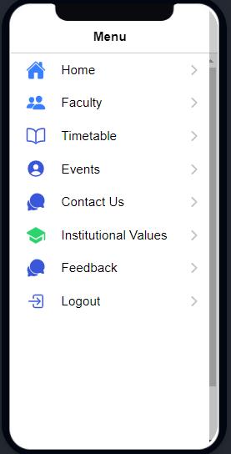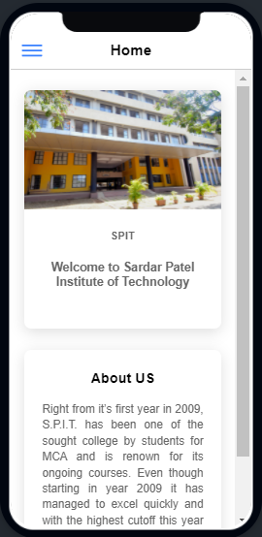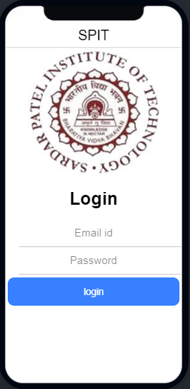

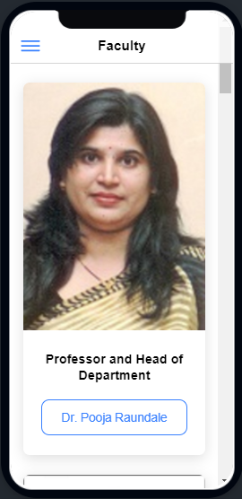

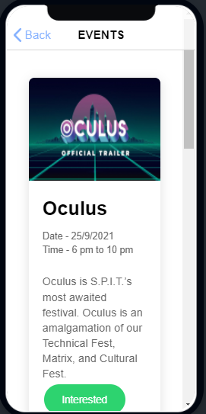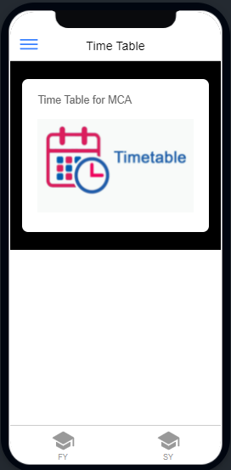

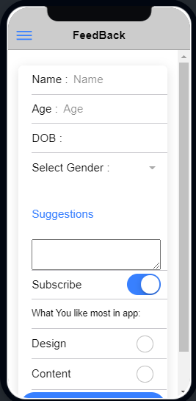

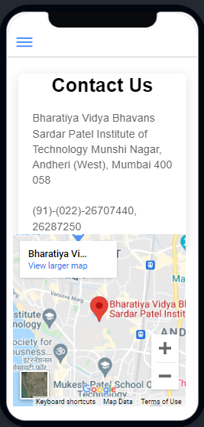

**Answers to the following questions:**  
a. How to merge Side Navigation and Tabs in one app?

->By Using

<ion-header>

  <ion-toolbar>

    <ion-title>S.P.I.T.</ion-title>

    <ion-button  slot="start">

      <ion-menu-button></ion-menu-button>

    </ion-button>

       <ion-button (click)="profile()" style="color: pink;"expand="block" fill="clear" shape="round">

        <h1> Side Navigation</h1>

       </ion-button>

       <br><br><br>

  </ion-toolbar>

</ion-header>

b. List down Good Features of Existing App.

->Contains all necessary tabs i.e.

1.Home

2.Profile

3.College

4.Faculty

5.Placement

6.Events

7.Logout

->Nice User Interface

->Flexible with navigation from one tab to another tab

c. List down the Drawbacks of Existing App.

->Type script functionality and features are remaining to add in page

d. List down the Features you are including in your app for better improvement.

->Faculty Page

->Google meet link provided in notification page

->Feedback Page